Vietnam National University, Hanoi
International School
============

M.A Thesis Proposal

Deep Learning-Based Detection of Student Behavior in Classroom Environments

NGUYEN TRUNG HIEU

Field: Informatics and Computer Engineering
Code: 8480111.01QTD

Hanoi - 2026

Vietnam National University, Hanoi
International School
============
M.A Thesis Proposal

Deep Learning-Based Detection of Student Behavior in Classroom Environments

NGUYEN TRUNG HIEU

Field: Informatics and Computer Engineering
Code: 8480111.01QTD
Supervisor: Kim Dinh Thai

Hanoi - 2026

CERTIFICATE OF ORIGINALITY
I, the undersigned, hereby certify my authority of the study project report entitled Deep Learning-Based Detection of Student Behavior in Classroom Environments submitted in partial fulfillment of the requirements for the degree of Master Informatics and Computer Engineering. Except where the reference is indicated, no other person’s work has been used without due acknowledgement in the text of the thesis.
Hanoi, 2024

Nguyen Trung Hieu

Approved by
SUPERVISOR

(Signature and full name)
Date:……………………

Abstract
Understanding student behavior is really important for improving teaching and keeping students safe in the classroom. But let us be honest it is not easy for teachers to watch everything that is going on all the time as It takes a lot of time. The teachers might miss something or see things differently. This research is about creating a system that can automatically recognize what students are doing, like raising their hands, sleeping, reading, or discussing with each other, etc. This research uses computer vision techniques to make this system work.
The study will use YOLO12 (You Only Look Once) architecture as a baseline and try to improve it using different methods. The difficulty of the research is dealing with the problem of the environment where the study is partially obscured by furniture or each other objects, the different of lighting conditions, angles, or small objects are mixed in a crowded space. The research uses the SCB5 dataset with preprocessed images to fine-tune the model and achieve a model that is balanced between accuracy and real-time processing speed.
The main goal of this thesis is to see how YOLO12 works compared to older versions like YOLO8 and YOLO11 and improve it. It aims to create a system that gives teachers information that they can actually use. Ultimately, the target of the research is to make a system that can detect student behavior reliably and show how artificial intelligence can help teachers manage their classrooms. This research is part of making education smarter. It can help both teachers and students in modern classrooms.
Keywords: Deep Learning, Student Behavior Detection, YOLO12 Computer Vision, Classroom Monitoring, Smart Education.

Contents
Abstract 4
Contents 5
List of Figures 7
List of Tables 7
Chapter I. Introduction 8
1.1. Rationale 8
1.2. Aim and objectives 9
1.3. Research questions 10
1.4. Methods of the study 10
1.5. Scope of the study 10
1.6. Significance of the study 11
1.7. Structure of the study 11
Chapter II. Literature review 12
2.1. Review of previous studies 12
2.2. Review of theoretical background 13
2.2.1. Object Detection 13
2.2.2. The Operating Principle of YOLO 13
2.2.3. The Evolution of the YOLO Model Family 14
2.2.4. YOLO12 16
2.2.5. Improving YOLO 20
Chapter III. Proposed Research Methodology 26
3.1. Research approaches 26
3.2. Population and sample 26
3.3. Research methods 27
Chapter IV. Finding and discussion 29
4.1. Baseline model 29
4.1.1. Data 29
4.1.2. Result on baseline model 31
4.2. SASE improvement 33
4.3. Dynamic Tanh improvement 34
4.3.1. Observations and Insights 35
4.3.2. Individual Class Performance 36
Chapter V. Conclusion 38
5.1. Summary of Research Contributions 38
5.2. Analysis of Experimental Results 38
5.2.1. Performance Breakthroughs 38
5.2.2. Critical Reflection on the SCB Dataset 39
5.3. Theoretical and Practical Significance 39
5.4. Limitations and Future Directions 39
References 41

List of Figures
Figure 1: YOLO12 Architecture [18] 18
Figure 2: Proposed YOLO12 Architecture with SASE improvement 21
Figure 3: Proposed Architecture using Dynamic Tanh (DyT) 23
Figure 4: Research Workflow 27
Figure 5: Data distribution 29
Figure 6: Example Image of Dataset (Back View) 30
Figure 7: Example Image of Dataset (Front View) 30
Figure 8: Example Image of Dataset (Close View) 31
Figure 9: Baseline YOLO8, YOLO11, YOLO12 on SCB5 32
Figure 10: Baseline YOLO12 vs YOLO12 with SASE 33
Figure 11: Baseline YOLO12 vs YOLO12 with DyT 35

List of Tables
Table 1: YOLO8, YOLO11 and YOLO12 31
Table 2: YOLO12 and YOLO12 with SASE comparison 33
Table 3: YOLO12 with DyT result 34
Table 4: Results of individual classes 36

Chapter I. Introduction

1.1. Rationale
Student Classroom Behavior (SCB) is a pivotal factor that has a direct and profound impact on the quality of education. Positive behaviors in the classroom, like paying attention, actively participating, and interacting with others, are important factors that increase academic performance and contribute to a positive learning environment [1]. When students stay engaged and focused, teaching becomes more effective, and the overall classroom atmosphere improves. In contrast, disruptive or negative behaviors can interrupt both the learning process of the student involved and that of the entire class. Those behaviors may reduce the effectiveness of teaching and create challenges for maintaining a good learning environment. For this reason, identifying and understanding Student Classroom Behaviors (SCB) is as important as it helps teachers intervene at the right time, provide appropriate support, and monitor their teaching strategies.
However, assessing student behavior is not always completely objective. Many studies have shown that teachers’ awareness and judgments can sometimes be influenced by factors unrelated to learning, such as students’ social background or race [2]. In fact, the same behavior may be interpreted differently depending on the student, leading to inconsistencies in evaluation and the possibility of unintended bias.
These limitations show that we need more objective and data-driven tools that can help teachers observe and understand classroom behavior. In recent years, Artificial Intelligence (AI) and Computer Vision technologies have shown strong potential in this area. By analyzing visual information from classroom environments, these systems can help provide consistent behavioral observations and reduce the influence of subjective human judgment.
Among the many approaches in computer vision, the YOLO (You Only Look Once) family of models has become one of the most widely used solutions for real-time object detection. YOLO8 is considered a strong baseline due to its balance between accuracy and efficiency [3]. More recent versions, such as YOLO11 and YOLO12, continue to improve the architecture and performance, making them increasingly suitable for practical applications that require fast and reliable detection [4], [5]. Based on this research, the main approach of this project is to build a model based on the YOLO12 foundational architecture. However, to address the specific challenge of identifying subtle student behaviors in a crowded classroom environment, another potential improvement has also been explored and may be applied: integrating the Coordinate Attention (CA) mechanism [6]. This mechanism is known as an effective and lightweight method that helps the model more accurately locate and focus on the position of the object of interest, a crucial factor for distinguishing between behaviors with similar manifestations [6].
To train these models, having a large and suitable dataset is a prerequisite. Notably, the SCB-dataset built in China provides a rich and challenging resource on student behavior [7]. Given the many cultural and educational environmental similarities between Asian countries, this dataset can be considered a suitable foundation for developing and refining models for application in Vietnamese classrooms.

1.2. Aim and objectives
The goal of this project is to develop a deep learning system that will enable real-time analysis by automatically identifying and categorizing student behaviors in a classroom. To achieve this goal, the study focuses on the following key tasks:
- Model research: Examine and investigate various YOLO family object detection models, including YOLO8, YOLO11, and YOLO12. To find the best model for identifying student behaviors, their architectures and performance will be examined.
- Data preparation: Prepare the SCB dataset for training, separate the data into training, validation, and testing sets, and use data augmentation techniques. The target is to make sure the data becomes more diverse, and the model's robustness will be strengthened.
- Model training and optimization: To increase detection accuracy and overall performance, train the chosen model using the prepared dataset and modify important training parameters and tactics.
- Performance evaluation: Evaluate the trained model using standard object detection metrics, compare its performance with existing YOLO models, and explore how it performs relative to other computer vision approaches.

1.3. Research questions
- How to design a deep learning model that is lightweight yet highly effective in detecting student behavior?
- How do different deep learning models yield different results when used on the SCB dataset?
- What is the impact of integrating custom techniques into the YOLO architecture on accuracy and processing speed?
- What useful insights can the analyses from this model provide for the field of education?

1.4. Methods of the study
This work combines primary research and secondary research to boost how well object detection systems recognize actions in classrooms. From earlier works, knowledge about the YOLO series and its upgrades shapes choices on design changes that could help. With those clues guiding decisions, experiments with modifications get applied directly to YOLO12. Each updated version is then compared with the starting model, measuring shifts in speed, accuracy, or both. Results emerge from side-by-side runs under identical conditions.
Carried out with the SCB-dataset [3], a publicly available resource built for analyzing student actions in classrooms, these tests begin only after careful adjustments to the data. Before any learning phase, the data gets preprocessed, and the experiment will use 6 labels, including bowhead, turnhead, discuss, hand-raising, read, and write, instead of only the latter 3. Training happens inside Google Colab, powered by a T4 GPU, keeping settings identical so results stay directly comparable. Each model reveals its strengths through common detection measures: mAP, precision, and recall shape how well detections hold up under scrutiny.

1.5. Scope of the study
- Data: The study uses the publicly available SCB-dataset (Student Classroom Behavior Dataset) [3].
- Model: The focus is on deep learning architectures from the YOLO family, including versions YOLO8, YOLO11, and YOLO12.
- Output: The model will identify the location and classify behaviors by generating bounding boxes and corresponding labels.
- Behavior: The behaviors to be classified include: bowhead, turnhead, discuss, hand-raising, read, and write.

1.6. Significance of the study
This work adds to knowledge in computer vision, especially how machines detect objects within actual classrooms. Rather than just proposing ideas, it tests specific upgrades on YOLO12, pushing forward how we think about refining models like those in the YOLO series. What sets this apart is its grounding in real conditions, where lighting shifts, students move unpredictably, and clutter fills the space. Instead of stopping at three actions, the project now covers six types of student conduct by the SCB-dataset [3]. Such expansion allows systems to tell finer differences in behavior, making automated observation more useful where it matters most. Teachers might find help in tracking how involved students are during lessons. Progress like this feeds into wider efforts using artificial intelligence inside schools. What emerged from testing also offers hints for those building better ways to spot objects outside controlled labs. Further research could build on these observations when refining real-life accuracy.

1.7. Structure of the study
The thesis is expected to consist of 5 main chapters: Introduction, Literature Review, Methodology, Findings and Discussion, and finally Conclusion and Future Work.

Chapter II. Literature review

2.1. Review of previous studies
The application of computer vision to analyze student behavior is a dynamic field of research that has been comprehensively reviewed in numerous survey papers [8]. Within this context, automated Human Behavior Analysis has become a topic of significant interest. Early methods focused on Action Recognition through skeleton-based analysis or optical flow, but these approaches were often complex and computationally intensive.
The advent of efficient object detection models has been a game-changer. While two-stage models like Faster R-CNN offer high accuracy, their slow processing speed makes them unsuitable for real-time applications. In contrast, single-stage models, most notably YOLO (You Only Look Once), have solved this problem by processing the entire image in a single pass, achieving a superior balance between speed and accuracy.
One of the factors driving this field is the emergence of large-scale, specialized datasets like Action-Net, where the authors demonstrated the effectiveness of the YOLO7 base model in multi-label recognition of student behavior [9]. The reality is that YOLO models, even stable versions like YOLO5, are continuously being improved to enhance their detection performance in classroom environments, as documented in a recent 2025 study [10]. The approach of improving native YOLO architectures by integrating supplementary modules, such as the CBAM attention mechanism into YOLO8 to enhance object detection capabilities, is also a common and effective research method [11].
However, our survey of existing works has identified several clear research gaps:
- Behavioral Complexity: Despite the availability of large datasets [9], accurately recognizing complex behaviors, group interactions, or subtle actions remains a challenge.
- Model Optimization: Studies often apply original models or make minor improvements. There is still a gap in systematically applying advanced improvement techniques [11] to the latest YOLO versions for the student behavior problem.
- Real-world Context: The deployment of models in actual classroom conditions, with issues like occlusion, changing lighting, and high student density, has not been thoroughly explored.
Therefore, this project is being conducted to address these limitations by experimenting with and comparing various YOLO and other Computer Vision models, while also finding ways to improve the results using custom and advanced methods to recognize a more diverse set of behaviors, ensuring effectiveness and applicability in real-world scenarios.

2.2. Review of theoretical background

2.2.1. Object Detection
Object detection is a cornerstone of computer vision; it have 2 task, which are identifying what’s in an image and pointing out exactly where it is. Basically, this means training a model to draw bounding boxes around objects and sort them into the right categories.
Modern object detection methods are typically divided into two groups:
- Two-stage models: These models perform the task in two steps. First, they propose a set of regions that are likely to contain objects (region proposals). The second step is using a neural network to classify the objects within these regions. An example is including the R-CNN family of models (Region-based Convolutional Neural Networks) and its variants such as Fast R-CNN and Faster R-CNN. The advantage of this approach is high accuracy, but it also has a disadvantage, which is slow processing speed, making it unsuitable for real-time applications.
- One-stage models: To increase the speed, one-stage models were developed. They process the entire image in a single pass, treating object detection as a regression problem to directly predict bounding boxes and class probabilities from the input image. YOLO (You Only Look Once) is the prime and pioneering representative of this approach.

2.2.2. The Operating Principle of YOLO
YOLO, first introduced by Joseph Redmon and his colleagues, revolutionised the field with its superior balance of speed and accuracy [12]. The groundbreaking idea of YOLO is that instead of looking at individual regions of the image, it "looks" at the entire image just once.
The basic operational process of YOLO is as follows:
- Grid Division: The input image is divided into a grid of cells of $S*S$. Each grid cell is responsible for detecting objects whose center falls within it.
- Bounding Box Prediction: At each grid cell, the model predicts B bounding boxes and a confidence score for each box.
  - A bounding box is represented by 5 values: ($x,y,w,h,confidence$). Here, ($x,y$) are the coordinates of the box's center relative to the grid cell, and w and h are the width and height of the box relative to the entire image.
  - The confidence score indicates how sure the model is that the box contains an object and the accuracy of that bounding box.
- Class Probability Prediction: Each grid cell also predicts C conditional probabilities for C different object classes. This probability indicates the likelihood that the object in the grid cell belongs to a specific class.
Finally, the predictions from all grid cells are combined. Non-Max Suppression (NMS) is applied to eliminate overlapping bounding boxes with low confidence scores, keeping only the best predictions for each object.

2.2.3. The Evolution of the YOLO Model Family
Since its first version, the YOLO model family has been continuously improved and developed through many generations, with each version bringing significant enhancements in architecture and performance.
- Early versions (YOLO1 - YOLO3): These versions laid the foundation for the one-stage architecture, focusing on increasing speed and improving the ability to detect small objects [12], [13], [14].
- Later versions (YOLO4 - YOLO7): These versions integrated many advanced techniques ("bag of freebies" and "bag of specials") into the network architecture to optimize the training process and enhance accuracy without significantly reducing processing speed [15].
- Latest generation (YOLO8 and its successors): As mentioned in the outline, YOLOv8 is considered a powerful base model developed by Ultralytics [16]. Successive versions like YOLO11 and YOLO12 continue to push the boundaries of performance, introducing new network structures, more efficient attention mechanisms, and optimized loss functions. These improvements help the models not only achieve higher accuracy but also become more flexible and easier to customize for specific tasks, such as recognizing student behavior in complex classroom environments.
Thanks to its superior processing speed and continuously improving accuracy, YOLO has become one of the top choices for real-time object detection applications in various fields.

2.2.4. YOLO12
Progress in spotting objects comes mostly from the YOLO series, designed to keep speed without losing precision. Instead of slower methods, these models process entire images in one pass. At first, YOLO systems used standard CNNs to pull out visual patterns from pixels. Though fast, such networks tend to miss broader connections across distant parts of a scene. Their local focus can be limiting when understanding cluttered environments. To improve context handling, newer studies began adding attention modules into these setups. These components were first seen in transformers, good at linking far-apart elements. Blending them with traditional detectors helps bridge gaps left by pure convolution approaches.
Emerging as part of an ongoing shift, YOLO12 integrates attention-driven components to strengthen how features are captured yet still operates quickly enough for live processing. As shown by Khanam and Hussain (2025) [17], it links fast convolutional methods with attention modules that grasp broader scene context. Instead of slowing down like many models using transformers, this blend seeks better accuracy at lower computing demand.
What sets YOLO12 apart begins with Area Attention, called A2. Instead of linking every pixel to all others across the entire feature map - how earlier models handled self-attention - it splits those maps into compact zones. Because full pairwise computation grows too heavy as image size increases, this regional split keeps demands manageable. Within each zone, interactions are calculated on their own, preserving local context that matters most. Efficiency rises since operations scale with area rather than total resolution squared. Even so, relevant patterns inside segments remain detectable and well-refined. The outcome? Stronger features emerge, yet processing time stays low during real-time use.
A key change in YOLO12's design involves Residual Efficient Layer Aggregation Networks, known as R-ELAN. Unlike prior versions, this approach builds on past methods meant to refine how gradients move and combine features across scales. Because it adds skip pathways during aggregation, data flows through layers more smoothly. Such paths allow stronger signal transmission without disrupting training stability. Feature representation improves - yet the system remains balanced throughout learning.
What helps YOLO12 move faster is FlashAttention, a method built to handle attention tasks more efficiently. Instead of slowing down due to heavy memory use, it smartly manages how data flows between the GPU’s storage and processing parts. Because of this adjustment, attention layers fit smoothly into the model, maintaining rapid detection speeds. High performance stays intact even when complex features are added.
Looking at its design, YOLO12 uses a standard setup seen in current object detectors - comprising backbone, neck, and head. Feature extraction happens first, handled by the backbone as it processes image data through layered representations. Rather than stopping there, multi-level outputs feed into the neck, which combines them across scales for better size adaptability. After that, predictions emerge: box locations and category scores generated directly by the detection head. What shifts here is the addition of attention mechanisms within feature processing, guiding focus where needed without slowing down convolutions. Though built on familiar parts, subtle integration of context-aware layers lifts overall awareness during analysis.
Results shared by Khanam and Hussain (2025) [17] show YOLO12 works well on multiple object detection tests. Although it builds on past versions, its gains in precision, recall, and mAP stand out clearly. Despite these upgrades, speed at inference remains fast enough for real-time use. Because attention modules were added thoughtfully, accuracy rises even when processing demands stay manageable. What emerges is a balance - better detection without high cost in speed.
Despite its simplicity, YOLO12 marks a notable step forward in the evolution of real-time detectors through thoughtful integration of attention modules. Instead of relying solely on standard convolutions, it blends them with focused attention applied selectively across spatial regions. Thanks to smarter computation routing, performance stays high while keeping latency low. Rather than favoring one approach, recent progress hints at synergy - mixing classic filters with dynamic weighting pays off. What emerges is less a revolution, more a careful refinement guided by efficiency demands.
About the architecture, YOLO12 have the structure show as below:
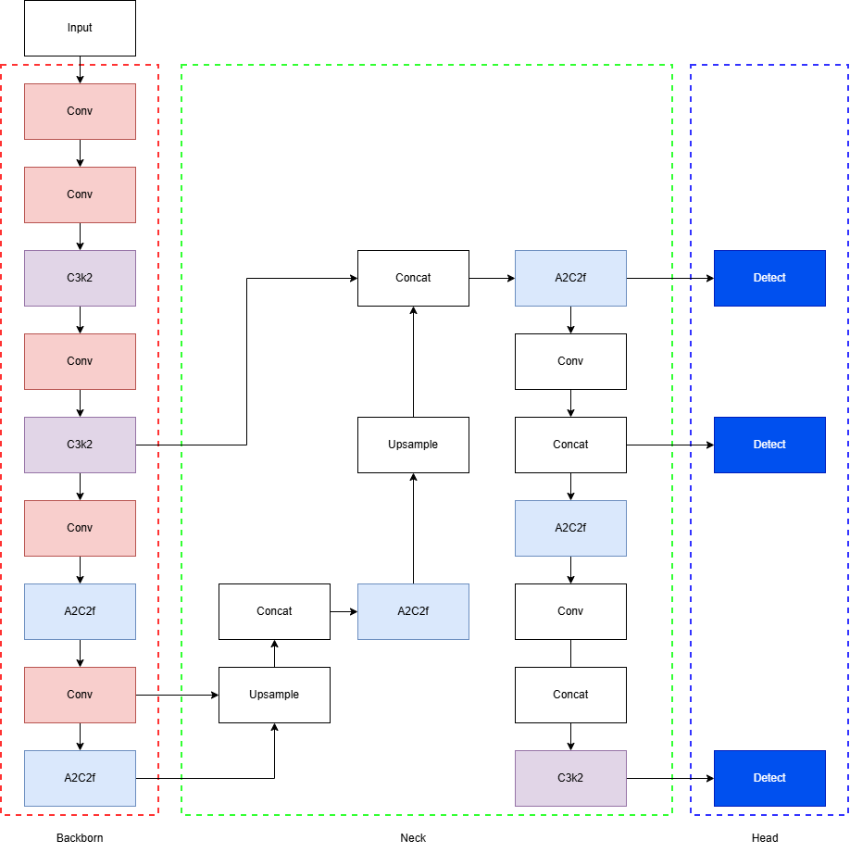
Figure 1: YOLO12 Architecture [18]
The structure includes:
- Conv (Convolution Layer): The Conv block is an important part of the network. It is where the network performs the convolution operation. This block has a convolution layer, batch normalization, and a nonlinear activation function like SiLU. The Conv block is good at finding low- and mid-level features in the input image, like edges and textures. It can also find patterns. If we change the values, the Conv layer can reduce the spatial resolution of feature maps and increase the depth of representation.
- C3k2 Module: The C3k2 Module is a version of the Cross Stage Partial architecture. It is designed to be more efficient while still being good at extracting features. This module has bottleneck layers with residual connections, which helps the network learn and reuse features. The "k2" configuration is a modification that reduces cost. This module helps balance the complexity and performance of the model, making it good for representations that're both lightweight and expressive.
- A2C2f Module: The A2C2f Module is a module that helps the network combine features. It is based on the Cross Stage Partial architecture. It is better at combining features from multiple layers. This helps the network learn complex patterns and relationships in the data. The A2C2f Module is really useful in the stages of the network, where high-level feature representation is important.
- Upsample: The Upsample operation increases the resolution of feature maps. It does this by using interpolation methods like neighbor or bilinear interpolation. This is important in frameworks like Feature Pyramid Networks, where level semantic features are combined with lower-level detailed features. By restoring dimensions, upsampling helps the network localize small objects and refine detection outputs.
- Concat (Concatenation): The Concat operation combines feature maps. It does this by merging them along the channel dimension. This operation is important for combining information from layers of the network, like shallow and deep features. The Concat operation preserves the dimensions of the input feature maps while increasing the richness of the representation. The Concat operation is widely used in the neck of the network to integrate multi-scale information and improve detection performance.
- Detect (Detection Head): The Detect block is part of the network. It is responsible for producing object detection outputs. It predicts bounding box coordinates, objectness scores, and class probabilities for each detected object. Modern YOLO architectures, like YOLO12, use anchor- detection mechanisms and multi-scale prediction heads to improve accuracy and efficiency. The Detect block transforms the learned feature representations into outputs that can be used in real-world applications. The Detect block is a part of the network, and it is what ultimately produces the object detection results.

2.2.5. Improving YOLO
During the research, there are multiple improvements considered and tried, many of which are based on secondary research that identifies the papers that applied improvements to older versions of YOLO or other models.

2.2.5.1. Improve base on Self-Adaption Squeeze-and-Excitation (SASE)
The paper "YOLO-SASE: An Improved YOLO Algorithm for Small Target Detection in Complex Backgrounds" [20] talks about ways to make the original YOLO framework better at finding objects in infrared images with complex backgrounds. One of the things they did was use a Super-Resolution Generative Adversarial Network, or SRGAN to preprocess the images. This means they did not just put the images into the detector. Instead they used SRGAN to make the images clearer; small objects that are only a few pixels big can be seen more easily. This helps the model see details that it would otherwise miss, and that makes it better at finding small objects.
The people who wrote the paper also came up with something called the Self-Adaptation Squeeze-and-Excitation or SASE module. This is a version of the usual SE attention mechanism. The SASE module is different from the SE blocks because it can change the weights it gives to different parts of the image while it is being trained. This makes the model learn features that're more useful, and it can focus on the small objects in the image even if the background is noisy or cluttered.
The paper also changes the way the detection layers work. Makes the receptive field bigger. They changed the number and arrangement of the detection outputs so they can find small objects better. This makes the model better at finding where the objects are and what they are. They also added something called Receptive Field Blocks or RFB and Spatial Pyramid Pooling or SPP to help the model understand objects of different sizes.
This makes the model more robust and better at handling scenes.
The experiments show that the new YOLO-SASE model is better than the YOLO model. It is 2 percent better at finding objects and 3 percent better at not missing objects, and it is more stable when it is being trained. This means that using SRGAN to preprocess the images, using the SASE module and getting features from scales all work together to make the model better at finding small objects. The YOLO-SASE model is better at finding objects because it uses these new techniques. The YOLO-SASE model is a version of the YOLO framework. It uses the YOLO framework. Adds new techniques to make it better at finding small objects in complex backgrounds.
The new SASE block will be implemented as figure below.
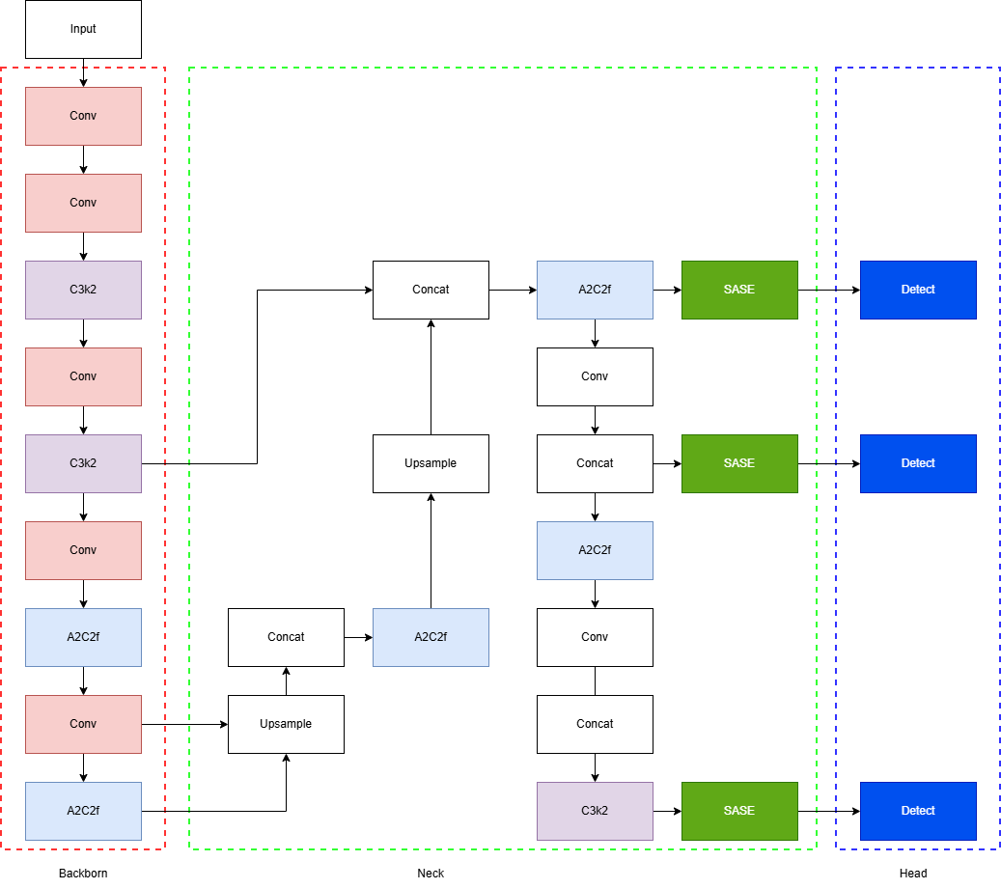
Figure 2: Proposed YOLO12 Architecture with SASE improvement

2.2.5.2. Improve based on Dynamic Tanh (DyT)
Inspired by the structural similarities between traditional normalization layers and scaled hyperbolic functions, we propose Dynamic Tanh (DyT) as a lightweight, drop-in replacement for standard normalization layers (such as Batch Normalization or Layer Normalization). [19]
Unlike conventional normalization that relies on computing batch-wide or layer-wide statistics (mean and variance), DyT operates independently on each input element. This avoids the computational overhead of global aggregations while preserving the core benefits of normalization: squashing extreme values in a non-linear fashion while maintaining near-linear transformations for central input values. [19]
Mathematical Formulation
A DyT layer is defined by the following operation:
$$DyT\left(x\right)= γ*tanh\left(αx\right)+ β$$
Equation 1
Where:
$α$: A learnable scalar parameter that dynamically scales the input $x$ to account for varying signal magnitudes.
$γ$,$β$: Learnable, per-channel vector parameters (affine parameters) similar to those found in standard normalization layers, allowing the output to be scaled back to any desired range.
YOLO12 introduced the Area-Attention and A2C2f (Area-Attention C2f) blocks to balance speed and accuracy. However, standard normalization layers within these blocks can sometimes be sub-optimal for edge deployment or extremely varied data distributions.
By replacing these layers with DyT, we aim to:
- Reduce Statistical Dependency: Eliminate the need for batch statistics, making the model more robust during small-batch inference.
- Enhance Non-linearity: Provide a more "squashed" distribution for feature maps, potentially improving gradient flow.
- Maintain Efficiency: DyT is computationally efficient and requires minimal hyperparameter tuning compared to traditional methods.
Our proposed modification focuses on the integration of DyT immediately following the A2C2f module. The typical data flow in the YOLO12 neck would be modified as follows:
Equation 2: Proposed Flow
In this configuration, DyT acts as a "drop-in" replacement for the normalization-activation pair or the normalization layer alone. By placing it after the A2C2f block, DyT can adaptively rescale the complex attention-based features generated by the Area-Attention mechanism before they are passed to subsequent layers. The new block will replace the old A2C2f block highlighted in the figure below.

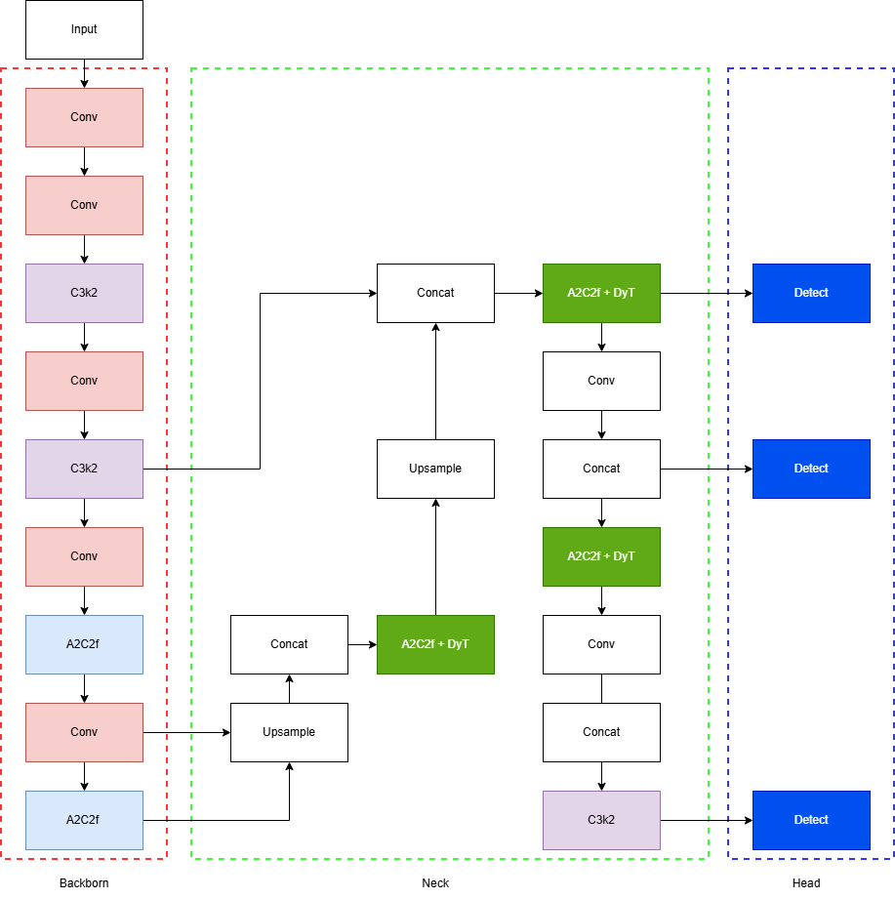
Figure 3: Proposed Architecture using Dynamic Tanh (DyT)
We hypothesize that this modification will lead to a more stable training process for YOLO12 and improved detection performance, particularly in scenarios where data distribution varies significantly (e.g., varying lighting or weather conditions in autonomous driving datasets). The removal of traditional normalization statistics also paves the way for easier quantization and deployment on specialized AI accelerators.

2.3. Summary
This review looks at how computer vision techniques are being used to analyze student behavior, focusing on object detection models from the YOLO family. Earlier methods, like skeleton-based action recognition and optical flow, were slow and hard to use in real time. With the arrival of single-stage detectors, especially YOLO, it's become possible to balance speed and accuracy, making it feasible to monitor classrooms in real-time.
Some recent studies have shown that YOLO-based models, including YOLO7, YOLO8, and YOLO12, work well in recognizing student behaviors. This is especially true when they use datasets. Adding attention mechanisms, like CBAM and SASE, has also proven to be effective in improving detection accuracy in complex environments.
There are two types of object detection methods: two-stage and one-stage approaches. YOLO stands out because of its efficient and can make predictions from start to finish. The YOLO family has evolved to include techniques like attention mechanisms and optimized training methods.
YOLO12 is a step forward. It includes attention-based components like Area Attention and FlashAttention, which help the model capture information while staying fast. Its architecture is also enhanced by modules like C3k2 and A2C2f, which improve feature extraction and fusion.
There are still some research gaps. These include challenges in recognizing student behaviors, limited optimization of newer YOLO versions, and not enough validation in real-world classroom conditions.
Overall, YOLO-based models provide a foundation for detecting student behavior in real-time. However, there's still room for improvement through modifications, better data handling, and more realistic deployment scenarios. This study aims to address these gaps by exploring and optimizing YOLO12 to achieve robust performance in classroom environments.

Chapter III. Proposed Research Methodology

3.1. Research approaches
The research is a combination of literature review and experimental and quantitative approaches. The literature review will focus on models that have already been trained on the SCB-dataset. In the experimental and quantitative approach, the researcher will build a behavior detection model, trained, and evaluated on the SCB-dataset to objectively measure its performance. Besides, the researcher will try to improve the model by modifying an existing model that has good results on the dataset.

3.2. Population and sample
- Population: The people we are looking at for this research are in the SCB-dataset, which is also known as the Student Classroom Behavior Dataset [7]. This dataset is available to the public. It is specifically made for looking at how students behave. The SCB-dataset has a lot of pictures that were taken in classrooms, and these pictures show students doing different things. The SCB-dataset is already labeled with different types of student behavior, which is really helpful for training and testing deep learning models that can be taught. The SCB-dataset is a tool for this kind of research because it has so many examples of student behavior.
- Sample: The sample will be derived by partitioning the entire SCB-dataset into three distinct, non-overlapping subsets:
  - Training Set (70%): We use this part of the data to teach our deep learning models. The model learns to spot patterns and features that match behaviors from this data.
  - Validation Set (15%): During training, we use this subset to adjust model settings like learning rate and number of training rounds. This helps prevent the model from getting too good at the training data and not good enough at the test data. It gives us an idea of how well the model is doing while we adjust things.
  - Testing Set (15%): We keep this part of the data separate until the end of training. Then we use it to see how well the trained model works on data it has not seen before. This is like a test run to see how the model would work in the real world with new data.

3.3. Research methods
The research will be conducted through a structured experimental workflow, as detailed below:
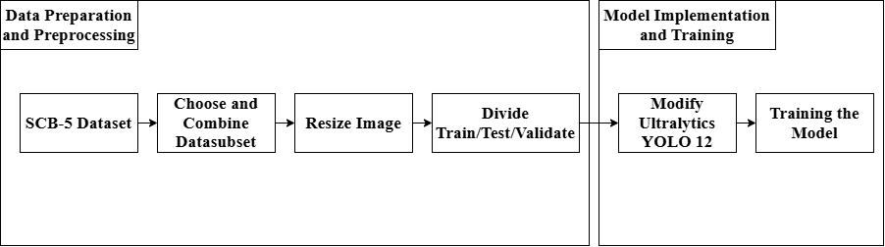
Figure 4: Research Workflow
- Data Preparation and Preprocessing:
  - Data Acquisition: Obtain the SCB-dataset from its official source.
  - Data Exploration: Look at the SCB-dataset to see what it is like. This means checking the distribution of classes, the size of the images, and the lighting. We do this to understand what the SCB-dataset is and what problems we might have with it.
  - Label Verification: Make sure the labels for the things we are looking for, like reading, writing, and raising-hand are correct and the same. We need to change these labels into the format that the YOLO models can use.
  - Data Augmentation: We will do some things to the training set to make the model better and to stop it from getting too used to the things. We will change the images in some ways, like turning them a little or making them bigger or smaller. We will also change how bright or dark they are and how colorful they are. We do this to the SCB-dataset to help the model work well with the SCB-dataset.
- Model Implementation and Training:
- Environment Setup: Set up the environment using Python, PyTorch, and necessary libraries like OpenCV and NumPy. I will use a CUDA-enabled GPU to speed up the training process.
- Model Selection: The research will focus on Deep Learning Models, specifically those based on YOLO, looking at versions of YOLO. For comparison, baseline models like YOLO8, YOLO11, and YOLO12.
- Training Process: Train each model on the prepared training dataset. Define training parameters such as batch size, learning rate, and optimizer. Decide on the number of training epochs. Optimize them using the validation set. Track the training progress by monitoring loss functions and validation metrics for each YOLO model.
- Performance Evaluation and Analysis:
- Evaluation Metrics: The performance of the trained models on the testing set will be measured using standard object detection metrics:
- Precision: The ratio of correctly predicted positive observations to the total predicted positive observations.
- Recall: The ratio of correctly predicted positive observations to all observations in the actual class.
- mAP (mean Average Precision): The primary metric for evaluating object detection accuracy. mAP@0.5 (mAP at an IoU threshold of 50%) and mAP@0.5:0.95 will be calculated to provide a comprehensive assessment.
- Frames Per Second (FPS): To measure the model's inference speed and evaluate its suitability for real-time applications.
- Comparative Analysis: A thorough comparison will be conducted between the modified and the baseline models. The analysis will focus on answering the research questions by evaluating the trade-offs between accuracy (mAP) and speed (FPS). The impact of the modified model on the outcome.
- Qualitative Analysis: In addition to quantitative metrics, a qualitative analysis will be performed by visualizing the detection results on sample images from the test set to identify the model's strengths and weaknesses in different scenarios (e.g., occlusion, varied lighting).

Chapter IV. Finding and discussion

4.1. Baseline model

4.1.1. Data
The data used is SCB-5 Data [7] with the distribution shown in the Figure below.
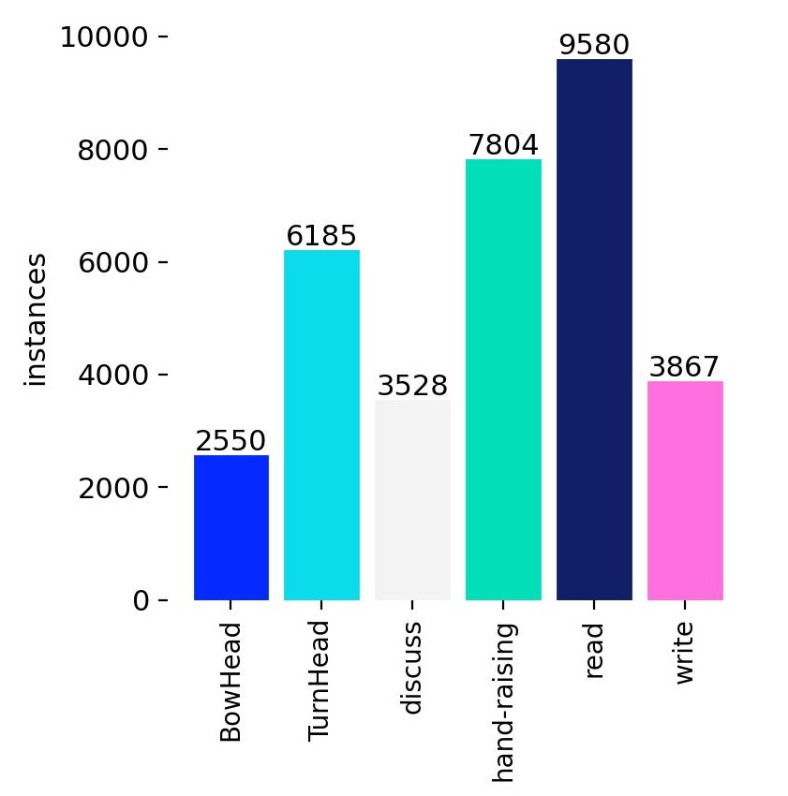
Figure 5: Data distribution
The chart shows that the number of reading students is the highest, which is almost 10000, while the lower ones, like bowhead, discuss and write, have only from 2500 to 4000 instances. This shows the imbalance and difficulty of the classroom environment where some actions have more students perform than the rest. Besides that, the number of instances shows that there are a good number of instances, enough for training and evaluating the models.
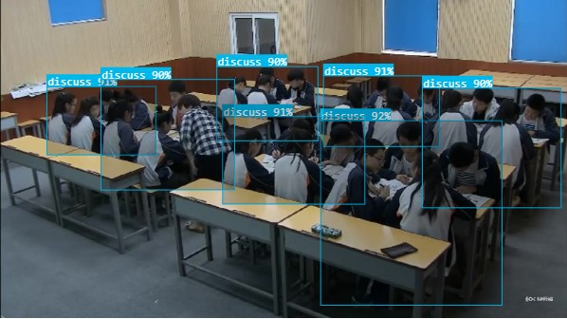
Figure 6: Example Image of Dataset (Back View)
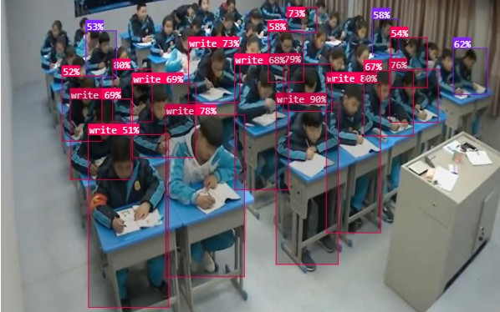
Figure 7: Example Image of Dataset (Front View)
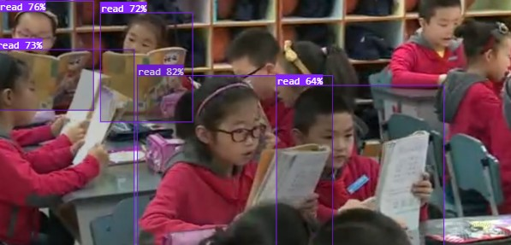
Figure 8: Example Image of Dataset (Close View)
The example image of the dataset in Figure 5 shows that there are multiple instances in one image. This shows that the model will have to work with many students in each image inside the classroom environment, making it challenging for models to detect and identify the objects.

4.1.2. Result on baseline model

Table 1: YOLO8, YOLO11 and YOLO12
 | Precision | Recall | mAP50 | mAP50-95 | fitness | GFLOPs | Param | FPS
YOLO8s | 0.735 | 0.717 | 0.773 | 0.620 | 0.620 | 28.817 | 11166560 | 77.76
YOLO11s | 0.729 | 0.721 | 0.774 | 0.618 | 0.618 | 21.718 | 9458752 | 72.96
YOLO12s | 0.737 | 0.710 | 0.774 | 0.617 | 0.617 | 21.5 | 9255458 | 64.72

Figure 9: Baseline YOLO8, YOLO11, YOLO12 on SCB5
YOLO12 has better precision with a score of 0.7372, meaning it’s less likely to hallucinate objects or give false positives than the older versions. It also hits the highest mAP50 mark (0.7750), though it’s essentially neck-and-neck with YOLO11. What’s really interesting is the "fitness paradox"—even though YOLO12 is better at identifying objects, YOLO8 still holds a slight lead in mAP50-95. This suggests that while the new model is smarter at spotting things, the older v8 architecture might actually be a bit more precise when it comes to drawing the exact "tight" boxes around them at higher accuracy thresholds.

In addition, the YOLO12 have also been improved by reducing the model. The developers managed to make it significantly "lighter" by reducing the parameter count down to about 9.25 million-which is about 17% smaller than YOLO8. They also managed to cut down the computationally heavy lifting; the GFLOPs dropped from 28.8 to just 21.5. Essentially, we’re seeing a shift toward models that can do more with less, making them much better candidates for deployment on mobile devices or edge hardware where memory and power are usually at a premium.

4.2. SASE improvement

Table 2: YOLO12 and YOLO12 with SASE comparison
 | Precision | Recall | mAP50 | mAP50-95 | fitness | GFLOPs | Param | FPS
YOLO12s | 0.737 | 0.710 | 0.774 | 0.617 | 0.617 | 21.5 | 9255458 | 64.72
YOLO12s + SASE | 0.742 | 0.711 | 0.773 | 0.620 | 0.620 | 21.7 | 9284096 | 55.82

Figure 10: Baseline YOLO12 vs YOLO12 with SASE
The SASE mechanism is a deal for the YOLO12 baseline. It makes the architecture better, which helps with detection quality. When we look at the numbers, we can see that the SASE version is better. For example, precision went up from 0.7372 to 0.7426. Recall also went up to 0.7115. This means the SASE mechanism is good at getting rid of background noise and false positives. So the YOLO12 baseline with SASE is more reliable for vision tasks.
When we look at how the model can find things, we see a big change. The mAP50 score went down a little. The mAP50-95 score went up by 0.33%. This is important because it means the SASE version is better at drawing boxes around objects. For things that need to be very precise, like knowing where something is, the SASE version is better. We can also see this in the Fitness score, which went up from 0.6174 to 0.6207. This means the model is better for real-world things.
From a point of view, the SASE upgrade is very good. The model did not get much bigger, only about 28.6k more parameters, which is a very small increase. The computer also does not have to work harder, only 0.2 more GFLOPs. This means the SASE layers help a lot without making the model too big or slow. The biggest trade-off is that it is a little slower. It went from 64.72 FPS to 55.82 FPS. This is a 13.7% decrease, which's worth noting. It is the price we pay for being more accurate.
At the end of the day, we have to choose between the YOLO12 baseline and the SASE version. Even though the SASE version is a little slower, it still works well at more than 50 FPS. This is good enough for video needs. If we need to be very accurate and reliable, like for self-driving cars or checking the quality of things, the SASE version is better. The YOLO12 baseline with SASE is more powerful and sophisticated. The SASE mechanism makes the YOLO12 baseline better. That is what matters.

4.3. Dynamic Tanh improvement
This report breaks down the performance changes observed after integrating Dynamic Tanh (DyT) into our baseline YOLO12 model. Based on the latest test results, the DyT version offers a clear step forward in detection accuracy. While it adds a tiny bit of computational weight, the improvement in how the model actually "sees" and identifies objects makes it a very strong candidate for our production environment.
Table 3: YOLO12 with DyT result
 | Precision | Recall | mAP50 | mAP50-95 | fitness | GFLOPs | Param | FPS
YOLO12s | 0.737 | 0.710 | 0.774 | 0.617 | 0.617 | 21.5 | 9255458 | 64.72
YOLO12s + A2C2fDyT | 0.732 | 0.726 | 0.776 | 0.626 | 0.626 | 21.7 | 9284096 | 63.58

Figure 11: Baseline YOLO12 vs YOLO12 with DyT

4.3.1. Observations and Insights
The most impressive takeaway here is the boost in Recall, which jumped from 0.710 to 0.727. In practical terms, this means the DyT-enhanced model is much better at catching objects it might have missed before. We're seeing fewer "false negatives," which is often more critical in real-world detection than a tiny variation in precision. Additionally, the 1.0% increase in mAP50-95 tells us that the model isn't just finding more objects; it's also getting better at drawing tighter, more accurate bounding boxes around them.
The model’s overall "Fitness" score rose by 1.6%. This is a great sign that the architectural tweak is actually working as intended and isn't just a fluke in one specific category. It confirms that the DyT version is a more robust, capable model across the board.
As expected with any architectural addition, there’s a small "tax" on performance, but it’s very manageable:
- Weight: We added about 28.6k parameters. For a model with over 9 million parameters, this is a drop in the bucket (roughly a 0.3% increase).
- Speed: The frame rate dipped by about 1.14 FPS. Since we're still cruising well above 60 FPS, the model remains perfectly suited for high-speed, real-time video processing without any noticeable lag.

4.3.2. Individual Class Performance
Table 4: Results of individual classes
Class | Images | Instances | Precision | Recall | mAP50 | mAP50-95
all | 1211 | 6911 | 0.733 | 0.726 | 0.777 | 0.627
discuss | 126 | 743 | 0.856 | 0.883 | 0.933 | 0.798
TurnHead | 277 | 1290 | 0.758 | 0.733 | 0.787 | 0.633
hand-raising | 548 | 1676 | 0.736 | 0.745 | 0.784 | 0.577
write | 146 | 767 | 0.673 | 0.683 | 0.734 | 0.626
BowHead | 140 | 566 | 0.732 | 0.643 | 0.729 | 0.579
read | 342 | 1869 | 0.643 | 0.672 | 0.694 | 0.549

Looking at the performance data, the model was tested against a solid dataset of 1,211 images containing over 6,900 individual action instances. On the whole, the results show a healthy balance between precision (0.733) and recall (0.726). A global mAP50 of 0.777 is a strong indicator that the model is quite reliable at pinning down where actions are happening, even if it sometimes trips up when trying to label exactly what they are in a split second.
When we dive into the specific classes, "discuss" is the clear standout with an mAP50 of 0.933. This high level of accuracy likely comes down to the very specific visual cues associated with people talking in groups—it's just a much easier pattern for the model to latch onto compared to subtle solo actions. Other categories like "TurnHead" and "hand-raising" also put up respectable numbers, generally keeping pace with or slightly outperforming the overall average. It’s clear the model has a firm grasp on these distinct, high-movement gestures.
However, the numbers also tell a story of where the model hits a wall, particularly with actions that look very similar from a distance. The "write" class saw a noticeable dip in precision, and "BowHead" really struggled with a recall of just 0.643, which is the lowest on the list. This tells us the model is frequently missing these actions entirely. From a human perspective, this isn't surprising; it’s genuinely hard to tell the difference between someone intentionally bowing their head and someone just glancing down for a moment, especially if the camera angle isn't perfect.
The real problem in this data is the "read" class. Usually, we assume more data leads to better results, but despite having the biggest sample size at nearly 1,900 instances, it actually performed the worst with a mAP50 of just 0.694. It’s a classic reminder that volume doesn't always trump clarity. Since reading, writing, and simply looking down all share the same basic "head-down, hands-on-desk" silhouette, the model is clearly getting caught in a bit of an identity crisis. It’s struggling to tell these lookalike actions apart because they’re just too visually crowded.
Fixing this isn't about just dumping more photos into the training set. Instead, the focus needs to shift toward cleaning up the labels and being much more intentional with how we augment the data. We need to help the model distinguish those tiny differences in desk-based activities. Adding attention layers that home in on small details - like the specific angle of a pen versus the steady gaze of a reader—might provide that extra bit of nuance needed to help the model finally see the difference.
The Dynamic Tanh (DyT) modification is a successful upgrade. By slightly increasing the model's complexity, we’ve gained a much more reliable detector that excels at finding objects and localizing them accurately.
We should move forward with the DyT-enhanced YOLO12. The trade-off of losing about 1 FPS to gain a 2.4% boost in recall is an easy trade to make for almost any high-performance application.

Chapter V. Conclusion

5.1. Summary of Research Contributions
This research set out to navigate the intricate challenges of detecting student behavior within the often chaotic environment of a modern classroom. By introducing specific, targeted improvements to a deep learning baseline, we aimed to move past the typical hurdles—like heavy occlusion, varying distances from the camera, and the subtle, often unpredictable nature of how students actually move and act in a crowded room.
The heart of this study lies in two key innovations below:
- Self-Adaptation Squeeze-and-Excitation (SASE): We integrated the SASE mechanism to give the model a better "eye" for detail across different scales. Unlike standard attention modules that can get overwhelmed by background noise, SASE hones in on the most informative frequency components. This proved essential for spotting small but significant objects, or identifying students sitting in the very back of the room.
- Dynamic Tanh (DyT) Function: We recognized that static activation functions often struggle with the high-variance, "noisy" data typical of human behavior. By introducing Dynamic Tanh, we allowed the model’s activation thresholds to evolve during the training process. This adaptability significantly boosted the network’s ability to represent complex features, leading to much more reliable detection regardless of classroom lighting or how tightly packed the desks were.

5.2. Analysis of Experimental Results
Putting our theories to the test on the Student Classroom Behavior (SCB) dataset provided some very encouraging insights. Our hybrid model, which brings together both SASE and DyT, consistently held its own against the baseline, showing clear improvements in both Mean Average Precision (mAP) and F1-score.

5.2.1. Performance Breakthroughs
One of the most satisfying results was seeing how SASE slashed the number of false negatives. It was particularly effective in "messy" scenes where students were partially hidden behind chairs or their classmates. The frequency-aware side of the attention helped the model stay focused on the students' actual movements rather than getting distracted by the classroom's busy background. At the same time, DyT made the training process smoother and faster. This helped the model pick up on those hard-to-spot behaviors, like a quick whisper or a glance at a phone, which rigid, traditional models often miss entirely.

5.2.2. Critical Reflection on the SCB Dataset
While the data shows a clear win, the gap between our model and the baseline wasn't quite as wide as we had first hoped. Looking closer at the results, it seems this "performance plateau" is largely a reflection of the SCB dataset itself:
- Environmental Homogeneity: Most of the footage features very similar lighting and camera angles. This likely capped the visible impact of DyT, which is designed to shine in more varied and unpredictable environments.
- Annotation Granularity: Many behaviors in the SCB dataset look very similar in a single frame. This visual overlap creates a "gray area" that even advanced attention mechanisms struggle to navigate without the help of video-based context over time.
- Scale Imbalance: The training set is somewhat weighted toward medium and large subjects. This likely diluted the perceived benefits of SASE’s scale-adaptive features when we looked at the final, global scores.

5.3. Theoretical and Practical Significance
Looking beyond the numbers, this research offers a meaningful contribution to the growing field of AI in Education (AIEd).
Theoretically, we’ve shown that pairing frequency-domain analysis with adaptive non-linearity creates a much tougher, more resilient detection pipeline. It offers a clear roadmap for how general object detection models can be fine-tuned for "human-centric" spaces where actions are small, and the background is loud.
Practically, this model provides the building blocks for smarter classroom management tools. These systems can give teachers a real-time "pulse" on student engagement, helping them identify who might be distracted or struggling. By keeping the model efficient, we’ve ensured that these enhancements can actually run on the kind of standard hardware found in schools today, rather than just in a high-powered lab.

5.4. Limitations and Future Directions
While we’ve made good progress, there are still plenty of areas to explore:
- Capturing the Flow of Time: Right now, the model looks at one frame at a time. But behavior is a sequence of events. Moving forward, incorporating temporal models like Transformers or GRUs to look at video clips rather than still images could drastically improve how we classify complex actions.
- Expanding Our Horizons: To truly prove the power of SASE and DyT, we need to test them across a wider range of settings-different cultures, different room layouts like labs or large lecture halls, and different camera perspectives.
- Synthesizing Better Data: To push past the limits of the SCB dataset, we are looking at using Generative Adversarial Networks (GANs) to create "stress-test" scenarios-synthetic classroom scenes with extreme lighting or heavy crowds.
- Edge Optimization: We want to push the efficiency even further. Research into model pruning and quantization will help ensure this model can run seamlessly on low-power devices without losing any of the accuracy we've worked hard to gain.
In short, even though the dataset provided a few hurdles, the success of SASE and DyT marks a genuine step forward in how we use AI to understand the classroom. It sets a solid foundation for the next generation of tools built to support both teachers and students in a more data-driven, responsive way.

References
[1] C. C. Yin Albert et al., “Identifying and Monitoring Students’ Classroom Learning Behavior Based on Multisource Information,” Mobile Information Systems, vol. 2022, pp. 1–8, Aug. 2022, doi:.
‌[2] S. Pribesh, “When Race Matters: Teachers’ Evaluations of Students’ Classroom Behavior,” Sociology of Education, Oct. 11, 2021. https://www.academia.edu/57198514/When_Race_Matters_Teachers_Evaluations_of_Students_Classroom_Behavior (accessed Sep. 01, 2025).
‌[3] M. Hussain, “YOLO-v1 to YOLO-v8, the Rise of YOLO and Its Complementary Nature toward Digital Manufacturing and Industrial Defect Detection,” Machines, vol. 11, no. 7, p. 677, Jul. 2023, doi: https://doi.org/10.3390/machines11070677.
‌[4] R. Khanam and M. Hussain, “YOLOV11: AN OVERVIEW OF THE KEY ARCHITECTURAL ENHANCEMENTS,” 2024. Available: https://arxiv.org/pdf/2410.17725
‌[5] Y. Tian, Q. Ye, and D. Doermann, “YOLOv12: Attention-Centric Real-Time Object Detectors FLOPs (G) MS COCO mAP (%) Latency (ms) MS COCO mAP (%).” Accessed: Sep. 01, 2025. [Online]. Available: https://arxiv.org/pdf/2502.12524
‌[6] Q. Hou, D. Zhou, and J. Feng, “Coordinate Attention for Efficient Mobile Network Design.” Accessed: May 04, 2023. [Online]. Available: https://openaccess.thecvf.com/content/CVPR2021/papers/Hou_Coordinate_Attention_for_Efficient_Mobile_Network_Design_CVPR_2021_paper.pdf
[7] F. Yang, “SCB-dataset: A Dataset for Detecting Student Classroom Behavior,” arXiv.org, 2023. https://arxiv.org/abs/2304.02488v5 (accessed Sep. 01, 2025).
‌[8] Q. Liu, X. Jiang, and R. Jiang, “Classroom Behavior Recognition Using Computer Vision: A Systematic Review,” Sensors, vol. 25, no. 2, p. 373, Jan. 2025, doi: https://doi.org/10.3390/s25020373.
‌[9] F. Yang, T. Wang, and X. Wang, “Student Classroom Behavior Detection based on YOLOv7-BRA and Multi-Model Fusion,” arXiv.org, 2023. https://arxiv.org/abs/2305.07825 (accessed Sep. 01, 2025).
‌[10] F. Yao, “Classroom Anomalous Behavior Detection Based on Improved YOLOv5,” Journal of Applied Science and Engineering, vol. 28, no. 7, pp. 1473–1481, doi: https://doi.org/10.6180/jase.202507_28(7).0008.
‌[11] F. Xiang and T. T. Toe, “Improvement of a Model for Detecting Student Classroom Behaviour Based on Yolov8 via CBAM,” pp. 169–173, Sep. 2024, doi: https://doi.org/10.1109/icacte62428.2024.10871726.
[12] Redmon, J., Divvala, S., Girshick, R., & Farhadi, A. (2016). You only look once: Unified, real-time object detection. In Proceedings of the IEEE Conference on Computer Vision and Pattern Recognition (pp. 779-788).
[13] Redmon, J., & Farhadi, A. (2017). YOLO9000: better, faster, stronger. In Proceedings of the IEEE Conference on Computer Vision and Pattern Recognition (pp. 7263-7271).
[14] Redmon, J., & Farhadi, A. (2018). YOLOv3: An incremental improvement. arXiv preprint arXiv:1804.02767.
[15] Bochkovskiy, A., Wang, C. Y., & Liao, H. Y. M. (2020). Yolov4: Optimal speed and accuracy of object detection. arXiv preprint arXiv:2004.10934.
[16] Ultralytics. (2023). YOLOv8. Retrieved from https://www.google.com/search?q=https://ultralytics.com/yolov8
[17] R. Khanam and M. Hussain, "A REVIEW OF YOLOV12: ATTENTION-BASED ENHANCEMENTS," Department of Computer Science, Huddersfield University, Huddersfield, 2025.
[18] K. Zhang, Y. Ye, K. Chen, Z. Li and H. Peng, "A Scale-Adaptive and Frequency-Aware Attention Network for Precise Detection of Strawberry Diseases," 2025.
[19] J. Zhu, X. Chen, K. He, Y. LeCun and Z. Liu, "Transformers without Normalization," Meta, p. 5, 2025.
[20] X. Zhou, L. Jiang, C. Hu, S. Lei, T. Zhang and X. Mou, "YOLO-SASE: An Improved YOLO Algorithm for the Small Targets Detection in Complex Backgrounds," Sensors, vol. 22, no. 12, 2022.

