Vietnam National University, Hanoi
International School

============

Master’s Thesis

UMBILICAL CORD MESENCHYMAL STEM CELLS – SYSTEMATIC REVIEW AND RECOMMENDATIONS FOR RESEARCH IN VIETNAM

DO THI MY HANH

Field | Biomedical Engineering and Technology
Supervisor | Assoc. Prof. Dr. Chu Dinh Toi
Supervisor | Dr. Nguyen Thi Bich Loan

Hanoi – 2026

Vietnam National University, Hanoi
International School
============

Master’s Thesis

UMBILICAL CORD MESENCHYMAL STEM CELLS – SYSTEMATIC REVIEW AND RECOMMENDATIONS FOR RESEARCH IN VIETNAM

DO THI MY HANH

Field | Biomedical Engineering and Technology
Supervisor | Assoc. Prof. Dr. Chu Dinh Toi
Supervisor | Dr. Nguyen Thi Bich Loan
Hanoi – 2026

CERTIFICATE OF ORIGINALITY

I, the undersigned, hereby certify my authority of the study project report entitled “Umbilical cord mesenchymal stem cells – Systematic review and recommendations for Research in Vietnam” submitted in partial fulfillment of the requirements for the degree of Master in Biomedical Engineering and Technology. I declare that this work is the product of my independent research under the supervision of Asc.Prof. Dinh-Toi Chu and Dr. Nguyen Thi Bich Loan , with all external data or contribution have been properly cited and acknowledged.

Hanoi, 2026

Do Thi My Hanh

Approved by

SUPERVISOR 1  (Signature and full name) | SUPERVISOR 2  (Signature and full name)
Chu Dinh Toi  Date:…………………………… | Nguyen Thi Bich Loan  Date:……………………………

ACKNOWLEDGEMENTS

After a period of study at the Faculty of Applied Science of the VNU–International School, with sincere gratitude and respect, I would like to express my thanks to the Board of Rectors, Faculty, the Graduate Office, and all the lecturers for their teaching and guidance throughout my course of learning.
In particular, I would like to express my deepest gratitude to Assoc. Prof. Dr. Dinh Toi Chu and Dr. Nguyen Thi Bich Loan, my two supervisors, for providing direction, expert advice, and motivation when I needed during the entire research process.
Special thanks are extended to my family and classmates, Ms. Ha Le and Ms. Anh Dao, for their steadfast support in mental aspects during my period of study and research. Heartfelt thanks to my husband, who always stands by me whenever I need, in my hardest time, during my depression treatment, and as a teacher in teaching me using data analysis software.
Despite my best efforts, due to constraints in time and my expertise, this thesis may still have some mistakes and omissions. I highly value and welcome any constructive feedback from professors, experts, and classmates to further refine and improve this research.
Hanoi, January 2026
Author

Do Thi My Hanh

ABSTRACT

Background: Umbilical cord-derived mesenchymal stem cells (UC-MSCs) have emerged as a promising therapeutic candidate due to their favorable biological characteristics; however, global literature currently lacks multi-level systematic reviews encompassing the full spectrum from laboratory to clinical research. In the context of Vietnam, despite increasing scientific interest, research efforts remain fragmented and are primarily characterized by small-scale trials conducted without standardized protocols or unified clinical guidelines. Consequently, there is a critical absence of a systematic evidence base to inform a comprehensive strategy for the production, preclinical evaluation, and clinical application of UC-MSCs for the local infrastructure.
Objective: This study aims to conduct a multi-level systematic review across manufacturing, preclinical, and clinical stages to identify existing gaps in UC-MSC research. Ultimately, it leverages these findings to establish a foundational evidence base and propose context-appropriate recommendations for the development of stem cell therapies in Vietnam.
Methods: This study employs a systematic analysis approach conducted in strict accordance with the PRISMA 2020 guidelines. A comprehensive literature search was performed across multiple electronic databases, utilizing predefined inclusion and exclusion criteria to ensure objectivity and minimize bias in data synthesis. Excel software was used to analyze data regarding production, preclinical and clinical data and visualize results in charts and graphs. Recommendations were generated based on the findings of systematic review and local context.
Results: The analysis of 68 studies plus 9 trials highlights a significant transparency gap in manufacturing, characterized by a "black box" in preclinical protocols regarding passage limits and media composition, contrasting with the higher safety compliance found in clinical trials. Furthermore, systemic delivery remains the dominant administration route in both settings, although localized injections are preferred for specific indications like osteoarthritis and myocardial infarction. While research trends have shifted from synchronized growth to a recent surge in human trials, liver diseases, type 2 diabetes, and neurological disorders emerge as the most promising indications with consistent therapeutic efficacy.
Recommendation: To address the identified "black box" in cell manufacturing, Vietnam should establish a comprehensive national regulatory framework that mandates the standardization of quality control protocols and manufacturing transparency for both preclinical and clinical research. Future research initiatives should prioritize high-efficacy therapeutic areas such as type 2 diabetes, chronic liver diseases, and neurological disorders while strategically expanding into rare or refractory conditions. Furthermore, clinical practice should transition toward a manufacturing - oriented mindset that emphasizes stringent safety assessments, including sterility and biological contaminant validation, to align with international GMP standards.
Keywords: “Umbilical cord-derived mesenchymal stem cells”, “systematic analysis”, “manufacturing transparency”, “preclinical-to-clinical translation”, “Vietnam”

LIST OF ABBREVIATIONS

Abbreviation | Full Term
MSCs | Mesenchymal stem cells
UC-MSC | Umbilical cord-derived mesenchymal stem cell
ISCT | International Society for Cell & Gene Therapy
WJ-MSCs | Wharton’s Jelly mesenchymal stem cells
GMP | Good Manufacturing Practice
DMEM | Dulbecco's modified Eagle medium
FBS | Fetal bovine serum
STR | Short tandem repeat
HLA | Human leukocyte antigen
iPSC | Induced pluripotent stem cells
QC | Quality control
EVs | Extracellular vesicles
CM | Conditioned medium
CFU-F / CFU-assay | Clonogenic / Colony-forming unit assay
FDA | Food and drug administration
EMA | European medicines agency
CT/MRI | Computed tomography/ Magnetic resonance imaging

LIST OF TABLES
Table 2.1. Current systematic analysis on UC-MSC in animal studies and clinical studies from 2006 – 2025 11
Table 2.2. Examples of animal model research and human clinical trials using UC-MSCs were conducted by various entities in Vietnam. 17
Table 3.1. Keywords 27
Table 3.2. Excluded publication types 29
Table 3.3. Reasons for assessing eligibility. 30
Table 3.4. Chosen variables for production dataset 32
Table 3.5. Chosen variables for animal study dataset 34
Table 3.6. Chosen variables for the clinical study dataset 34
Table 5.1. Proposed recommendations for future researchs in Vietnam 50

LIST OF FIGURES
Figure 2.1. Illustration of different compartments of umbilical cord 4
Figure 2.2. UC-MSCs manufacturing process 5
Figure 2.3. Summary of sources, potential of MSC therapy, and advantages 8
Figure 2.4. Publication trend of UC-MSC and animal study articles on PubMed 9
Figure 2.5. Publication trend of UC-MSC and clinical study articles on PubMed 10
Figure 2.6. Publication trend of UC-MSC and animal study articles in Vietnam on PubMed 14
Figure 2.7. Publication trend of UC-MSC and clinical study articles in Vietnam on PubMed 15
Figure 3.1. Step-by-step approach of the research 22
Figure 3.2. Outcomes of searching and selection of studies 25
Figure 4.1. Transparency landscape of preclinical studies 38
Figure 4.2. Percentage of each QC measure 39
Figure 4.3. Transparency landscape of clinical trials in term 40
Figure 4.4. QC compliance ranking in clinical studies 41
Figure 4.5. Animal research trend 42
Figure 4.6. Animal efficacy in depth 43
Figure 4.7. Animal route distribution 44
Figure 4.8. Clinical research trend 45
Figure 4.9. Efficacy of UC-MSCs therapy in clinical trials 47
Figure 4.10. Delivery mode distribution in clinical trials 48

TABLE OF CONTENTS

CERTIFICATE OF ORIGINALITY 3
ABSTRACT 5
LIST OF ABBREVIATIONS 7
LIST OF TABLES 9
LIST OF FIGURES 10
CHAPTER 1. INTRODUCTION 1
1.1. Research necessity 1
1.2. Research objectives 2
1.3. Scope of the study 3
1.4. Research questions 3
CHAPTER 2. LITERATURE REVIEW 4
2.1. Biology and manufacturing process of umbilical cord mesenchymal stem cells (UC-MSCs) 4
2.2. Global overview 7
2.3. Vietnam context overview 14
CHAPTER 3. RESEARCH METHODOLOGY 22
3.1. Research approach 22
3.2. Research methods 23
3.2.1. Study subject 23
3.2.2. Study design 24
3.2.3. Selection 28
CHAPTER 4. RESULTS 38
4.1. The landscape of manufacturing standardization and quality control 38
4.1.1. Preclinical studies: Transparency gap and quality control limitations 38
4.1.2. Clinical studies: The shift toward safety compliance and biological standardization 39
4.2. Therapeutic efficacy analysis and translational pattern 42
4.2.1. A comprehensive overview of UC-MSCs efficacy in animal models 42
4.2.2. Comparative analysis of UC-MSC efficacy: trends and disparities 45
CHAPTER 5. RECOMMENDATION AND CONCLUSION 50
5.1. Recommendations 50
5.2. Summary and concluding remarks 52
5.3. Limitations of the research 53

INTRODUCTION

Research necessity
Cell-based therapy is a promising therapy that has been intensively researched in recent years. The cell type that can be used in this kind of therapy is not only somatic, mature cells, but also stem cells [1]. Among stem cell kinds, mesenchymal stem cells (MSCs) are the most promising candidates. This is because it has beneficial characteristics like low immunogeneicity, wide-ranging differentiation capacity, and paracrine factors [2-4]. MSCs can be found in various organs in the adult human body, for example, bone marrow, adipose tissue, dental pulp, endometrium,… and even in prenatal tissue like the umbilical cord [2]. Among all these sources, umbilical cord-derived MSC (hereafter called UC-MSC) is one of the most naïve, has the strongest proliferation ability, the widest range of differentiation, reduced infectious risk, negligible tumorigenicity, and low immunogenic potential [5-7]. In 2006, the International Society for Cellular Therapy released Minimal criteria for defining MSCs, these criteria serve as a quality control standard for MSC products [8]. After 2006, the number of animal studies and clinical studies on UC-MSCs has steadily increased. This shows the great interest of the science society and indirectly proves the potential of UC-MSCs as a promising intervention for human disorders. However, on a global scale, the majority of studies belong to developed countries like the USA, Europe, South Korea, China, and Japan, which has a lot of GMP laboratories for UC-MSC production and sufficient financial support [9]. As a result, the secondary analysis of systematic reviews, which are the consolidated guidance for the UC-MSC field, extracts data from original research of these developed countries [9]. Moreover, most of systematic analyses are focused on specific fields like production, animal studies, or clinical studies only, as evidenced by the data presented in Table 2.1 of this thesis. There is a lack of multi-level systemic review on UC-MSC from lab to clinical reseach worldwide.
Looking at the Vietnam context, the number of UC-MSC preclinical studies and human trials has increased over the years, showing that the Vietnamese scientists have adapted to these new therapeutic interventions. This underscores the interest of the Vietnamese scientific community and government in promoting the in-country development of cell therapy. However, locally, the research was often conducted by independent entities, resulting in clinical trials that were mostly small- to medium-sized. There was a clear limitation in both the number of large-scale trials and the total number of registered studies. Due to the prevalence of studies conducted in isolation by individual units, standardized protocols and unified clinical research recommendations (or guidelines) are currently absent. This deficiency has subsequently led to procedural polymorphism across the different studies and trials. Furthermore, Vietnam is still progressing in cell therapy research, so only some of the facilities meet the world-recognized standards, and the rest are still small and developing. Therefore, some recommendations derived from systematic review and analysis can not be adapted to Vietnam production facilities. Conversely, there is a distinct absence of a systematic evidence base for UC-MSCs that could inform the development of a scientific strategy covering production, preclinical evaluation, and clinical testing. Few comprehensive systematic reviews are available to synthesize multi-level evidence (encompassing manufacturing, preclinical, and clinical data), provide guidance, and offer recommendations for clinical and paraclinical studies appropriate for conditions in Vietnam.
Therefore, this study aims to provide a multi-level systematic review spanning manufacturing, preclinical (animal) trials, and clinical trials, which will serve as a basis for providing recommendations for research in Vietnam, from production to application.

Research objectives
- General aim: The main objective of this thesis is to conduct a comprehensive systematic analysis of the production processes, preclinical safety, and clinical efficacy of UC-MSCs, thereby establishing an evidence-based framework for the development of cell therapy and translational research in Vietnam.
- Specific aims:
- Identify existing gaps of preclinical and clinical studies using umbilical cord–derived mesenchymal stem cells (UC-MSCs) as the therapeutic intervention.
- Propose context-appropriate recommendations for the development and application of UC-MSC-based therapies in Vietnam based on identified gaps.

Scope of the study
The scope of this systematic analysis is strictly limited to studies involving human naïve UC-MSCs. The author will not extend the analysis to include MSCs derived from other species or sources, nor will consider modified UC-MSCs, MSC derivatives (such as extracellular vesicles, exosomes, secretome and conditioned medium), or combination therapies (Eg. UC-MSC combined hydrogel or scaffold).
Data will be sourced exclusively from English-language, peer-reviewed studies published and clinical trials registered between 2006 and 2025, with the starting year chosen to reflect the period following the International Society for Cell & Gene Therapy (ISCT) establishment of minimum criteria for defining MSCs.
The analysis will integrate findings from both included preclinical and clinical trials.

Research questions
Research question 1: What are the reported production processes, dosing regimens, administration routes, and treatment outcomes in preclinical and clinical studies using UC-MSCs as the primary intervention?
Research question 2: What research gaps and limitations exist in the current body of evidence on UC-MSC applications?
Research question 3: What evidence-based recommendations can be formulated to inform future research and application of UC-MSC therapies in Vietnam

LITERATURE REVIEW

Biology and manufacturing process of umbilical cord mesenchymal stem cells (UC-MSCs)
UC-MSCs are most commonly classified by their anatomical origin within the umbilical cord as illustrated in Figure 2.1: including Wharton’s jelly (WJ-MSCs), perivascular regions (HUCPVCs), sub-amniotic layers or cord-lining membrane (CL-MSCs) [10]. Wharton’s Jelly MSCs (WJ-MSCs): Located in the gelatinous connective tissue surrounding the vessels; the most abundant and widely studied subtype. HUCPVCs can be found surrounding the umbilical arteries and vein. CL-MSCs can be isolated from the subamniotic region or cord lining membrane [10].
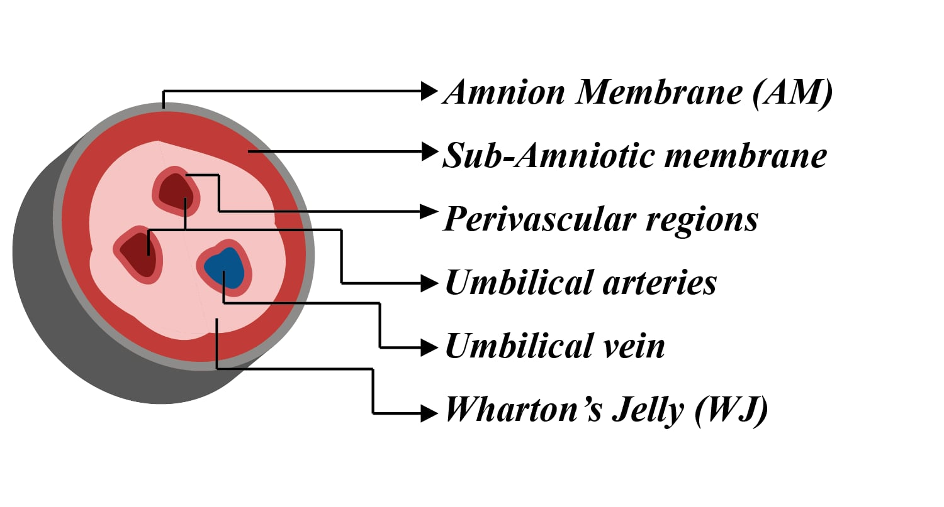
Figure 2.1. Illustration of different compartments of umbilical cord
The International Society for Cellular Therapy (ISCT) has established minimal criteria to define MSCs regardless of tissue source. According to the ISCT a valid MSC population must: (1) exhibit plastic adherence under standard culture conditions, (2) express surface markers CD73, CD90, and CD105 (≥ 95%) while lacking expression of hematopoietic markers such as CD34, CD45, CD14 or CD11b, CD79a or CD19, and HLA-DR (≤2%), and (3) demonstrate trilineage differentiation capacity into osteocytes, chondrocytes, and adipocytes in vitro [8]. These criteria provide a universal benchmark to verify MSC identity and quality control, forming the basis for production standardization.
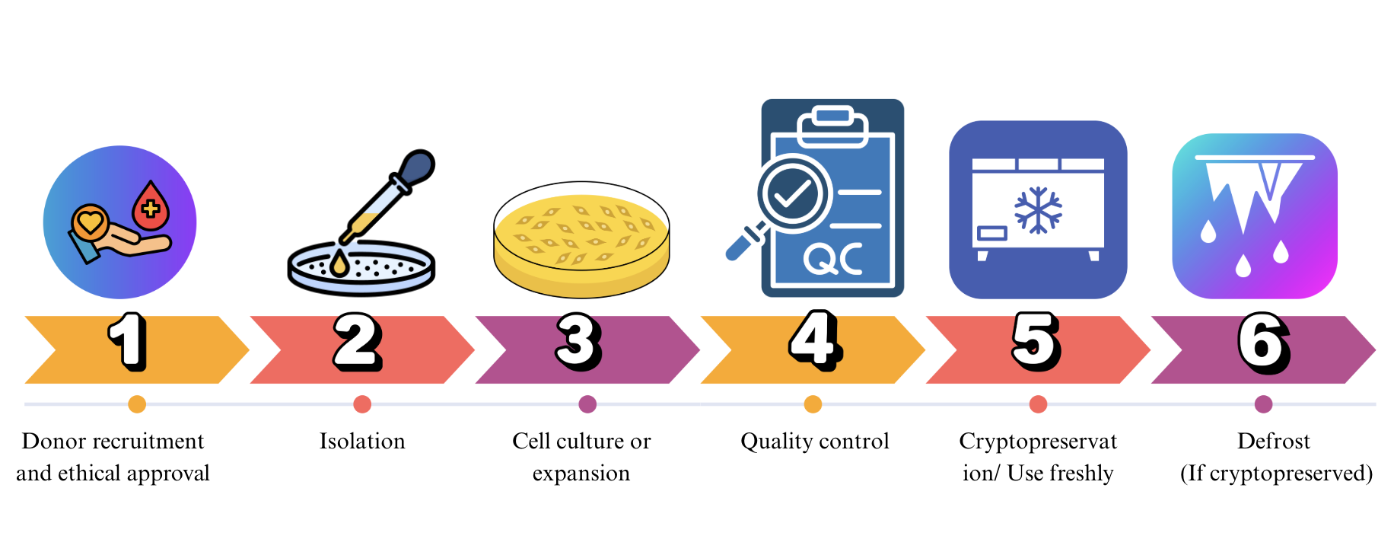
Figure 2.2. UC-MSCs manufacturing process
The production of UC-MSC is a stepwise procedure designed to ensure sterility, reproductivity, and quality. The workflow can be consolidated into six main steps [11] as shown in Figure 2.2.
Starting from step 1: Donor recruitment and ethical approval. Umbilical cord has to be collected from healthy donors with informed consent from parents [11].
Step 2: In the processing facility, the cord tissues are washed to remove cord blood, then processed either by the explant method or enzymatic digestion. Enzymatic isolation employs enzymes like collagenase or hyaluronidase [7].
Step 3: Cell culture and expansion. Cells can be cultured under 2D or 3D systems. 2D systems are using T-flasks, Petri dishes, or multiwell plates. 3D systems utilize hydrogels or scaffolds, microcarriers, and bioreactors (spinner flask, stirred-tank bioreactor, perfusion system). The culture medium consists of three main components: basal medium, primary supplements, and secondary additives. Basal medium can be DMEM, alpha MEM, DMEM low glucose… [11] Primary supplements can be FBS with a concentration of 10%, 15%, or 20%; human serum (platelet lysate (PL) or PRP), or none of them. Secondary additives are various and can be classified into seven main kinds: growth factor, nutrients/metabolic, protein/carrier, anticoagulant, antibiotics/antimycotics, antioxidants, and cytokines. UC-MSCs are cultured at 37 °C under 5% CO2 conditions [11]. Morphologically, these cells consistently display a characteristic spindle-shaped, fibroblast-like appearance.
Step 4: Cells were then harvested and underwent pre-cryptopresevation quality control. This step involves multiple assays to check whether the cell batch is qualified or not. QC assays in this step can be identified by flow cytometry, viability, trilineage differentiation, sterility, mycoplasma, and endotoxin karyotyping [11]. Beyond these assays, other tests, such as those detailed in the following list, may also be conducted:
- Safety test: Hemocompatibility (coagulation/complement activation test), allergenicity/hypersensitivity testing, Immunogenicity test, tumorigenicity, adventitious viral agents (human origin), Residual animal-derived protein test; Toxicity testing (Eg, Alanine aminotransferase)
- Cell quality: cellular size, proliferation ability và cell cycle, clonogenic/colony forming unit assay (CFU-F or CFU-assay), metabolic/mitochondrial health assay, senescence
- Functional test: Immunomodulatory potency, secretome/secreted factor profiling, angiogenesis/endothelial tube formation assay, specific lineage differentiation capacity, migration capacity.
- Short Tandem Repeat (STR) analysis can be performed to confirm genetic identity and prevent cross-contamination among cell lines. The STR profile of each UC-MSC batch was compared with that of its original cord tissue to ensure donor authenticity and traceability.
Step 5: The cell batch that passed pre-cryopreservation quality control will be preserved in cryoprotectant under controlled-rate freezing [11].
Step 6: Approaching the date of use, the cells are thawed and subsequently undergo post-thaw QC, which involves assessing viability, morphological assessment, sterility screening, cytogenetic stability, post-thaw proliferation capacity, and microbial examination (such as sterility, mycoplasma, endotoxin) [12].

Global overview
In the context of modern medicine, scientific research and technological innovation are increasingly regarded as the foundation for the development and implementation of novel therapeutic approaches [13]. In particular, within interdisciplinary fields such as regenerative medicine, medical biotechnology, and artificial intelligence in healthcare, research capacity not only determines the ability to generate new knowledge but also directly influences clinical effectiveness and patient safety [14]. Many reports highlight that strong investments in translational research in medicine can lead to faster progress in technology transfer, novel therapy development, and commercialization of biomedical products [15, 16].
Cell-based therapy is a typical example of novel therapy in the treatment of human diseases. Cell-based therapy is a potential medical treatment that involves the use of living cells, either allogenic or autologous, to repair or replace damaged tissues or organs [17]. Cell-based therapy can be classified into 2 main types based on the nature of the cells used: stem cell therapy and non-stem cell therapy [1]. Mesenchymal stem cells (MSCs) are the most extensively studied for cell-based therapy due to the easy harvesting process and promising characteristics suitable for medical purposes. Mesenchymal stem cells are a pluripotent stem cell characterized by plastic-adherence, positively expressed markers like CD105, CD73, and CD90, and negatively expressed markers such as CD45, CD34, CD14, or CD11b, CD79a, or CD19, and HLA class II, and the ability to differentiate to chondroblast, adipocyte and osteoblast [8]. MSCs can be isolated from many sources within the human body, from adult tissues like bone marrow, adipose tissue, dental tissues, endometrium, to perinatal tissues like amniotic fluid, placenta, and fetal membrane, Wharton's jelly [2]. MSCs are a promising cell for the treatment therapy of many diseases, ranging from cardiovascular to reproductive and nervous system [18], due to their striking natures: the three germ-line differentiation potential [2], weak immunogenicity [3], and paracrine factors [4]. Among all kinds of mesenchymal stem cells, the umbilical cord-derived mesenchymal stem cell (UC-MSC) is proven to be the most naïve, has the highest proliferation ability, reduced propensity for infection, minimal oncogenicity, and negligible immunogenicity [5, 7]. Moreover, the umbilical cord is. A gestational tissue that is usually considered medical waste, and UC-MSC collection raises no ethical concern and requires a non-invasive procedure. Figure 2.3 is a summary of sources, potential of MSC therapy, and its advantages. UC-MSC has been investigated for its therapeutic effects on various diseases, ranging from neurological, cardiovascular, endocrinological diseases to reproductive-related and respiratory disorders [18].
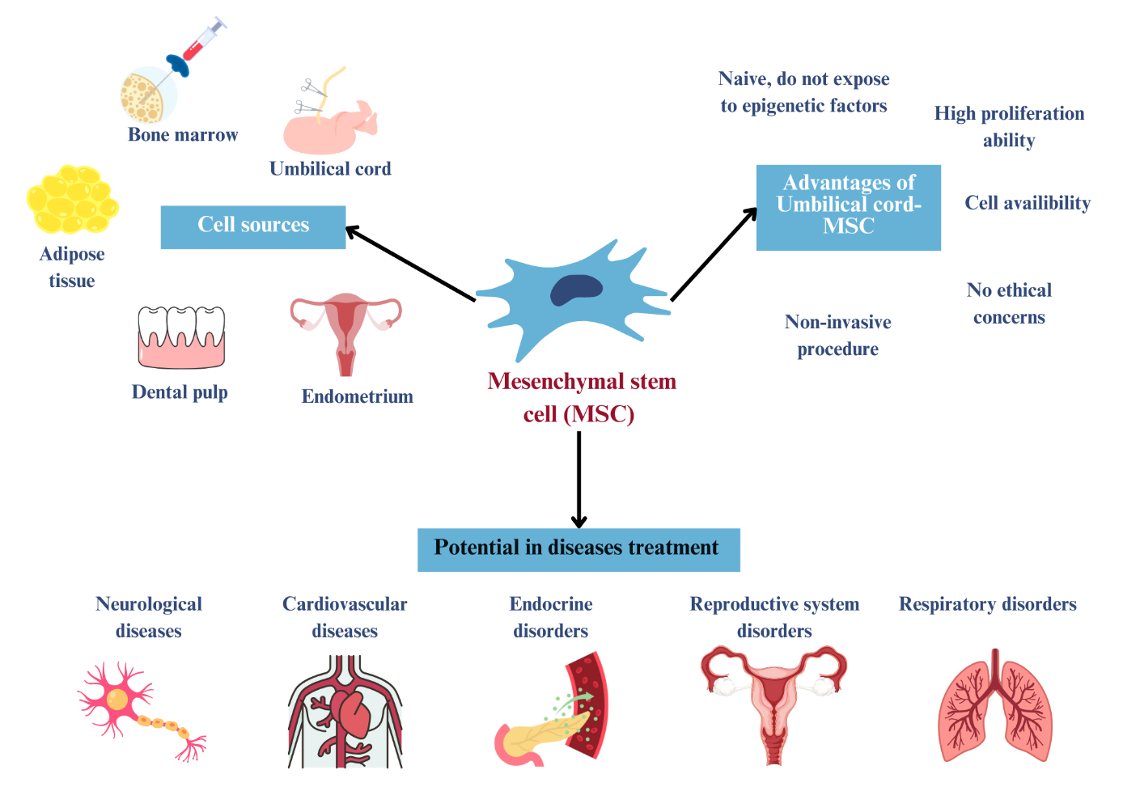
Figure 2.3. Summary of sources, potential of MSC therapy, and advantages
of UC-MSCs
The increasing trend in the number of UC-MSC articles, which is illustrated in the following Figures 2.4 and 2.5, indicates escalating scientific attention, indirectly
validating the practical application potential of these cells. After searching in databases PubMed and ScienDirect with keywords of “(umbilical cord mesenchymal stem cells OR UC-MSCs OR Wharton’s jelly mesenchymal stem cells OR WJ-MSCs) and (animal study OR preclinical study)”, 2708 results were found overall. From 2006 to 2015, after ISCT released the minimal criteria for defining MSC, the number of results was 687. However, only after 5 years, this figure for the period 2016-2020 is 915. Only in 5 years later, the number of articles found is even more than 1441.
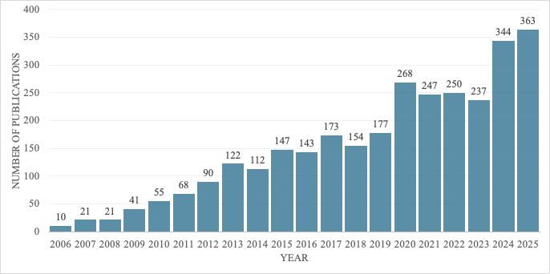
Figure 2.4. Publication trend of UC-MSC and animal study articles on PubMed
Figure 2.4 legend: Data were retrieved from PubMed on October 27, 2025, using the following search string: (umbilical cord mesenchymal stem cells OR UC-MSCs OR Wharton’s jelly mesenchymal stem cells OR WJ-MSCs) AND (animal study OR preclinical study).
The trend is also the same in human studies. Keywords are now changed to: (umbilical cord mesenchymal stem cells OR UC-MSCs OR Wharton’s jelly mesenchymal stem cells OR WJ-MSCs) and (trial OR clinical trial), the intervention remains the same. The PubMed database shows 205 results for the range of 2006 to 2015. Only 5 years later, from 2016 to 2021, the number is nearly twice as large with 375 articles found. 5 years from 2021 to 2025 shows the explosion in the number of academic papers found. 475 papers published in only 6 years.
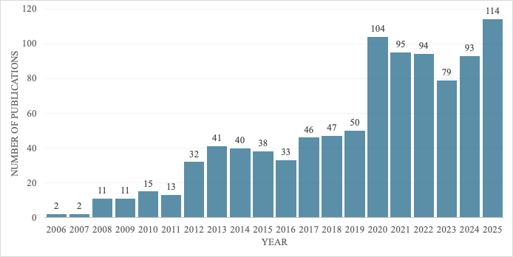
Figure 2.5. Publication trend of UC-MSC and clinical study articles on PubMed
Figure 2.5 legend: Data were retrieved from PubMed on October 27, 2025, using the following search string: (umbilical cord mesenchymal stem cells OR UC-MSCs OR Wharton’s jelly mesenchymal stem cells OR WJ-MSCs) and (trial OR clinical trial).
UC-MSC studies and clinical trials are primarily centered in developed nations - specifically the United States, Europe, South Korea, China, and Japan - where conditions such as robust GMP systems and sufficient budgets are readily available [19].
There are also multiple systematic reviews and meta-analyses (shown in Table 2.1) available to guide the field and consolidate evidence from UC-MSC studies. As a result of the high concentration of studies in developed countries compared to developing ones, both the original research and these systematic reviews primarily extract data concerning production and application under conditions prevalent in developed countries.
Table 2.1. Current systematic analysis on UC-MSC in animal studies and clinical studies from 2006 – 2025
This search is performed on PubMed with keywords (Umbilical cord-derived mesenchymal stem cells OR UC-MSCs OR Wharton's jelly mesenchymal stem cells OR WJ-MSCs ) AND (clinical trial OR human study) AND systematic review NOT (spheroid OR extracellular vesicles OR exosomes OR secretome OR conditioned medium)” on October 2025. Exclude one study because of using combined UC-MSC and scaffold, and one article publishes a systematic review protocol only.
No | Author, Year | Field |  |  | Area of expertises
No | Author, Year | Production | Animal study | Clinical study | Area of expertises
1 | Chen, X., Zheng, J., Yin, L. et al. (2024) [20] |  | x | x | Knee osteoarthritis
2 | Page, M.J., et al. [21] |  |  | x | Psoriasis
3 | Dhillon, J., et al. [22] |  |  | x | Knee osteoarthritis
4 | Riggle, C., et al. [23] |  |  | x | Knee osteoarthritis
5 | Yang, C.W., et al. [24] |  |  | x | COVID-19
6 | Taufiq, H., et al. [25] |  |  | x | COVID-19
7 | Koishybayeva, D., et al. [26] |  |  | x | Diabetes
8 | Garzon, I., et al. [6] | X (Differentation assays – only) |  |  | Wide range of somatic cell types
9 | Xiao, Z., et al. [27] |  |  | x | Knee osteoarthritis
10 | Alizadeh, S.D., Jahani, S., Rukerd, M.R.Z. et al. [28] |  |  | x | Diabetic peripheral neuropathy
11 | Wang, X., et al. [29] |  | x |  | Primary ovarian insufficiency
12 | Xie, R.-h., et al. [30] |  |  | x | Knee osteoarthritis
13 | Beese, S.E., Price, M.J., Tomlinson, C. et al. [31] |  |  | x | Type 1 diabetes
14 | Tang, X., H. Huang, and L. Hao [32] |  |  | x | Knee osteoarthritis
15 | Bojanic, C., et al. [33] |  | x |  | Peripheral nerve regeneration
16 | Pawitan, J.A., et al. [34] |  |  | x | Type 2 diabetes
17 | Page, M.J., et al. [35] |  |  | x | Hepatitis B virus-related liver failure
18 | Wei, R., et al. [36] |  | x |  | Ischemic stroke
19 | Liu, J., Y. Yang, and Y. Qi [37] |  |  | x | Type 1 diabetes
20 | Karamini, A., et al. [38] |  |  | x | Rheumatoid arthritis
21 | Peng, W., et al. [39] |  | x |  | Traumatic brain injury
22 | Abouzid, M.R., et al. [40] |  |  | x | Heart failure and myocardial Infarction
23 | Uwishema, O., Ghezzawi, M., Wojtara, M. et al. [41] |  |  | x | Dementia
24 | Wang, J., et al. [42] |  |  | x | COVID-19-related pneumonia
25 | Sourugeon, Y., et al. [43] |  | x |  | Osteoarthritis
26 | Liu, Y., Dong, Y., Wu, X. et al. [44] |  |  | x | Chronic liver failure and diseases
27 | Oloyo, A.K., M.A. Ambele, and M.S. Pepper [45] |  | x |  | Tumor
28 | Azimi, A., et al. [46] |  | x |  | Spinal cord injury
29 | Bruschettini, M., A. Badura, and O. Romantsik [47] |  |  | x | Stroke in newborn infants
30 | Liu, S., et al. [48] |  |  | x | Spinal cord injury
31 | Hum, C., et al. [49] |  | x |  | Sepsis
A comprehensive systematic review that integrates all preclinical, clinical, and production parameters for UC-MSCs is currently lacking. Existing reviews are fragmented, often focusing only on specific diseases or clinical outcomes, and they notably lack an analysis of the manufacturing processes.

Vietnam context overview
In Vietnam context, the number of studies using UC-MSCs is limited. The paucity of research in this field is demonstrated through search results from clinical and pre-clinical databases, as visualized in Figures 2.6 and 2.7. Upon searching in PubMed using keywords: “(umbilical cord mesenchymal stem cells OR UC-MSCs OR Wharton’s jelly mesenchymal stem cells OR WJ-MSCs) AND (animal study OR preclinical study OR in vivo) AND (Vietnam or Vietnamese)”, 21 results were found, with the number of articles increasing significantly after 2019.
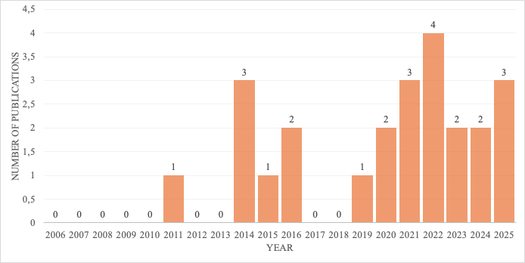
Figure 2.6. Publication trend of UC-MSC and animal study articles in Vietnam on PubMed
Figure 2.6 legend: Data were retrieved from PubMed on October 27, 2025, using the following search string: (umbilical cord mesenchymal stem cells OR UC-MSCs OR Wharton’s jelly mesenchymal stem cells OR WJ-MSCs) AND (animal study OR preclinical study OR in vivo) AND (Vietnam or Vietnamese).
Using the same database with search queries: (umbilical cord mesenchymal stem cells OR UC-MSCs OR Wharton’s jelly mesenchymal stem cells OR WJ-MSCs) AND (trial OR clinical trial) AND (Vietnam OR Vietnamese), the number of articles is 8.
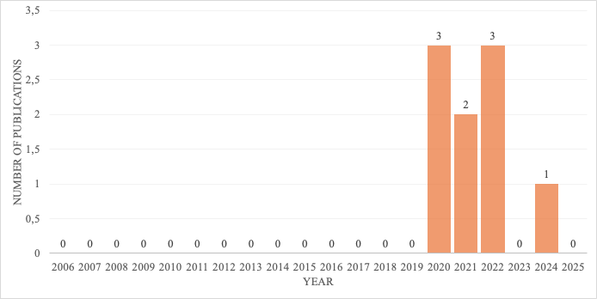
Figure 2.7. Publication trend of UC-MSC and clinical study articles in Vietnam on PubMed
Figure 2.7 legend: Data were retrieved from PubMed on October 27, 2025, using the following search string: (umbilical cord mesenchymal stem cells OR UC-MSCs OR Wharton’s jelly mesenchymal stem cells OR WJ-MSCs) AND (animal study OR preclinical study OR in vivo) AND (Vietnam or Vietnamese).
By searching in Clinical.gov, Vietnam only has 8 trials and most of them belongs to the early-phase (phase 1 or phase 2) category.
The majority of the studies were conducted independently by individual institutions, lacking standardized protocols and unified recommendations (or guidelines) for clinical research; this has led to heterogeneity in preclinical study and trial procedures.
Currently, research institutions in Vietnam that have conducted and published articles or clinical trials include the VinUniversity-Vinmec Research Institute of Stem Cell and Gene Technology, the Laboratory of Stem Cell Research and Application (University of Science, Ho Chi Minh City), Van Hanh General Hospital, and Tam Anh Hospital.
Table 2.2 provides illustrative examples of selected animal model studies and human clinical trials that demonstrate the existing heterogeneity among research institutions regarding production and trial methodologies.
Table 2.2. Examples of animal model research and human clinical trials using UC-MSCs were conducted by
various entities in Vietnam.
Precinical study
Author | Institute | Purpose | Animal model | Culture medium | Passage at administration | QC criteria | Dose
Dang, L.T.-T., Bui, A. N.-T., Nguyen, C. L.-T., Truong, N. C., Bui, A. T.-V., Le, P. T.-B., & Phan, N. K. [50] | Laboratory of Stem Cell Research and Application, University of Science, Vietnam National University, Ho Chi Minh city | Treat type 1 diabetes | Mice | MSCCult Medium, Regenmed Lab | 5 | Immunophenotyping by flowcytometry and 2-lineage differentiation assay (osteogenic and adipogeneic) | 2 x 10⁶ (It is unclear whether this represents the total cell quantity or the dose per kilogram)
Dinh, N.TH., Nguyen, Q.T., Hang, N.T. et al. [51] | Vinmec International Hospital | Vascular and muscle stimulation | New Zealand white rabbits | StemMACS™ MSC Expansion Media (Miltenyi Biotec, Germany) | 6 | Immunophenotyping by flowcytometry  3-lineage differentiation assay (osteogenic, adipogeneic, chondrogenic)  Sterility and mycoplasma | 0.5 × 10⁶ cells/kg
Clinical study
Author | Institute | Disease | Age | Culture medium | Passage at administration | QC criteria | Dose and route
Le Thi Bich, P., et al. [52] | Van Hanh General Hospital (Ho Chi Minh City) | Chronic obstructive pulmonary disease | 40–80 | Not reported (serum-free and xeno-free condition) | 5 | Immunophenotyping by flowcytometry  3-lineage differentiation assay (osteogenic, adipogeneic, chondrogenic)  Sterility  Tumorigenicity  Immunomodulatory potency | 1.5 × 10⁶ cells/kg, intravenous
Nguyen, L.T., et al. [53] | Vinmec International Hospital | Bronchopulmonary dysplasia | Infant (less than 32 weeks) | Serum-free PowerStem MSC1 culture media, P04-77355 K | 5 | Immunophenotyping by flowcytometry  3-lineage differentiation assay (osteogenic, adipogeneic, chondrogenic)  Sterility  Mycoplasma  Endotoxin  Karyotyping  CFU assay | 1 × 10⁶ cells/kg, intravenous
Hoang, D.M., et al. [54] | Vinmec Research Institute of Stem Cell and Gene Technology | Frailty | 60-85 | Not reported | 3 | Immunophenotyping by flowcytometry  3-lineage differentiation assay (osteogenic, adipogeneic, chondrogenic)  Sterility  Mycoplasma  Endotoxin  Karyotyping  Cell viability | 1.5 × 10⁶ cells/kg, intravenous
Long, N.T., et al. [55] | Tam Anh General Hospital, Long Bien District,  Hanoi, | Knee osteoarthritis | 50 | Not reported | 3 | Immunophenotyping by flowcytometry  3-lineage differentiation assay (osteogenic, adipogeneic, chondrogenic)  Sterility  Mycoplasma  Endotoxin  Karyotyping  Cell viability | 20 x 10⁶ cells per  Joint, intra-articular

RESEARCH METHODOLOGY

Research approach
The research approach of this study is illustrated in Figure 3.1 below.
Research aim: Generate evidence-based recommendations for future research
Review theoretical background on local context
Reseach objective 1: Identify research gaps
Research question 1: What are the reported production processes, dosing regimens, administration routes, and treatment outcomes in preclinical and clinical studies using UC-MSCs as the primary intervention?
Reseach question 3: What are the recommendations can be formulated base on that gaps?
Research objective 2: Proposed context-appropriated recommendations
Research question 1: What research gaps and limitations exist in the current body of evidence on UC-MSC applications?
Systematic analysis of animal studies and clinical trials from databases and registry
Figure 3.1. Step-by-step approach of the research

Research methods

Study subject
This study includes peer-reviewed original research articles from 2006 to 2025 that utilized UC-MSCs as the main intervention in both animal models and human trials. Only those satisfying eligibility criteria are included, while any articles aligning with the exclusion parameters are omitted from the data extraction and analysis.
- Inclusion criteria:
Studies were eligible for data extraction and analysis if they met the following criteria:
- Publication period: The study was released between 2006 and 2025.
- Language and peer Review: Only English-language, peer-reviewed articles were considered.
- Study type: The work must be original research.
- Intervention: Naive UC-MSCs served as the main intervention in the study.
- Study population: The research must have been conducted on either animal or human models.
- Exclusion parameters: Studies were excluded from the analysis if they met any of the following criteria:
- Timeline and language: Published before 2006 or in a non-English language.
- Publication type: Non-peer-reviewed materials (theses, dissertations, preprints) and secondary research (reviews, conference proceedings, editorials).
- Research focus: Studies centered on UC-MSC manufacturing or production protocols.
- Intervention specifics: Use of modified UC-MSCs, derivatives (extracellular vesicles, conditioned medium), or other cell populations as the main intervention.
- Study role: Trials where UC-MSCs served as the comparative control group.
- Experimental model: Absence of in vivo animal or human models.

Study design

Systematic review
This study is conducted as a systematic review structured in accordance with the PRISMA 2020 guidelines (Prefferred Reporting Items for Systematic Review and Meta analysis) [56] as shown in Figure 3.2.
Records identified from databases:
Pubmed (n = 118)
Sciencedirect (n= 579)
Register (n= 482)

Records removed before screening:
Duplicate records removed (n = 8+ 209*)
Retracted/withdrawn articles (n = 4)
Records removed for not having abstract (n = 36 )

Records screened
(n = 649 + 273*)

Records excluded:
Reason 1: Not eligible publication/ study type (n= 338 )
Reports sought for retrieval
(n = 311 + 273*)
Reports excluded:
Reason 1: Full text not available (n = 57 )
Reason 2: Non-English (n = 0 )
Reports assessed for eligibility
(n = 254 + 273*)
Reports excluded:
Reason 1: Wrong intervention/material (n = 103 + 47*)
Reason 2: Wrong study design (n= 68 + 5*)
Reason 3: Insufficient data (n = 15 + 201* )
Reason 4: Duplicated clinical trial (n = 11*)
Studies included in review
(n = 23 + 45 + 9*)
Identification
Screening

Included
Figure 3.2. Outcomes of searching and selection of studies
Legend: *: Number of results retrieved and screened from ClinicalTrials.gov
By searching in 2 databases and register, the total outputs is 1179 results and trials, including 118 from PubMed, 579 from ScienceDirect and 482 trials from Clinical.gov. Using Excel software, 8 duplications were detected among results from 2 databases. 209 clinical trials are duplicated and also removed. Furthermore, 4 retracted and withdrawn papers adn 36 non-abstract articles were omitted. By manual screening of articles, 338 articles were excluded because of an ineligible type, other 57 articles were not included due to unavailable full-lenght text.
Next step involves considering intervention, study design and data provided in the articles. As depicted in Figure 8, 150 and 73 studies were excluded because of mismatch in the primary intervention and study design. 216 studies failed to provide sufficient data and also are removed from final analysis. Further screening in trials found in register, 11 duplicated trials are detected. Finally, 68 studies were included, consist of 23 preclinical trials, 45 clinical trials from databases, which accompanied with 9 clinical trials from register.

Database and searching method
- Article database
- Database: PubMed and ScienceDirect are chose as databases for article searching. Additionally, Clinical.gov serves as the supplementary source in order to obtain more clinical trials.
- Time: The publication period applied as a filter when searching the databases spans from 2006 to 2025. The starting year, 2006, was chosen as the year the ISCT released the minimum criteria for defining UC-MSCs, and 2025 represents the current time of access.

- Keywords: The keywords are potential to used are listed in Table 3.1 below:
Table 3.1. Keywords
Categories | Keywords
Intervention | Human umbilical cord mesenchymal stem cells, hUC-MSC, Wharton’s jelly mesenchymal stem cell, WJ-MSCs
Preclinical study | Animal study
Clinical trial | Clinical trial
Exclusion | Exosome, extracellular vesicle, scaffold
- Searching strategies:
The aforementioned keywords are combined with Boolean operators (AND, OR, NOT). Boolean operators “NOT” are used to exclude the studies on exosomes, extracellular vesicles or stem cell combined scaffold. The keywords were flexibly adapted based on the MeSH terms and database-specific indexing limitations, thereby ensuring keyword consistency across all search platforms. Due to PubMed's capability to comprehend complex keyword combinations and no restriction on the number of Boolean operators used, the maximum number of keywords was utilized, combined with parentheses to structure the search layering. In contrast, ScienceDirect restricts searches to eight Boolean operators per search term, thereby limiting the scope of both keywords and operators. Therefore, the author utilized the following subset of keywords from the list of the terms above for the combined search strategy.
- Search queries on PubMed: ("umbilical cord mesenchymal stem cells" OR "Wharton's jelly mesenchymal stem cells" OR "UC-MSCs" OR "WJ-MSCs") AND ("animal study" OR "clinical trial") NOT (exosome OR extracellular vesicle OR scaffold)

- Search queries on ScienceDirect: ("umbilical cord mesenchymal stem cells" OR "Wharton's jelly mesenchymal stem cells" OR "UC-MSCs" OR "WJ-MSCs") AND (“animal study” OR "clinical trial") NOT (exosome OR extracellular vesicle OR scaffold)
- Registry database search:
UC-MSC has a lot of synonyms, therefore the author chose these synonyms to use as keyword for intervention: “umbilical cord mesenchymal stem cells”, “umbilical cord-derived mesenchymal stem cells”, “UC-MSC”, “Wharton's jelly mesenchymal stem cells”, “WJ-MSC”, “umbilical cord stromal cells”.
The search was further refined using the following filters on ClinicalTrials.gov: studies status (Not yet recruiting, Recruiting, Active - not recruiting, Completed); participant age (Child [birth – 17], Adult [18 – 64], Older adult [65+]); trial phase (Early Phase 1, 1, 2, 3, 4, Not applicable); Interventional studies only; and a study start date ranging from February 1, 2006, to January 1, 2026. These filters help to exclude non-interventional studies, withdrawn or terminated trials, and cover all age ranges and phases. The results obtained from the keyword searches will be pooled to constitute the primary registry results. Subsequently, the search outcomes from the article databases and the registry database will be merged to form the initial search results for further steps.

Selection
- Deduplication:
Within article results, duplicated papers will be removed using Excel. Additional deduplication will be conducted manually to avoid missing.
- Before screening, duplicates as well as retracted or withdrawn papers will be removed. Abstract screening will be performed to exclude those not having abstract.
- After screening, only peer-reviewed original research articles will be kept. The list of not eligible publication types are listed below in Table 3.2.
Table 3.2. Excluded publication types
No | Not eligible type
 | Case report/ Case series
 | Review
 | Systematic review / Meta-analysis
 | Book
 | Conference abstract/ poster
 | Master thesis, PhD dissertation
 | Editorial/ Commentary/ Opinion/ Perspective/ Correspondence
 | Database entry/ Patent application/ Forum/ Non-academic paper
 | Not peer-reviewed (preprint)
 | Corrigendum
- Reports sought for retrieval will be continued scanning for full-text availability and language. The articles that can not be found in a full-text version will be excluded. The articles written in other languages will also be excluded at this stage. Only full text available and English papers will go to further steps.
- The following step is called “Reports assessed for eligibility”. There are four reasons to assess the eligibility of papers in this work. These reasons and detailed explanations are informed by Table 3.3 below:
Table 3.3. Reasons for assessing eligibility.
Reason | Explanations
Wrong intervention/material | Studies were excluded if they involved non-Umbilical Cord Mesenchymal Stem Cells (e.g., BM-MSC, AD-MSC, iPSC), animal-derived MSCs, ESC- or iPSC-derived MSCs, or any UC-MSC derivatives such as extracellular vesicles (EVs), conditioned medium (CM), or secretome. Research investigating modified UC-MSCs or mixed cell therapies (e.g., multiple cell lines or cell + scaffold combinations) was also excluded. Only studies employing native UC-MSCs as the sole and primary intervention were eligible.
Wrong study design/ purpose | Studies were excluded if they focused solely on in vitro procedures or production, did not evaluate UC-MSCs as the primary intervention, used UC-MSCs merely as a comparator, or were limited only to mechanistic, biodistribution, clearance assessments
Insufficient data | Articles were excluded if they represented protocols only, failed to specify a clear MSC origin
Duplicated publication | The article and registration derived from one trial with unique identifier, the article will be kept and corresponding registration will be excluded.  In case that the article not indicated the identifier of trial, identifier will be marked as “Not reported” and the article will be kept.
Subpopulation of UC-MSC (UC-MSC enrichment) and UC-MSC therapy after conventional interventions are also accepted.
Studies using UC-MSC in combination with drugs, devices, scaffolds, biomaterials, other cell types, or EVs, regardless of the presence of a monotherapy arm, were excluded entirely.
This decision was made to ensure that only direct UC-MSC applications were analyzed, without influence from secondary products or altered cellular phenotypes and avoid intended bias.

Data extraction
Data extraction aims to systematically collect, organize, and standardize key information from all eligible studies to enable comprehensive comparison and synthesis across production, preclinical, and clinical research domains related to UC-MSCs studies. Extracted information contains article identifiers (such as year, author, title, DOI, and URL) and trial identifiers (such as title, registry identifier number, and URL).
The data extraction process was performed using a standardized data extraction sheet developed in Microsoft Excel. Discrepancies were resolved by discussion or through consultation with supervisors.
Data from eligible studies were systematically extracted using a predefined Excel template designed to capture key variables for production, preclinical, and clinical research domains. Registered clinical trials identified through ClinicalTrials.gov were recorded in a separate table to illustrate the current research landscape, but ongoing trials were excluded from the efficacy synthesis as outcome data were not yet available.
Tables 3.4, 3.5 and 3.6 below provide a list of production-related variables that will be extracted from the included studies.
Table 3.4. Chosen variables for production dataset
Production
Production clarity | P1 – Direct description  P2 – Indirect (single reference) or Multiple but consistent  P3 – Indirect (multiple and inconsistent references, Untraceable chain of reference)  P4 – Not reported/ Inaccessible production data
Isolation
Isolation method |  | Enzymatic or Explant method or Mixed or Not reported
Expansion
Culture medium |  | Basal medium
 |  | Primary supplement and concentration OR characteristic of culture medium (Xeno-free or Serum-free)
 |  | Secondary additives
Culture system |  | 2D or 3D
Passage at administration |  | Min
 |  | Max
Quality control (QC) test
Flowcytometry (ISCT-Identity compliance) |  | Yes/ Partialy/ No/ Not reported
Sterility |  | Yes/ Not tested/ Not reported
Mycoplasma |  | Yes/ Not tested/ Not reported
Endotoxin |  | Yes/ Not tested/ Not reported
Viability |  | Yes/ Not tested/ Not reported
Karyotype/ Genetic stability test |  | Yes/ Not tested/ Not reported
Trilineage differentiation assay |  | Yes/ Partial (1-2/3)/ Not reported

Table 3.5. Chosen variables for animal study dataset
Animal study
Animal | Species
Animal | Strain
Disease | Organ system
Disease | Disorder
Intervention
Route | Intravenous, local, body cavitie,…
Result
Outcome measures
Histological | Improved/ Not improved/ Worsened/ Mixed - Unclear
Physiological | Improved/ Not improved/ Worsened/ Mixed - Unclear
Imaging | Improved/ Not improved/ Worsened/ Mixed - Unclear
Biochemical / Molecular | Improved/ Not improved/ Worsened/ Mixed - Unclear

Table 3.6. Chosen variables for the clinical study dataset
Clinical study
Disease | Organ system
Disease | Disorder
Intervention
Route | Intravenous, local, body cavitie,…
Result
Outcome measures
Histological | Improved/ Not improved/ Worsened/ Mixed - Unclear
Physiological | Improved/ Not improved/ Worsened/ Mixed - Unclear
Imaging | Improved/ Not improved/ Worsened/ Mixed - Unclear
Biochemical / Molecular | Improved/ Not improved/ Worsened/ Mixed - Unclear

Analysis method
Extracted data were analyzed using a descriptive quantitative synthesis and a narrative approach, as a formal meta-analysis was not feasible due to the high clinical and methodological heterogeneity across the included studies (e.g., diverse disease models, varying administration routes, and unstandardized dosing regimens). This analytical strategy was designed in accordance with the Synthesis Without Meta-analysis (SWiM) reporting guidelines [57]. Data processing, standardization, and visualization will be conducted utilizing computational tool – Microsoft Excel.
The data analysis strategy encompassed the following steps:
- Data standardization and categorization:
- First, data cleaning was performed to remove duplicate records, correct inconsistent entries, and address missing values through standardized coding (e.g., "Not reported"). Data standardization was applied to harmonize variables across studies, ensuring that units, terminology, and categorical labels were uniform across all three domains—manufacturing, preclinical, and clinical. For treatment efficacy data, the standard coding is applied as follows: “Improved” for trials reporting efficacy, and “Not improved” for trials reporting no improvement, worsened, mixed results, or unclear efficacy.
- Secondly, regarding the classification of variables, preclinical models and clinical indications are grouped by organ system (e.g., nervous, musculoskeletal, autoimmune) to allow for comparisons between studies. Cell delivery methods are grouped into three main clinical categories: systemic (e.g., systemic intravenous), local (e.g., subcutaneous injection, intra-articular injection), and mixed-route approaches. The effectiveness of animal and human trials is evaluated based on the domains: histological, physiological/functional, imaging-based, and biochemical/molecular.
- Descriptive statistical analysis: The cleaned data were analyzed and graphed based on the characteristics of the variables. Microsoft Excel was used to assist in the analysis and graphing.
- Regarding production data for both datasets for animal and human studies: To characterize the manufacturing and QC landscape of UC-MSCs, descriptive statistics were employed as follows:
- Reporting transparency and compliance analysis were constructed by calculating the proportion (%) of included studies that reported each predefined manufacturing variable - namely isolation method, culture medium, primary supplements, and passage number. The reporting rate for each variable was calculated as the number of studies disclosing that parameter divided by the total number of included studies in the respective domain (preclinical or clinical), multiplied by 100. Results were displayed as horizontal bar charts to enable direct visual comparison of reporting rates across parameters.
- QC parameter distribution were generated by calculating the frequency and proportion of studies performing each specific QC assay, including flow cytometry (ISCT identity), trilineage differentiation, sterility, mycoplasma, endotoxin, karyotype, and cell viability. Each assay category was treated as an independent binary variable (“reported” versus “not reported/not tested”). Results were ranked by reporting frequency and displayed as bar charts to identify the most and least consistently reported QC parameters.
- In addition to manufacturing parameters, the analysis extended to the clinical application and efficacy of UC-MSCs through the following methods:
- Temporal trend analysis by disease indication was constructed by classifying each included study according to its disease indication and publication year. Studies were grouped by organ system category and counted per defined time period. Bubble charts were used to simultaneously represent disease diversity (y-axis), research volume (bubble size), and temporal trend (x-axis), providing an integrative overview of how scientific interest has shifted across disease areas over the study period.
- Efficacy metric mapping (heatmap analysis) were constructed by calculating, for each disease-outcome domain combination, the percentage of studies reporting improvement. The four outcome domains assessed were: histological, physiological/functional, imaging-based, and biochemical/molecular. Outcome data from each study were coded as Improved, Not Improved, Worsened, or Mixed/Unclear. The improvement rate (%) was calculated as the number of studies reporting improved divided by the total number of studies for that disease, expressed as a percentage. Color gradients were applied to the resulting matrix to visualize efficacy patterns across diseases and outcome domains simultaneously.
- Comparative translational analysis: A side-by-side comparative analysis was conducted between preclinical and clinical datasets to identify translational gaps.

RESULTS

The landscape of manufacturing standardization and quality control

Preclinical studies: Transparency gap and quality control limitations
Totally, 23 preclinical studies are included in this work. While the preclinical production landscape is characterized by the vast majority of included studies adhering to ISCT standards for MSC identification, our data indicates that there is a critical transparency gap in manufacturing protocols and a widespread of unreporting safety parameters.
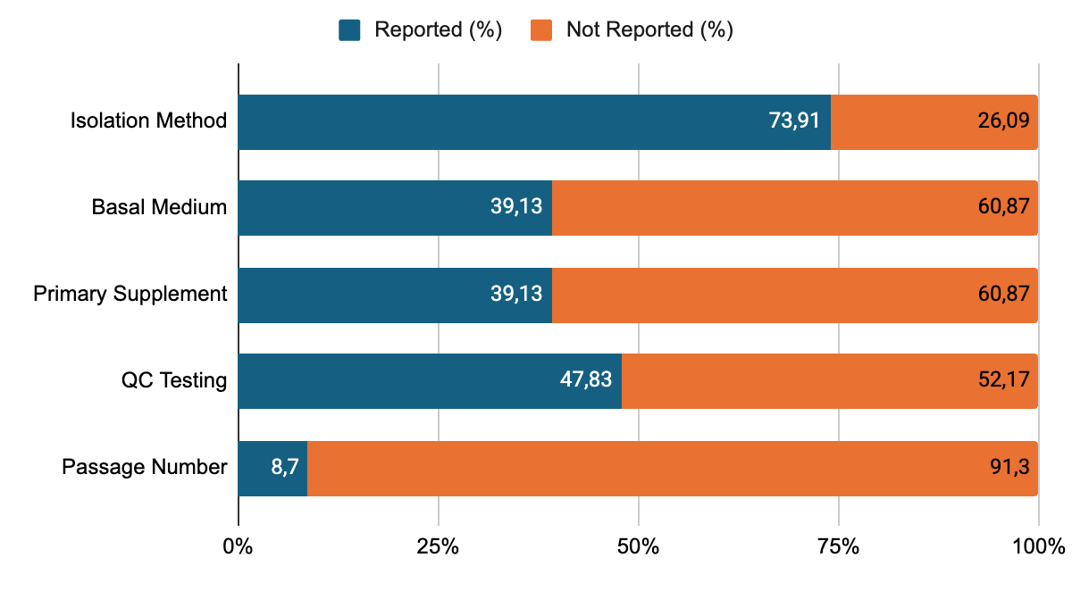
Figure 4.1. Transparency landscape of preclinical studies
When it comes to the transparency landscape of production information from included studies, the data reveals a “black box” of cell manufacturing. The isolation method is reported in 73.91% number of articles (n=17). However, more than 60% of articles fail to detail basal medium, supplements used (n= 14). Only 2 studies disclose the minimum passage of UC-MSC utilized, accounting for 8.7%. More than half of preclinical studies (n=12) do not indicate any QC testing, only 01 study does not perform QC testing due to an untraceable chain of references. This clear asymmetry in reporting transparency is visualized in Figure 4.1. This "black box" in the cell expansion phase severely limits the reproducibility of the studies. Furthermore, without defined passage limits, the consistency of the cell product can not be guaranteed.
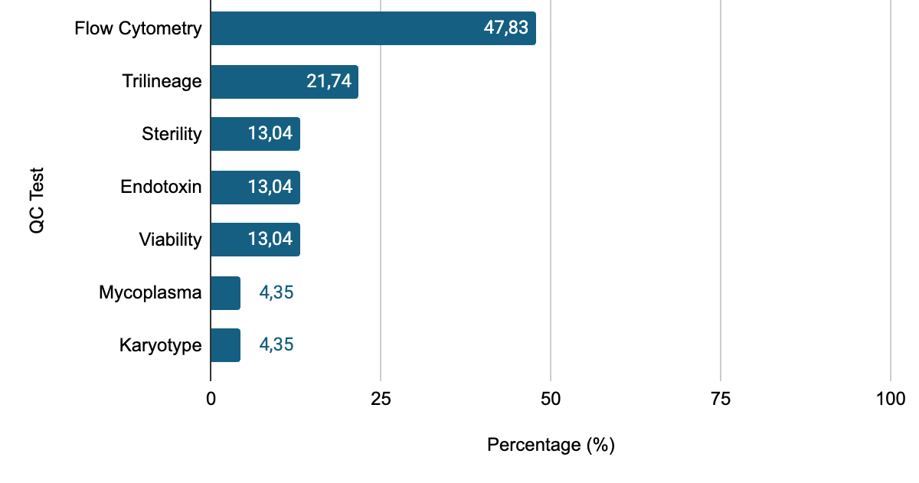
Figure 4.2. Percentage of each QC measure
As presented in Figure 4.2, another asymmetry occurs between identity and safety parameters. Identity test by flow cytometry has the highest rate of compliance, at 47.83% (n=11), followed by the trilineage differentiation assay. The safety category, including sterility and endotoxin, is evaluated in 3 studies. Accounted for 4.35%, only 1 study details that mycoplasma and karyotype assays were done. This pattern suggests an “academic mindset” focused on discovery, rather than a “manufacturing mindset” focused on clinical safety.

Clinical studies: The shift toward safety compliance and biological standardization
Moving from preclinical research to clinical trials involves a shift toward robust safety adherence and uniform study designs, although challenges regarding production transparency remain; it may be due to trade-secret commercial kits. Figure 4.3 depicts the transparency landscape of UC-MSC production within clinical trials based on the analyzed data.
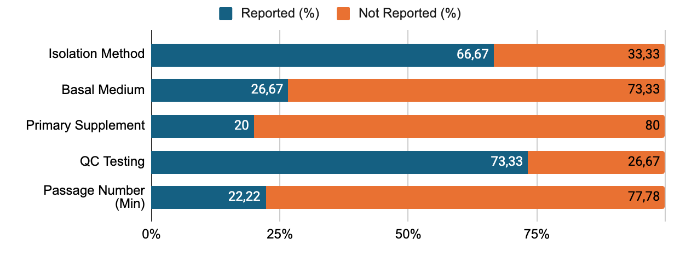
Figure 4.3. Transparency landscape of clinical trials in term
The isolation method remains highly reported, at a rate of two-thirds among all included trials. Meanwhile, culture media and supplements are detailed in about 20% (26.67%, n=12, and 20.00%, n=9, respectively). In comparison to the reporting percentage of animal studies, the counterpart in human trials is lower. A potential reason for this phenomenon is that clinical trials employ commercial products or intellectual property-protected protocols, which restrict the disclosure of ingredients. This constitutes a critical research gap in terms of scientific transparency. However, the data reveal that QC reporting proportion of the clinical trial, standing at 73.33%, is approximately two times higher than the corresponding figure of animal studies. The rate of human trials that report the biological age of UC-MSCs used is also higher than the same percentage of animal trials. These changes may suggest a movement toward more adherence to safety standards and biological aging assessments for UC-MSCs within human clinical trials compared to the levels observed in preclinical models.
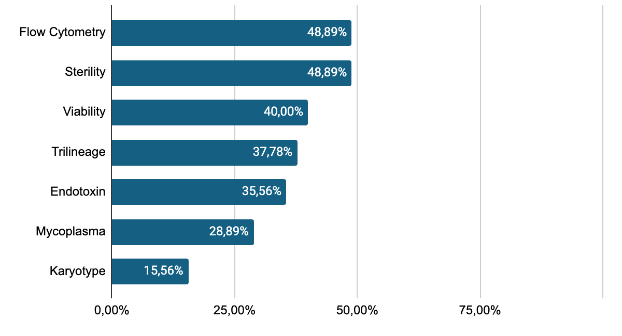
Figure 4.4. QC compliance ranking in clinical studies
The distribution of QC compliance rates documented in clinical trials is presented in the chart in Figure 4.4. Sterility assay and identity assay stand at the top, with the highest reported rate among all kinds of QC tests, at 48.89% (n=22). In preclinical studies, the same rate is four times lower, at 13%. This may indicate that when it comes to clinical trials, assessing cell identity and viability is not the sole focus. Evaluating safety and sterility validation is a pivotal priority. Looking at Figure 4.4, endotoxin and mycoplasma assessments ranked in the middle-tier range, accounting for 36% and 29%, respectively. In preclinical trials, the prevalence observed is 13% for the former and 4% for the latter, showing the escalating trend of the two indicators. This sharp increase reflects more compliance with stringent regulatory requirements, such as those from FDA and EMA, where GMP standards necessitate the compulsory control of biological contaminants.

Therapeutic efficacy analysis and translational pattern

A comprehensive overview of UC-MSCs efficacy in animal models
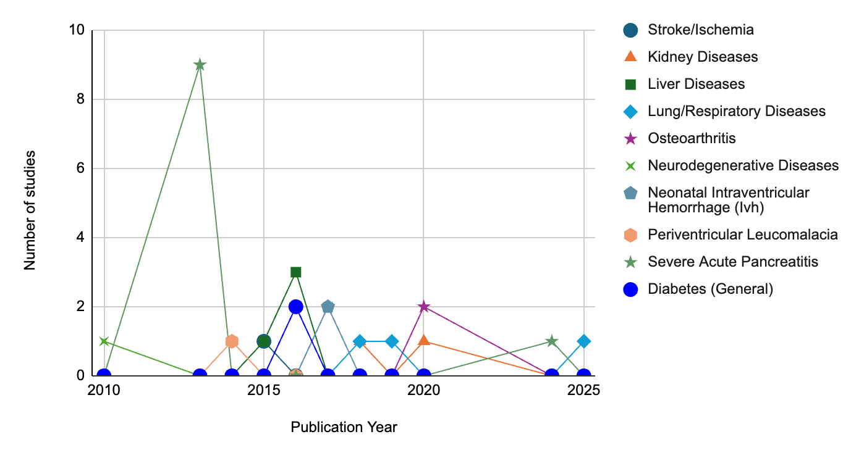
Figure 4.5. Animal research trend
Analysis of the preclinical efficacy dataset in terms of animal research trend, as illustrated in Figure 4.5, shows a predominance of both acute disease and chronic diseases. Acute pancreatitis got the highest number of studies (n=10), followed by liver disease (n=4) and respiratory illnesses (n=3). A smaller but consistently stable number of studies over the years has been observed for neurological diseases and osteoarthritis. Conversely, cardiovascular and genitourinary diseases appear to be under-investigated. When it comes to the trend, the period from 2010 to 2014 saw a significant volume of work with 11 studies; however, the pathological focus remained limited. The subsequence, 2015-2020, marked a shift as research interests branched out into more diverse medical fields such as neurology, metabolism, respiratory and digestive ailments, peaking at 17 studies. Since 2021, the research output has largely plateaued, showing a consistent level of activity through 2025.
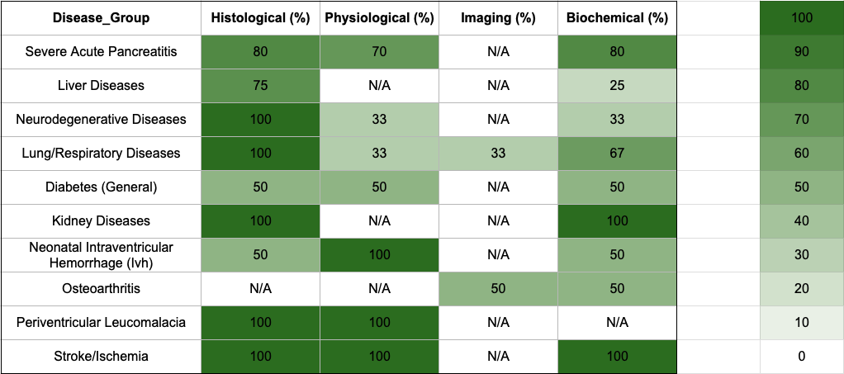
Figure 4.6. Animal efficacy in depth
Regarding efficacy in preclinical trials, Figure 4.6 is a heatmap showing the percentage of research reporting that UC-MSC improves treatment outcomes. Examining chart 3, it is clear that the efficacy of UC-MSC intervention is heterogeneous among diseases. The chart depicts a dominant blue palette, indicating successes; no disease has achieved an absolute 100% efficiency improvement rate across all parameters. Fluctuations in color intensity across the grid - with values stagnating between 25% and 100% - underscore the reality that a notable proportion of trials yielded either “No Improvement” or “Mixed” outcomes.
However, by looking at the heatmap, it is shown that UC-MSCs are effective at a certain level in all diseases. Notably, UC-MSCs demonstrated a higher frequency of reported improvement in several specific conditions compared to others, particularly in neurological, pulmonary, and renal disorders, as well as gastrointestinal pathologies of the liver and pancreas. In the neurological category, all illnesses show a high proportion of trials documenting clinical gains following UC-MSC therapy. A typical example is neurodegenerative diseases, at which 100% of studies reported histological benefits. A similar reporting rate is observed in stroke and periventricular leukomalacia. Notably, 100% improved rate is also reported for physiological and biochemical improvement in stroke animal models. However, in neonatal intraventricular hemorrhage, histological improvement is documented in only 50% of trials, although functional recovery reached 100%. Lung diseases showed a great histological improvement of 100% reporting rate, while the improvement in biochemical markers was more modest, appearing in approximately two-thirds of the trials. Nevertheless, evidence of recovery was also documented across functional and imaging criteria in all included research. Therefore, UC-MSC shows a comprehensive reporting of efficacy across all four evaluation parameters. Regarding renal ailments, recovery is detailed in 100% of studies for both histology and biochemistry aspects. In the gastrointestinal field, particularly acute pancreatitis in animal models, the incidence of reported improvement is high and consistent across histological, physiological function, and biochemistry, with reporting frequencies ranging from 70 to 80%.
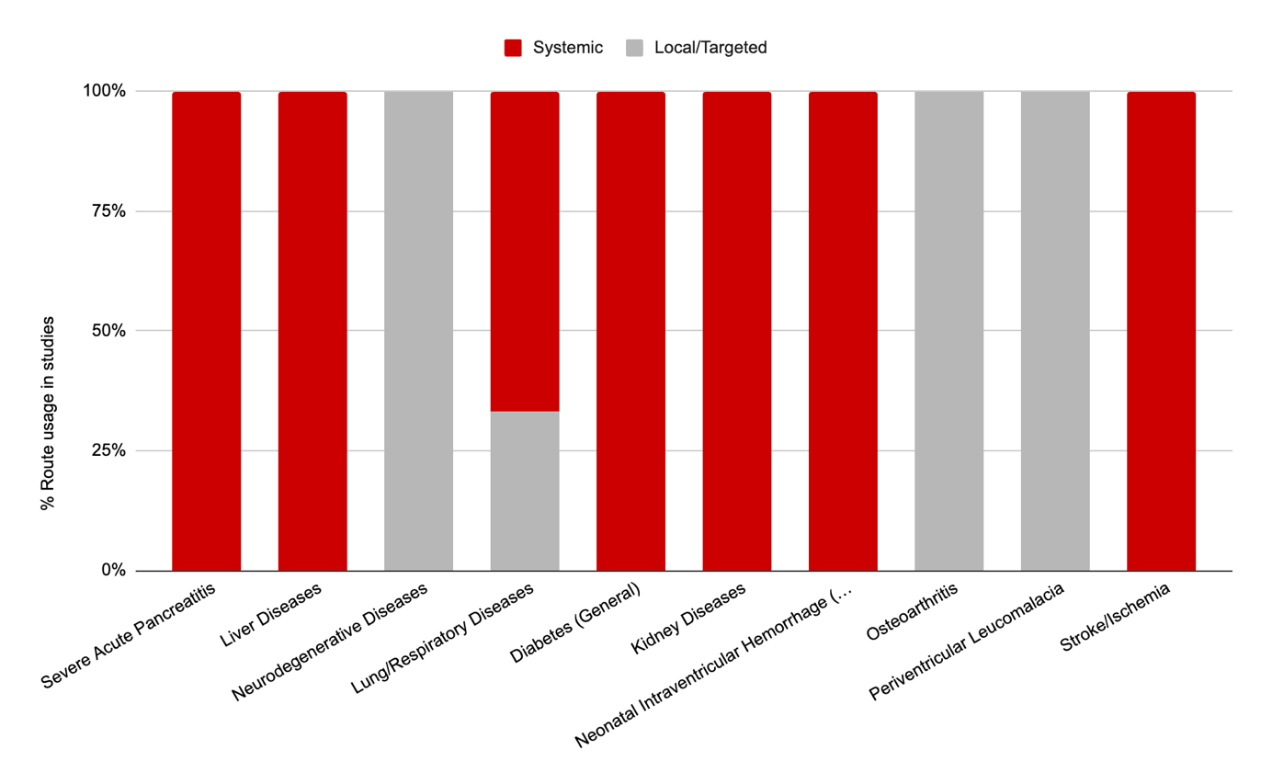
Figure 4.7. Animal route distribution

Concerning administration routes, as depicted in Figure 4.7, the systemic delivery predominates in almost all diseases. Nevertheless, in specific instances of neurological disorders (neurodegenerative disease, periventricular leucomalacia) and osteoarthritis, locally targeted administration remains the preferred approach. 100% experiments used systemic vein to deliver UC-MSC in acute pancreatitis and liver diseases. For respiratory illnesses, both local and systemic routes were used with the ratio 1:2. When it comes to systemic metabolic disease like diabetes, prefered mode of administration is through intravenous veins.

Comparative analysis of UC-MSC efficacy: trends and disparities
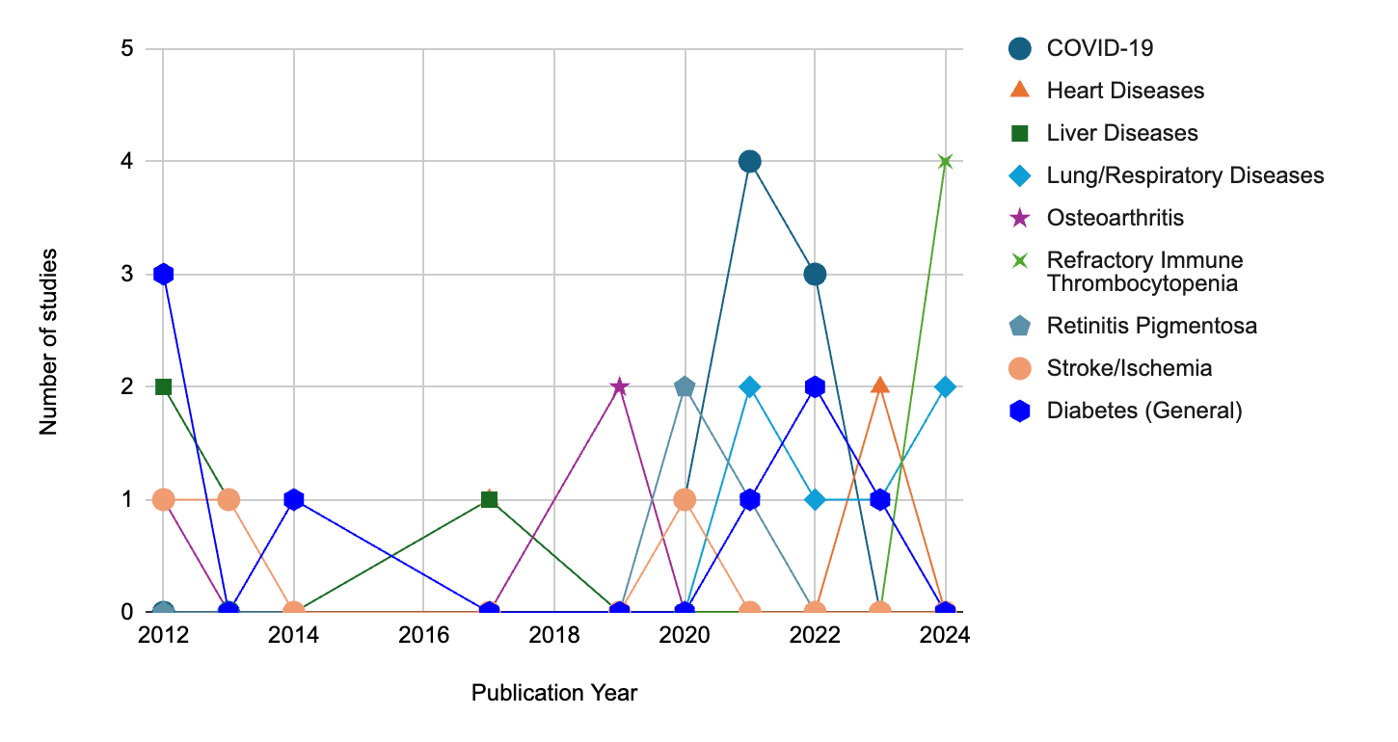
Figure 4.8. Clinical research trend
When it comes to clinical research trends, data analysis shown in Figure 4.8 reveals that the dominant transient group consists of COVID-19, with 8 included studies, and other respiratory diseases with 6 trials. The predominance of UC-MSC trials in COVID-19 exploded in the period of 2020 – 2022. This underscores the remarkable flexibility of UC-MSCs. As the pandemic erupted, clinical research priorities were refocused on acute anti-inflammatory therapy. Six studies of other respiratory diseases were scattered but increased after the COVID-19 pandemic, from 2021 to 2024. This surge in research may be attributed to the reported efficacy of UC-MSC therapy in COVID-19 patients, coupled with promising results from preclinical animal models. Furthermore, the rising prevalence of post-COVID complications has intensified the research focus and led to more frequent clinical trials for this disease group. The stable group includes classic chronic diseases like diabetes type 1 & 2 diabetes, liver diseases, and heart diseases, with 4-5 studies each during the years. While lacking the surge in research numbers, these diseases have sustained a steady study presence over the years. Next, the least common group is formed by osteoarthritis, stroke, and retinitis pigmentosa, with 2-3 studies each disease, distributed between 2012 and 2019. The year 2024 witnessed the emergence of research into refractory immune thrombocytopenia. This suggests a key marker of a new research direction. As research into common diseases reaches saturation, the clinical focus is shifting toward rare or refractory diseases.
When comparing to animal research trends, the period of 2010-2014 witnessed a synchronization in trend. Both animal studies and clinical trials exhibit a positively correlated growth trend. During this “hype phase” of UC-MSC therapy, overly optimistic early findings drove a dual-track research approach. Scientists moved forward with both intensive murine models and clinical trials in an effort to stay ahead of the curve. The 2015–2020 period was a time of divergence; while preclinical studies surged across a diverse range of pathologies, clinical trials experienced a notable stagnation. This trend is likely caused by rigorous regulatory oversight concerning the safety of biological therapies. Researchers were also required to wait for preclinical data to establish clear mechanisms of action and dosage standards, ensuring a solid scientific foundation prior to subsequent clinical phases. Inversion occurred between 2021 and 2025, depicted by the plateau of the number of preclinical studies and the explosion of human trials. This indicates that studies on murine models were saturated. The vast volume of data accumulated from animal studies over the previous decade (2010–2020) has reached a level of maturity sufficient to convince regulatory bodies (such as the FDA, EMA, and Ministry of Health) to authorize widespread human trials. The pandemic served as a “catalyst” that broke through regulatory barriers, accelerating the spread of clinical applications built upon a robust preclinical foundation.

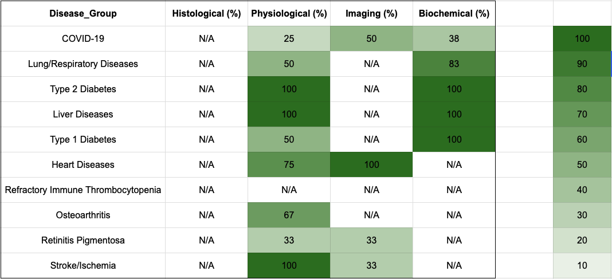
Figure 4.9. Efficacy of UC-MSCs therapy in clinical trials
Regarding the efficacy of UC-MSCs reported in clinical trials, similar to preclinical animal studies, the outcomes vary significantly across different pathologies, with reports of improvement, no improvement, and mixed results. This demonstrates that the findings from human trials remain highly inconsistent. Furthermore, a shift in efficacy endpoints is evident in human clinical trials. Rather than relying on rigid parameters such as histological improvement, constraints regarding invasiveness and biopsy procedures in patients have led to the adoption of indirect criteria. These encompass improvements in physiological functions, imaging findings, and laboratory-based biochemical assays. Consistent with the overall findings from animal studies, UC-MSCs demonstrated clinical improvement across most pathologies, with reported efficacy rates ranging from 25% to 100%. As illustrated in Figure 4.9, conditions that respond favorably to UC-MSC therapy include type 2 diabetes, liver diseases, and cardiovascular/ cerebrovascular disorders such as stroke; these are represented by emerald-colored cells, indicating that 100% of the studies reported efficacy in at least one evaluation criterion. Both liver disease and type 2 diabetes exhibited a 100% reported efficacy rate across all analyzed trials. For cardiovascular diseases, 100% success was restricted to imaging-based improvements, whereas in stroke cases, UC-MSCs consistently led to improved neurological outcomes in 100% of reports. However, 25% of trials indicated a failure to improve cardiovascular function, and 66.7% showed no significant changes in CT/MRI scans related to cerebrovascular lesions. In respiratory diseases, results exhibit significant discrepancies across multiple studies. Only approximately 25 - 80% of trials reported that UC-MSCs yielded positive outcomes across various evaluation criteria. Regarding osteoarthritis, two - thirds of the trials reported improvements in knee joint function post -treatment.
These results differ slightly from the pathologies where UC-MSCs exhibited high potential in animal models. In preclinical studies, as analyzed previously, neurological, pulmonary, renal, and hepatopancreatic diseases showed high percentages of reported improvement. For human subjects, although neurological, cardiovascular, and hepatic indications show similar promise, type 2 diabetes is notably added to this cluster. Conversely, pulmonary disease outcomes continue to show heterogeneity in clinical trials.
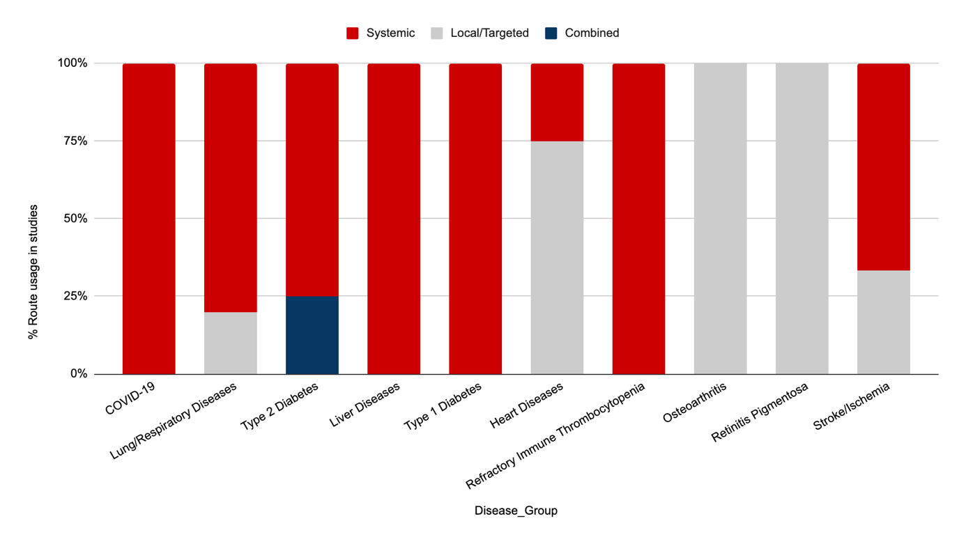
Figure 4.10. Delivery mode distribution in clinical trials
In terms of delivery modes, as shown in Figure 4.10, in human subjects, the dominance of the systemic vascular route is easily recognized even in localized abnormalities like stroke, retinitis pigmentosa, and respiratory illnesses. This dominance is similar to those findings in animal route distribution shown in Figure 4.7. For osteoarthritis, 100% of studies used the intra-articular route, similar to the major route utilized in animal models. In the treatment of heart diseases, except for the intravenous mode used in heart failure, in myocardial infarction, 100% of the studies utilized direct intracoronary injection. Furthermore, a pioneering study by Xuebin Liu [58] and colleagues integrated dual delivery routes - systemic intravenous and local pancreatic injection - resulting in significant improvements in both blood glucose levels and pancreatic islet beta-cell function tests. Understandably, the targeted-tissue route is limited due to its invasiveness and technological restrictions, and systemic vascular remains a major mode of UC-MSC delivery into patient bodies.

RECOMMENDATION AND CONCLUSION

Recommendations
Table 5.1. Proposed recommendations for future researchs in Vietnam
Evidence-based recommendations for UC-MSC research in Vietnam
Based on systematic analysis of manufacturing, preclinical, and clinical data (2006–2025)
CLUSTER 1  Manufacturing standardization  & reporting transparency | CLUSTER 2  Safety - centric &  GMP-aligned mindset | CLUSTER 3  Targeted clinical development  & delivery innovation
[1] Establish a national regulatory framework mandating standardized QC protocols for UC-MSC manufacturing | [1] Make biosafety assays mandatory in all domestic studies: sterility, endotoxin, mycoplasma, karyotype | [1] Prioritize high-efficacy indications: type 2 diabetes, hepatic diseases, and neurological disorders
[2] Require full disclosure of critical production parameters: basal medium, supplements, and passage. | [2] Transition from "academic/discovery mindset" to "manufacturing mindset" in preclinical research | [2] Expand research into rare or refractory conditions (e.g., immune thrombocytopenia)
[3] Develop clinical disclosure mechanisms for commercial products without compromising intellectual property | [3] Align with international GMP standards (FDA, EMA) for biological contaminant control | [3] Investigate targeted-tissue and dual-delivery routes for localized disease indications
Evidence - based: 68 studies (23 preclinical + 45 clinical trials) + 9 registered trials | Period: 2006–2025 | PRISMA 2020 compliant [55]

Based on the comprehensive analysis of manufacturing gaps and therapeutic trends, the following recommendations, which are summarized in Table 5.1, are proposed to enhance the quality and clinical translation of UC-MSC research in Vietnam:
- Standardization of manufacturing protocols and reporting transparency
- Establishment of a national regulatory framework: It is imperative to develop a national guideline for UC-MSC manufacturing and QC reporting to eliminate the persistent “black box” phenomenon in preclinical and clinical research.
- Mandatory transparency in production parameters: Research entities must ensure full disclosure of critical manufacturing parameters, including basal media, primary supplements, and cell passage limits, to guarantee scientific reproducibility.
- Clinical disclosure mechanisms: For trials utilizing commercial products, mechanisms should be established to facilitate the disclosure of essential technical specifications without compromising intellectual property rights.
- Strategic shift towards safety-centric and GMP-aligned mindsets
- Prioritization of biosafety indicators: There is a critical need to transition from a discovery-focused approach to a manufacturing-oriented mindset by making safety assays - specifically sterility, endotoxin, mycoplasma, and karyotype analysis - mandatory for all domestic studies.
- Adherence to international GMP standards: Adopting stringent regulatory requirements, such as those from the FDA or EMA, is essential to ensure the compulsory control of biological contaminants during the cell expansion phase.
- Targeted clinical development and innovative administration routes
- Focus on high - potential indications: Clinical resources should be prioritized for pathologies that have demonstrated consistent cross-domain success, notably type 2 diabetes, hepatic diseases, and neurological disorders.
- Strategic exploration of rare diseases: As research into common diseases reaches saturation, the focus should expand toward rare or refractory conditions, such as refractory immune thrombocytopenia, to stay aligned with global biomedical trends.
- Diversification of delivery modes: While systemic vascular delivery remains the primary mode, further research is recommended into targeted-tissue routes or dual-delivery strategies to optimize therapeutic outcomes for localized anomalies.

Summary and concluding remarks
This research provides a comprehensive analysis of the current landscape of UC-MSC manufacturing and therapeutic trends, leading to several pivotal conclusions:
- First, there is a major problem with the so-called “black box” in cell manufacturing. Researchers keep skipping over key details - over 60% of preclinical studies failed to report what basal media or supplements were used. That opacity shows up in both preclinical and clinical research, and it makes it almost impossible for others to reproduce.
- Second, evolutionary shifts are observed in research trends. A distinct transition was observed from a synchronized growth phase (2010 - 2014) to a recent “clinical inversion” (2021–2025), where human trials exploded in volume while preclinical output plateaued. Besides classic chronic diseases like diabetes, liver diseases, cardiovascular and cerebrovascular diseases, there is a new shift toward rare and refractory illnesses.
- Third, the UC-MSC therapy field itself is changing. Early on, between 2010 and 2014, research activity in preclinical and clinical trials moved in sync, building momentum together. Lately, though, that balance has flipped. Since 2021, clinical trials have surged while preclinical work has leveled off. Researchers were not just focused on the usual suspects like diabetes, liver disease, and cardiovascular conditions anymore, either. Now, there is a clear push toward tackling rare and stubborn illnesses - an important shift in where this science is heading.
- In addition, therapeutic efficacy and promising indications of UC-MSCs are evident. UC-MSCs stand out for their solid therapeutic effects, particularly in hepatic diseases, type 2 diabetes, and neurological disorders, where scientists observed high rates of improvement in four fields, from structure to physical function and lab findings.
- When it comes to regulation and safety, clinical trials tend to stick to stricter quality control than preclinical studies. Still, reporting is all over the place, shaped more by each research group than by any clear national standard. In the end, if Vietnam wants UC-MSC therapy to move beyond the lab and become a real part of clinical practice, the whole process needs a shift. The focus has to move from viewing this as just academic research to treating it like manufacturing - every step, from the lab bench to the clinic, must follow GMP-level safety and standardization.

Limitations of the research
A major obstacle in the field is the persistent issue of reporting asymmetry. Many published studies are frustratingly opaque, treating their experimental methods almost like trade secrets rather than scientific protocols to be shared and scrutinized. Essential details - such as the exact media formulations used in experiments - are often omitted or hidden behind vague descriptions. This lack of transparency makes it extremely challenging, if not impossible, for other researchers to replicate findings or to draw clear, causal relationships between specific experimental variables and observed clinical outcomes. Without a full picture of what was actually done in each study, efforts to synthesize knowledge or advance the field are severely hampered.
Complicating matters further is the inconsistency in the data itself. Across studies, there is little standardization: dosages can vary dramatically from one experiment to the next, methods of administration may shift without clear rationale, and outcome measures are often defined idiosyncratically. Each research team seems to develop its own set of parameters and assessment tools, making direct comparisons difficult. This patchwork approach leads to datasets that are heterogeneous and incompatible, which in turn renders traditional meta-analytic techniques largely ineffective. Consequently, the scientific community struggles not only with interpreting individual studies, but also with forming a cohesive and reliable body of evidence that can guide practice and inform future research. These systemic issues highlight the urgent need for more rigorous reporting standards and greater methodological harmonization across studies.The prevalence of the “black box” in published literature prevented a detailed correlational analysis between specific media formulations and clinical outcomes.
Geographic and language barriers shaped this review. Even though the author pulled from the main databases, this work might have missed important trials - especially those published in languages other than English or tucked away in private company records.
Clinical trials often steer clear of biopsies because they’re invasive, so researchers turn to indirect measures like imaging or physiological markers instead of the strict histological benchmarks used in preclinical studies. This shift in endpoints makes it harder to directly compare how effective treatments really are across different settings.
REFERENCES
1. El-Kadiry, A.E.-H., M. Rafei, and R. Shammaa, Cell Therapy: Types, Regulation, and Clinical Benefits. Frontiers in Medicine, 2021. Volume 8 - 2021.
2. Ullah, I., Raghavendra B. Subbarao, and Gyu J. Rho, Human mesenchymal stem cells - current trends and future prospective. Bioscience Reports, 2015. 35(2).
3. Ryan, J.M., et al., Mesenchymal stem cells avoid allogeneic rejection. Journal of Inflammation, 2005. 2(1): p. 8.
4. Harrell, C.R., et al., Molecular Mechanisms Responsible for Therapeutic Potential of Mesenchymal Stem Cell-Derived Secretome. Cells, 2019. 8(5).
5. Jin, H.J., et al., Comparative Analysis of Human Mesenchymal Stem Cells from Bone Marrow, Adipose Tissue, and Umbilical Cord Blood as Sources of Cell Therapy. International Journal of Molecular Sciences, 2013. 14(9): p. 17986-18001.
6. Garzon, I., et al., Expanded Differentiation Capability of Human Wharton's Jelly Stem Cells Toward Pluripotency: A Systematic Review. Tissue Eng Part B Rev, 2020. 26(4): p. 301-312.
7. Nagamura-Inoue, T. and H. He, Umbilical cord-derived mesenchymal stem cells: Their advantages and potential clinical utility. World J Stem Cells, 2014. 6(2): p. 195-202.
8. Dominici, M., et al., Minimal criteria for defining multipotent mesenchymal stromal cells. The International Society for Cellular Therapy position statement. Cytotherapy, 2006. 8(4): p. 315-7.
9. Liu, M., F. Yang, and Y. Xu, Global Trends of Stem Cell Precision Medicine Research (2018–2022): A Bibliometric Analysis. Frontiers in Surgery, 2022. Volume 9 - 2022.
10. Chetty, S., et al., Umbilical cord mesenchymal stromal cells—from bench to bedside. Frontiers in Cell and Developmental Biology, 2022. Volume 10 - 2022.
11. Aabling, R.R., et al., A Narrative Review on Manufacturing Methods Employed in the Production of Mesenchymal Stromal Cells for Knee Osteoarthritis Therapy. Biomedicines, 2025. 13(2): p. 509.
12. Laroye, C., et al., Mesenchymal Stem/Stromal Cell Production Compliant with Good Manufacturing Practice: Comparison between Bone Marrow, the Gold Standard Adult Source, and Wharton's Jelly, an Extraembryonic Source. J Clin Med, 2019. 8(12).
13. Chamberlain, J.S. Bridging the Gap: Why Translational Research is Key to Unlocking Cell & Gene Therapy Innovation. 2024 [cited 2025 Sep 23]; Available from: https://www.asgct.org/publications/news/july-2024/translational-research-key-to-unlocking-cell-gene.
14. Flenady, T., et al., Research capacity-building for clinicians: understanding how the research facilitator role fosters clinicians’ engagement in the research process. Health Research Policy and Systems, 2022. 20(1): p. 45.
15. Martin, I., et al., Editorial: Clinical Translation and Commercialisation of Advanced Therapy Medicinal Products. Frontiers in Bioengineering and Biotechnology, 2020. Volume 8 - 2020.
16. Negre, O. Translational Science. 2023 [cited 2025 Sep 23]; Available from: https://www.eurogct.org/research-pathways/research-and-innovation/translational-science?
17. Campbell, A., et al., Concise Review: Process Development Considerations for Cell Therapy. Stem Cells Translational Medicine, 2015. 4(10): p. 1155-1163.
18. Hoang, D.M., et al., Stem cell-based therapy for human diseases. Signal Transduction and Targeted Therapy, 2022. 7(1): p. 272.
19. Monsarrat, P., et al., Spatial and temporal structure of the clinical research based on mesenchymal stromal cells: A network analysis. Cytotherapy, 2017. 19(1): p. 47-60.
20. Chen, X., et al., Transplantation of three mesenchymal stem cells for knee osteoarthritis, which cell and type are more beneficial? a systematic review and network meta-analysis. Journal of Orthopaedic Surgery and Research, 2024. 19(1): p. 366.
21. Diotallevi, F., et al., Mesenchymal Stem Cells and Psoriasis: Systematic Review. International Journal of Molecular Sciences, 2022. 23(23): p. 15080.
22. Dhillon, J., et al., Umbilical Cord–Derived Stem Cells for the Treatment of Knee Osteoarthritis: A Systematic Review. Orthopaedic Journal of Sports Medicine, 2022. 10(7): p. 23259671221104409.
23. Riggle, C., et al., Complications of Stem Cell–Based Injections for Knee Osteoarthritis: A Systematic Review. HSS Journal®, 2025. 21(4): p. 476-484.
24. Yang, C.W., et al., Efficacy of umbilical cord mesenchymal stromal cells for COVID-19: A systematic review and meta-analysis. Front Immunol, 2022. 13: p. 923286.
25. Taufiq, H., et al., Systematic review and meta-analysis of mesenchymal stromal/stem cells as strategical means for the treatment of COVID-19. Ther Adv Respir Dis, 2023. 17: p. 17534666231158276.
26. Koishybayeva, D., et al., Mesenchymal stem cell therapy for diabetes: An umbrella review. Tissue Cell, 2025. 96: p. 103043.
27. Xiao, Z., et al., Effects of the umbilical cord mesenchymal stem cells in the treatment of knee osteoarthritis: A systematic review and meta-analysis. Medicine (Baltimore), 2024. 103(46): p. e40490.
28. Alizadeh, S.D., et al., Human studies of the efficacy and safety of stem cells in the treatment of diabetic peripheral neuropathy: a systematic review and meta-analysis. Stem Cell Research & Therapy, 2024. 15(1): p. 442.
29. Wang, X., et al., Therapeutic prospect on umbilical cord mesenchymal stem cells in animal model with primary ovarian insufficiency: a meta-analysis. Front Med (Lausanne), 2023. 10: p. 1211070.
30. Xie, R.-h., et al., Effect of mesenchymal stromal cells transplantation on the outcomes of patients with knee osteoarthritis: A systematic review and meta-analysis. Journal of Orthopaedic Research, 2024. 42(4): p. 753-768.
31. Beese, S.E., et al., A systematic review and network meta-analysis of interventions to preserve insulin-secreting beta cell function in people newly diagnosed with type 1 diabetes: results from randomised controlled trials of immunomodulatory therapies. BMC Medicine, 2025. 23(1): p. 351.
32. Tang, X., H. Huang, and L. Hao, Decadal analysis of efficacy and safety profiles of mesenchymal stem cells from varied sources in knee osteoarthritis patients: A systematic review and network meta-analysis. Experimental Gerontology, 2024. 192: p. 112460.
33. Bojanic, C., et al., Human umbilical cord derived mesenchymal stem cells in peripheral nerve regeneration. World J Stem Cells, 2020. 12(4): p. 288-302.
34. Pawitan, J.A., et al., Towards Standardized Stem Cell Therapy in Type 2 Diabetes Mellitus: A Systematic Review. Curr Stem Cell Res Ther, 2018. 13(6): p. 476-488.
35. Cheng, F., et al., Mesenchymal Stem Cell Transplantation For Hepatitis B Virus-Related Acute-on-Chronic Liver Failure: A Systematic Review and Meta-Analysis. Curr Stem Cell Res Ther, 2023. 18(6): p. 834-842.
36. Wei, R., et al., Efficacy and Potential Mechanisms of Umbilical Cord-Derived Mesenchymal Stem Cells in the Treatment of Ischemic Stroke in Animal Models: A Meta-Analysis. CNS Neurosci Ther, 2025. 31(4): p. e70357.
37. Liu, J., Y. Yang, and Y. Qi, Efficacy of mesenchymal stromal cells in the treatment of type 1 diabetes: a systematic review. Cell Tissue Bank, 2024. 25(2): p. 663-676.
38. Karamini, A., et al., Therapeutic Potential of Mesenchymal Stromal Stem Cells in Rheumatoid Arthritis: a Systematic Review of In Vivo Studies. Stem Cell Rev Rep, 2020. 16(2): p. 276-287.
39. Peng, W., et al., Systematic review and meta-analysis of efficacy of mesenchymal stem cells on locomotor recovery in animal models of traumatic brain injury. Stem Cell Res Ther, 2015. 6(1): p. 47.
40. Abouzid, M.R., et al., The Safety and Efficacy of Human Umbilical Cord-Derived Mesenchymal Stem Cells in Patients With Heart Failure and Myocardial Infarction: A Meta-Analysis of Clinical Trials. Cureus, 2023. 15(11): p. e49645.
41. Uwishema, O., et al., Stem cell therapy use in patients with dementia: a systematic review. Int J Emerg Med, 2025. 18(1): p. 95.
42. Wang, J., et al., Research Status of the Safety and Efficacy of Mesenchymal Stem Cells in the Treatment of COVID-19-Related Pneumonia: A Systematic Review and Meta-Analysis. Stem Cells Dev, 2021. 30(19): p. 947-969.
43. Sourugeon, Y., et al., Cell-based therapies have disease-modifying effects on osteoarthritis in animal models: A systematic review by the ESSKA Orthobiologic Initiative. Part 3: Umbilical cord, placenta, and other sources for cell-based injectable therapies. Knee Surg Sports Traumatol Arthrosc, 2025. 33(5): p. 1695-1708.
44. Liu, Y., et al., The assessment of mesenchymal stem cells therapy in acute on chronic liver failure and chronic liver disease: a systematic review and meta-analysis of randomized controlled clinical trials. Stem Cell Res Ther, 2022. 13(1): p. 204.
45. Oloyo, A.K., M.A. Ambele, and M.S. Pepper, Contrasting Views on the Role of Mesenchymal Stromal/Stem Cells in Tumour Growth: A Systematic Review of Experimental Design. Adv Exp Med Biol, 2018. 1083: p. 103-124.
46. Azimi, A., et al., Stem cell therapy for locomotion recovery and neuropathic pain alleviation in spinal cord injury: an umbrella review and meta-analysis. Spinal Cord, 2025. 63(8): p. 393-409.
47. Bruschettini, M., A. Badura, and O. Romantsik, Stem cell-based interventions for the treatment of stroke in newborn infants. Cochrane Database Syst Rev, 2023. 11(11): p. Cd015582.
48. Liu, S., et al., A Comparative Study of Different Stem Cell Transplantation for Spinal Cord Injury: A Systematic Review and Network Meta-Analysis. World Neurosurg, 2022. 159: p. e232-e243.
49. Hum, C., et al., Efficacy and Safety of Umbilical Cord-Derived Mesenchymal Stromal Cell Therapy in Preclinical Models of Sepsis: A Systematic Review and Meta-analysis. Stem Cells Transl Med, 2024. 13(4): p. 346-361.
50. Dang, L.T.-T., Bui, A. N.-T., Nguyen, C. L.-T., Truong, N. C., Bui, A. T.-V., Le, P. T.-B., & Phan, N. K. , Xenotransplantation of human umbilical cord derived stem cells for treatment of type 1 diabetes mellitus in mice. Biomedical Research and Therapy, 2016. 3(12): p. 16.
51. Dinh, N.T.-H., et al., Assessment of the safety of hypoxia-primed mesenchymal stem cells derived from umbilical cord and adipose tissues in animals. Scientific Reports, 2025. 15(1): p. 36055.
52. Le Thi Bich, P., et al., Allogeneic umbilical cord-derived mesenchymal stem cell transplantation for treating chronic obstructive pulmonary disease: a pilot clinical study. Stem Cell Research & Therapy, 2020. 11(1): p. 60.
53. Nguyen, L.T., et al., Allogeneic administration of human umbilical cord-derived mesenchymal stem/stromal cells for bronchopulmonary dysplasia: preliminary outcomes in four Vietnamese infants. J Transl Med, 2020. 18(1): p. 398.
54. Hoang, D.M., et al., Clinical Study of Mesenchymal Stem/Stromal Cell Therapy for the Treatment of Frailty: A Proposed Experimental Design for Therapeutic and Mechanistic Investigation. J Gerontol A Biol Sci Med Sci, 2022. 77(7): p. 1287-1291.
55. Long, N.T., et al., Establishing a mesenchymal stem cell bank from umbilical cord tissue for cell therapy and initial application in the treatment of knee osteoarthritis at Tam Anh general hospital. Vietnam Journal of Biotechnology, 2024. 22(2): p. 197-211.
56. Page, M.J., et al., The PRISMA 2020 statement: an updated guideline for reporting systematic reviews. BMJ, 2021. 372: p. n71.
57. Campbell, M., et al., Synthesis without meta-analysis (SWiM) in systematic reviews: reporting guideline. BMJ, 2020. 368: p. l6890.
58. Liu, X., et al., A preliminary evaluation of efficacy and safety of Wharton's jelly mesenchymal stem cell transplantation in patients with type 2 diabetes mellitus. Stem Cell Res Ther, 2014. 5(2): p. 57.

Supervisor’s Confirmation

I hereby confirm that I have read and approved the student’s research proposal titled:
“Umbilical cord mesenchymal stem cells – Systematic review and recommendations for research in Vietnam”

Supervisor 1
Name: Assoc.Prof.Dr. Chu Dinh Toi

Signature:

Date:

Supervisor 2
Name: Dr. Nguyen Thi Bich Loan

Signature:

Date:

