Vietnam National University, Hanoi
International School
============

Master Thesis

EVALUATION OF PARACLINICAL CHARACTERISTICS AND RELATED FACTORS IN OVARIAN CANCER PATIENTS WITH HIGH AND LOW MUTATION RISK IN VIETNAM
NGO ANH DAO

Field: BIOMEDICAL ENGINEERING TECHNOLOGY
Code: 84290.01QTD

Hanoi - 2026
Vietnam National University, Hanoi
International School
============
Master Thesis

EVALUATION OF PARACLINICAL CHARACTERISTICS AND RELATED FACTORS IN OVARIAN CANCER PATIENTS WITH HIGH AND LOW MUTATION RISK IN VIETNAM

NGO ANH DAO

Field: BIOMEDICAL ENGINEERING TECHNOLOGY
Code: 84290.01QTD

Supervisor: Dr. M.D. Pham Gia Anh
Assoc. Prof. Dr. Chu Dinh Toi

Hanoi - 2026

CERTIFICATE OF ORIGINALITY
I, the undersigned, hereby certify my authority of the study project report entitled “EVALUATION OF PARACLINICAL CHARACTERISTICS AND RELATED FACTORS IN OVARIAN CANCER PATIENTS WITH HIGH AND LOW MUTATION RISK IN VIETNAM”, under the supervision of Assoc. Prof. Chu Dinh Toi and Dr. Pham Gia Anh submitted in partial fulfillment of the requirements for the Master's degree in Biomedical Engineering Technology. Except where the reference is indicated, no other person’s work has been used without due acknowledgement in the text of the thesis.
Hanoi, 2026

Ngo Anh Dao
Approved by
SUPERVISOR 1 SUPERVISOR 2

Dr. M.D. Pham Gia Anh Assoc. Prof. Dr. Chu Dinh Toi
Date:……………………

ACKNOWLEDGEMENTS
First and foremost, I would like to express my sincere and profound gratitude to the Board of Rectors, the Office of Academic Affairs, Faculty of Applied Science and all faculty members involved in teaching the Master’s program in Biomedical Engineering Technology at the International School, Vietnam National University, Hanoi, for providing me with favorable conditions throughout my academic studies, research activities, and the completion of this thesis. The lecturers have accompanied and supported me by providing fundamental knowledge, enabling both myself and other students to establish clear scientific orientations and broaden our understanding of the biomedical and technological fields. This valuable knowledge has served as an essential foundation that allowed me to approach and conduct this research systematically and scientifically.
I would like to express my deepest and most sincere appreciation to Assoc. Prof. Chu Dinh Toi and Dr. Pham Gia Anh, my respected supervisors, who directly guided, oriented, and accompanied me throughout the entire process of conducting this thesis. Their dedication, scientific rigor, and invaluable comments not only contributed significantly to the completion of this thesis but also helped me develop scientific thinking, research methodology, and an independent working spirit. The professional guidance and timely encouragement provided by Assoc. Prof. Dr. Chu Dinh Toi and Dr. MD. Pham Gia Anh were a great source of motivation that enabled me to overcome numerous challenges during the research process.
I would also like to extend my sincere thanks to all members and collaborators of the Interdisciplinary Research Group on Biomedicine and Health, International School, Vietnam National University, Hanoi, for their support and assistance in collecting medical record data and performing data cleaning. In addition, I am deeply grateful to the physicians and administrative staff of the Oncology Department and the General Planning Department at Viet Duc University Hospital for their wholehearted support, guidance, and for creating the most favorable conditions to facilitate the collection of patient medical records during the course of this study.
Furthermore, I would like to gratefully acknowledge the Vingroup Innovation Foundation (VINIF) for providing me with a scholarship during my Master’s studies in Biomedical Engineering Technology and throughout the completion of this master’s thesis. The financial support from VINIF represents a significant recognition and encouragement for me in my academic and professional journey. This thesis by Ngo Anh Dao was funded by the Master’s and PhD Scholarship Programme of Vingroup Innovation Foundation (VINIF), code VINIF.2024.ThS.47.
Finally, I would like to express my deepest gratitude to my family—who have always stood by my side, cared for me, and provided the most favorable conditions for me to pursue academic knowledge and scientific research with peace of mind. The understanding, sharing, and unconditional support from my parents, siblings, and family members have been a solid foundation that enabled me to complete this thesis.
Although every effort has been made to incorporate constructive feedback and improve the quality of this thesis, certain limitations are unavoidable. I sincerely look forward to receiving understanding and valuable comments from the members of the thesis evaluation committee and fellow researchers so that this work may be further improved in future studies.
Sincerely,
Ngo Anh Dao

ABSTRACT
Ovarian cancer is one of the most dangerous gynecological diseases in women, not only causing death but also affecting female fertility. Many studies have shown that the BRCA gene is closely related to the risk of ovarian cancer, and those with family members who have the disease, carry the gene mutation, or develop the disease at a young age have a higher risk of carrying this gene mutation. BRCA gene mutations are known to impair the ability to repair genetic material, leading to an increased risk of common and potentially life-threatening cancers. Therefore, classifying ovarian cancer patients with this gene mutation is crucial in treatment protocols to improve treatment effectiveness and patient quality of life. Currently, there are no studies worldwide or in Vietnam examining the relationship between paraclinical indicators and the likelihood of carrying a gene mutation in ovarian cancer patients. While paraclinical characteristics are diverse and objectively reflect a part of a patient's health status or treatment response, this relationship remains unexplored. Therefore, this retrospective cross-sectional study was conducted to compare the paraclinical characteristics between a group of ovarian cancer patients with a high risk of carrying gene mutations and a group of patients with a low risk of carrying gene mutations. In addition, the study also aimed to analyze factors that may be associated with the likelihood of carrying gene mutations in ovarian cancer patients. With 223 patient records obtained from tertiary cancer treatment hospitals, the study showed that the paraclinical characteristics of ovarian cancer patients were mostly within normal values. Several clinical indicators, such as red blood cell count, MCH, %LYM, MPV, fibrinogen determination, creatine, glucose, SGOT and SGPT, urea, albumin, and cancer markers CA125 and HE4 showed statistically significant differences between the group of ovarian cancer patients with a high risk of gene mutations and the group of patients with a low risk of gene mutations. Through univariate logistic regression analysis, red blood cell count, MCH, %LYM, urea, and albumin were identified as potentially related subclinical indicators associated with the ability to classify ovarian cancer patients as carriers of gene mutations. However, after adjustment using multivariate logistic regression, only two indicators, MCH and albumin, remained independently associated with the risk of carrying gene mutations in ovarian cancer patients.

LIST OF ABBREVIATIONS
Abbreviation | Definition
BRCA 1/2 | The BReast CAncer 1/2 gene mutation
CA125 | Cancer antigen 125
95% CI | 95% confidence interval
BMI | Body mass index
DNA | Deoxyribonucleic Acid
HDI | Human development index
FIGO | International Federation of Gynecology and  Obstetrics
HE4 | Human epididymis secretory protein 4
OR | Odds ratio
PARP | Polyadenosine diphosphate ribose polymerase
WHO | World Health Organization

LIST OF TABLES

Table 2.1. Differences in the prevalence of ovarian cancer patients carrying BRCA1/2 mutations across countries and ethnic groups. 12
Table 2.2. Clinical and para-clinical features are often of interest in patients with ovarian cancer 17
Table 2.3. Several BRCA testing strategies according to international guidelines. 28
Table 4.1. Characteristics of ovarian cancer patients 37
Table 4.3. Blood clotting test results between high-risk and low-risk patient groups carrying the gene mutation. 44
Table 4.2. Para-clinical characteristics of patients at high/low risk of carrying BRCA gene mutations 46
Table 4.4. Paraclinical characteristics associated with the likelihood of gene mutations in ovarian cancer patients 48
Table 4.5. Multivariate regression analysis of paraclinical indicators and gene mutation likelihood in ovarian patient groups 49

LIST OF FIGURES
Figure 1.1. Classification of ovarian cancer based on histology 1
Figure 1.2. Stages of ovarian cancer progression in women (Amer et al., 2025) 3
Figure 1.3. The prevalence of ovarian cancer by age group in the United States population over 4 years (Florczak, Królikowska, Mazurek, Woźniak, & Domagala, 2025). 4
Figure 2.1. An overview of ovarian cancer incidence rates in different regions. 7
Figure 2.2. Illustrating common types of ovarian carcinoma. 9
Figure 2.3. Images of mixed germ cell ovarian cancer cells observed under a microscope. 10
Figure 2.4. Images of genital cord tumors were stained and observed under a microscope. 11
Figure 2.5. Distribution of BRCA1/2 prevalence in ovarian cancer patients across several study populations. 13
Figure 2.6. Mechanism of action of PARP inhibitors in ovarian cancer cells carrying BRCA mutations. 15
Figure 2.7. The BRCA genes repair DNA damage 19
Figure 2.8. Some characteristics and classifications of ovarian cancer. 21
Figure 2.9. Several machines are used in para-clinical diagnosis. 23
Figure 2.10. Total blood cell analysis test result. 25
Figure 2.11. Blood coagulation test results and blood biochemistry test results. 26
Figure 2.12. Test results of some common cancer markers. 27
Figure 2.13. Several factors increase a woman's risk of developing ovarian cancer. 30
Figure 4.1. Proportion of patients at high/low risk of carrying gene mutations 39
Figure 4.2. Comparison of several blood biochemical parameters between high-risk and low-risk ovarian cancer patients carrying BRCA gene mutations. 45
Figure 4.3. Comparison of mean values ​​of electrolyte parameters between two groups of ovarian cancer patients. 46
TABLE OF CONTENTS
CERTIFICATE OF ORIGINALITY i
ACKNOWLEDGEMENTS ii
ABSTRACT iv
LIST OF ABBREVIATIONS v
LIST OF TABLES vi
LIST OF FIGURES vii
Chapter 1. INTRODUCTION 1
1.1. Rationale 1
1.2. Objectives of the research 3
Chapter 2. LITERATURE REVIEW 6
2.1. Research in the world 6
2.1.1. The disease burden of ovarian cancer 6
2.1.2. Histopathological characteristics and subgrouping of ovarian cancer 7
2.1.3. The percentage of ovarian cancer patients carrying the BRCA gene mutation worldwide 11
2.1.4. BRCA mutations: therapeutic significance and paraclinical screening 14
2.2. Research in Vietnam 16
2.3. BRCA1/2 gene mutations and ovarian cancer 18
2.4. Overview of characteristics of ovarian cancer patients 20
2.4.1. Clinical characteristics of ovarian cancer patients 20
2.4.2. Paraclinical characteristics of ovarian cancer patients 22
2.5. Evaluation of patients at high risk of carrying BRCA gene mutations 27
2.5.1. Genetic testing strategies and screening guidelines worldwide 27
2.5.2. Evaluation of ovarian cancer patients at high risk of carrying the BRCA mutation 29
Chapter 3. RESEARCH METHODOLOGY 32
3.1. Research approaches 32
3.2. Population and sample 32
3.3. Research methods 34
Chapter 4. RESULTS AND DISCUSSION 36
4.1. General characteristics of ovarian cancer patients 36
4.2. Differences in paraclinical characteristics between high- and low-risk patient groups carrying gene mutations 40
4.3. Factors associated with a patient's likelihood of carrying a gene mutation 47
Chapter 5. CONCLUSION AND RECOMMENDATIONS 50
5.1. Recapitulation 50
5.2. Concluding remarks 51
5.3. Limitations of the research 52
5.3. Recommendations 53
REFERENCES

Chapter 1. INTRODUCTION

Rationale
Ovarian cancer is one of the most common types of female genital cancers, which can be divided into three main types: epithelial, stromal, and germ cell cancers, based on the origin of the tumor; of which serous carcinoma is the most frequent type (Gaona-Luviano, Medina-Gaona, & Magana-Perez, 2020) (Figure 1.1). One of the long-term consequences of ovarian cancer is infertility due to the removal of the ovaries. In addition, the increase in the number of patients and deaths related to ovarian cancer also has a great impact on the economy and human development in many countries, especially those in Africa (Cabasag et al., 2022; Hutchinson et al., 2025). Currently, there are many methods of treating ovarian cancer, such as surgery, chemotherapy, or radiotherapy. However, these methods demonstrate high efficiency in the early stages, but their ability to treat gradually decreases for advanced stages. Therefore, patients who are detected and treated at late stages often face higher treatment costs, and those of working age also have to pay a larger amount for treatment than those who do not have ovarian cancer (Chin, Hansen, & Carlson, 2020).
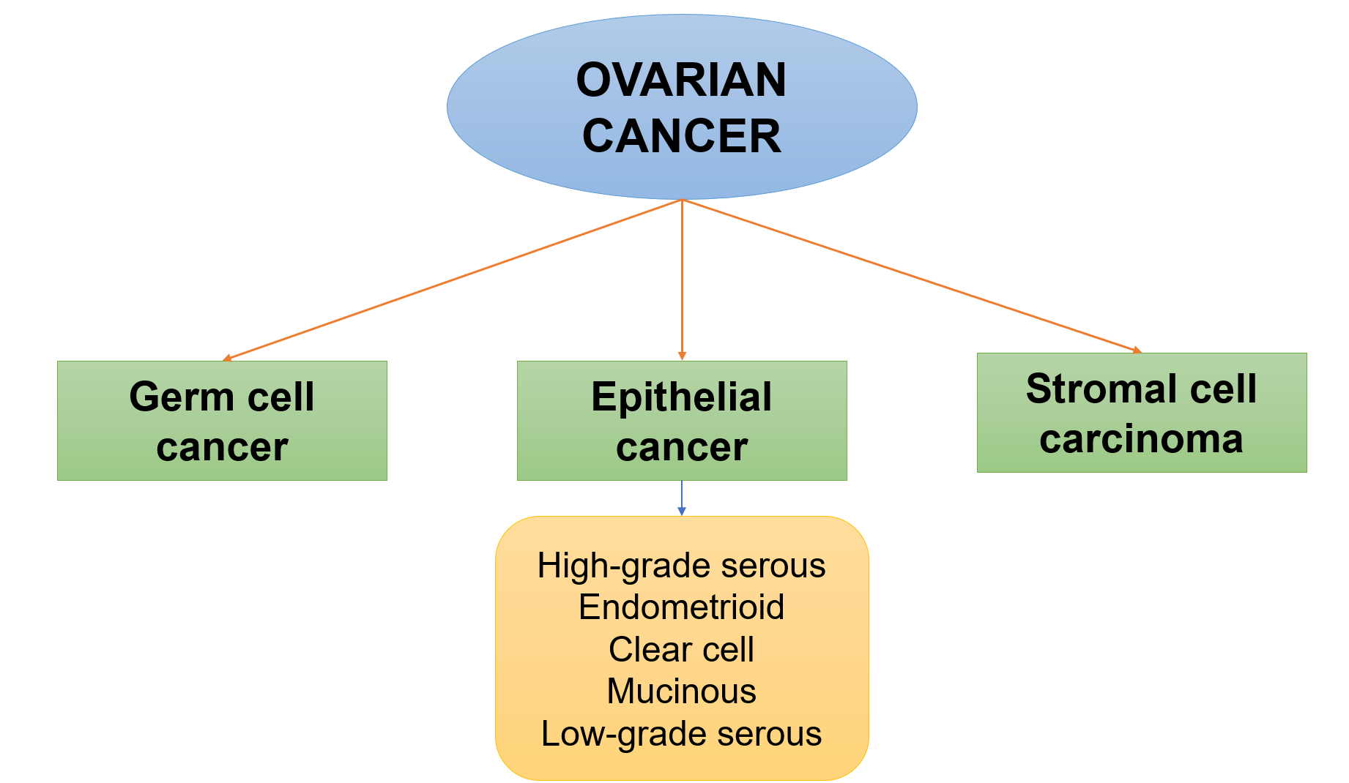
Figure 1.1. Classification of ovarian cancer based on histology
Patients with ovarian cancer are often detected at late stages, when the tumor has progressed, even metastasized, leading to many difficulties in care and treatment. Tumor detection markers commonly used in testing today include cancer antigen 125 (CA125) or human epididymis secretory protein 4 (HE4); however, these markers show low specificity for ovarian cancer. Therefore, in practice, doctors still need to combine marker test results with clinical, para-clinical, or ultrasound results to make the most accurate diagnosis (Zhang, Siu, Ngan, & Chan, 2022). In addition, current diagnostics cannot provide an assessment of the risk of carrying dangerous gene mutations in patients. The BReast CAncer 1/2 (BRCA1/2) gene mutation has been reported to worsen conditions in people with ovarian cancer (Birkbak et al., 2013). People with this gene mutation often show a lower 5-year survival rate and are more resistant to treatment. Therefore, we conducted the project "Evaluation of paraclinical characteristics and related factors in ovarian cancer patients with high and low mutation risk in Vietnam " with the hope of providing preliminary indicators to screen patients at risk of carrying the gene mutation. Therefore, the results from this topic can support doctors, medical staff, and patients in choosing appropriate treatment regimens, thereby increasing the effectiveness of medical examinations and treatments and reducing costs.
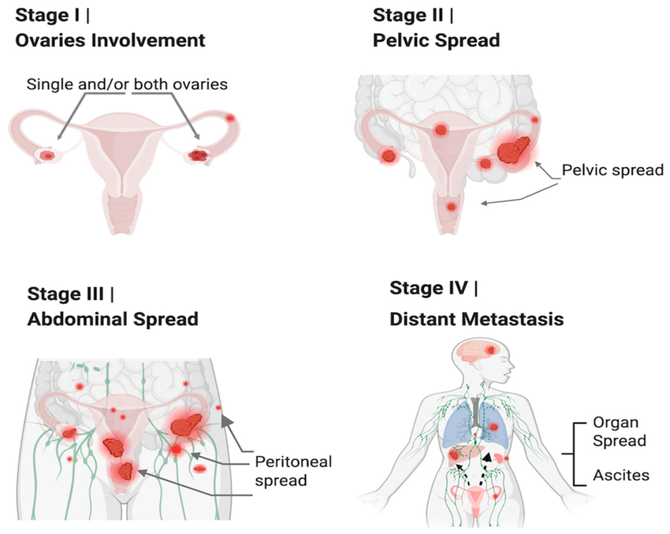
Figure 1.2. Stages of ovarian cancer progression in women (Amer et al., 2025)

Objectives of the research
Cancer is one of the most common diseases today. This is a condition in which cells divide uncontrollably, leading to compression of surrounding tissues and organs, impairing the function of the organs, and these cells can metastasize to other parts of the body (Krieghoff-Henning, Folkerts, Penzkofer, & Weg-Remers, 2017). According to the GLOBOCAN 2022 report, more than 20 million people are suffering from cancer, and approximately 9.7 million people are dying from cancer (Bray et al., 2024). For women, ovarian cancer is one of the cancers with high incidence and mortality rates, greatly affecting people's quality of life and socio-economics. Recent studies show that the mortality rate due to ovarian cancer is on the decline, but the number of incidents is increasing and occurring at younger ages, possibly due to the high rates of obesity and metabolic syndromes among women (Huang, Huang, Wang, Chung, & Wong, 2018; Z. Liu et al., 2015).
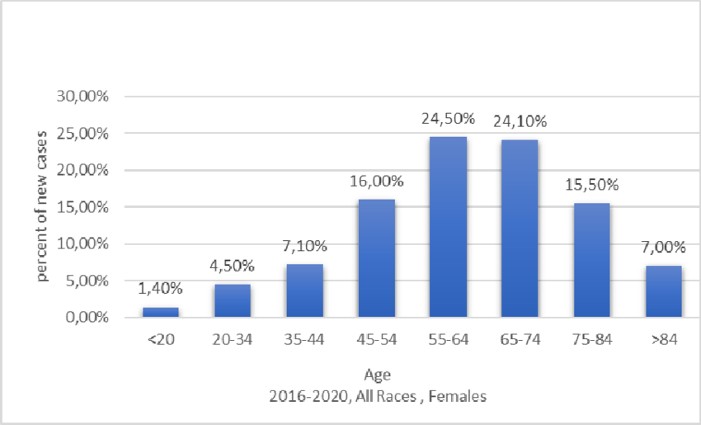
Figure 1.3. The prevalence of ovarian cancer by age group in the United States population over 4 years (Florczak, Królikowska, Mazurek, Woźniak, & Domagala, 2025).

One of the factors leading to this disease in women is the mutation of some special genes, such as BReast CAncer 1 (BRCA1) and BReast CAncer 2 (BRCA2). These genes play a role in repairing DNA damage during replication, and a deficiency in the BRCA1/2 genes can increase the risk of breast and ovarian cancer (Schoolmeester et al., 2017). Research by Toss et al. shows that detecting and identifying mutations in the BRCA1/2 genes plays an important role in assessing survival and disease progression in women with ovarian cancer (Toss et al., 2021). Early detection of individuals carrying BRCA gene variants before they develop cancer will greatly contribute to effective surveillance, prevention, and treatment strategies for this disease (Burke et al., 1997; Pujade-Lauraine et al., 2017). In addition, early detection and monitoring of people carrying the above gene mutations also help reduce the rate of disease progression and death in people with hereditary ovarian cancer (T. Liu et al., 2023).
Clinical guidelines around the world currently recommend genetic testing for cancer patients, including ovarian cancer, to suggest the most effective treatment regimens for each individual. However, due to financial and technological difficulties, genetic testing for ovarian cancer patients is not yet popular in hospitals in Vietnam.
Therefore, this study has great significance and is necessary to compare the para-clinical characteristics of patients with high/low risk of carrying BRCA gene mutations. Our research is expected to support doctors in diagnosing patients with a high probability of having gene mutations, thereby having the most appropriate treatment therapies.
As a result, we conducted the topic "Evaluation of paraclinical characteristics and related factors in ovarian cancer patients with high and low mutation risk in Vietnam " with the main objective of making initial recommendations on the para-clinical differentiation between the high-risk group of patients carrying the mutation and the lower-risk group. To achieve that general goal, this thesis aims for two main results:
- Describe the para-clinical characteristics of ovarian cancer patients in Hanoi, Vietnam.
- Compare the para-clinical characteristics between patients with high and low risk of BRCA1/2 gene mutations and related factors.

Chapter 2. LITERATURE REVIEW

Research in the world

The disease burden of ovarian cancer
Ovarian cancer is one of the most dangerous gynecological diseases, with a high risk of causing infertility and mortality in women (Cabasag et al., 2022). According to the GLOBOCAN 2022 report, ovarian cancer ranked 14th among cancers that cause death in women, with approximately 207,000 deaths and more than 324,000 new cases (Bray et al., 2024). This disease not only causes negative health consequences and shortens life expectancy but also significantly affects the quality of life and socio-economic development in countries (Figure 2.1). According to research by Brian and colleagues, ovarian cancer is expected to claim the lives of about 8 million women between 2022 and 2050 and lead to huge economic losses in many countries (Hutchinson et al., 2025). Accordingly, economic burden in countries without early screening and treatment measures can amount to tens of billions of dollars, along with a crisis in the health care system and a decline in the health of workers. Countries with high human development index (HDI) often show higher rates of gynecological diseases in young people but lower mortality rates than countries with a low HDI (Ceolotto et al., 2024). In addition, ovarian cancer also needs to be considered in adolescents, who will contribute greatly to the socio-economic development of countries. However, the disease burden of ovarian cancer is alarming and continues to increase globally, especially in countries with middle and low economic levels (Che & Yin, 2025). Therefore, governments and health systems in countries need to take measures to detect individuals who may have ovarian cancer early and treat them at the early stages to reduce the burden of this disease.
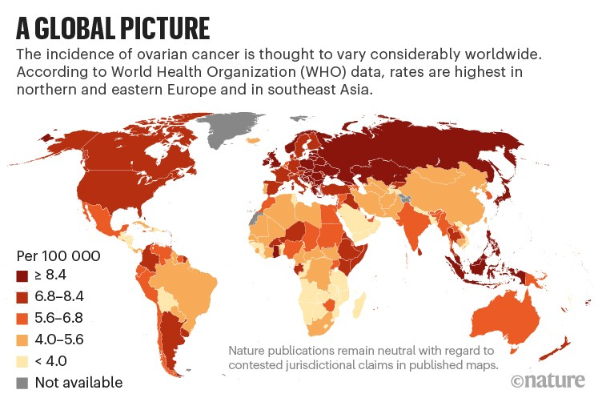
Figure 2.1. An overview of ovarian cancer incidence rates in different regions.
Overall, Southeast Asia, Northern and Eastern Europe have the highest rates of ovarian cancer in the world (2021) ((Fiscutean & Ashour, 2021).

Histopathological characteristics and subgrouping of ovarian cancer
Ovarian tumors are pathologies encompassing various histopathological types, differing in their cellular origin, molecular biological characteristics, and treatment responses. Histopathological classification plays a crucial role in diagnosis, prognosis, and the selection of optimal treatment strategies for patients. According to the updated WHO classification from 2020, malignant ovarian tumors are divided into three main groups: ovarian carcinoma, germ cell tumors, and stromal tumors (Hohn et al., 2021). Of these three main groups, carcinoma is the most common, with the highest incidence and mortality rates among ovarian cancers (Kurman & Shih Ie, 2016).
Ovarian carcinoma originates from the surface epithelium of the ovary, fallopian tube epithelium, or precancerous lesions in the fimbriae of the fallopian tubes. It is the most common type of ovarian cancer, often detected in middle-aged or older women. Based on morphological, immunohistochemical, and molecular biological characteristics, ovarian carcinoma is divided into major subgroups: high-grade serous carcinoma (HGSC), low-grade serous carcinoma (LGSC), mucinous carcinoma, endometrial carcinoma, and clear cell carcinoma (Zamwar & Anjankar, 2022). Of the main subtypes mentioned above, HGSC is the most common, accounting for approximately 70% of ovarian cancer cases, and has the worst prognosis. HGSC is characterized by high malignancy, a large mitotic index, and is often diagnosed at a late stage, and is strongly associated with abnormalities in DNA repair mechanisms, particularly BRCA1/2 mutations and homologous recombination deficiency (HRD) (Bowtell et al., 2015; Cancer Genome Atlas Research, 2011). On the other hand, the LGSC subgroup grows more slowly, is less sensitive to chemotherapy, but has a better prognosis than HGSC. Besides classifying ovarian carcinoma into the main subgroups mentioned above, many studies also use a classification system into Type I and Type II, based on carcinogenesis and molecular biological characteristics (Figure 2.2). Based on this classification, Type I includes LGSC, mucinous carcinoma, endometrial carcinoma, and clear cell carcinoma – slow-growing tumors, often arising from precancerous lesions, and with less genetic instability. Type II, typically HGSC, is characterized by high invasiveness, severe genetic instability, and is often associated with BRCA and p53 mutations (Koshiyama, Matsumura, & Konishi, 2014).

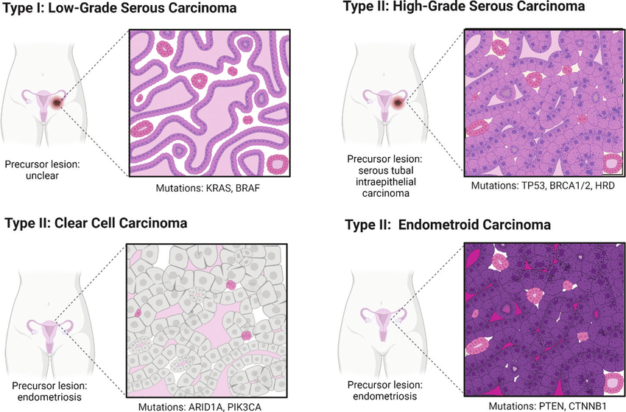
Figure 2.2. Illustrating common types of ovarian carcinoma. Epithelial ovarian carcinoma can be divided into two types based on the stage of disease progression and prognosis (Aviles, Warshal, Buchbinder, & Ostrovsky, 2022).

In contrast to epithelial ovarian cancer, germ cell ovarian tumors are a rarer group of cancers, accounting for approximately 5–10% of malignant ovarian tumors, and usually occur in young women and adolescents. Common types include malignant teratoma, yolk sac tumor, and embryonal carcinoma (Figure 2.3). This group has distinct biological characteristics, is often sensitive to chemotherapy, and has a relatively good prognosis if diagnosed and treated early (Gica et al., 2022).
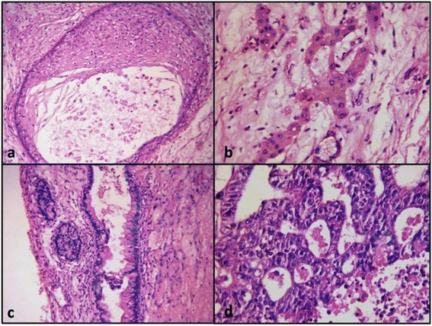
Figure 2.3. Images of mixed germ cell ovarian cancer cells observed under a microscope. Images a, b, c, and d respectively show the teratoma, mucinous epithelium, hepatocytes, and embryonic cancer, respectively ((Goyal, Kaur, & Kawatra, 2014).

Similar to germ cell tumors, cord-stromal tumors also account for a very low percentage of ovarian cancer patients, at around 5%. They originate from the supporting cells of the ovary, such as granulosa cells or Leydig cells. These tumors are often endocrine-active, manifesting as menstrual irregularities or increased estrogen production, and generally have a better prognosis than epithelial ovarian carcinoma (Schultz et al., 2016).
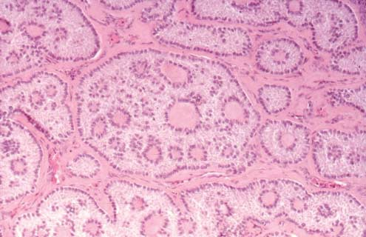
Figure 2.4. Images of genital cord tumors were stained and observed under a microscope. Image of gonadal cord tumor tissue from an ovarian cancer patient with characteristic ring-shaped ducts (Young, 2005).

The percentage of ovarian cancer patients carrying the BRCA gene mutation worldwide
BRCA1 and BRCA2 gene mutations are important genetic factors associated with the risk of ovarian cancer. Recent epidemiological studies on ovarian cancer patient populations in various countries have shown that the prevalence of BRCA1/2 mutations varies significantly between regions and histopathological types, reflecting the genetic diversity of the population and the study's sample selection criteria. A study on an Eastern European population reported that among 158 unselected ovarian carcinoma patients, 11.4% carried BRCA1 mutations and 4.4% carried BRCA2 mutations, for a total of approximately 15.8% of patients who carried at least one BRCA1/2 mutation (Jasiewicz et al., 2022). Similarly, another study in the high-grade non-mucinous carcinoma group noted that 18.37% of patients tested positive for BRCA1/2 mutations, with BRCA1 being the majority (6/49 cases) and BRCA2 accounting for the remainder (3/49) (Christianto & Ariani, 2025).
Table 2.1. Differences in the prevalence of ovarian cancer patients carrying BRCA1/2 mutations across countries and ethnic groups.
Statistical table comparing the number of ovarian cancer patients, the number of patients carrying BRCA1/BRCA2 gene mutations, and the percentage of patients carrying BRCA1/BRCA2 gene mutations in several notable countries (Sekine, Nishino, & Enomoto, 2021).
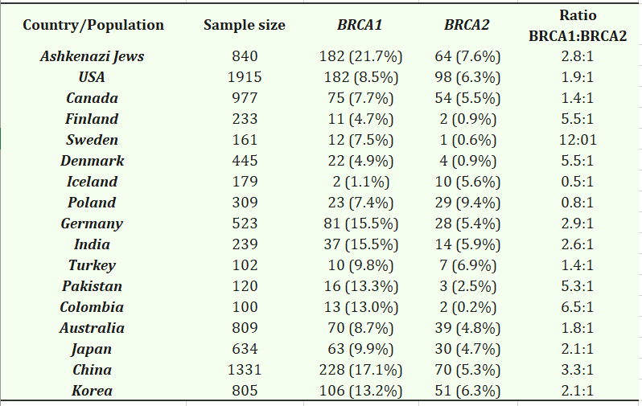
Furthermore, larger-scale epidemiological reports also show significant variability in the prevalence of BRCA1/2 mutations among ethnic groups and geographical regions. An updated international study for 2025 indicated that the prevalence of disease-causing BRCA1/2 variants in ovarian cancer patients is approximately 26.6%, with BRCA1 accounting for 20.8% and BRCA2 for 5.5% (Peng et al., 2025). Another study by De Matteis and colleagues using next-generation gene sequencing technology also showed that approximately 29.8% of patients carried BRCA1/2 mutations, with BRCA1 being more prevalent (75.8%) than BRCA2 among 319 ovarian cancer patients (De Matteis et al., 2024).
In contrast to the reports on the prevalence of gene mutations mentioned above, the prevalence of BRCA1/2 mutations appears to be significantly lower in some Asian populations. A study in a Thai population revealed that the total mutation rate (germline and somatic) was only about 8.7% in 138 ovarian cancer patients, with the strongest association between the mutation and high-grade serous carcinoma (Lertkhachonsuk et al., 2020). Differences in the proportion of ovarian cancer patients carrying gene mutations reflect differences in study samples, patient selection rates based on clinical criteria, and differences in population genetics. A study in South Korea also shared the same finding, noting that the prevalence of BRCA1/2 mutations in ovarian cancer patients varied widely from approximately 5% to over 30%, depending on the patient group and the testing method used (Paik et al., 2021).

Figure 2.5. Distribution of BRCA1/2 prevalence in ovarian cancer patients across several study populations.
These reports highlight the importance of understanding the prevalence and distribution of BRCA1/2 mutations across different patient populations to guide appropriate genetic screening and clinical intervention policies. In particular, high-grade serous carcinoma, the most common type of ovarian cancer, often has a higher BRCA mutation rate compared to other subgroups, emphasizing the role of genetic testing in personalized diagnostic and treatment approaches (Lanjouw et al., 2023).

BRCA mutations: therapeutic significance and paraclinical screening

BRCA1/2 gene mutations not only play a crucial role in the pathogenesis of ovarian cancer but also have profound therapeutic and prognostic implications, especially in the context of personalized medicine. Numerous international studies have demonstrated that ovarian cancer patients carrying BRCA1/2 mutations respond better to platinum-based chemotherapy and have longer overall survival (OS) and progression-free survival (PFS) compared to those without the mutation, particularly in HGSC patients (Lheureux, Gourley, Vergote, & Oza, 2019; Moore et al., 2018). Ovarian cancer cells with BRCA gene mutations are cells whose ability to repair double-strand breaks in DNA is inactivated. Therefore, these cancer cells become more sensitive to DNA-damaging agents, particularly platinum-containing chemotherapy drugs and PARP inhibitors (Figure 2.6) (Banerjee, Kaye, & Ashworth, 2010). Clinical trials have also shown positive signs in prolonging life in ovarian cancer patients carrying the gene mutation (Gonzalez-Martin et al., 2019; Ray-Coquard et al., 2023).
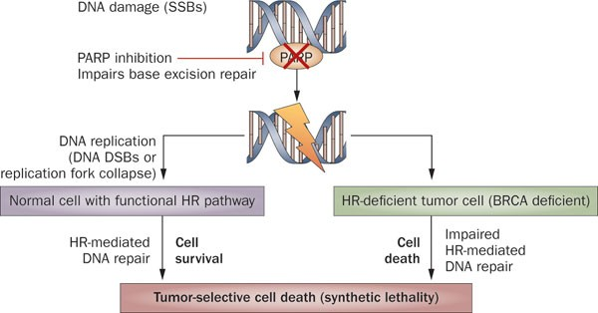
Figure 2.6. Mechanism of action of PARP inhibitors in ovarian cancer cells carrying BRCA mutations. The image illustrating the mechanism of PARP inactivation is taken from the report by Banerjee (Banerjee et al., 2010).

Although genetic testing is the gold standard for identifying BRCA mutations, its widespread adoption remains limited in many countries due to high costs, technical infrastructure, and healthcare resources. Therefore, recent studies worldwide are increasingly focusing on identifying clinical and paraclinical characteristics that may suggest a risk of carrying BRCA mutations, in order to support screening and prioritize genetic testing
Ovarian cancer patients often have different clinical and para-clinical characteristics depending on the stage of disease progression, genetic characteristics, and tumor origin, so there should be appropriate treatment regimens for each patient's characteristics (Biglia et al., 2016; Park et al., 2024; Yoshida, 2021). Many studies have indicated that patients with relatives who have breast cancer or ovarian cancer will have a high risk of carrying BRCA mutations and developing ovarian cancer (Kim et al., 2018; Sighinolfi et al., 2025). BRCA gene mutation characteristics have also been shown to be associated with survival and treatment efficacy with different chemotherapy regimens in ovarian cancer patients (Ji et al., 2021; Lau-Min, McCarthy, Nathanson, & Domchek, 2023). Current medical literature in the world encourages screening and testing for ovarian oncogene mutations to find optimal treatment methods for each patient (Bookman, Tyczynski, Espirito, Wilson, & Fernandes, 2017; Lanjouw et al., 2023; Tsibulak et al., 2018; Yuan et al., 2024). Previous studies have shown that there is a correlation between the clinical characteristics of ovarian cancer patients and the likelihood of carrying gene mutations such as BRCA1/2, and this information can be used to advise and prescribe early genetic testing for similar patients (Ferretti et al., 2024; Kwon et al., 2019; Norquist et al., 2013). However, studies on the association between para-clinical characteristics of ovarian cancer patients and the possibility of carrying BRCA gene mutations have not been comprehensively studied in many countries or regions. For that reason, further studies are needed to examine the correlation between patient characteristics and para-clinical index with the risk of carrying gene mutations.

Research in Vietnam
In Vietnam, ovarian cancer has recently emerged as a threat to reproductive health and a major disease burden in women. According to the World Health Organization report in 2022, the number of new cases and deaths from ovarian cancer is 1,534 and 1,003 cases, respectively, with 8.7 out of every 100,000 women suffering from this disease (Bray et al., 2024). This cancer is often detected at a late stage in stage III, IV ( the stage when cancer cells have metastasized to nearby lymph nodes, the abdomen, and other important organs such as the lungs and liver) because the initial symptoms are atypical, easily missed, and confused with other health problems (Phạm, Nguyễn, & Vũ, 2023; Trần, Võ, & Nguyễn, 2024).
Ovarian cancer can be caused by many factors, one of which is genetic defects. Some studies in Vietnam have shown that people with a family history of diseases such as ovarian cancer or breast cancer have a 27.3% risk of carrying a BRCA1 gene mutation, and 9.1% of people tested have a BRCA2 mutation (Le et al., 2022). Another study in 2022 showed that the frequency of carrying the BRCA gene mutation associated with hereditary breast and ovarian cancer syndrome in the Vietnamese population was 1.3%, and in those at high risk of related cancers was 4.3% (Nguyễn et al., 2022). Understanding the risk of gene mutations in patients contributes significantly to the development of personalized medicine, improving the effectiveness of diagnosis and treatment of ovarian cancer in the early stages (Đức, Khôi, Tú, Thịnh, & Quý, 2023; Marchetti et al., 2024).
However, genetic testing for all ovarian cancer patients in Vietnam faces many obstacles, especially in terms of economics. In Vietnam, there are currently no standards for screening patients at high risk of harboring BRCA gene mutations in ovarian cancer patients (Đức Long, Thị Anh Đào, & Quang Vinh, 2022). Studies evaluating clinical and paraclinical characteristics in Vietnam mainly only summarize and describe patient characteristics or histopathology without any connection with genetic factors (Linh et al., 2021) (Table 2.2). Studies in Vietnam have not specifically focused on the relationship between para-clinical characteristics in ovarian cancer patients and the possibility of carrying BRCA gene mutations, which helps save costs and increase the efficiency of gene mutation identification. In conclusion, para-clinical features will be a potential marker to help healthcare professionals identify early ovarian cancer patients at high risk of BRCA gene mutations.

Table 2.2. Clinical and para-clinical features are often of interest in patients with ovarian cancer
Classify | Common symptoms/Indications of interest
- Clinical characteristics
Functional symptoms | - Dull abdominal pain or pressure in the lower abdomen  - Bloating, flatulence  - Digestive disorders  - Frequent or difficult urination  - Menstrual disorders
Systemic symptoms | - Fatigue, unexplained weight loss  - Anorexia
Clinical examination | - Palpable pelvic mass  - Ascites (in late stages)
- Para-clinical characteristics
Cancer marker test/ Blood test | - CA125: elevated (especially in epithelial ovarian cancer)  - HE4 (incorporated in ROMA test)  - General tests: anemia, increased CRP
Diagnostic imaging | - Abdominal and vaginal ultrasound: detects ovarian tumors  - CT scan / MRI: assess extent of spread, lymph nodes, metastasis  - PET-CT (in some cases to evaluate distant metastases)
Histopathological test | - Biopsy of mass or ascites  - Determine histological type: epithelial, germ cell, stromal-gonadal
Stage Assessment | - Based on FIGO classification (I – IV), combining imaging, surgery and histology
Note: CA125 (Cancer Antigen 125): (tumor marker); HE4 (Human Epididymis Protein 4): specific indicator in diagnosing ovarian cancer; ROMA test (Risk of Ovarian Malignancy Algorithm test): a test index based on an algorithm that combines the results of CA125 and HE4 combined with the menstrual cycle to assess the risk of ovarian cancer; CRP (C-Reactive Protein): a non-specific inflammatory response protein; CT scan (Computed Tomography): computed tomography; MRI (Magnetic Resonance Imaging): electron resonance; PET-CT (Positron Emission Tomography – Computed Tomography): Combination of PET and CT scan; FIGO (International Federation of Gynecology and Obstetrics): gynecological cancer staging system.

BRCA1/2 gene mutations and ovarian cancer
BRCA1/2 are genes that play an important role in maintaining chromosome stability. Under normal functioning, BRCA1/2 plays a role in repairing DNA damage in the human body by fixing breaks in DNA molecules. Abnormal BRCA1/2 function, possibly due to mutations, impairs the cell's ability to repair genetic material, leading to the accumulation of mutations and the expression of disease phenotypes (Figure 2.7). Mutations of these genes can cause dangerous diseases such as breast cancer or ovarian cancer. With mutations detected in approximately 6-15% of ovarian cancer patients, abnormalities in BRCA1/2 gene activity are considered a very high-risk factor for ovarian cancer (Talwar & Rauthan, 2022). Several studies have shown that older women carrying BRCA1 or BRCA2 gene mutations have an 11 - 39% higher risk of developing ovarian cancer than those who do not have the mutation (Talwar & Rauthan, 2022). Furthermore, mutations in this gene may be hereditary in ovarian and breast cancer (Morgan et al., 2022). Approximately 22% of patients with ovarian tumors due to germline and somatic mutations carry variants of the BRCA1/2 gene, a significantly higher rate than other gene mutations, indicating the prevalence of BRCA mutations in ovarian carcinoma (Cancer Genome Atlas Research, 2011). Data on the prevalence of this gene mutation shows that one of the urgent goals of current medicine is to early categorize ovarian cancer patients with BRCA gene mutations to provide accurate and highly effective treatment options.

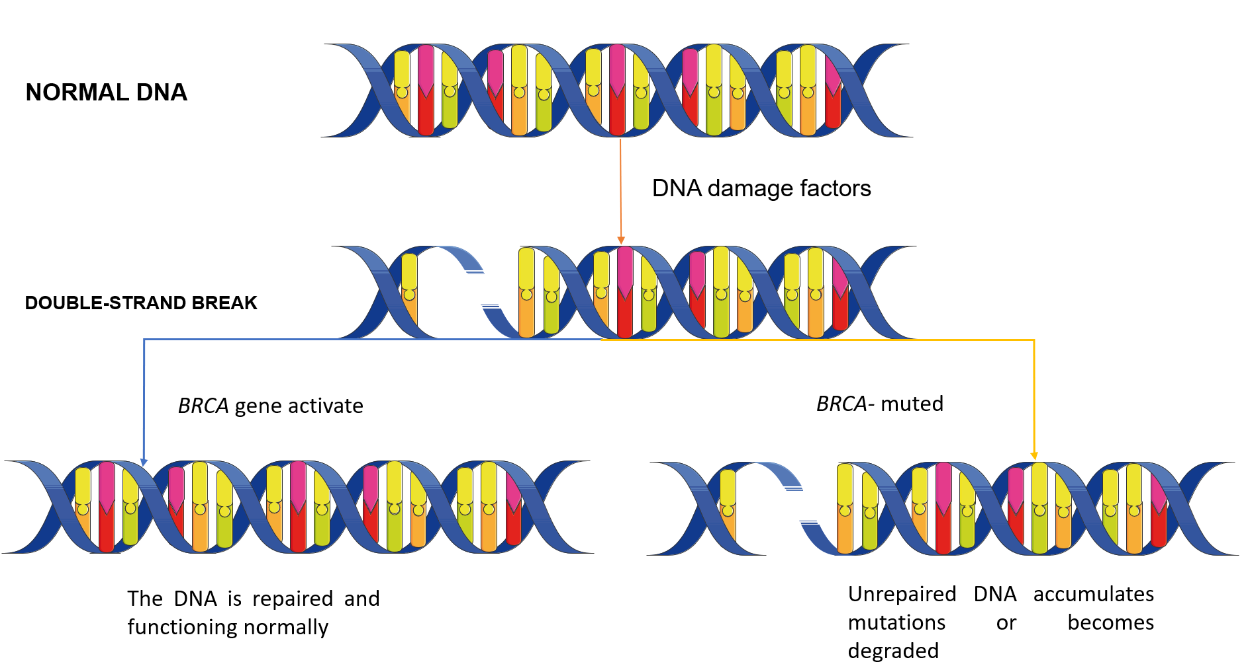
Figure 2.7. The BRCA genes repair DNA damage
The accumulation of BRCA mutations may pose a significant risk to adolescents or adults of reproductive age (Dias Nunes, Demeestere, & Devos, 2023). This genetic instability can lead to infertility in both men and women by exacerbating ovarian aging, reducing ovarian reserve, or causing infertility. Conversely, some studies have shown that patients with BRCA1/2 mutations have longer survival times and better prognosis than patients with high-grade serous ovarian cancer who do not carry the disease-causing gene mutation (Sutrisno, Marlina, Tjandraprawira, & Adinda Adriansyah, 2024). In addition, patients with BRCA mutations have also been reported to be well-responsive to PARP (polyadenosine diphosphate ribose polymerase) inhibitor therapy. However, early screening or testing for BRCA genes in ovarian cancer patients at high risk of gene mutations, such as those with high-grade serous carcinoma, has not received adequate attention in many settings (Lanjouw et al., 2023). Early detection of patients with gene mutations makes preventive interventions more effective, thereby reducing the risk of disability and death from ovarian cancer, especially in cases of hereditary ovarian cancer (T. Liu et al., 2023). As a result, developing guidelines and recommendations for genetic testing in people with ovarian tumors is practical and important to optimize the treatment process for patients.

Overview of characteristics of ovarian cancer patients

Clinical characteristics of ovarian cancer patients
In medicine in general and in monitoring the formation and progression of ovarian cancer patients in particular, the clinical and para-clinical characteristics of the patient are of great interest. Clinical characteristics are the manifestations or symptoms that the patient shows. Doctors can easily identify these characteristics through clinical examination, listening, questioning, and observation. In people with ovarian cancer, common clinical symptoms include irregular menstruation, abdominal pain, pain in the lower abdomen, or even palpable tumors. Clinical characteristics of patients are also analyzed to make judgments about survival, diagnosis of progression, or risk of platinum resistance in people with ovarian cancer (Miras, Estevez-Garcia, & Munoz-Galvan, 2024; Mousavi et al., 2024).
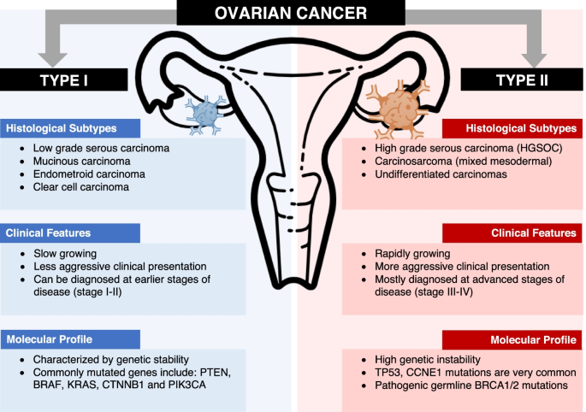
Figure 2.8. Some characteristics and classifications of ovarian cancer.
Ovarian cancer is classified based on histological, clinical, and molecular profile characteristics (Zhu, Charkhchi, & Akbari, 2022).

Several recent epidemiological and clinical studies report that ovarian cancer patients carrying BRCA1/2 mutations exhibit significantly different clinical characteristics compared to those without the mutation. BRCA1/2 mutations are not only a genetic risk factor increasing disease incidence but also influence clinical morphology, disease progression, and treatment response. Lheureux's study indicated that patients with BRCA1 mutations typically experience disease onset at a younger age compared to those with BRCA2 and those without the mutation, with a median age at diagnosis approximately 3–7 years lower (Lheureux et al., 2019). Contrary to the above study's findings, Norquist and colleagues showed that the age of ovarian cancer patients with gene mutations was significantly higher than that of other patients (Norquist et al., 2013). Nevertheless, both studies showed that patients carrying the BRCA mutation had a better prognosis than other ovarian cancer patients.
In terms of histopathological classification, the majority of patients positive for BRCA1/2 mutations belong to the HGSC type of ovarian cancer – the most common and highly invasive form. Compared to other histopathological subtypes, HGSC in patients with BRCA mutations is often associated with greater peritoneal spread, larger tumor volume, and a higher frequency of distant metastases (Nougaret et al., 2017). At the same time, these studies also noted a higher incidence of ascites and lymph node involvement in ovarian cancer patients with gene mutations, reflecting a faster disease progression.

Paraclinical characteristics of ovarian cancer patients

On the other hand, para-clinical features include test results, ultrasound images, MRI, biopsy, and pathology (Figure 2.9). To obtain clear para-clinical results, medical staff must use biomedical equipment and machines such as blood testing machines, X-ray machines, or MRI machines without being able to directly observe or ask patients. Para-clinical results give doctors an objective and relatively accurate view of the disease progression, thereby providing appropriate treatment regimens (Kwon et al., 2019). In addition, para-clinical results have also been reported to be potentially related to BRCA1/2 gene mutations. Para-clinical results often noted in ovarian cancer patients are ultrasound results, tumor size, and markers CA125 or HE4 (Phạm et al., 2023; Trần et al., 2024). The above reports all indicate that the common types of ovarian cancer are epithelial cancer, teratoma, or cyst, with variable tumor size, and rare malignant prognosis.
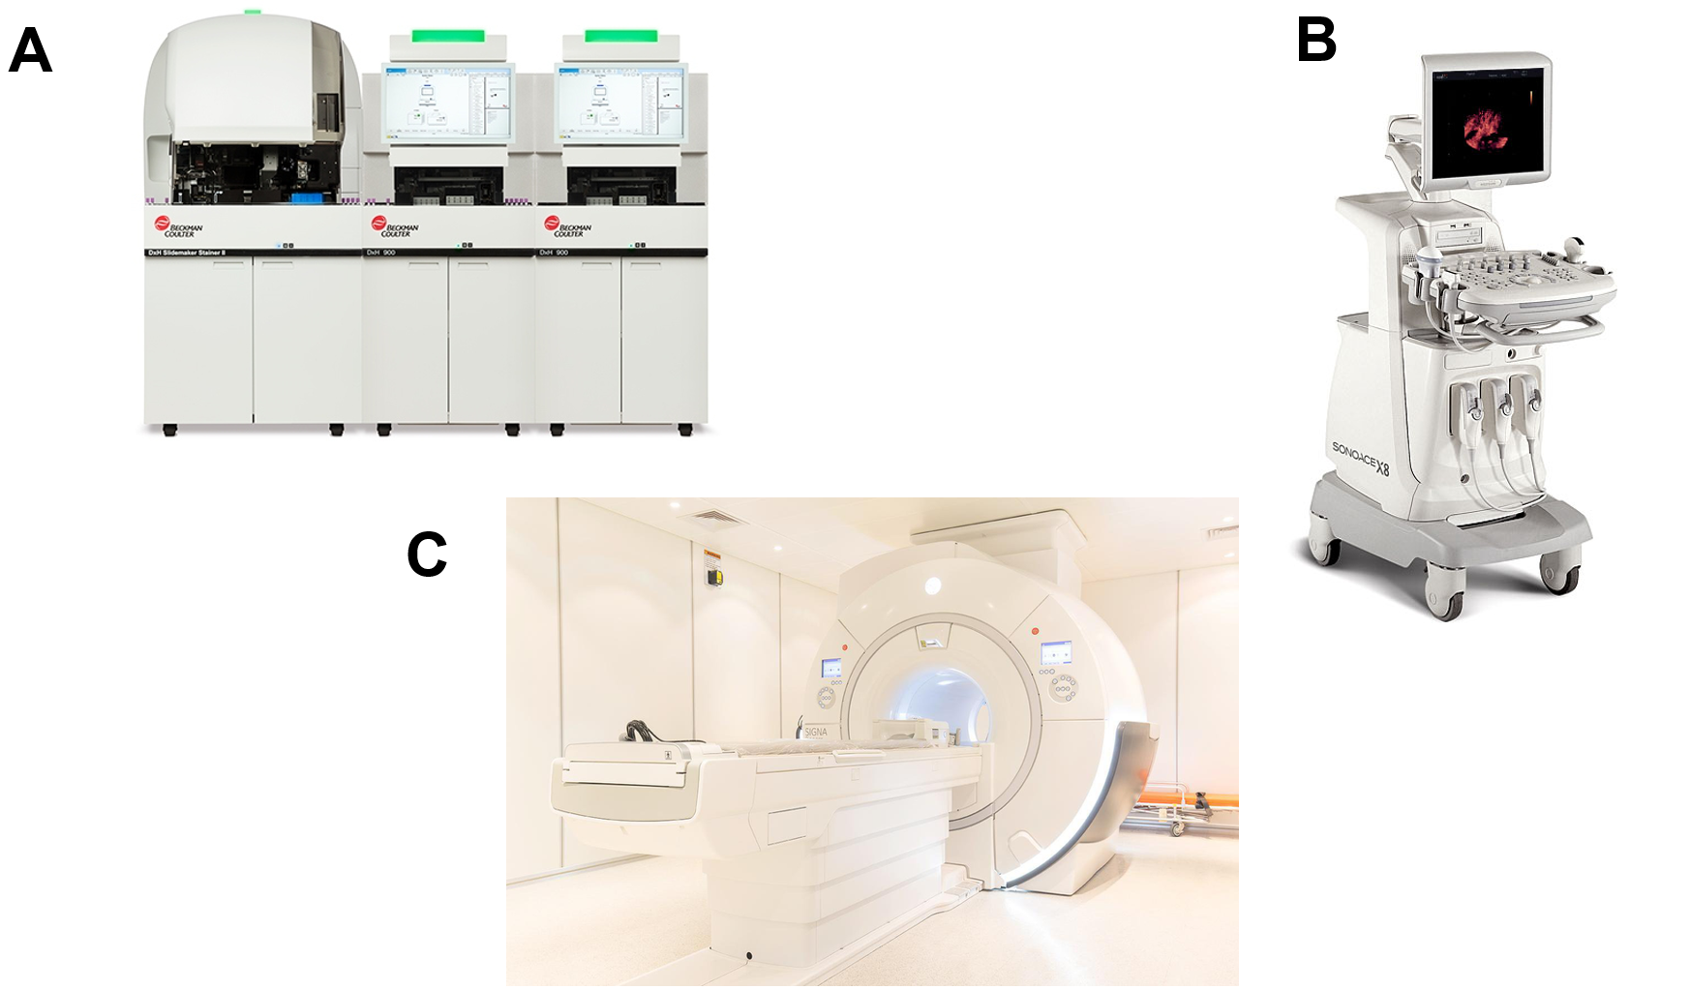
Figure 2.9. Several machines are used in para-clinical diagnosis.
A. Hematology analyzer; B. Ultrasound machine; C. MRI (Magnetic Resonance Imaging) machine.

For ovarian cancer patients examined and treated at the hospital, tests typically include a total blood cell analysis, coagulation tests, blood biochemistry tests, electrolyte tests, and tests related to cancer markers. A total blood cell analysis is one of the basic hematological tests, providing paraclinical indicators, and is routinely performed in hospitals for many different diseases (Figure 2.10). This test simultaneously evaluates multiple blood components, such as red blood cells, white blood cells, platelets, and other indicators, to provide clinical information that allows doctors and healthcare professionals to monitor and diagnose various medical conditions in the body (El Brihi & Pathak, 2025). Parameters related to red blood cells provide information about their ability to transport oxygen to tissues and organs; therefore, values ​​different from the normal threshold signal anemia due to various causes such as deficiencies in trace minerals, vitamins, or bone marrow abnormalities, etc (El Brihi & Pathak, 2025). Extended indicators such as mean corpuscular volume (often abbreviated as MCV), mean corpuscular hemoglobin concentration (MCHC), mean corpuscular hemoglobin (MCH), and red cell distribution width-coefficient of variation (RDW-CV) contribute additional evidence and important indicators for healthcare professionals regarding the causes and classification of anemia due to nutritional deficiencies or chronic diseases, thus guiding specific treatment. Besides red blood cell indicators, the number and proportion of different white blood cell groups are also frequently considered in complete blood count tests. Indicators such as total white blood cell count, neutrophils, lymphocytes, monocytes, eosinophils, and basophils are often analyzed to assess the body's inflammatory or immune status (Seo & Lee, 2022). Lower or higher than normal values ​​of white blood cell groups may suggest side effects of treatments or be used to identify underlying infections or chronic inflammation in patients. A small number of platelet counts are also analyzed in complete blood count tests in patients. These counts provide information about clotting function in patients, especially the elderly and those with metabolic disorders (Essawi et al., 2023). A decrease in platelet count and related indicators such as plateletcrit (PCT) and mean platelet volume (MPV) can be suggestive of bone marrow failure, thrombocytopenia due to bleeding, or chronic inflammation (Walle, Arkew, Asmerom, Tesfaye, & Getu, 2023).
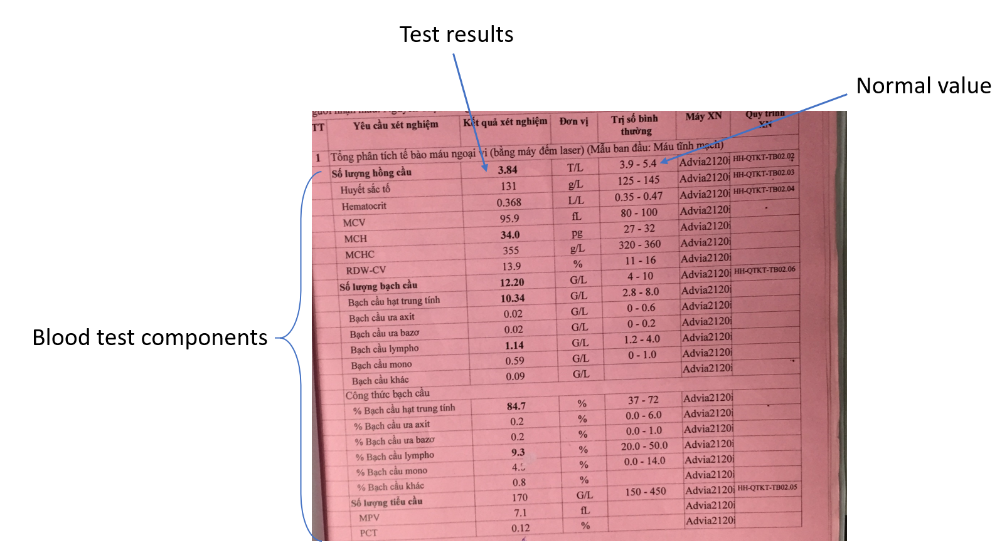
Figure 2.10. Total blood cell analysis test result. The images of blood test results were taken from the patients' medical records collected in the study, with the patients' personal information removed

In addition to a complete blood count, ovarian cancer patients are also often prescribed coagulation tests and electrolyte tests. These two tests provide additional paraclinical information about the patient's home environment, as well as underlying diseases, nutritional status, and the risk of complications during treatment. Coagulation tests are usually focused on indicators such as prothrombin time (seconds), prothrombin time (%), INR (international normalized ratio), fibrinogen determination, and APTT values (Figure 2.11A). These test results contribute to assessments of blood clotting disorders in patients, the risk of thrombosis, and their impact on the prognosis of certain diseases (Ay, Pabinger, & Cohen, 2017; Lê, Suzanne, Nguyễn, Huỳnh, & Nguyễn, 2025). Notably, fibrinogen abnormalities have been reported as an indicator of worsening ovarian cancer and some other types of cancer (Ay et al., 2017). Along with coagulation tests, indicators of major ions in the body, such as Na⁺, K⁺, and indicators reflecting the body's nutrition, such as total calcium and albumin, are also often considered in patients, especially those with ovarian cancer (Berardi et al., 2019) (Figure 2.11B). These indicators not only contribute to assessing overall health and nutrition but also reveal the health of vital organs such as the heart, kidneys, and nervous system. People with cancer undergoing treatments such as chemotherapy, radiation therapy, or surgery often need to closely monitor these indicators to assess treatment progress and potential side effects affecting organ function. Furthermore, studies have shown a link between electrolyte imbalance and a reduced quality of life and worsening disease progression in cancer patients (Rashidi et al., 2025). Blood biochemistry indicators are also routinely used in cancer patients, including ovarian cancer patients. Indicators such as blood glucose, liver enzyme levels like SGPT (serum glutamic pyruvic transaminase), SGOT (serum glutamic-oxaloacetic transaminase), and creatine provide information about liver and kidney function and the patient's blood sugar status. They play a crucial role in monitoring cancer progression as well as the effectiveness and side effects of treatments.
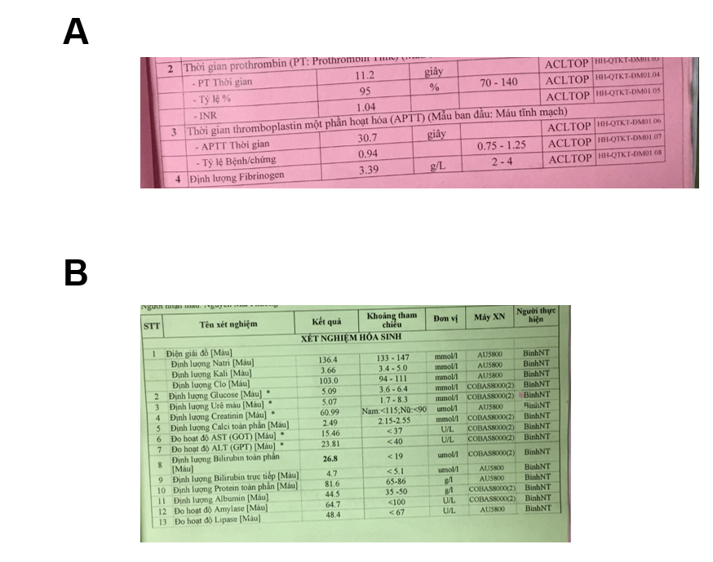
Figure 2.11. Blood coagulation test results and blood biochemistry test results.
- Results of blood clotting-related tests in ovarian cancer patients. B. Results of blood biochemistry and electrolyte tests. Images are taken from medical records of ovarian cancer patients collected in the study; personal information has been removed.

Finally, one of the notable paraclinical indicators in cancer patients is cancer marker testing. Common markers such as CA125, HE4, CEA (carcinoembryonic antigen), and CA19-9 (carbohydrate antigen 19-9) are frequently used to aid in diagnosis, monitor progression, and assess treatment response in cancer patients, including ovarian cancer (Figure 2.12). CEA is a glycoprotein marker that is highly expressed during pregnancy and decreases afterward; however, in patients with colorectal cancer or mucinous ovarian cancer, the expression of this marker is abnormally high (Fletcher, 1986). In Vietnam and around the world, CEA is often recommended for use in combination with other markers to improve the effectiveness of cancer diagnosis for patients (Duffy, 2013; Thị Nga, Quốc Tuấn, Thị Hồng, & Thị Hồng Lê, 2021). CA125 is known for its frequent appearance in the diagnosis and screening of serous epithelial ovarian cancer (Charkhchi et al., 2020). Although playing a crucial role in managing tumor progression, this marker is also recommended to be combined with other markers, as guided by health organizations. The marker commonly combined with CA125 is HE4. The combination of these two markers has been reported to increase the accuracy in identifying malignancies and is highly significant in monitoring the pathological status of ovarian cancer patients (Chudecka-Glaz et al., 2023; Song et al., 2023). Unlike the cancer markers mentioned above, CA19-9 is usually specific to cancers of the digestive system or pancreatic cancer, but it is also indicated for ovarian cancer patients in some cases. This marker is also often tested along with CA125 or other cancer markers to assess the metastasis and origin of cancer cells (Locker et al., 2006).
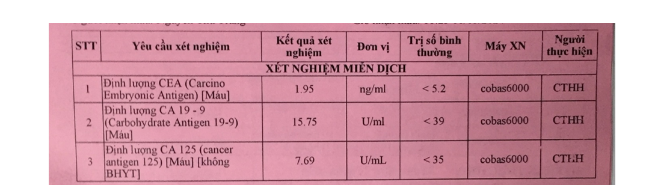
Figure 2.12. Test results of some common cancer markers.
Commonly used cancer markers include CEA, CA125, and CA19-9.

Evaluation of patients at high risk of carrying BRCA gene mutations

Genetic testing strategies and screening guidelines worldwide
Genetic testing strategies for ovarian cancer patients carrying BRCA1/2 mutations have become an essential component of global clinical care, aiming to optimize treatment options and minimize family risk. International guidelines from specialized organizations such as the National Comprehensive Cancer Network (NCCN), the American Society of Clinical Oncology (ASCO), and the European Society for Medical Oncology (ESMO) all emphasize the importance of assessing genetic risk and performing BRCA testing for ovarian cancer patients, not only for prevention but also directly influence targeted therapy strategies (Daly et al., 2023; McDevitt et al., 2024).
According to NCCN guidelines, all patients diagnosed with ovarian cancer, suspected metastatic ovarian cancer, or primary peritoneal cancer with a family history should undergo risk assessment and be referred for BRCA1/2 genetic testing, including germline testing and, in some cases, somatic tumor testing to determine responsiveness to PARP inhibitors (Daly et al., 2023). Meanwhile, ASCO has updated and expanded its recommendations for polygenic testing when results influence treatment choices or are based on personal or family history, with the goal of optimizing the diagnostic and treatment outcomes for related cancers (Tung et al., 2024). In addition, ESMO/ESGO also recommends BRCA genetic testing for all women diagnosed with ovarian cancer or with a family history of breast/ovarian cancer to guide proactive prevention strategies, such as reducing the risk through surgical removal of reproductive organs, to lessen the burden caused by these diseases (Sessa et al., 2023).
In the current context, a comprehensive map of BRCA1/2 genetic testing guidelines has been developed, revealing over 30 individual or reference guidelines, varying in requirements and scope of application across numerous countries and regions. This statistical report also highlights the uneven access to genetic testing and counseling services, particularly in resource-limited countries, resulting in BRCA1/2 testing not being as widespread as in developed countries (Hughes et al., 2023).

Table 2.3. Several BRCA testing strategies according to international guidelines.
Guidelines | Application | Primary screening target | Objectives
NCCN (2025) | Ovarian cancer, ovarian metastasis, peritoneal cancer | Both germline and somatic BRCA | Treatment and prevention
ASCO (2024) | Ovarian cancer, breast cancer, and related cancers | Patient indications for treatment, family history | Expand testing and multigene panel
ESMO/ESGO | HBOC syndrome | All ovarian cancer patients with a related family history | Supporting screening and prevention strategies
EMQN (2024) | Tumor and germline testing | People diagnosed with ovarian cancer | Technical and quality guidelines for laboratory testing

Evaluation of ovarian cancer patients at high risk of carrying the BRCA mutation
Women at high risk of ovarian cancer are older, those who have never had children or have children late in life, and obese women are also more likely to develop tumors (Pruthi, Gostout, & Lindor, 2010) (Figure 2.13). A family history of cancer is also a risk factor for ovarian cancer. However, early identification of BRCA mutation carriers in the population is currently facing many difficulties. Current markers such as the CA125 marker, family history of cancer, or ultrasound results are often used to recommend patients for genetic testing, but the reliability is not high (Lewis, Lu, Klimczak, & Mok, 2018).
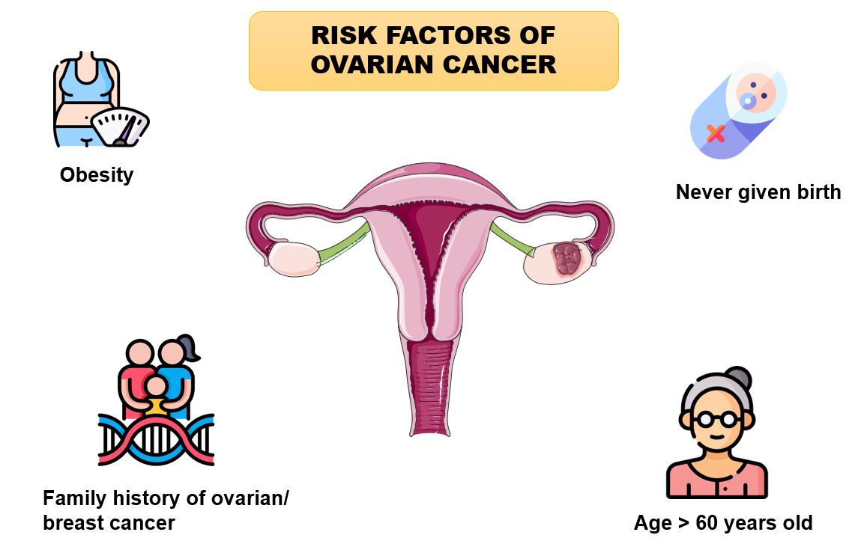
Figure 2.13. Several factors increase a woman's risk of developing ovarian cancer.

Otherwise, some signs such as age of onset, type of ovarian cancer, or clinical and para-clinical characteristics can contribute to indicating patients at high risk of carrying genetic mutations. Specifically, one study showed that patients with BRCA gene variants had larger peritoneal tumors and larger lymph nodes than those without the mutation (Petrillo et al., 2017). Other research shows that people who carry BRCA1 mutations tend to develop ovarian tumors much earlier than those who do not carry the mutation or who carry a BRCA2 mutation (Temkin, Bergstrom, Samimi, & Minasian, 2017). In addition, patients diagnosed with invasive epithelial and high-grade serous ovarian cancer had significantly higher frequencies of gene mutation carriers than patients with other histological subtypes (Alsop et al., 2012). Identifying patients at high risk for ovarian cancer, along with those at high risk for carrying genetic mutations, is important because it will help the health system develop more specific, personalized strategies to reduce the time living with the disease, provide early prevention methods, and reduce the mortality rate from ovarian cancer.

Chapter 3. RESEARCH METHODOLOGY

Research approaches
From the two main results, the study was conducted with the following contents:
The first content describes the para-clinical characteristics of ovarian cancer patients in the Hanoi area, Vietnam. A retrospective study will be conducted to describe the paraclinical characteristics of patients by collecting medical records of patients diagnosed with ovarian cancer admitted to end-line cancer hospitals in the Hanoi area, such as the Vietnam National Cancer Hospital, Oncology and Radiation Therapy Department of Viet Duc University Hospital. This research is a part of and is supported by a VNU-IS project entitled "Evaluate the clinical and para-clinical characteristics between ovarian cancer patients with high versus low risk of BRCA1/2 genetic mutations in Hanoi" (Decision No. 1389/QĐ-TQT), led by Dr. Dinh-Toi Chu, which is further developed and analyzed from the data in the previous group's VNU project on ovarian cancer.
The second content is a comparison of para-clinical characteristics and some other related factors between two groups of ovarian cancer patients with high and low risk of BRCA1/2 gene mutation. Based on the results described in the first part, the association of some para-clinical, epidemiological factors, etc, with the risk of gene mutations in ovarian cancer patients will be investigated through statistical tests, including Student’t test, Mann-Whitney U, and regression models. Thereby, future research directions and screening for gene mutations in ovarian cancer patients will be proposed.

Population and sample
- Research object: Medical records of patients diagnosed with ovarian cancer admitted to end-line oncology hospitals in Hanoi, part of which was inherited from the previous research of the group in the VNU-Hanoi project on ovarian cancer (Decision No. 776/QD-VNU). These medical records were collected at hospitals such as the Vietnam National Cancer Hospital, Oncology and Radiation Therapy Department of Viet Duc University Hospital.
- Sampling range: Patients at end-line cancer hospitals in the Hanoi area, such as the Vietnam National Cancer Hospital, Oncology and Radiation Therapy Department of Viet Duc University Hospital.
- Sampling method: Using the convenience sampling method
+ Selection criteria: Medical records of patients diagnosed with ovarian cancer admitted to end-line cancer hospitals in the Hanoi area
+ Exclusion criteria: Medical records with incomplete clinical and paraclinical information.

- Research sample size: Based on the formula for calculating the sample size of 2 proportions for 2 groups of subjects (Sutrisno et al., 2024)
+ Error level $α=0.05$ then $Z_{2α}=1,96$
+ Error level $β=0.05$ then $Z_{2β}=1,04$
+ $p_{1}$ is the proportion of patients with advanced ovarian cancer in the group with gene mutations, in which $p_{1}=0,96$ and $q_{1}=1-p_{1}=0,04$
+ $p_{2}$ is the proportion of patients with advanced ovarian cancer in the group without gene mutations, in which $p_{2}=0,82$ and $q_{2}=1-p_{2}=0,18$
+ p = $\frac{p_{1}+p_{2} }{2}$ = 0,89, q = 1- p = 0,11
Results are estimated based on the study by Cunningham et al. 2014 (Cunningham et al., 2014).
Therefore, the study requires a minimum of 84 patients per group. The actual sample size may be larger than the minimum sample size.

Research methods
- Research design: A cross-sectional retrospective study using secondary data extracted from medical records to describe the differences between para-clinical characteristics in ovarian cancer patients with high and low risk of gene mutations in Vietnam and some related factors.
- Subgrouping of patients at high risk for carrying a gene mutation based on recommendations from the United States Preventive Services Task Force (USPSTF) (Force et al., 2019) and research of Petrucelli N (Petrucelli, Daly, & Pal, 1993). Accordingly, patients with a personal/family history of one of the following characteristics are at high risk of carrying a BRCA mutation:
+ Patients who develop ovarian cancer before the age of 50
+ Patients with ovarian cancer who have a family history of ovarian or breast cancer
+ Having at least one male relative who has had breast cancer
+ Many cases of breast cancer run in families, with one or more family members having two major types of cancer linked to the BRCA gene
+ Patients with triple-negative ovarian cancer (ER, PR, HER2)
+ Patients have a family member with a known BRCA1 or BRCA2 pathogenic variant.
- Collecting data: The research team searched the patient's paper medical records stored at hospitals or oncology departments, then entered data using Google Forms. The data is then compiled into a Microsoft Excel file for cleaning and analyzing the information fields. Information on the clinical, para-clinical, and epidemiological characteristics of the patients was collected. Specifically, the data collected includes:
+ General patient information, such as age, ethnicity, and occupation, is extracted from medical records
+ Information about the patient's personal medical history, the medical history of family members, and information about their treatment at the hospital
+ Information on para-clinical tests such as complete blood count, coagulation factor test, blood biochemistry test, electrolytes, and tumor marker concentration test, such as CEA, CA125, HE4 in plasma.
+ Staging is performed by the attending physician and is determined based on the criteria of the International Federation of Gynecology and Obstetrics (FIGO).
- Statistical analysis: SPSS v. 27 software was used for statistical analysis. Percentages (%) and mean values (SD) were used to describe para-clinical and some epidemiological characteristics of patients. Mann-Whitney U test and multivariate logistic regression were used to find out the associated factors with p<0.05, which was considered a statistically significant difference.

Chapter 4. RESULTS AND DISCUSSION

General characteristics of ovarian cancer patients
After data collection and cleaning, this study collected 223 medical records of ovarian cancer patients from tertiary hospitals such as the Vietnam National Cancer Hospital, Oncology and Radiation Therapy Department of Viet Duc University Hospital. The general characteristics of ovarian cancer patients are shown in Table 4.1 below, where characteristics such as age, weight, body mass index (BMI), and length of hospital stay are statistically presented using mean and standard error (SDThe remaining characteristics, such as ethnicity, jobs, diagnosis, and other variables, are statistically analyzed by the number and percentage of each characteristic in the total number of collected medical records.
In this study, the average age of ovarian cancer patients was 52.11 (± 14.73), and the average weight was approximately 51 kg (50.93 ± 8.82). The average BMI of the patients in the study was 21.03 (± 3.65), which, according to the WHO classification, is within the normal range for these patients. Patients were hospitalized for a relatively long time, with an average value of more than 38 days (38.24 ± 4.30). The average age of ovarian cancer patients in this study was lower than that of studies on ovarian cancer patients at the Vietnam National Cancer Hospital by Nguyen Linh Toan et al. and Dang Tien Giang et al., which were 57.7 ± 17.2 and 58.5 ± 9.5, respectively (Đặng, Khúc, Phan, & Lại, 2024; Linh et al., 2021). The differences in study age may be explained by differences in study subject selection and the inconsistent number of case histories among accessible studies. On the other hand, similar ages in ovarian cancer patients were observed in a Korean study of patients carrying the BRCA gene mutation (Kwon et al., 2019). Next, there is a similarity in the body condition of ovarian cancer patients between this study and Nguyen Linh Toan's study, as the majority of patients did not have noticeable abnormalities in the BMI (Linh et al., 2021).
Of the 223 patient records, the Kinh ethnic group accounted for the majority at 91.5%, while other ethnic groups such as Tay, Thai, and others accounted for a significantly smaller proportion with only 19 records. Occupation was not clearly stated in the records, with over 50% of the records not mentioning the patient's occupation. Regarding the primary diagnosis recorded in the records, the majority of patients had ovarian cancer as their primary diagnosis, accounting for 69.5%; in addition, the records also recorded cases of ovarian cysts and other pathological conditions related to ovarian cancer, accounting for 17.5% and 13% respectively. Table 4.1 also shows that 75.8% of patients had no underlying medical conditions, while a small percentage had common underlying conditions such as hypertension, diabetes, or tumors in other locations. This characteristic is similar to previous studies on ovarian cancer patients, where the majority of study subjects had a healthy personal history with no recorded comorbidities (Linh et al., 2021). Similar to this study's report, Tarkhov and colleagues' research also noted that conditions such as diabetes, hypertension, and obesity are common underlying diseases in ovarian cancer patients (Tarkhov et al., 2025).
Regarding medical history, 9 cases reported a family history of cancer, and 81 medical records showed that patients had previously had cancer, accounting for 2.95% and 36.3% respectively. While family cancer history is often explored in studies of ovarian cancer, research in Vietnam rarely records cases of patients with family members suffering from ovarian cancer or related cancers (Linh et al., 2021). Meanwhile, another study conducted in 2012 showed significant differences in family history between groups of ovarian cancer patients with different BRCA gene mutations (Alsop et al., 2012). This difference may be explained by a lack of information in medical records or insufficient attention to patients' family history in Vietnam. After hospital treatment, the majority of patients were assessed as having a positive discharge status, such as recovery, improvement, or reduction in symptoms, while only 8.5% and 2.20% of patients had unchanged or worsening conditions.

Table 4.1. Characteristics of ovarian cancer patients
Characteristics |  | N (Mean) | % (SD) | N total
Age |  | 52.11 | 14.73 | 223
Weight |  | 50.93 | 8.82 | 203
BMI |  | 21.03 | 3.65 | 185
Ethnicity | Kinh | 204 | 91.5 | 223
Ethnicity | Others | 19 | 8.5 | 223
Job | Workers and civil servants | 19 | 8.50 | 223
Job | Student | 5 | 2.20 | 223
Job | Retirement | 29 | 13.0 | 223
Job | Others | 170 | 76.20 | 223
Hospital stay |  | 38.24 | 4.30 | 219
Diagnose | Ovarian cancer | 155 | 69.50 | 223
Diagnose | Ovarian cysts | 39 | 17.50 | 223
Diagnose | Others | 29 | 13.00 | 223
Comorbidities | Diabetes | 13 | 5.80 | 222
Comorbidities | Hypertension | 28 | 12.60 | 222
Comorbidities | Have a tumor in another location | 12 | 5.40 | 222
Comorbidities | Normal | 169 | 75.80 | 222
Family history | Relatives with cancer | 9 | 2.95 | 223
Family history | No relatives with cancer | 214 | 70.16 | 223
Personal history | Had cancer | 81 | 36.30 | 223
Personal history | Did not have cancer | 142 | 63.70 | 223
Discharge status | Cured | 43 | 19.30 | 223
Discharge status | Reduced | 156 | 70.00 | 223
Discharge status | Unchanged | 19 | 8.50 | 223
Discharge status | More severe, death | 5 | 2.20 | 223

223 patient records of ovarian cancer were divided into two groups: high-risk patients carrying the BRCA gene mutation and low-risk patients carrying the gene mutation, based on the classification criteria mentioned in the research methods section. This study included 97 records classified as high-risk (43.5% of the total patients) and 126 records showing low-risk patients carrying the gene mutation (Figure 4.1). The number of records in each group did not differ significantly and also exceeded the minimum number of records required for each group as calculated in the study sample size.

Figure 4.1. Proportion of patients at high/low risk of carrying gene mutations

Differences in paraclinical characteristics between high- and low-risk patient groups carrying gene mutations
The paraclinical parameters evaluated in this study included total blood cell analysis, coagulation tests, blood biochemistry, electrolytes, and commonly used cancer markers (Table 4.2). First, the total blood cell analysis results in most patient groups were within normal ranges. However, the mean hemoglobin levels in both high-risk and low-risk groups were significantly lower than normal. The mean red blood cell count in the high-risk group with the gene mutation was significantly higher than in the low-risk group (p<0.001); however, these values ​​were still within the normal range. Similarly, the mean MPV in the high-risk group was significantly higher than in the low-risk group (p=0.05). The mean lymphocyte ratio in the high-risk group was also higher than in the low-risk group (p=0.02). Notably, this index in the low-risk group showed a lower mean value than the normal value. Conversely, the mean MCH value of the high-risk group of patients carrying the gene mutation was lower than the mean MCH of the low-risk group (27.64±0.38 and 28.97±0.22, p=0.04).
Table 4.2. Para-clinical characteristics of patients at high/low risk of carrying BRCA gene mutations
Para-clinical characteristics | Normal value | High risk of mutation |  | Low risk of mutation |  | p-value
Para-clinical characteristics | Normal value | Mean | SD | Mean | SD | p-value
TOTAL BLOOD CELL ANALYSIS
Red blood cell count | 3.9-5.4 T/L | 4.34 | 0.07 | 4.05 | 0.05 | <0.001ª
Hemoglobin level | 125-145 g/L | 118.27 | 1.73 | 115.44 | 1.65 | 0.24ª
Hematocrit | 0.35-0.47 L/L | 0.36 | 0.01 | 0.35 | 0.01 | 0.15ª
Mean Corpuscular Volume (MCV) | 83-100 fL | 84.12 | 0.94 | 86.88 | 0.55 | 0.09ª
Mean Corpuscular Hemoglobin Concentration (MCHC) | 320-360 g/L | 327.97 | 1.58 | 331.52 | 1.11 | 0.13^{b}
Mean corpuscular hemoglobin (MCH) | 27-32 pg | 27.64 | 0.38 | 28.97 | 0.22 | 0.04^{b}
Red Cell Distribution Width-Coefficient of Variation (RDW-CV) | 11-16 % | 14.66 | 0.29 | 14.27 | 0.17 | 0.22ª
White blood cell count | 4-10 G/L | 9.08 | 0.5 | 9.49 | 0.37 | 0.21^{b}
Neutrophil percentage (%NEU) | 37-72 % | 67.07 | 1.65 | 70.17 | 1.35 | 0.15ª
Lymphocyte ratio (%LYM) | 20-45 % | 22.38 | 1.27 | 18.37 | 0.97 | 0.02^{b}
Monocytes ratio (%MON) | 0-14 % | 6.94 | 0.35 | 6.66 | 0.24 | 0.58^{b}
Eosinophil ratio (%EOS) | 0-6.0 % | 2.12 | 0.23 | 2.8 | 0.53 | 0.96^{b}
Basophil ratio (%BASO) | 0-1 % | 0.37 | 0.03 | 0.39 | 0.03 | 0.87^{b}
Absolute neutrophil count (NEU) | 2.8-8.0 G/L | 6.43 | 0.51 | 6.95 | 0.37 | 0.07^{b}
Absolute lymphocyte count (LYM) | 1.2-4.0 G/L | 2.06 | 0.42 | 1.51 | 0.06 | 0.22^{b}
Absolute monocyte count (MON) | 0-1.0 G/L | 0.58 | 0.04 | 0.63 | 0.03 | 0.58^{b}
Absolute eosinophil count (EOS) | 0-0.6 G/L | 0.16 | 0.02 | 0.2 | 0.02 | 0.89^{b}
Absolute basophil count (BASO) | 0-0.2 G/L | 0.03 | 0.003 | 0.03 | 0.003 | 0.09^{b}
Platelet count | 150-450 G/L | 276.7 | 8.89 | 313.23 | 11.56 | 0.08^{b}
Mean platelet volume (MPV) | fL | 8.93 | 0.16 | 8.56 | 0.13 | 0.05^{b}
Plateletcrit (PCT) | % | 0.25 | 0.01 | 0.26 | 0.01 | 0.59^{b}
BLOOD COAGULATION TEST
Prothrombine (s) <per second> | 11.5 | 12.38 | 0.39 | 12.02 | 0.21 | 0.24^{b}
Prothrombine (%) | 70-140 % | 91.14 | 2.13 | 94.54 | 1.87 | 0.27^{b}
International Normalized Ratio (INR) | 0.85-1.25 | 1.08 | 0.04 | 1.04 | 0.02 | 0.37^{b}
Fibrinogen determination | 2-4 g/L | 4.06 | 0.55 | 4.07 | 0.15 | <0.001^{b}
APTT (s) | 31 | 29.24 | 0.81 | 28.88 | 0.89 | 0.57^{b}
APTT ratio (Disease/control) | 0.75-1.25 | 0.96 | 0.03 | 0.95 | 0.03 | 0.38^{b}
BLOOD BIOCHEMISTRY TEST
Creatine | <90 umol/l | 61.19 | 3.37 | 69.67 | 4.92 | 0.02^{b}
Glucose | 3.9-6.4 mmol/l | 5.71 | 0.42 | 6.91 | 0.38 | <0.001^{b}
SGOT | <37 U/L | 23.73 | 2.02 | 30.03 | 2.25 | <0.001^{b}
SGPT | <40 U/L | 18.88 | 2.1 | 26.17 | 2.88 | <0.001^{b}
Billirubin total | <19 mmol/l | 11.39 | 1.58 | 11.7 | 2.31 | 0.95^{b}
Protein total | 65-86 g/l | 62.3 | 5.18 | 57.41 | 5.33 | 0.30^{b}
Ure | 1.7-8.3 mmol/l | 4.08 | 0.22 | 6.17 | 0.87 | 0.04ª
ELECTROLYTE TEST
Na+ | 133-147 mmol/l | 136.39 | 0.38 | 136.21 | 0.38 | 0.60^{b}
K+ | 3.4-5.0 mmol/l | 3.73 | 0.08 | 3.63 | 0.04 | 0.24^{b}
Calcium total | 2.15-2.55 mmol/l | 2.07 | 0.1 | 2.04 | 0.07 | 0.56^{b}
Albumin | 35-50 g/l | 38.64 | 0.75 | 34.28 | 0.91 | <0.001^{b}
CANCER MARKER
CEA | <5 ng/ml | 10.47 | 3.88 | 11.3 | 6.21 | 0.81^{b}
CA125 | <35 U/ml | 473.5 | 192.59 | 1000.41 | 246.08 | 0.03^{b}
HE4 | <70 pmol/L | 114.02 | 37.19 | 268.75 | 72.33 | 0.001^{b}
CA 19-9 | <37 U/ml | 5243.18 | 4864.03 | 402.69 | 351.1 | 0.21^{b}
*Note: a-Perform Student's t-test for variables with normal distributions; b- Mann-Whitney test for variables with non-normal distributions.
Coagulation test results did not show significant differences between the two patient groups (Table 4.3). Clinical values ​​assessing coagulation ability, such as Prothrombin (%), INR, and APTT ratio, were within the normal range for both groups. Meanwhile, Prothrombin (s) in both high-risk and low-risk groups were higher than normal, but there was no noticeable difference between the two groups. APTT (s) values ​​showed the opposite, with the mean values ​​in both groups being lower than normal. Furthermore, Fibrinogen levels showed a significant difference between the low-risk and high-risk groups (p<0.001), and these values ​​were higher than normal in both groups. Some recent studies suggest that Fibrinogen, in addition to its role as an indicator of coagulation status, may also be a reliable marker in diagnosing ovarian cancer (Wu, Zhang, Liu, & Ge, 2023). This study also indicated that fibrinogen levels were higher in patients with malignant ovarian cancer, and that combining this test with cancer markers such as CA125 could improve the accuracy of diagnosing ovarian tumors.

Table 4.3. Blood clotting test results between high-risk and low-risk patient groups carrying the gene mutation.
Para-clinical characteristics | Normal value | High risk of mutation |  | Low risk of mutation |  | p-value
Para-clinical characteristics | Normal value | Mean | SD | Mean | SD | p-value
Prothrombine (s) <per second> | 11.5 | 12.38 | 0.39 | 12.02 | 0.21 | 0.24
Prothrombine (%) | 70-140 % | 91.14 | 2.13 | 94.54 | 1.87 | 0.27
International Normalized Ratio (INR) | 0.85-1.25 | 1.08 | 0.04 | 1.04 | 0.02 | 0.37
Fibrinogen determination | 2-4 g/L | 4.06 | 0.55 | 4.07 | 0.15 | <0.001
APTT (s) | 31 | 29.24 | 0.81 | 28.88 | 0.89 | 0.57
APTT ratio (Disease/control) | 0.75-1.25 | 0.96 | 0.03 | 0.95 | 0.03 | 0.38

The blood biochemical test results of most patient groups were within normal ranges. However, indicators such as creatinine, SGOT, SGPT, and urea showed significant differences between high-risk and low-risk groups carrying the gene mutation (Figure 4.2). Specifically, the mean values ​​of creatinine and urea were significantly higher in the low-risk group compared to the high-risk group, with values ​​of 69.67±4.92 - 61.19±3.37 (p=0.02) and 6.17±0.87 – 4.08±0.22 (p=0.04), respectively. Similarly, the low-risk patient group also had significantly higher mean SGOT and SGPT values ​​(30.03±2.25 and 26.17±2.88, respectively) compared to the high-risk patient group (23.73±2.02 and 18.88±2.1, respectively) with p<0.001. The high-risk group carrying the gene mutation had a mean glucose index within the normal range (5.71±0.42), but the low-risk group had a significantly higher value, at the level of diabetes mellitus (6.91±0.38) with p<0.001.

Figure 4.2. Comparison of several blood biochemical parameters between high-risk and low-risk ovarian cancer patients carrying BRCA gene mutations.

In the electrolyte test results, the mean total calcium values ​​of both groups were lower than the normal range, but there were no significant differences between the two groups (Figure 4.3). Meanwhile, the mean albumin of the low-risk group was significantly lower (34.28±0.91) than that of the high-risk group (38.64±0.75), which was within the normal range with p<0.001.
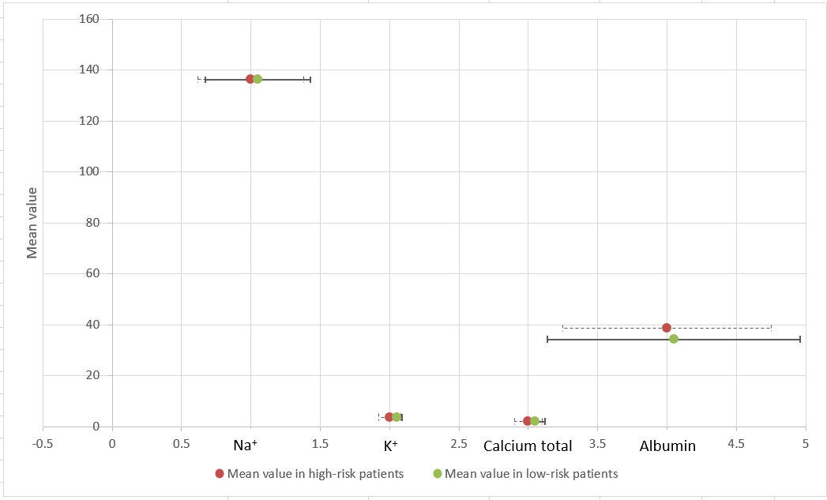
Figure 4.3. Comparison of mean values ​​of electrolyte parameters between two groups of ovarian cancer patients.

All cancer marker test values ​​in the patient groups were higher than normal. Except for CA19-9, the remaining markers, such as CEA, CA125, and HE4, showed that the low-risk group had higher mean values ​​than the high-risk group carrying the gene mutation. Notably, the mean values ​​of CA125 and HE4 in the low-risk group were significantly higher than in the other group, with p-values ​​of 0.03 and 0.001, respectively.

4.3. Factors associated with a patient's likelihood of carrying a gene mutation
To assess the correlation between paraclinical indicators and the likelihood of carrying BRCA gene mutations, we used logistic regression to identify factors potentially associated with mutation risk in ovarian cancer patients. Univariate regression analysis of paraclinical indicators showed significant differences between high-risk and low-risk groups carrying gene mutations, as presented in Table 4.4. Logistic regression analysis results showed that red blood cell count, MCH, %LYM, glucose, urea, and albumin were related to the risk of carrying gene mutations. Specifically, red blood cell count, %LYM, and albumin levels were positively correlated with the odds of carrying gene mutations. Conversely, MCH, glucose, and urea showed a reduced odds of carrying gene mutations in ovarian cancer patients.
In univariate regression analysis, a one-unit increase in red blood cell count increased the odds of carrying the gene mutation in patients by 2.11 times (95% CI: 1.34-3.31; p=0.001). Increases in %LYM and albumin also increased the odds of risk in patients, with ORs of 1.03 (95% CI: 1.01-1.05; p=0.01) and 1.09 (95% CI: 1.03-1.14; p<0.001), respectively. On the other hand, a one-unit increase in MCH decreased the odds by 13% (OR=0.87; p=0.003). Glucose and urea levels in patients also showed an inverse correlation with the odds of carrying a gene mutation, with ORs of 0.90 (95% CI: 0.81-1.00; p=0.049) and 0.79 (95% CI: 0.68-0.92; p=0.002), respectively. The remaining indicators, such as MPV, fibrinogen determination, creatine, SGOT, SGPT, CA125, and HE4, did not show a strong correlation with the risk of carrying mutations in ovarian cancer patients.

Table 4.4. Paraclinical characteristics associated with the likelihood of gene mutations in ovarian cancer patients
Factors | OR | 95% CI |  | P value
Factors | OR | Lower | Upper | P value
Red blood cell count | 2.11 | 1.34 | 3.31 | 0.001
Mean corpuscular hemoglobin (MCH) | 0.87 | 0.79 | 0.95 | 0.003
Lymphocyte ratio (%LYM) | 1.03 | 1.01 | 1.05 | 0.01
Mean platelet volume (MPV) | 1.19 | 0.99 | 1.43 | 0.07
Fibrinogen determination | 1.00 | 0.92 | 1.09 | 0.99
Creatine | 1.00 | 0.99 | 1.00 | 0.23
Glucose | 0.90 | 0.81 | 1.00 | 0.049
SGOT | 0.98 | 0.97 | 1.00 | 0.06
SGPT | 0.99 | 0.97 | 1.00 | 0.08
Ure | 0.79 | 0.68 | 0.92 | 0.002
Albumin | 1.09 | 1.03 | 1.14 | <0.001
CA125 | 1.00 | 1.00 | 1.00 | 0.14
HE4 | 1.00 | 0.995 | 1.00 | 0.09

To more accurately assess the correlation between clinical indicators and the likelihood of carrying gene mutations in ovarian cancer patients, multivariate logistic regression analysis was used to adjust for confounding factors (Table 4.5). In the multivariate regression model, only MCH and albumin showed a statistically significant association with the risk of carrying gene mutations in patients. Indeed, each unit increase in albumin increased the odds of carrying gene mutations by 1.15 times (95% CI: 1.05-1.25; p=0.002). Meanwhile, MCH still showed an inverse correlation with the odds of carrying mutations with an OR=0.86 (95% CI: 0.74-0.99; p=0.04).
Some paraclinical parameters such as red blood cell count, lymphocyte ratio, glucose, and urea, although statistically significant in univariate analysis, did not show a clear correlation in multivariate logistic regression analysis. This suggests that the association of these parameters in univariate regression analysis may still be influenced by other confounding factors. After multivariate adjustment, mean corpuscular hemoglobin and albumin still showed a correlation with the likelihood of carrying gene mutations in ovarian cancer patients, suggesting that these parameters are independently associated with the risk of carrying gene mutations in patients. The biological mechanism of the relationship between MCH and albumin in carrying gene mutations in patients remains unclear. However, it is possible that carrying BRCA1/2 gene mutations in ovarian cancer patients affects their immunity and nutritional status.
Table 4.5. Multivariate regression analysis of paraclinical indicators and gene mutation likelihood in ovarian patient groups
Factors | OR | 95% CI |  | P value
Factors | OR | Lower | Upper | P value
Red blood cell count | 0.49 | 0.21 | 1.18 | 0.11
Mean corpuscular hemoglobin (MCH) | 0.86 | 0.74 | 0.99 | 0.04
Lymphocyte ratio (%LYM) | 0.98 | 0.94 | 1.02 | 0.40
Glucose | 0.91 | 0.8 | 1.04 | 0.16
Ure | 0.82 | 0.66 | 1.02 | 0.08
Albumin | 1.15 | 1.05 | 1.25 | 0.002

Chapter 5. CONCLUSION AND RECOMMENDATIONS

5.1. Recapitulation
A retrospective cross-sectional study collected 223 medical records of ovarian cancer patients at tertiary hospitals in Hanoi, such as the Vietnam National Cancer Hospital, Oncology Department of Viet Duc University Hospital. The average age of the patients was 52.11 ± 14.73. Of the collected records, 69.5% had a primary diagnosis of ovarian cancer, and the majority did not have underlying or comorbid conditions. Based on the criteria for classifying patients at high risk for carrying BRCA gene mutations, 43.5% of the patients were classified as high-risk carriers, and the remaining 126 (equivalent to 56.5%) were classified as low-risk carriers. Statistical methods such as the Student's t-test and Mann-Whitney test were used to compare differences in paraclinical characteristics between the two groups of ovarian cancer patients. The results of the total blood cell analysis for both patient groups were mostly within the normal range. However, some indicators, such as red blood cell count, MPV, and lymphocyte percentage, were significantly higher in the high-risk group carrying the gene mutation compared to the other group, while the mean MCH value showed the opposite. Among the coagulation test parameters, fibrinogen determination was the only indicator showing a statistically significant difference between the two patient groups, and this indicator also exceeded the normal range in both groups. Blood biochemical parameters such as creatinine, glucose, SGOT, SGPT, and urea all showed that patients in the low-risk group had significantly higher mean values ​​for these parameters compared to patients in the high-risk ovarian cancer group carrying the gene mutation (p<0.05). Specifically, the mean blood glucose levels of low-risk patients carrying the mutation were within pathological limits. There were no significant differences between patient groups in the mean values ​​of electrolyte tests. The only characteristic showing a significant difference between the two patient groups was mean albumin, with low-risk patients having lower mean albumin values ​​than high-risk patients (p<0.001). This study focused on four common cancer markers: CEA, CA125, CA19-9, and HE4. Surprisingly, the mean values ​​of CEA, CA125, and HE4 were higher in the low-risk group carrying the gene mutation than in the high-risk group. The mean values ​​of CA125 and HE4 were statistically significantly higher, with p values ​​of 0.03 and 0.001, respectively.
To assess the association of paraclinical characteristics with the risk of carrying gene mutations in ovarian cancer patients, univariate and multivariate logistic regression analysis was used. In the univariate analysis model, red blood cell count, MCH, %LYM, glucose, urea, and albumin were found to be associated with the risk of carrying gene mutations. After adjustment with multivariate logistic regression, only MCH and albumin were found to be independently associated with the risk of carrying gene mutations in ovarian cancer patients. Albumin increased the odds of carrying mutations in patients (OR=1.15; CI 95%: 1.05-1.25; p=0.002), while MCH was inversely correlated with the risk odds (OR=0.86; CI 95%: 0.74-0.99; p=0.04).

5.2. Concluding remarks
In order to address the research objectives and provide evidence on the association between paraclinical characteristics and BRCA1/2 mutation risk in ovarian cancer patients, a retrospective cross-sectional study was conducted on the collected dataset. The findings contribute to improving the understanding of potential indicators that may support early risk stratification and clinical decision-making. In this study, we have achieved the two initial objectives we set out to:
- Describe the para-clinical characteristics of ovarian cancer patients in Hanoi, Vietnam
- With 223 collected medical records, the study revealed some common characteristics and paraclinical features of ovarian cancer patients at several hospitals in Hanoi. Most of the patients' paraclinical indicators, such as total blood cell analysis, coagulation tests, biochemical tests, and electrolyte levels, were within normal ranges.
- However, the patients' blood fibrinogen and glucose levels were higher than normal. In particular, the average levels of cancer markers in ovarian cancer patients in this study were significantly higher than normal.
- Compare the para-clinical characteristics between patients with high and low risk of BRCA1/2 gene mutations and related factors
- To assess the differences in mean values ​​of paraclinical indicators between two groups of ovarian cancer patients, the study used the Student's t-test and Mann-Whitney test to compare paraclinical indicators in the high-risk group carrying BRCA gene mutations with the low-risk group carrying the mutation. The results showed that there were statistically significant differences between the two groups of patients in indicators such as red blood cell count, MCH, %LYM, MPV, fibrinogen determination, creatine, glucose, two liver enzyme indicators (SGOT and SGPT), urea, albumin, and 2/4 cancer markers (CA125 and HE4).
- Among these paraclinical indicators, red blood cell count, MCH, %LYM, urea, and albumin were associated with the likelihood of carrying gene mutations in ovarian cancer patients in the univariate logistic regression analysis model. However, after adjustment in the multivariate logistic regression model, only MCH and albumin remained independently associated with the risk of carrying gene mutations in ovarian cancer patients.

5.3. Limitations of the research
Besides the strengths mentioned, this study also has some limitations that need to be considered and addressed in subsequent studies. First, the number of patient records accessed by the study is quite limited, and these records are physical records, not digitized. Therefore, many records lack the necessary information and data for analysis. This reduces the statistical analysis capabilities of the study, and related factors may be distorted due to the lack of information fields. Second, because the study was designed as a retrospective cross-sectional study, it faces the inherent limitations of this type of research, including the lack of paraclinical index variables and inconsistent data between hospital units. Furthermore, a limitation of retrospective studies is the inability to assess changes in patient conditions and the linear relationships between patient characteristics over time. Finally, this study was unable to perform gene sequencing on patients to directly and accurately determine the research results, and was primarily based on stratifying the likelihood of carrying BRCA gene mutations. This limitation prevents the study from fully reflecting the relationship between subclinical characteristics and the likelihood of carrying gene mutations in ovarian cancer patients, and further studies are needed to clarify this.

5.3. Recommendations
This represents a new research direction and approach to risk stratification in ovarian cancer patients. However, this study is not without its limitations, and there are some suggestions for similar research in the future:
- The scope of sampling and the number of samples collected from hospitals need to be expanded. A large and diverse number of medical records will help make the statistics and descriptions of cancer patients more objective.
- This study is a foundation for conducting further studies on gene sequencing in ovarian cancer patients. From there, studies can consolidate previous research results, providing a more comprehensive and accurate overview of related factors and clinical characteristics that can help in the early classification of ovarian cancer patients carrying gene mutations.
- This study also contributes to suggesting the possibility of applying information technology in analyzing and classifying the characteristics of high- and low-risk patients carrying gene mutations in people with ovarian cancer. The study, combining two fields of biomedical science and information technology, and artificial intelligence, can provide early diagnostic models for patients carrying gene mutations; thus, doctors and medical staff can provide more effective care and treatment for the disease.

REFERENCES
Alsop, K., Fereday, S., Meldrum, C., deFazio, A., Emmanuel, C., George, J., . . . Mitchell, G. (2012). BRCA Mutation Frequency and Patterns of Treatment Response in BRCA Mutation–Positive Women With Ovarian Cancer: A Report From the Australian Ovarian Cancer Study Group. Journal of Clinical Oncology, 30(21), 2654-2663. doi:10.1200/JCO.2011.39.8545
Amer, H., Flanagan, K. L., Kampan, N. C., Itsiopoulos, C., Scott, C. L., Kartikasari, A. E. R., & Plebanski, M. (2025). Interleukin-6 Is a Crucial Factor in Shaping the Inflammatory Tumor Microenvironment in Ovarian Cancer and Determining Its Hot or Cold Nature with Diagnostic and Prognostic Utilities. Cancers (Basel), 17(10). doi:10.3390/cancers17101691
Aviles, D., Warshal, D., Buchbinder, M., & Ostrovsky, O. (2022). Influence of Aberrant Epigenetic Changes and the Tumor Microenvironment in Ovarian Cancer Metastasis. In C. M. Sergi (Ed.), Metastasis. Brisbane (AU).
Ay, C., Pabinger, I., & Cohen, A. T. (2017). Cancer-associated venous thromboembolism: Burden, mechanisms, and management. Thromb Haemost, 117(2), 219-230. doi:10.1160/TH16-08-0615
Banerjee, S., Kaye, S. B., & Ashworth, A. (2010). Making the best of PARP inhibitors in ovarian cancer. Nature Reviews Clinical Oncology, 7(9), 508-519. doi:10.1038/nrclinonc.2010.116
Berardi, R., Torniai, M., Lenci, E., Pecci, F., Morgese, F., & Rinaldi, S. (2019). Electrolyte disorders in cancer patients: a systematic review. Journal of Cancer Metastasis and Treatment, 5. doi:10.20517/2394-4722.2019.008
Biglia, N., Sgandurra, P., Bounous, V. E., Maggiorotto, F., Piva, E., Pivetta, E., . . . Pasini, B. (2016). Ovarian cancer in BRCA1 and BRCA2 gene mutation carriers: analysis of prognostic factors and survival. Ecancermedicalscience, 10, 639. doi:10.3332/ecancer.2016.639
Birkbak, N. J., Kochupurakkal, B., Izarzugaza, J. M., Eklund, A. C., Li, Y., Liu, J., . . . Wang, Z. C. (2013). Tumor mutation burden forecasts outcome in ovarian cancer with BRCA1 or BRCA2 mutations. PLoS One, 8(11), e80023. doi:10.1371/journal.pone.0080023
Bookman, M. A., Tyczynski, J. E., Espirito, J. L., Wilson, T. W., & Fernandes, A. W. (2017). Impact of primary platinum-free interval and BRCA1/2 mutation status on treatment and survival in patients with recurrent ovarian cancer. Gynecol Oncol, 146(1), 58-63. doi:10.1016/j.ygyno.2017.04.011
Bowtell, D. D., Bohm, S., Ahmed, A. A., Aspuria, P. J., Bast, R. C., Jr., Beral, V., . . . Balkwill, F. R. (2015). Rethinking ovarian cancer II: reducing mortality from high-grade serous ovarian cancer. Nat Rev Cancer, 15(11), 668-679. doi:10.1038/nrc4019
Bray, F., Laversanne, M., Sung, H., Ferlay, J., Siegel, R. L., Soerjomataram, I., & Jemal, A. (2024). Global cancer statistics 2022: GLOBOCAN estimates of incidence and mortality worldwide for 36 cancers in 185 countries. CA Cancer J Clin, 74(3), 229-263. doi:10.3322/caac.21834
Burke, W., Daly, M., Garber, J., Botkin, J., Kahn, M. J., Lynch, P., . . . Varricchio, C. (1997). Recommendations for follow-up care of individuals with an inherited predisposition to cancer. II. BRCA1 and BRCA2. Cancer Genetics Studies Consortium. JAMA, 277(12), 997-1003.
Cabasag, C. J., Fagan, P. J., Ferlay, J., Vignat, J., Laversanne, M., Liu, L., . . . Soerjomataram, I. (2022). Ovarian cancer today and tomorrow: A global assessment by world region and Human Development Index using GLOBOCAN 2020. Int J Cancer, 151(9), 1535-1541. doi:10.1002/ijc.34002
Cancer Genome Atlas Research, N. (2011). Integrated genomic analyses of ovarian carcinoma. Nature, 474(7353), 609-615. doi:10.1038/nature10166
Ceolotto, N., Dollamore, P., Hold, A., Balne, B., Jagadeesan, K. K., Standerwick, R., . . . Kasprzyk-Hordern, B. (2024). A new Wastewater-Based Epidemiology workflow to estimate community wide non-communicable disease prevalence using pharmaceutical proxy data. Journal of Hazardous Materials, 461, 132645. doi:https://doi.org/10.1016/j.jhazmat.2023.132645
Charkhchi, P., Cybulski, C., Gronwald, J., Wong, F. O., Narod, S. A., & Akbari, M. R. (2020). CA125 and Ovarian Cancer: A Comprehensive Review. Cancers (Basel), 12(12). doi:10.3390/cancers12123730
Che, M., & Yin, R. (2025). Analysis of the global burden of ovarian cancer in adolescents. International Journal of Gynecological Cancer, 35(4). doi:10.1016/j.ijgc.2024.101620
Chin, L., Hansen, R. N., & Carlson, J. J. (2020). Economic Burden of Metastatic Ovarian Cancer in a Commercially Insured Population: A Retrospective Cohort Analysis. J Manag Care Spec Pharm, 26(8), 962-970. doi:10.18553/jmcp.2020.26.8.962
Christianto, M. A., & Ariani, G. (2025). Prevalence of BRCA1/2 Mutation in High-Grade Non-Mucinous Ovarian Carcinoma. Asian Pac J Cancer Prev, 26(11), 4179-4183. doi:10.31557/APJCP.2025.26.11.4179
Chudecka-Glaz, A., Strojna, A., Michalczyk, K., Wieder-Huszla, S., Safranow, K., Skwirczynska, E., & Jurczak, A. (2023). Evaluation of He4 Use in the Diagnosis of Ovarian Cancer: First and Second Recurrence, and an Analysis of HE4 Concentration during Second- and Third-Line Chemotherapy. Diagnostics (Basel), 13(3). doi:10.3390/diagnostics13030452
Cunningham, J. M., Cicek, M. S., Larson, N. B., Davila, J., Wang, C., Larson, M. C., . . . Goode, E. L. (2014). Clinical Characteristics of Ovarian Cancer Classified by BRCA1, BRCA2 and RAD51C Status. Scientific Reports, 4(1), 4026. doi:10.1038/srep04026
Daly, M. B., Pal, T., Maxwell, K. N., Churpek, J., Kohlmann, W., AlHilli, Z., . . . Darlow, S. D. (2023). NCCN Guidelines(R) Insights: Genetic/Familial High-Risk Assessment: Breast, Ovarian, and Pancreatic, Version 2.2024. J Natl Compr Canc Netw, 21(10), 1000-1010. doi:10.6004/jnccn.2023.0051
Đặng, T. G., Khúc, C. H., Phan, N. H., & Lại, T. T. H. (2024). KẾT QUẢ ĐIỀU TRỊ BỆNH NHÂN UNG THƯ BUỒNG TRỨNG GIAI ĐOẠN IIIC – IV BẰNG PHÁC ĐỒ PHỐI HỢP PHẪU THUẬT, HÓA CHẤT TIỀN PHẪU, HÓA CHẤT HẬU PHẪU TẠI BỆNH VIỆN K. Tạp chí Y học Việt Nam, 535(1). doi:10.51298/vmj.v535i1.8337
De Matteis, E., Tumolo, M. R., Tarantino, P., Ciccarese, M., Grassi, T., Bagordo, F., . . . Ronzino, G. (2024). Prevalence and spectrum of germline BRCA1 and BRCA2 in a cohort of ovarian cancer patients from the Salento peninsula (Southern Italy): a matter of preventive health. Oncotarget, 15, 134-141. doi:10.18632/oncotarget.28561
Dias Nunes, J., Demeestere, I., & Devos, M. (2023). BRCA Mutations and Fertility Preservation. Int J Mol Sci, 25(1). doi:10.3390/ijms25010204
Đức Long, P., Thị Anh Đào, L., & Quang Vinh, T. (2022). TÌM HIỂU VAI TRÒ CỦA CA 125, HE4 VÀ ROMA TEST TRONG DỰ ĐOÁN UNG THƯ BUỒNG TRỨNG TẠI BỆNH VIỆN PHỤ SẢN HÀ NỘI. Tạp chí Y học Việt Nam, 510(1). doi:10.51298/vmj.v510i1.1946
Đức, P. T. H., Khôi, N. T., Tú, T. A., Thịnh, N. H., & Quý, N. H. (2023). KHẢO SÁT BƯỚC ĐẦU VỀ TÌNH TRẠNG ĐỘT BIẾN GEN BRCA1/2 VÀ ĐỐI CHIẾU CÁC TRƯỜNG HỢP LÂM SÀNG TRÊN BỆNH NHÂN UNG THƯ VÚ VÀ UNG THƯ BUỒNG TRỨNG TẠI BỆNH VIỆN UNG BƯỚU TP. HCM. Tạp chí Y học Việt Nam.
Duffy, M. J. (2013). Tumor markers in clinical practice: a review focusing on common solid cancers. Med Princ Pract, 22(1), 4-11. doi:10.1159/000338393
El Brihi, J., & Pathak, S. (2025). Normal and Abnormal Complete Blood Count With Differential. In StatPearls. Treasure Island (FL) ineligible companies. Disclosure: Surabhi Pathak declares no relevant financial relationships with ineligible companies.
Essawi, K., Dobie, G., Shaabi, M. F., Hakami, W., Saboor, M., Madkhali, A. M., . . . Hamali, H. A. (2023). Comparative Analysis of Red Blood Cells, White Blood Cells, Platelet Count, and Indices in Type 2 Diabetes Mellitus Patients and Normal Controls: Association and Clinical Implications. Diabetes Metab Syndr Obes, 16, 3123-3132. doi:10.2147/DMSO.S422373
Ferretti, S., Sassoli de Bianchi, P., Canuti, D., Campari, C., Cortesi, L., Arcangeli, V., . . . The Hboc Study, G. (2024). Evaluation of an Italian Population-Based Programme for Risk Assessment and Genetic Counselling and Testing for BRCA1/2-Related Hereditary Breast and Ovarian Cancer after 10 Years of Operation: An Observational Study Protocol. Methods Protoc, 7(4). doi:10.3390/mps7040063
Fiscutean, A., & Ashour, M. (2021). CRUNCHING THE NUMBERS. In (Vol. 600, pp. S48-S49): NATURE PORTFOLIO HEIDELBERGER PLATZ 3, BERLIN, 14197, GERMANY.
Fletcher, R. H. (1986). Carcinoembryonic antigen. Ann Intern Med, 104(1), 66-73. doi:10.7326/0003-4819-104-1-66
Florczak, A., Królikowska, A., Mazurek, M., Woźniak, S., & Domagala, Z. (2025). Most relevant genetic factors in ovarian cancer development. AIMS Molecular Science, 12, 1-25. doi:10.3934/molsci.2025001
Force, U. S. P. S. T., Owens, D. K., Davidson, K. W., Krist, A. H., Barry, M. J., Cabana, M., . . . Wong, J. B. (2019). Risk Assessment, Genetic Counseling, and Genetic Testing for BRCA-Related Cancer: US Preventive Services Task Force Recommendation Statement. JAMA, 322(7), 652-665. doi:10.1001/jama.2019.10987
Gaona-Luviano, P., Medina-Gaona, L. A., & Magana-Perez, K. (2020). Epidemiology of ovarian cancer. Chin Clin Oncol, 9(4), 47. doi:10.21037/cco-20-34
Gica, N., Peltecu, G., Chirculescu, R., Gica, C., Stoicea, M. C., Serbanica, A. N., & Panaitescu, A. M. (2022). Ovarian Germ Cell Tumors: Pictorial Essay. Diagnostics (Basel), 12(9). doi:10.3390/diagnostics12092050
Gonzalez-Martin, A., Pothuri, B., Vergote, I., DePont Christensen, R., Graybill, W., Mirza, M. R., . . . Investigators, P. E.-O. G.-. (2019). Niraparib in Patients with Newly Diagnosed Advanced Ovarian Cancer. N Engl J Med, 381(25), 2391-2402. doi:10.1056/NEJMoa1910962
Goyal, L. D., Kaur, S., & Kawatra, K. (2014). Malignant mixed germ cell tumour of ovary--an unusual combination and review of literature. J Ovarian Res, 7, 91. doi:10.1186/s13048-014-0091-5
Hohn, A. K., Brambs, C. E., Hiller, G. G. R., May, D., Schmoeckel, E., & Horn, L. C. (2021). 2020 WHO Classification of Female Genital Tumors. Geburtshilfe Frauenheilkd, 81(10), 1145-1153. doi:10.1055/a-1545-4279
Huang, J., Huang, J., Wang, J., Chung, V., & Wong, M. (2018). Metabolic syndrome and risk of cancer in Chinese populations: a systematic review and meta-analysis in 57 260 individuals. The Lancet, 392, S15. doi:10.1016/S0140-6736(18)32644-8
Hughes, B. N., Jorgensen, K. A., Cummings, S., Morah, D., Krause, K., Rauh-Hain, J. A., & Herzog, T. J. (2023). Systematic mapping review of guidelines for BRCA1/2 genetic testing globally: investigating geographic and regional disparities in health equity for women and families at risk for hereditary ovarian cancer. Int J Gynecol Cancer, 33(2), 250-256. doi:10.1136/ijgc-2022-003913
Hutchinson, B., Euripides, M., Reid, F., Allman, G., Morrell, L., Spencer, G., . . . Casolino, R. (2025). Socioeconomic Burden of Ovarian Cancer in 11 Countries. JCO Glob Oncol, 11, e2400313. doi:10.1200/GO-24-00313
Jasiewicz, A., Rudnicka, H., Kluzniak, W., Gronwald, W., Kluz, T., Cybulski, C., . . . Gronwald, J. (2022). Frequency of BRCA1 and BRCA2 mutations in ovarian cancer patients in South-East Poland. Hered Cancer Clin Pract, 20(1), 12. doi:10.1186/s13053-022-00219-z
Ji, G., Yao, Q., Bao, L., Zhang, J., Bai, Q., Zhu, X., . . . Zhou, X. (2021). Germline and tumor BRCA1/2 mutations in Chinese high grade serous ovarian cancer patients. Ann Transl Med, 9(6), 453. doi:10.21037/atm-20-6827
Kim, D. H., Cho, C. H., Kwon, S. Y., Ryoo, N. H., Jeon, D. S., Lee, W., & Ha, J. S. (2018). BRCA1/2 mutations, including large genomic rearrangements, among unselected ovarian cancer patients in Korea. J Gynecol Oncol, 29(6), e90. doi:10.3802/jgo.2018.29.e90
Koshiyama, M., Matsumura, N., & Konishi, I. (2014). Recent concepts of ovarian carcinogenesis: type I and type II. Biomed Res Int, 2014, 934261. doi:10.1155/2014/934261
Krieghoff-Henning, E., Folkerts, J., Penzkofer, A., & Weg-Remers, S. (2017). Cancer - an overview. Med Monatsschr Pharm, 40(2), 48-54.
Kurman, R. J., & Shih Ie, M. (2016). The Dualistic Model of Ovarian Carcinogenesis: Revisited, Revised, and Expanded. Am J Pathol, 186(4), 733-747. doi:10.1016/j.ajpath.2015.11.011
Kwon, B. S., Byun, J. M., Lee, H. J., Jeong, D. H., Lee, T. H., Shin, K. H., . . . Kim, K. H. (2019). Clinical and Genetic Characteristics of BRCA1/2 Mutation in Korean Ovarian Cancer Patients: A Multicenter Study and Literature Review. Cancer Res Treat, 51(3), 941-950. doi:10.4143/crt.2018.312
Lanjouw, L., Mourits, M. J. E., Bart, J., Ter Elst, A., Berger, L. P. V., van der Hout, A. H., . . . de Bock, G. H. (2023). BRCA1/2 testing rates in epithelial ovarian cancer: a focus on the untested patients. Int J Gynecol Cancer, 33(8), 1260-1269. doi:10.1136/ijgc-2023-004307
Lau-Min, K. S., McCarthy, A. M., Nathanson, K. L., & Domchek, S. M. (2023). Nationwide Trends and Determinants of Germline BRCA1/2 Testing in Patients With Breast and Ovarian Cancer. J Natl Compr Canc Netw, 21(4), 351-358 e354. doi:10.6004/jnccn.2022.7257
Le, T. N., Tran, V. K., Nguyen, T. T., Vo, N. S., Hoang, T. H., Vo, H. L., . . . Tran, H. T. (2022). BRCA1/2 Mutations in Vietnamese Patients with Hereditary Breast and Ovarian Cancer Syndrome. Genes (Basel), 13(2). doi:10.3390/genes13020268
Lê, T. T. N., Suzanne, M. C. B., Nguyễn, A. V., Huỳnh, T. B. H., & Nguyễn, H. N. (2025). KHẢO SÁT MỐI LIÊN QUAN GIỮA NỒNG ĐỘ FIBRINOGEN VÀ CÁC THÔNG SỐ PHÂN TÍCH DẠNG SÓNG ĐÔNG MÁU CWA. Tạp chí Y học Việt Nam, 546(3). doi:10.51298/vmj.v546i3.12756
Lertkhachonsuk, A. A., Suprasert, P., Manchana, T., Kittisiam, T., Kantathavorn, N., Chansoon, T., . . . Chantratita, W. (2020). Prevalence of Tissue BRCA Gene Mutation in Ovarian, Fallopian Tube, and Primary Peritoneal Cancers: A Multi-Institutional Study. Asian Pac J Cancer Prev, 21(8), 2381-2388. doi:10.31557/APJCP.2020.21.8.2381
Lewis, K. E., Lu, K. H., Klimczak, A. M., & Mok, S. C. (2018). Recommendations and Choices for BRCA Mutation Carriers at Risk for Ovarian Cancer: A Complicated Decision. Cancers, 10(2). doi:10.3390/cancers10020057
Lheureux, S., Gourley, C., Vergote, I., & Oza, A. M. (2019). Epithelial ovarian cancer. Lancet, 393(10177), 1240-1253. doi:10.1016/S0140-6736(18)32552-2
Linh, B. S. N. T., Dũng, T. S. T. N., Sơn, P. G. S. T. S. H. A., Hằng, T. S. N. T., Chung, T. S. Đ. T., Hiền, B. S. N. T., . . . Toàn, G. S. T. S. N. L. (2021). NGHIÊN CỨU ĐẶC ĐIỂM LÂM SÀNG VÀ CẬN LÂM SÀNG 50 BỆNH NHÂN UNG THƯ BIỂU MÔ BUỒNG TRỨNG TÍP THANH DỊCH. Tạp chí Y học Quân sự(352), 45-49.
Liu, T., Yu, J., Gao, Y., Ma, X., Jiang, S., Gu, Y., & Ming, W. K. (2023). Prophylactic Interventions for Hereditary Breast and Ovarian Cancer Risks and Mortality in BRCA1/2 Carriers. Cancers (Basel), 16(1). doi:10.3390/cancers16010103
Liu, Z., Zhang, T. T., Zhao, J. J., Qi, S. F., Du, P., Liu, D. W., & Tian, Q. B. (2015). The association between overweight, obesity and ovarian cancer: a meta-analysis. Jpn J Clin Oncol, 45(12), 1107-1115. doi:10.1093/jjco/hyv150
Locker, G. Y., Hamilton, S., Harris, J., Jessup, J. M., Kemeny, N., Macdonald, J. S., . . . Asco. (2006). ASCO 2006 update of recommendations for the use of tumor markers in gastrointestinal cancer. J Clin Oncol, 24(33), 5313-5327. doi:10.1200/JCO.2006.08.2644
Marchetti, C., Ataseven, B., Perrone, A. M., Cassani, C., Fruscio, R., Sassu, C. M., . . . Fagotti, A. (2024). Clinical characteristics and survival outcome of early-stage, high-grade, serous tubo-ovarian carcinoma according to BRCA mutational status. Gynecol Oncol, 187, 170-177. doi:10.1016/j.ygyno.2024.05.008
McDevitt, T., Durkie, M., Arnold, N., Burghel, G. J., Butler, S., Claes, K. B. M., . . . Hume, S. (2024). EMQN best practice guidelines for genetic testing in hereditary breast and ovarian cancer. Eur J Hum Genet, 32(5), 479-488. doi:10.1038/s41431-023-01507-5
Miras, I., Estevez-Garcia, P., & Munoz-Galvan, S. (2024). Clinical and molecular features of platinum resistance in ovarian cancer. Crit Rev Oncol Hematol, 201, 104434. doi:10.1016/j.critrevonc.2024.104434
Moore, K., Colombo, N., Scambia, G., Kim, B. G., Oaknin, A., Friedlander, M., . . . DiSilvestro, P. (2018). Maintenance Olaparib in Patients with Newly Diagnosed Advanced Ovarian Cancer. N Engl J Med, 379(26), 2495-2505. doi:10.1056/NEJMoa1810858
Morgan, R. D., Burghel, G. J., Flaum, N., Bulman, M., Smith, P., Clamp, A. R., . . . Evans, D. G. R. (2022). BRCA1/2 in non-mucinous epithelial ovarian cancer: tumour with or without germline testing? Br J Cancer, 127(1), 163-167. doi:10.1038/s41416-022-01773-y
Mousavi, A., Eshraghi, N., Akhavan, S., Sheikhhasani, S., Zamani, N., Valian, Z., & Jamkhane, A. E. (2024). Clinical features and survival rate of patients with ovarian granulosa cell tumor in Iran; a 10-year retrospective study. BMC Cancer, 24(1), 1318. doi:10.1186/s12885-024-13069-w
Nguyễn, L. H. Đ., Tăng, H. S., Phan, N. M., Nguyễn, T. T., Nguyễn, D. Q., Tiêu, B. L., . . . Đỗ, T. T. T. (2022). Tần suất và phổ đột biến gen của Hội chứng ung thư vú và buồng trứng di truyền trên quần thể người Việt Nam. Tạp chí Phụ sản, 20(3), 130-135. doi:10.46755/vjog.2022.3.1433
Norquist, B. M., Pennington, K. P., Agnew, K. J., Harrell, M. I., Pennil, C. C., Lee, M. K., . . . Swisher, E. M. (2013). Characteristics of women with ovarian carcinoma who have BRCA1 and BRCA2 mutations not identified by clinical testing. Gynecol Oncol, 128(3), 483-487. doi:10.1016/j.ygyno.2012.12.015
Nougaret, S., Lakhman, Y., Gonen, M., Goldman, D. A., Micco, M., D'Anastasi, M., . . . Sala, E. (2017). High-Grade Serous Ovarian Cancer: Associations between BRCA Mutation Status, CT Imaging Phenotypes, and Clinical Outcomes. Radiology, 285(2), 472-481. doi:10.1148/radiol.2017161697
Paik, E. S., Heo, E. J., Choi, C. H., Kim, J. H., Kim, J. W., Kim, Y. M., . . . Kim, B. G. (2021). Prevalence and clinical characterization of BRCA1 and BRCA2 mutations in Korean patients with epithelial ovarian cancer. Cancer Sci, 112(12), 5055-5067. doi:10.1111/cas.15166
Park, J., Kim, J. C., Lee, Y. J., Kim, S., Kim, S. W., Shin, E. C., . . . Park, S. H. (2024). Unique immune characteristics and differential anti-PD-1-mediated reinvigoration potential of CD8(+) TILs based on BRCA1/2 mutation status in epithelial ovarian cancers. J Immunother Cancer, 12(7). doi:10.1136/jitc-2024-009058
Peng, Y., Liao, J., He, X., Zhou, Y., Zhang, L., Jia, Y., & Yang, H. (2025). Prevalence of BRCA1 and BRCA2 mutations in ovarian cancer patients from Yunnan Province in southwest China. Eur J Cancer Prev, 34(3), 231-240. doi:10.1097/CEJ.0000000000000931
Petrillo, M., Marchetti, C., De Leo, R., Musella, A., Capoluongo, E., Paris, I., . . . Fagotti, A. (2017). BRCA mutational status, initial disease presentation, and clinical outcome in high-grade serous advanced ovarian cancer: a multicenter study. American Journal of Obstetrics & Gynecology, 217(3), 334.e331-334.e339. doi:10.1016/j.ajog.2017.05.036
Petrucelli, N., Daly, M. B., & Pal, T. (1993). BRCA1- and BRCA2-Associated Hereditary Breast and Ovarian Cancer. In M. P. Adam, J. Feldman, G. M. Mirzaa, R. A. Pagon, S. E. Wallace, L. J. H. Bean, K. W. Gripp, & A. Amemiya (Eds.), GeneReviews((R)). Seattle (WA).
Phạm, T. H., Nguyễn, Q. T., & Vũ, B. Q. (2023). Đặc điểm lâm sàng, cận lâm sàng và giai đoạn ung thư tế bào mầm buồng trứng tại Bệnh viện Phụ sản Trung ương. Tạp chí Phụ sản, 20(2), 51-56. doi:10.46755/vjog.2022.2.1341
Pruthi, S., Gostout, B. S., & Lindor, N. M. (2010). Identification and Management of Women With <em>BRCA</em> Mutations or Hereditary Predisposition for Breast and Ovarian Cancer. Mayo Clinic Proceedings, 85(12), 1111-1120. doi:10.4065/mcp.2010.0414
Pujade-Lauraine, E., Ledermann, J. A., Selle, F., Gebski, V., Penson, R. T., Oza, A. M., . . . investigators, S. O. E.-O. (2017). Olaparib tablets as maintenance therapy in patients with platinum-sensitive, relapsed ovarian cancer and a BRCA1/2 mutation (SOLO2/ENGOT-Ov21): a double-blind, randomised, placebo-controlled, phase 3 trial. Lancet Oncol, 18(9), 1274-1284. doi:10.1016/S1470-2045(17)30469-2
Rashidi, A., Youssef, N., Workeneh, B., Carsel, A., Gutgarts, V., & Latcha, S. (2025). Electrolytes Abnormalities in Cancer Patients. Am J Nephrol, 1-16. doi:10.1159/000544877
Ray-Coquard, I., Leary, A., Pignata, S., Cropet, C., Gonzalez-Martin, A., Marth, C., . . . investigators, P. A.-E.-o. (2023). Olaparib plus bevacizumab first-line maintenance in ovarian cancer: final overall survival results from the PAOLA-1/ENGOT-ov25 trial. Ann Oncol, 34(8), 681-692. doi:10.1016/j.annonc.2023.05.005
Schoolmeester, J. K., Moyer, A. M., Goodenberger, M. L., Keeney, G. L., Carter, J. M., & Bakkum-Gamez, J. N. (2017). Pathologic findings in breast, fallopian tube, and ovary specimens in non-BRCA hereditary breast and/or ovarian cancer syndromes: a study of 18 patients with deleterious germline mutations in RAD51C, BARD1, BRIP1, PALB2, MUTYH, or CHEK2. Hum Pathol, 70, 14-26. doi:10.1016/j.humpath.2017.06.018
Schultz, K. A., Harris, A. K., Schneider, D. T., Young, R. H., Brown, J., Gershenson, D. M., . . . Frazier, A. L. (2016). Ovarian Sex Cord-Stromal Tumors. J Oncol Pract, 12(10), 940-946. doi:10.1200/JOP.2016.016261
Sekine, M., Nishino, K., & Enomoto, T. (2021). Differences in Ovarian and Other Cancers Risks by Population and BRCA Mutation Location. Genes (Basel), 12(7). doi:10.3390/genes12071050
Seo, I. H., & Lee, Y. J. (2022). Usefulness of Complete Blood Count (CBC) to Assess Cardiovascular and Metabolic Diseases in Clinical Settings: A Comprehensive Literature Review. Biomedicines, 10(11). doi:10.3390/biomedicines10112697
Sessa, C., Balmana, J., Bober, S. L., Cardoso, M. J., Colombo, N., Curigliano, G., . . . clinicalguidelines@esmo.org, E. G. C. E. a. (2023). Risk reduction and screening of cancer in hereditary breast-ovarian cancer syndromes: ESMO Clinical Practice Guideline. Ann Oncol, 34(1), 33-47. doi:10.1016/j.annonc.2022.10.004
Sighinolfi, G., Grandi, G., Barbieri, E., Venturelli, M., Piombino, C., Melotti, C., . . . Toss, A. (2025). Reduced reproductive potential in young healthy women with hereditary breast and/or ovarian cancer syndrome. Commun Med (Lond), 5(1), 70. doi:10.1038/s43856-025-00788-9
Song, L., Qi, J., Zhao, J., Bai, S., Wu, Q., & Xu, R. (2023). Diagnostic value of CA125, HE4, and systemic immune-inflammation index in the preoperative investigation of ovarian masses. Medicine (Baltimore), 102(37), e35240. doi:10.1097/MD.0000000000035240
Sutrisno, S., Marlina, D., Tjandraprawira, K. D., & Adinda Adriansyah, P. N. (2024). The impact of pathogenic BRCA1/2 tumor mutation status on high grade serous epithelial ovarian cancer survival outcome: A multicenter study from Indonesia. SAGE Open Med, 12, 20503121241299849. doi:10.1177/20503121241299849
Talwar, V., & Rauthan, A. (2022). BRCA mutations: Implications of genetic testing in ovarian cancer. Indian J Cancer, 59(Supplement), S56-S67. doi:10.4103/ijc.IJC_1394_20
Tarkhov, A., Goncharov, M., Tereschenko, A., Zvezdina, N., Buksel, N., Ukolova, D., . . . Selyakova, M. (2025). Modern clinical portrait of ovarian cancer patient in the Novosibirsk region. Siberian journal of oncology, 24, 5-14. doi:10.21294/1814-4861-2025-24-1-5-14
Temkin, S. M., Bergstrom, J., Samimi, G., & Minasian, L. (2017). Ovarian Cancer Prevention in High-risk Women. Clin Obstet Gynecol, 60(4), 738-757. doi:10.1097/GRF.0000000000000318
Thị Nga, N., Quốc Tuấn, N., Thị Hồng, N., & Thị Hồng Lê, N. (2021). NGHIÊN CỨU GIÁ TRỊ CỦA CA125, HBE4 TRONG CHẨN ĐOÁN U NHẦY BUỒNG TRỨNG TẠI BỆNH VIỆN PHỤ SẢN TRUNG ƯƠNG TRONG 5 NĂM TỪ 2016 ĐẾN 2020. Tạp chí Y học Việt Nam, 504(2). doi:10.51298/vmj.v504i2.897
Toss, A., Piombino, C., Tenedini, E., Bologna, A., Gasparini, E., Tarantino, V., . . . Cortesi, L. (2021). The Prognostic and Predictive Role of Somatic BRCA Mutations in Ovarian Cancer: Results from a Multicenter Cohort Study. Diagnostics (Basel), 11(3). doi:10.3390/diagnostics11030565
Trần, V. N., Võ, C. Q. A., & Nguyễn, H. T. (2024). NGHIÊN CỨU ĐẶC ĐIỂM LÂM SÀNG, CẬN LÂM SÀNG CỦA CÁC TRƯỜNG HỢP UNG THƯ BUỒNG TRỨNG TẠI BỆNH VIỆN PHỤ SẢN TP. CẦN THƠ. Tạp chí Y học Việt Nam, 544(2). doi:10.51298/vmj.v544i2.11845
Tsibulak, I., Wieser, V., Degasper, C., Shivalingaiah, G., Wenzel, S., Sprung, S., . . . Zeimet, A. G. (2018). BRCA1 and BRCA2 mRNA-expression prove to be of clinical impact in ovarian cancer. Br J Cancer, 119(6), 683-692. doi:10.1038/s41416-018-0217-4
Tung, N., Ricker, C., Messersmith, H., Balmana, J., Domchek, S., Stoffel, E. M., . . . Vidal, G. A. (2024). Selection of Germline Genetic Testing Panels in Patients With Cancer: ASCO Guideline. J Clin Oncol, 42(21), 2599-2615. doi:10.1200/JCO.24.00662
Walle, M., Arkew, M., Asmerom, H., Tesfaye, A., & Getu, F. (2023). The diagnostic accuracy of mean platelet volume in differentiating immune thrombocytopenic purpura from hypo-productive thrombocytopenia: A systematic review and meta-analysis. PLoS One, 18(11), e0295011. doi:10.1371/journal.pone.0295011
Wu, J., Zhang, Y., Liu, G., & Ge, L. (2023). New use of preoperative fibrinogen in ovarian cancer management. Transl Cancer Res, 12(11), 3105-3112. doi:10.21037/tcr-23-908
Yoshida, R. (2021). Hereditary breast and ovarian cancer (HBOC): review of its molecular characteristics, screening, treatment, and prognosis. Breast Cancer, 28(6), 1167-1180. doi:10.1007/s12282-020-01148-2
Young, R. H. (2005). Sex cord-stromal tumors of the ovary and testis: their similarities and differences with consideration of selected problems. Modern Pathology, 18(2), S81-S98. doi:10.1038/modpathol.3800311
Yuan, H., Xiu, L., Li, N., Li, Y., Wu, L., & Yao, H. (2024). PARPis response and outcome of ovarian cancer patients with BRCA1/2 germline mutation and a history of breast cancer. J Gynecol Oncol, 35(4), e51. doi:10.3802/jgo.2024.35.e51
Zamwar, U. M., & Anjankar, A. P. (2022). Aetiology, Epidemiology, Histopathology, Classification, Detailed Evaluation, and Treatment of Ovarian Cancer. Cureus, 14(10), e30561. doi:10.7759/cureus.30561
Zhang, R., Siu, M. K. Y., Ngan, H. Y. S., & Chan, K. K. L. (2022). Molecular Biomarkers for the Early Detection of Ovarian Cancer. Int J Mol Sci, 23(19). doi:10.3390/ijms231912041
Zhu, J. W., Charkhchi, P., & Akbari, M. R. (2022). Potential clinical utility of liquid biopsies in ovarian cancer. Molecular Cancer, 21(1), 114. doi:10.1186/s12943-022-01588-8

