Vietnam National University, Hanoi
International School
============

M.A THESIS
STUDY ON THE MOLECULAR CHARACTERIZATION OF RETINOSCHISIS AND NORRIE DISEASE IN CHILDREN FROM NORTHERN VIETNAM

NGUYEN KHANH LINH
Field: Biomedical Engineering Technology
Code: 84290.01QTD

Hanoi - 2026

Vietnam National University, Hanoi
International School
============
M.A THESIS
STUDY ON THE MOLECULAR CHARACTERIZATION OF RETINOSCHISIS AND NORRIE DISEASE IN CHILDREN FROM NORTHERN VIETNAM

NGUYEN KHANH LINH
Field: Biomedical Engineering Technology
Code: 84290.01QTD
Supervisors: Assoc. Prof. Dr. Nguyen Hai Ha
Dr. Hoang Van Vinh

Hanoi - 2026

CERTIFICATE OF ORIGINALITY
I, the undersigned, hereby certify my authority of the study project report entitled “Study on the molecular characterization of Retinoschisis and Norrie disease in children from Northern Vietnam” submitted in partial fulfillment of the requirements for the degree of Master Biomedical Engineering Technology. Except where the reference is indicated, no other person’s work has been used without due acknowledgement in the text of the thesis.

Hanoi, 2026

Nguyen Khanh Linh

Approved by
SUPERVISOR 1  (Signature and full name)  Nguyen Hai Ha  Date:…………………….. | SUPERVISOR 2  (Signature and full name)  Hoang Van Vinh  Date:……………………..

ACKNOWLEDGEMENT
I would like to express my greatest gratitude to individuals and institutions whose support and contributions have been instrumental in the completion of this study. First and foremost, I extend my heartfelt thanks to my supervisor, Assoc. Prof. Dr. Nguyen Hai Ha, for her unwavering guidance, countless support as well as her motivation and immense knowledge throughout the entire period of project. I am also extremely grateful to the Institute of Biology - Vietnam Academy of Science and Technology for the laboratories and required facilities. Additionally, special thanks are to Dr. Hoang Van Vinh, my co-supervisor, who gave me insight remarks, feedback and helped upon the finalization of the manuscript. Furthermore, I am indebted to my lab-mates and friends who provided a supportive and stimulating academic environment. Lastly, I am deeply thankful to my family for their support and encouragement.

LIST OF ABBREVIATIONS
IRD: | Inherited Retinal Disorder
XLRS: | X-linked retinoschisis
ND: | Norrie disease
WES: | Whole-exome sequencing
PCR: | Polymerase chain reaction
MLPA: | Multiplex ligation-dependent probe amplification
DNA: | Deoxyribonucleic Acid
NCBI: | National Center for Biotechnology Information
SNP: | Single Nucleotide Polymorphism
ACMG/AMP: | American College of Medical Genetics and Genomics/the Association for Molecular Pathology
TE: | Tris-Ethylenediaminetetraacetic acid
bp: | Base pair
min: | Minute
sec: | Second
rpm: | Revolutions per minute

LIST OF TABLES
Table 1: Primer sequences used for this study.
Table 2: The temperature and number of cycles used for DNA amplification.
Table 3: The components of PCR for Sanger sequencing.
Table 4: Parameters of capillary electrophoresis in Sanger sequencing system.
Table 5: Clinical characteristics of XLRS patients.
Table 6: Clinical findings of suspected Norrie patients.
Table 7: Concentration and purity assessment of DNA extracted from samples.
Table 8: Genetic variants identified in patients.
Table 9: Phenotype-genotype correlation of XLRS patients.
Table 10: Clinical ocular features of NDP-related retinopathies in Vietnam.

LIST OF FIGURES
Figure 1: Cross-sectional anatomy of the human eye.
Figure 2: Schematic presenting location of RS1 function in retinal cell type.
Figure 3: The separation of retinal layers in eyes with retinoschisis.
Figure 4: Description of retinoschisin-mediated signaling model and retinal structural stabilization.
Figure 5: Description of Norrin/β-catenin signaling pathway.
Figure 6: The structural model of the NDP gene.
Figure 7: The diagram describes the steps in the research.
Figure 8: Ophthalmology phenotype of patients.
Figure 9: Visualization of extracted DNA from patient samples on 1% agarose gel.
Figure 10: Molecular genomic analysis of familial pedigree in XLRS patients.
Figure 11: Disulfide bond between Cys59 and Cys223 in retinoschisin.
Figure 12: RS1 gene and retinoschisin protein structure highlighting mutation sites in this study.
Figure 13: Molecular genomic analysis of familial pedigree in ND patients.

CONTENTS
CERTIFICATE OF ORIGINALITY i
ACKNOWLEDGEMENT ii
LIST OF ABBREVIATIONS iii
LIST OF TABLES iv
LIST OF FIGURES v
ABSTRACT viii
CHAPTER 1. INTRODUCTION 1
1.1. Brief history and ophthalmology disorders status 1
1.2. The necessity of the study 3
1.3. Objectives 4
1.4. Scope and subject 4
CHAPTER 2. LITERATURE REVIEW 6
2.1. Overview of Inherited Retinal Disorders 6
2.2. Overview of X-linked retinoschisis 8
2.3. Overview of Norrie disease 11
2.4. Molecular diagnostic approaches for inherited retinal disorders 12
2.5. Genetical research status in the global and Vietnam 19
CHAPTER 3. MATERIALS AND METHODS 22
3.1. Research approaches 22
3.2. Patient cohort and phenotypes 23
3.3. Materials used for this study 23
3.4. Genomic DNA extraction 24
3.5. Whole-exome sequencing (WES) 25
3.6. Primer design and polymerase chain reaction (PCR) 26
3.7. Sanger sequencing 28
CHAPTER 4. RESULTS AND DISCUSSION 31
4.1. Clinical characteristics of patients 31
4.2. Blood sample collection and DNA extraction 35
4.3. Genetic analysis for X-linked retinoschisis group 36
4.3.1. Genetic analysis for XLRS patients and their familial members 36
4.3.2. Evaluation of genotype-phenotype correlation in XLRS patients 51
4.4. Genetic analysis for Norrie disease group 55
4.4.1. Genetic analysis for ND patients and their familial members 55
4.4.2. Evaluation of genotype-phenotype correlation in ND patients 57
CHAPTER 5. CONCLUSION 59
REFERENCES 61
APPENDICES 78

ABSTRACT
Inherited retinal disorders (IRDs) are a heterogeneous group of hereditary disorders that directly affect human retinal structure and function directly and often lead to progressive vision loss, in which X-linked retinoschisis and Norrie disease are especially notable because they mainly affect male children. X-linked retinoschisis (XLRS) is a monogenic disorder caused by pathogenic variants in the RS1 gene, resulting in the retinal layers splitting and affecting retinal structural integrity. While Norrie disease (ND) is another severe retinal disorder due to the mutations in the NDP gene, resulting in retinal detachment, blindness, and other ocular complications. This study aims to identify the underlying genetic causes for pediatric patients from Northern Vietnam who were diagnosed with or suspected of having XLRS or ND at the National Eye Hospital from 2020 to 2025. The sequencing technology including whole-exome sequencing (WES) or Sanger sequencing, was employed to detect causative variants in patients, along with segregation analysis for the familial members of the patients. A total of sixteen patients from twelve unrelated families including fourteen with XLRS and two with ND that were successfully diagnosed at the molecular level. Pathogenic or likely pathogenic variants in RS1 and NDP were identified in affected males, and fourteen female relatives were confirmed as asymptomatic carriers, facilitating future genetic counseling and management. These findings demonstrate the effectiveness of Sanger sequencing as a cost-effective approach for RS1-associated XLRS and support the application of WES for genetically heterogeneous retinal disorders such as ND. Furthermore, the identified variants expand the mutational spectrum of RS1 and NDP in the Vietnamese population and provide valuable evidence for molecular diagnosis, and clinical management.
Keywords: X-linked retinoschisis, Norrie disease, RS1 gene, NDP gene, WES, Vietnam.

CHAPTER 1. INTRODUCTION

Brief history and ophthalmology disorders status
Visual impairment is a global health concern affecting individuals of all ages. According to the World Health Organization (WHO), at least 2.2 billion people worldwide experience vision-related issues, with approximately 1 billion cases being preventable or treatable through ophthalmic interventions. Vision impairment would lead to delayed development including language, motor, social and cognitive aspects, or reduced educational levels in children (Fenner et al., 2023; Heath Jeffery et al., 2021). Adults can suffer from a low quality of life with increasing unemployment and anxiety rates. Furthermore, Burton et al reported that visual impairment imposes a substantial economic burden, with an estimated $411 billion lost annually due to reduced productivity associated with poor vision in 2021 (Burton et al., 2021). Globally, visual impairments such as glaucoma, age-related macular degeneration, and retinal dysfunction present with varying symptoms and progression patterns. Early detection through routine screening, including in newborns, can facilitate timely intervention (Kooiker et al., 2021).
Retinal disorders result from genetic or environmental factors cause directly severe visual impairment, affect distinct retinal regions, and normally lead to blindness. The retina is the innermost neural layer lining the posterior segment of the eye, located internal to the choroid and sclera, and extending from the optic disc anteriorly toward the ciliary body (Figure 1) (Gelatt, 2021). It is responsible for photoreception and transmission of visual signals to the brain via the optic nerve. Mutations in various genes associated with retinal disorders are involved in diverse biological processes including eye development, retinal function, and the maintenance of ocular structures. Notably, the pathogenic effects of these genes exhibit highly diverse phenotypes, reflecting the involvement of numerous molecular mechanisms along the structural-functional axis of the retina, from the retinal pigment epithelium (RPE) and photoreceptor cells to synapses and on-bipolar cells, as described by the layer-specific distribution together with disease-associated genes across the retinal layers (Figure 2).
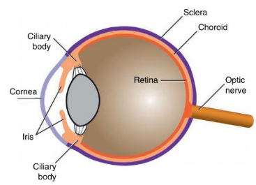
Figure 1: Cross-sectional anatomy of the human eye (Gelatt, 2021).
Disruptions of specific genes within each cell type can result in impaired photoreceptor function, defective nerve signal conduction, or structural instability of the retinal layers, thus creating characteristic disease phenotypes. The diversity of genes causing IRDs along with their different inheritance patterns and genotype-phenotype correlations underscores the importance of comprehensive and well-interpreted genetic testing (Schneider et al., 2022).
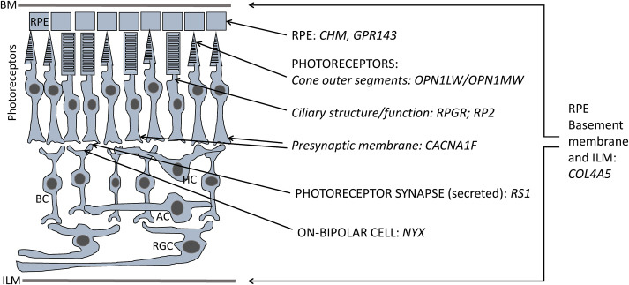
Figure 2: Schematic presenting location of RS1 function in retinal cell type (De Silva et al., 2021).
There was rapid progress in human understanding about the biological basis of these diseases over the past ten years, as well as significant advances towards gene-based therapies for each distinct genetic defect (Sahel et al., 2024). Addressing these challenges requires a comprehensive understanding of the genetic characteristics of such ocular diseases within each population, which provides an essential foundation for both clinical management and future therapeutic application. The majority of IRDs are treated symptomatically such as correcting the refractive error or surgery for media clear. In addition, the management is influenced by the age at which the disease first manifests. A multispecialty approach is crucial, for instance infants with significant visual impairment may also experience delays or challenges with speech, behavior, and social skills. The foundation for facilitating access to and possible benefits from the continuous advancements in the treatment is the molecular characterization of patients (Schneider et al., 2022).

The necessity of the study
X-linked retinoschisis and Norrie are two rare retinal disorders which result in severe impaired vision in children. They both have complicated clinical manifestations and easily overlap with other retinal diseases such as retinal detachment and retinopathy of prematurity. Given the urgent need for early and accurate diagnosis of the two conditions, reliance on clinical findings alone is insufficient. The integration of molecular diagnostic approaches is essential to enable precise disease and prognostic identification and provide appropriate genetic counseling for families. Genetic counseling helps families understand the risk of recurrence in subsequent pregnancies, enabling them to plan for prenatal screening or preimplantation genetic diagnosis (PGD), thereby contributing to reducing the disease burden.
To date, no scientific publications have reported on the genetic mutation characteristics underlying X-linked ophthalmic diseases, including XLRS and ND, in Vietnam. Therefore, conducting research utilizing eligible sequencing technologies to identify and characterize RS1 and NDP gene variants in XLRS and ND patients is significant. For the first time, this study will provide data on the mutation spectrum and association between genetic variants and clinical manifestations in the Vietnamese population. This research findings will contribute to the global genetic mutation database, better understand genetic diversity, and potentially detect variants specific to both Vietnamese and Southeast Asian population.
The status in developing solutions to treat inherited retinal diseases global is to create gene therapy for each individual defect. To solve the above problem, understanding, experience and knowledge about the genetic characteristics of each group of retinal diseases are extremely valuable. Along with this, accurately identifying mutation spectrum is a crucial first step in preparing for the future application of individualized therapies within the Vietnamese population.

Objectives
This study was implemented to detect pathogenic variants and characterize the molecular features in children diagnosed or suspected with XLRS and ND from Northern Vietnam. Detailed objectives include:
- collect a group of pediatric patients with a clinical diagnosis or suspect of XLRS and ND;
- analyze the molecular genetic of patients, genetic sequencing of RS1 and NDP gene to identify the causative or potentially pathogenic variants for two XLRS and ND groups, respectively;
- evaluate the possible associations between the variant type and/or location on the gene, and the clinical characteristics of the disease.

Scope and subject
This study only focuses on retinoschisis and Norrie disease by identifying the molecular characteristics of RS1 and NDP gene mutations in patients clinically diagnosed at the Vietnam National Eye Hospital from 2020 to 2025. Patients were examined and clinically diagnosed by clinical ophthalmologists. They were selected following the main criteria. The subjects included male pediatric patients aged less than 16-year-old, as both retinoschisis and Norrie predominantly affect males due to their X-linked recessive inheritance pattern. The eligible participants presented with clinical features suggestive of retinoschisis, consisting of schisis cavities, reduced visual acuity or retinal cysts. Clinical manifestations indicative of Norrie disease included early-onset vision loss, retinal detachment, cataract, or microphthalmia. All patients were from Northern Vietnam and their families agreed to provide informed consent for study participation as anonymous. This study also included the relatives of patients to confirm disease-gene carriers or transmitters and analyze familial segregation.
Each case was jointly discussed by ophthalmologists and genetic specialists to determine appropriate testing strategies and methodologies. According to the purpose of molecular analysis in this study, peripheral blood samples from the patient and familial members were collected and stored. The research will encompass ranging from clinical to molecular techniques. Functional assays, long-term follow-up, and therapeutic interventions are beyond the scope of this study.

CHAPTER 2. LITERATURE REVIEW

Overview of Inherited Retinal Disorders
The retina is a highly specialized neural tissue that plays a crucial role in visual perception by transforming light stimuli into electrical signals and sending them to the brain through delicate and precisely organized cellular networks (Bechrakis et al., 2015). Normal retinal function depends on the integrity of several retinal layers and the appropriate function of many retina-specific proteins. Disruption of these structural or molecular processes can impair signal transduction and lead to visual dysfunction.
Inherited retinal disorder (IRDs) is a heterogeneous group of ophthalmic disorders that affect human retina development, maintenance, and function directly and often lead to progressive loss of vision or blindness in children and young adults (Cremers et al., 2018; Liew et al., 2014). Genetic factors contribute significantly to various ophthalmological disorders with simple inheritance patterns in most cases ranging from autosomal dominant and recessive to X-linked transmission (Ben-Yosef, 2022). As reported in Retinal Information Network (RetNet), more than 300 different genes are associated with these modes of inheritance (https://sph.uth.edu/retnet). These genes encode proteins that serve a variety of purposes in the retina, from essential components of the phototransduction and retinoid cycle to structural aspects of retinal cells. Clinically, they encompass across distinct IRD subtypes and genes with a wide range of phenotypes such as retinitis pigmentosa, Leber congenital amaurosis, Stargardt disease, and retinoschisis. Due to the various genes cause IRDs, genetic testing plays an essential role with the abilities of differential diagnosis, management improvement of patients, prognosis development, and genetic counselling (Karali et al., 2022).
Over the past two decades, genetic diagnosis of inherited retinal diseases has advanced substantially, driven by remarkable progress in DNA sequencing technologies and human genomics. The availability has publicly accessible databases containing selected genomic variants and allele frequency data, together with improved pathogenic prediction tools, has significantly enhanced variant interpretation. Thus, the diagnostic yield and accuracy are also significantly increased. In parallel, the continuous reduction in sequencing costs has made genetic screening accessible to a broader patient population. Consequently, the number of molecularly characterized IRD cases has been growing, enabling deeper insights into disease etiology and the identification of clinically meaningful genotype–phenotype correlations (Karali et al., 2022). In addition, because IRD genes are linked to many clinical forms, only molecular genetics is frequently insufficient to strongly support a clinical hypothesis, highlighting the necessity of the combined knowledge of clinicians and ophthalmic geneticists in IRD patient administration.
X-linked retinopathies hold a major amount of monogenic retinal disorder and clinical importance due to their unique inheritance mechanism, mainly affecting males while female carriers may remain asymptomatic (Altun, 2020; Järvinen et al., 2025). For instance, the Center for Hereditary Retinal Degenerations from USA published that a significant proportion of X-linked inheritance found in a total of patients with IRDs who performed genetic testing (Garafalo et al., 2020). In both the overall and pediatric cohorts from United Kingdom, X-linked inheritance also accounted for a notable percentage of affected families, with a higher proportion observed in children. This might reflect the early onset and clinical severity characteristic of X-linked retinopathies (De Silva et al., 2021).
Within X-linked cases, RS1 was frequently found to be one of the most implicated genes, consistent with its role as the primary cause of X-linked retinoschisis, a condition that usually manifests in early childhood and is therefore more easily detected in pediatric cohorts (De Silva et al., 2021). Despite accounting for a smaller number of cases compared with RS1, NDP-associated retinopathy is nonetheless clinically relevant because of the severe and frequent congenital symptoms of Norrie disease such as bilateral retinal dysplasia and early-onset blindness. The comparatively low prevalence of NDP may be due to the rarity of the condition and possible underdiagnosis, especially in regions with limited access to advanced retinal imaging or molecular testing. However, both retinoschisis and Norrie disease are two notable conditions, each exhibiting distinct molecular mechanisms and complex phenotypic manifestations. Despite their distinct genetic etiologies, these conditions share overlapping clinical features in early childhood, including abnormal retinal findings and early-onset visual impairment or even blindness. Such phenotypic similarities may lead to diagnostic confusion. Therefore, genetic analysis is important for accurately identifying the underlying molecular causes of retinoschisis and Norrie disease, especially in male patients presenting with early-onset visual impairment. Early molecular diagnosis not only simplifies accurate clinical classification and prognosis but also permits appropriate genetic counseling and may inform emerging gene-based treatment approaches for X-linked retinal disorders.

Overview of X-linked retinoschisis
X-linked retinoschisis (or juvenile retinoschisis) is one of retinal disorders that lead to the splitting of neural retina and early reduced visual acuity (Duan et al., 2024; Weber et al., 2002). The number of X-linked retinoschisis (XLRS) patients is going up, but most are rare with an estimated prevalence of range between 1/5.000 to 1/25.000 males worldwide (Kjellstrm et al., 2010). Severe cases of XLRS are predominantly found in males, while female carriers do not exhibit any symptoms, although a thorough clinical examination can identify slight retinal abnormalities (Kim et al., 2007). Characteristic symptoms include mild to severe central vision loss, radial streaks from foveal schisis, inner retinal layer splitting in the peripheral retina, and a negative electroretinogram (ERG) due to a significant decrease in b-wave amplitude (Hu et al., 2017; Neriyanuri et al., 2016; Xu et al., 2011). The patients were normally diagnosed with XLRS at school age with the symptoms reading difficulties and poor vision (Hahn et al., 2022a). The XLRS typically presents in patients before the age of 10 years, and visual acuity (VA) at the initial examination is commonly from 20/60 to 20/120 (Hahn et al., 2022b). VA often worsens during the first and second decades of life, then generally remains stable until the fifth or sixth decade, when visual decline may occur due to macular atrophy. By the sixth to seventh decade, patients may progress to legal blindness (VA < 20/200).
The severity and progression of XLRS can vary between individuals and familial members. The hallmark of XLRS is foveal schisis or retinal splitting, which occurs in 98 to 100% of cases, as shown in the example of Figure 3. XLRS is also characterized by a cartwheel pattern of folds radiating out from the fovea, though, this might become less clear over time. Retinoschisis can be caused by the coalescence of intraretinal microcysts, which often advance from the inner nuclear layer or the outer plexiform layer to the inner retinal stratum (Molday et al., 2012). More than half of individuals experience schisis in the periphery, although it usually occurs in the macula. About 50% of individuals have bilateral maculopathy and peripheral retinoschisis, which are typically found in the inferotemporal region (Barbisan & Barbisan, 2021). Additionally, sublinear retinal fibrosis, vascular attenuation or sheathing, and pigmentation, which can mimic retinitis pigmentosa, are possible further peripheral alterations (Molday et al., 2012).
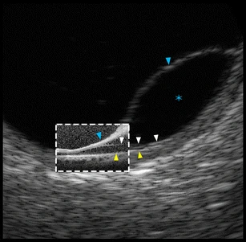
Figure 3: The separation of retinal layers in eyes with retinoschisis
(Agarwal et al., 2015).
X-linked retinoschisis is an inherited recessive degeneration caused by pathogenic variants of RS1 gene which lead to the deficient activity of a 224-amino-acid extracellular protein called retinoschisin. The retinoschisin protein functions as a homo-oligomeric octamer and is secreted by both photoreceptor and bipolar cells where it supports the preservation of the photoreceptor-bipolar synapses’ structure and the retina's cellular arrangement (Molday et al., 2012; Wu et al., 2005). Studies on pathogenesis show that the mutated protein cannot be secreted outside the cell or is structurally deformed, causing retinal structural trouble (Molday et al., 2012; Wu et al., 2005). At the cell surface, retinoschisin interacts with the Na⁺/K⁺-ATPase complex through its α and β subunits, thereby anchoring the protein to the plasma membrane and linking the extracellular environment to intracellular cytoskeletal organization and signaling pathways (Figure 4). This interaction is essential for maintaining retinal layer adhesion, synaptic stability, and proper signal transmission within the retina. Each RS1 subunit consists of four distinct domains: an N-terminal signal sequence (encoded by exons 1 and 2), a retinoschisin-specific domain (exon 3), a discoidin domain (exons 4 to 6), and a C-terminal segment (exon 6) (Wang et al., 2022). In which, the discoidin region is a common feature of many highly conserved extracellular proteins and a crucial role in cell-tissue interactions. It functions to form the octameric structure of retinoschisin, which contributes significantly to cellular organization and maintenance of synaptic connectivity in the retina (Bush et al., 2016).
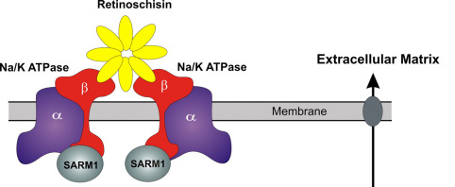
Figure 4: Description of retinoschisin-mediated signaling model and retinal structural stabilization (Molday et al., 2007).
Understanding XLRS at clinical, genetic, molecular, and cellular levels has advanced significantly. RS1 (OMIM: 300839) is a single-copy gene that spans around 32.421 kb of DNA on human chromosome Xp22.1, contains six exons and five introns. More than 250 mutations of the RS1 gene have been discovered to cause XLRS according to the public database of Human Gene Mutation Database (HGMD: https://portal.biobase-international.com) in 2019 (Kondo et al., 2019). Most of the variants belonging to the RS1 gene were missense resulting in single amino acid substitution, especially at the location of exon 4 and 6 (Huang et al., 2014). As reported in ClinVar, RS1 mutations are primarily single nucleotide changes.
Although no specific treatment is currently available to restore the split retinal, several management strategies may help control symptoms and prevent complications. Possible ways are comprised of regular follow-up to monitor disease progression, the use of carbonic anhydrase inhibitors such as acetazolamide or dorzolamide to reduce complications in XLRS and temporarily improve visual acuity, and surgical intervention in cases of retinal detachment or severe vitreous hemorrhage, though with limited prognosis (Wey et al., 2023). Gene therapy, which is currently under investigation, represents a promising future approach aimed at replacing or correcting RS1 gene mutations to recover retinal function.

Overview of Norrie disease
Norrie disease (ND, OMIM: 310600) is another rare inherited disorder that affects the growth of the neural retina’s vasculature (Le et al., 2023a). Most of affected patients are males, while females are usually asymptomatic (Huang et al., 2017). Males with Norrie disease often get bilateral and symmetrical ocular abnormalities. Rare cases of women suffered from moderate ocular phenotype or loss of hearing. These occurrences are secondary to spontaneous somatic mutations, non-random X-chromosome inactivation, or a mutation on both X chromosomes that occur in consanguineous families (Shastry et al., 1999; Sims et al., 1997). This disease is characterized by fibrous and vascular alterations in the retina at birth, which worsen throughout the course of childhood and adolescence and result in varying degrees of visual impairment (Donnai et al., 1988). The typical symptom of ND patients is blindness related to abnormal features such as retinal detachment, opacification of lens (cataract), iris atrophy, corneal opacity, or fibrovascular mass (pseudoglioma) (Rivera-Vega et al., 2005; Wu et al., 2007). Other ocular signs were also reported including increased intraocular pressure followed by the globe shrinkage (phthisis bulbi), glaucoma, or anterior and/or posterior synechiae (Scruggs et al., 2023). Beyond ocular features, ND patients may also develop learning or behavioral issues, peripheral vascular disease, and hearing loss (Sudha et al, 2017).
Norrie disease is caused by pathogenic variants in the NDP gene, which encodes Norrin, a small and secreted protein belonging to the cystine-knot growth factor superfamily (Hayashi et al., n.d.; Sudha et al, 2017). Norrin is structurally composed of two major domains: a highly conserved cysteine-knot motif that makes up most of the protein and an N-terminal signal peptide that aids in the protein's extracellular export (Le et al., 2023a). The retinal Müller glial cells secrete the Norrin protein that acts a ligand binding to Frizzle-4 (FZD-4) and low-density lipoprotein receptor-related protein-5 (LRP-5) receptors and activating the Wnt/β- catenin signaling pathway (Ohlmann & Tamm, 2012a; Ye et al., 2009). The β-catenin is subsequently translocated into the nucleus to trigger LEF/TCF transcription factors to regulate the target genes expression (Figure 5). It is thought that this pathway influences molecular mechanisms essential to the healthy development of the eye and other body systems, so the effects of ND are pleiotropic. Norrin is particularly important for the specialization of retinal cells and the creation of blood supply to the retina (De Silva et al., 2021).
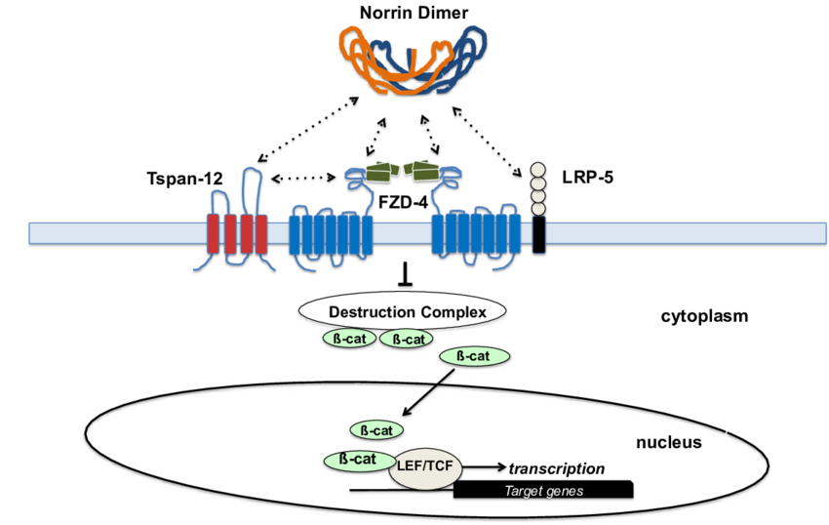
Figure 5: Description of Norrin/β-catenin signaling pathway (Le et al., 2023b).
The NDP gene spans 28 kb on chromosome Xp11.3 that consists of three exons, in which exons 2 and 3 are encoded, along with two introns (Figure 6). More than 160 pathogenic variants have been reported, ranging from single-nucleotide substitutions and small deletions or insertions to regulatory region variants (Jia & Ma, 2021). Most of the NDP variants were single nucleotide variants reported in ClinVar, resulting in an aberrant gene product (Zhou et al., 2021). The NDP mutations cause the vitreous chamber to fill with masses of immature retinal cells. A retrolental mass of disordered tissue results from retinal tissue breakdown brought on by disruption in the formation of blood vessels supplying the eye (Paes et al., 2011). Missense mutations that alter or remove individual amino acids but do not stop the synthesis of whole proteins typically have less extensive effects (Smith et al., 2012).
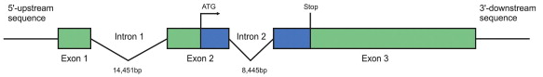
Figure 6: The structural model of the NDP gene (Ohlmann & Tamm, 2012b).

Molecular diagnostic approaches for inherited retinal disorders
Molecular diagnostics are an essential component of accurately classifying and managing IRDs due to their clinical overlap and genetic variability. Depending on the implicated genes, the inheritance pattern, and the clinical findings, several molecular approaches can be used. To interpret the genetic basis of IRDs, a range of technologies have been applied to identify disease-causing variants in the world. These include next-generation sequencing (NGS), particularly whole-exome sequencing (WES), Sanger sequencing or, in selected cases, multiplex ligation-dependent probe amplification (MLPA) for the detection of copy number variations.
    - Next-generation sequencing for IRDs
Next-generation sequencing (NGS) is widely applied to large IRD cohorts such as targeted gene panels, whole genome sequencing (WGS), or whole exome sequencing (WES) (Carss et al., 2016a, 2016b; Pozo-Valero et al., 2022; Stone et al., 2017). NGS has enabled extensive in-depth research that allows researchers to explore the complexities of genetic information in unprecedented ways. With its potential to analyze large datasets and affordable costs, NGS has become a foundational tool to discover more genes associated with human genetic disorders, along with contributing to elucidating the molecular basis of complex diseases (Coonrod et al., 2013). Furthermore, due to its ability to perform parallel sequencing of multiple target regions on NGS platforms, this technology has been continuously widely applied in diagnosis.
Building upon NGS, WES has been a cost-optimized approach to gene discovery that focuses on the functional coding regions of the human genome. The exome comprises approximately 1% of the genome, with roughly 30 million base pairs that contain about 85% of the mutations identified in Mendelian diseases (Ng et al., 2009). Recent advances in high-throughput sequence capture methods have made exome sequencing an effective and viable strategy for studying variants in coding regions. By sequencing the exome, WES provides us the genetic variations including single-nucleotide variants (SNVs), insertions, or deletions within protein-coding regions (Rabbani et al., 2013a). Normally, the sequencing process includes three main steps which are gDNA sample preparation, exome enrichment, and exome sequencing. In WES, after the genomic DNA is extracted and fragmented into short sequences, library preparation was employed through PCR amplification. The probes designed to capture protein-coding regions of the genome are used for target enrichment. Sequencing adapters and sample-specific barcodes are consequently ligated to the fragments, following multiplex sequencing. After that, the prepared libraries are sequenced that generate millions of short reads with sufficient depth of coverage to ensure reliable variant detection (Seaby et al., 2016). Bioinformatics pipelines are applied to process raw sequencing data, including read alignment, variant calling, and annotation .
Early research quickly demonstrated its clinical value, WES was able to detect causative mutations in uncommon Mendelian diseases after its introduction. As reported, more than 150 genes have been characterized as rare Mendelian disorders using WES, and this figure is rapidly increasing. By the early 2010s, WES became widely accepted in research and diagnostics due to its cost-effectiveness and relatively high diagnostic yield. Recent studies have reported that this method can achieve a diagnostic rate of approximately 25% in rare diseases, reflecting the potential application of WES in molecular diagnosis, treatment support, and genetic counseling (Yang et al., 2013). Nowadays, WES remains a key tool in medical genetics, rare disease discovery, and precision medicine (Goh & Choi, 2012). WES has demonstrated outstanding effectiveness in detecting disease-causing variants with overlapping clinical manifestations such as ophthalmic diseases. Conditions characterized by phenotypic or genetic heterogeneity are difficult to diagnose, and the application of WES has facilitated the diagnostic process (Rabbani et al., 2013b). Furthermore, WES allows for rapid sequencing of substantial amounts of DNA and aiding in differential diagnosis among various disease subtypes.
Several articles have discussed the efficacy of WES in the diagnosis of not only retinal disorders but also other inherited ophthalmology diseases. For example, WES was used to evaluate the genetic profile of suspected retinitis pigmentosa in a population of 279 Korean patients. Combined genetic testing using NGS and/or WES discovered a mutation in 44 retinopathy genes and 7 IRDs genes, and the overall mutation detection rate accounted for 57%. Among these, WES detected some concerning genotypes such as RS1 that were confirmed by ophthalmological re-phenotyping (Kim et al., 2021). In individuals that were clinically and genetically diverse, WES proved successful in diagnosing XLRS (Chen & Zhu, 2021). Additionally, in recent years, WES has been increasingly used to comprehensive detection of disease-causing variants in NDP (Dan et al., 2022; Gong et al., 2022; Li et al., 2022). In short, these studies highlight the necessity of WES for identifying genetic NDP subtypes, which is crucial for understanding the disease mechanism, improving diagnosis, and facilitating genetic counseling. Although WES effectively allows detection of variants in the coding region, this technique still has the risk of errors due to uneven coverage, exon capture errors, or bioinformatics analysis. Therefore, important variants detected from WES need to be confirmed by Sanger sequencing. Sanger sequencing is used on short gene segments to verify the accuracy of the results which provides much lower cost than repeating WES. This is especially necessary in the clinical application context, where errors in genetic diagnosis can greatly affect treatment or counseling decisions.
    - Sanger sequencing for IRDs
Sanger sequencing remains the most reliable method for analyzing individual candidate genes in cases with a well-defined phenotype or known familial mutation such as retinoschisis, Best disease, or choroideremia (Liu et al., 2021; Strupaitė et al., 2018; Weisschuh et al., 2020). Sanger sequencing is ideal to detect pathogenic variants of single gene with the detection rate of 86.58% that is higher than WES. This method is based on the “chain termination” technique by using modified deoxynucleotides that have lost the hydroxyl group at the 3’ end of sugar molecule. The 3’-OH group plays a role in allowing the addition of a new nucleotide to the chain. The sequencing reaction contained a mixture of dNTPs (dATP, dTTP, dCTP, dGTP), along with a little amount of fluorescently labeled ddNTPs (ddATP, ddTTP, ddCTP, ddGTP). The DNA polymerase synthesizes new strands until random incorporation of ddNTP elongates chain termination (Eren et al., 2022).
DNA strands of different lengths are separated by capillary electrophoresis, in which the fluorescently labeled ddNTPs indicates the terminating nucleotide of each fragment (Eren et al., 2022). The emitted fluorescent signals are detected and converted into an electropherogram that determines the nucleotide sequence of DNA. Capillary electrophoresis systems enable automated DNA sequence analysis and allow multiple samples to be analyzed in a single run (Garrido-Cardenas et al., 2017). Fluorescent signals are excited by a laser as DNA fragments pass through the detection window of the capillary, and the light is captured by a detector and recorded as fluorescence intensity over time. This information is translated into a chromatogram that can be visualized using DNA sequence analysis software. This data is also further processed into nucleotide sequences represented by the bases A, C, G, and T which displayed green, blue, black, and red, respectively (McCombie et al., 2019).
According to retinal disorder, Sanger sequencing was useful to identify the disease-causing of 149 Chinese patients affected with retinal dystrophies (Liu et al., 2021). In some patients who exhibited a compatible symptom and monoallelic pathogenic variants, WES was replaced by Sanger sequencing to find known intronic variants which were absent in the panel used (Karali et al., 2022). Sanger sequencing has also been normally performed to validate candidate variants of ophthalmic cases detected by WES (Jespersgaard et al., 2019; Luo et al., 2023). Additionally, Sanger sequencing is effectively analyzed individual candidate genes giving accurate results, reasonable cost and has been used routinely in the diagnosis of retinoschisis (Liu et al., 2021; Strupaitė et al., 2018). For instance, Sanger sequencing was effectively conducted to identify the RS1 variants from a South and North Indian patient cohort (Chatterjee et al., 2023; Chowdhury et al., 2024).
    - Multiplex ligation-dependent probe amplification (MLPA) for IRDs
Multiplex ligation-dependent probe amplification is useful for detecting copy number variants (CNVs) of IRDs that are not detected by sequencing. MLPA is a series of PCR-based reactions that enable the simultaneous amplification of multiple target sequences using only a single pair of primers. MLPA kits consist of multiple probes, each of which is composed of a pair of oligonucleotides designed to detect a specific DNA target region. Each oligonucleotide hybridizes complementarily to its corresponding sequence on the target DNA. Each MLPA probe has a unique length, generating amplification products of distinct sizes that can be separated by capillary electrophoresis. The forward primers used for probe amplification are fluorescently labeled, allowing each amplification product to be detected during capillary electrophoresis. By comparing the relative peak heights or areas of the amplification products from the test sample with those from a reference sample with a normal copy number, researchers can perform relative quantification of each target sequence. This relative ratio serves as a measure of the copy number present in the DNA region of interest (Stuppia et al., 2012).
MLPA not only facilitates definitive diagnosis but also informs prognosis, allows for familial screening, and supports the development of personalized treatment strategies, including gene therapy. For instance, screening of RB1 gene of retinoblastoma patients was performed by MLPA analysis using SALSA MLPA kit (Gupta et al., 2021). MLPA was also used to identify CNVs from 42 retinitis pigmentosa patients who were undiagnosed by NGS (Hiraoka et al., 2024). However, MLPA is rarely applied for variant detection in the RS1 and NDP genes, given the most pathogenic variants reported in these genes are single-nucleotide variants (SNVs) or small indels.
    - Molecular approaches used in this study
Depending on the suspected genetic etiology and clinical context, each of above molecular approaches offers distinct benefits. Retinoschisis cases are normally well-defined phenotypes which are mostly associated with the disease cause of RS1 gene. Thus, Sanger sequencing is the optimal approach used to identify pathogenic variants of RS1 gene in patients diagnosed with XLRS in this study. In addition, whole-exome sequencing was performed in patients suspected of XLRS and ND. WES was chosen to find NDP variants in Norrie cases because they exhibit symptoms like many diseases of the familial exudative vitreoretinopathy (FEVR) group, which are determined by multiple different genes (Trang et al., 2022a).
In this study, genomic DNA was extracted and used as the template for downstream molecular analyses including WES and Sanger sequencing. Nucleic acids need to be separated from impurities such as proteins, carbohydrates, and lipids, as the quality and integrity of the obtained nucleic acids directly affect the accuracy and reliability of subsequent studies. Therefore, DNA extraction procedures are designed to achieve high recovery efficiency and produce highly pure DNA. Early DNA extraction methods between 1950s and 1970s mostly relied on phenol–chloroform extraction and ethanol precipitation that were time-consuming, required toxic chemicals, and produced variable results. Silica-based purification methods were subsequently developed in 1990s which were based on the DNA binding selectively to silica in the presence of chaotropic salts (J Shetty, 2020). Recently, the development of commercial extraction kits such as Qiagen, Promega, and ThermoFisher have increased. They have been relied on the mini column method which standardized DNA isolation with high yield, purity, and reproducibility, and without hazardous solvents.
The process of DNA extraction and purification can be divided into two main groups, extraction of recombinant DNA such as plasmids or bacteriophages, and extraction of genomic DNA from prokaryotes or eukaryotes. The classic method of DNA extraction is based on the usage of organic or inorganic reagents and has been recently developed into the application of physical (J Shetty, 2020). Generally, DNA extraction involves four key steps, (i) breaking down the nuclear and cytoplasmic membranes to release genetic material; (ii) denaturation of nucleoprotein complexes; (iii) inactivation of nuclease enzymes to prevent nucleic acid degradation; and (iv) removal of contaminants to obtain purified DNA. To perform the desired downstream applications, it is essential to guarantee the quality and quantity of the extracted DNA that are assessed by gel electrophoresis or spectrophotometry.
As the extracted genomic DNA contains the entire genome and the target regions of interest are present at low abundance, direct Sanger sequencing is not feasible. Therefore, polymerase chain reaction (PCR) was performed to selectively amplify the target genomic regions, generating enough specific and homogeneous DNA fragments of appropriate length for sequencing. In a PCR reaction, the components include DNA template, primers, deoxynucleotide triphosphates (dNTPs), DNA polymerase, buffer, and Mg²⁺ ions, all of which are necessary for the amplification process to be accurate and efficient. Nowadays, instead of preparing each component separately, a pre-made and optimized mixture known as a master mix is commonly used (Lorenz, 2012). Master mix could reduce pipetting errors, save preparation time, increase the reproducibility of the reaction, and ensure optimal enzyme concentrations.
Typically, PCR is series of cycles, and each consists of three main phases, denaturation, annealing, and extension. Complete denaturation of the DNA template is crucial so that the primers can bind when the reaction complex cools. If the DNA template is not completely denatured, the two complementary strands tend to be quickly repaired, reducing the efficiency of primer annealing and extension, or leading to self-priming. The initial temperature increases to 94°C or 95°C in a few minutes, which is sufficient to separate the double-stranded DNA template into two single strands by breaking the hydrogen bonds between bases. In the subsequent step, choosing the annealing temperature is the most important factor in designing a thermal cycle for high-specificity PCR. The physical and chemical characteristics of the primers in solution determine the ideal annealing temperature. The temperature is normally lowered to around 54°C to 60°C allowing DNA primers to bind to complementary sequences on the single DNA strands, marking the start points for synthesis. Then, the reaction temperature is raised to 72°C for a few seconds to one minute for DNA polymerase to synthesize new strands. In practice, the reaction time and temperature depend on the DNA strand to be amplified. At the end of each cycle, one double-stranded DNA molecule synthesizes two double-stranded DNA, and by this way, the reaction occurs in 30 to 40 cycles. After the last cycle, the temperature is maintained at 72°C to complete the entire chain extension process for the partially synthesized products and to help the single strands pair up (Marmiroli & Maestri, 2025). The temperature is then lowered to 4°C for storage of the products. Following PCR amplification, gel electrophoresis was performed again to quantify the PCR products. Apart from size separation, electrophoresis-based nucleic acid fractionation can serve as a first step towards additional purification of a band of interest.

Genetical research status in the global and Vietnam
Hereditary eye diseases have gained considerable research attention in recent years. Studies have indicated that genetic factors play a critical role in the pathogenesis of ocular disorders, while rapid advances in genetic screening and therapeutic interventions are continually emerging (Lin et al., 2024). Recently, large-scale genetic screening initiatives for inherited eye disorders have expanded globally with the Global Eye Genetics Consortium (GEGC). GEGC are comprising more than 200 members from 30 countries, establishing the GenEye database to support research and promote international collaboration in rare inherited ocular diseases. In Asia, the Japanese Eye Genetics Consortium (JEGC) collected data from 1.538 families over a decade, WES was effective to increase the diagnostic yield from 17% to 53% (Iwata, 2022). Similarly, Chinese research involving 800 families with non-syndromic inherited retinal dystrophies highlighted the significant improvement in diagnostic accuracy achieved through molecular genetic testing (Liu et al., 2021). Overall, research in this field has continued to expand with annual publications increasing in recent years.
The X-linked ophthalmological diseases such as XLRS and ND have been globally in-depth over many decades. Both are rare genetic disorders affecting significantly visual function. Their clinical manifestations are diverse and easily confused, starting in childhood and progressing gradually over time. Several international studies have highlighted the phenotypic variability observed among patients carrying the same genetic mutation, underscoring the influence of genetic background and other regulatory factors (Xiao et al., 2016). Many studies have applied advanced technologies such as next generation sequencing to identify hundreds of RS1 and NDP gene variants and enhance the ability of diagnosis and genetic counseling. However, most current research has comprehensive clinical in European or East Asian populations, in which developed countries such as the United States, Germany, Chinese and Italian have been accessed to comprehensive clinical, application of modern technology and genetic databases facilitates large-scale studies (Den Dunnen et al., 1998; Huang et al., 2022; Pimenides et al., 2005; Simonelli et al., 2003). There are still limitations, such as the lack of ethnic-specific or regional studies, as well as the incomplete exploitation of the influence of factors regulating gene expression (van der Veen et al., 2024). Developing regions such as Southeast Asia, the Middle East, and Africa are less well-exploited for genetic data on XLRS and Norrie. Very few associated studies have compared retinal disorders such as between XLRS and ND using the same approach, creating a gap in understanding the common pathogenesis between the two diseases with the same X-linked inheritance pattern.
For instance, data from developing countries including Vietnam remain limited. To date, there have been no science reports characterizing RS1 or NDP gene variants in the Vietnamese population. This reflects a broader gap in the field of ocular genetics in Vietnam, where most research efforts have focused on more common ophthalmic conditions such as glaucoma, cataracts, diabetic retinopathy, or age-related macular degeneration. Several national-level medical institutions in Vietnam, such as the Vietnam National Eye Hospital and the Medical Genetics Institute in Ho Chi Minh City, have implemented next-generation sequencing (NGS) technologies. However, these efforts have primarily focused on oncology and pediatric metabolic disorders, with limited attention given to rare ophthalmological conditions such as XLRS and Norrie. Current diagnostic approaches for eye disorders mostly rely on clinical imaging and electrophysiological testing (e.g., OCT, ERG), which are insufficient for precise molecular diagnosis in genetically heterogeneous disorders.
In Vietnam, one of the main strengths of domestic research lies in the accessibility to diverse patient populations, as well as the growing collaboration between clinical institutions and genetic testing laboratories. However, this absence of comprehensive genomic research and epidemiological data on XLRS and ND in Vietnam not only highlights a critical knowledge gap but also presents significant challenges in clinical diagnosis, genetic screening, and genetic counseling. Given the early-onset and phenotypic variability of these disorders, missed or delayed diagnoses may lead to ineffective interventions or mismanagement. The accurate diagnosis of ophthalmology disease can be hard because many disorders of visual impairment have overlapping manifestations that require the support of genetic testing.
The status in genetic research on XLRS and ND in Vietnam significantly underscores the urgent need to conduct this study. Implementing studies using genomic technologies including whole-exome sequencing (WES) and Sanger sequencing to identify RS1 and NDP variants in the Vietnamese population is both timely and essential. Such efforts would not only expand the national database of inherited retinal disorders but also facilitate early diagnosis and treatment and improve genetic counseling for families affected by rare X-linked retinal conditions.

CHAPTER 3. MATERIALS AND METHODS

Research approaches
In this study, a genomic approach combined with clinical data was chosen to elucidate the genetic mechanism of retinoschisis and Norrie disease. Patients were first identified clinically through extensive ophthalmologic examination. Then, a genetic analysis strategy was implemented including (i) Whole-exome sequencing (WES) was applied for patients suspected of XLRS and ND; (ii) Sanger sequencing focusing on exons and intron-exon junctions of the RS1 gene for patients diagnosed with XLRS (Figure 7). In parallel, a family-based approach using Sanger sequencing was applied in cases with familial members to analyze the segregation of the variant in the pedigree, thereby increasing the confidence in confirming inheritance pattern. Finally, genetic variants and clinical manifestations were preliminarily observed to evaluate the genotype-phenotype correlation, contributing to expanding understanding of the genetic pathology of two rare disease groups in Vietnamese patients. The overall steps performed in this study are created and shown in Figure 7.
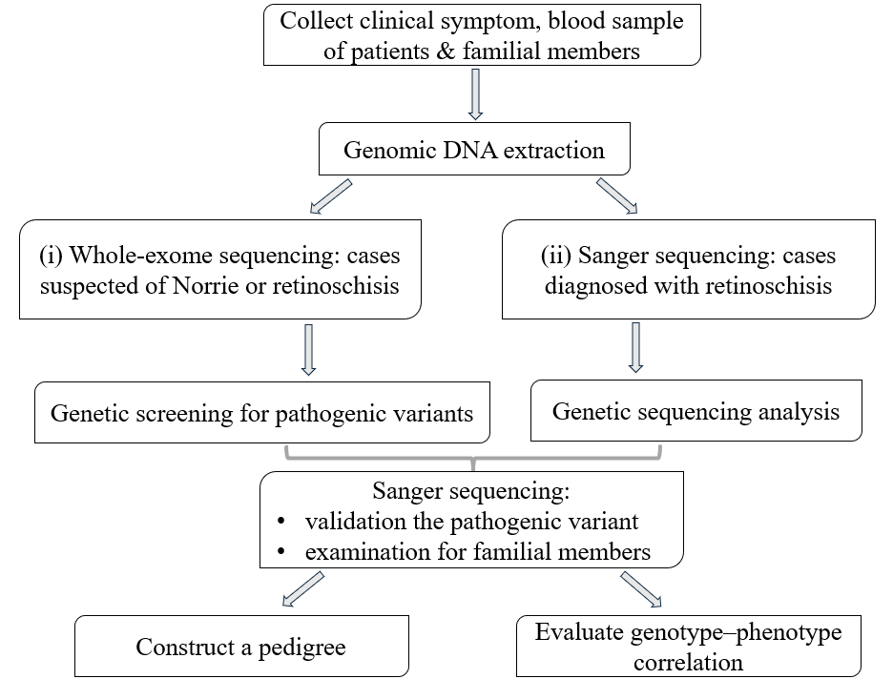
Figure 7: The diagram describes the steps in the research.

Patient cohort and phenotypes
The pediatric patients from Northern Vietnam who diagnosed or suspected with retinoschisis or Norrie disease at the National Eye Hospital (VNEH) in Hanoi were enrolled in this study, as well as their familial members. Due to the rare characteristics of two above diseases, the subject was chosen by convenience sampling method (Etikan et al., 2016). All the patients were ophthalmological examined and clinically diagnosed by ophthalmologists. The medical records were collected from 2020 to 2025, and the patient’s age was documented at the time of sample collection. Clinical ocular examinations were performed on the patients, including visual acuity test, fundoscopy (ophthalmoscopy) and/or ocular ultrasound (B-scan). The parents of patients voluntarily gave informed consent for the genetic testing of all familial members after receiving counseling from the clinician and genetic researcher. The approval of this study was obtained from the Institutional Review Board of the Institute of Genome Research, Vietnam Academy of Science and Technology (Approval No.4-2024/NCHG-HĐĐĐ). Peripheral blood samples (2 ml) of the patients and their family members were collected into tubes containing ethylenediamine-tetraacetic acid (EDTA) anticoagulants and kept at -20℃ until use.

Materials used for this study
The materials and instruments used for this study belong to the Institute of Biology, Vietnam Academy of Science and Technology.
The principal equipment used included a vortex mixer (Dragon, China), a −20 °C freezer (Sanaky, China), an analytical scale (Ohaus, USA), a refrigerator with freezer compartment (Electrolux, Sweden), a centrifuge (Eppendorf, Germany), and a multifunctional refrigerated centrifuge 5810R (Germany), a spectrophometer of NanoDrop™ Lite (ThermoFisher Scientific, USA), a PCR thermal cycler (Mastercycler Pro S, Germany), an electrophoresis system (Bio-Rad), a gel automated imaging of DigiDoc-It™ System (Ultra-violet Production, USA), a vacuum concentrator of SpeedVac (Eppendorf, Germany), and a DNA sequencer Applied Biosystems 3500/3500xL Genetic Analyzer system (Applied Biosystems, Waltham, Massachusetts, USA).
Laboratory consumables and instruments included single and multichannel micropipettes (Eppendorf, Germany), stepper pipettes with combitips (Eppendorf, Germany), 1.5 mL microcentrifuge tubes (Corning, USA), 15 and 50 mL falcon centrifuge tubes (Biologix, USA), 0.2 mL PCR tubes (QSP, USA), 96-well PCR plates (Biologix, USA), 96-well purification plates (Merck Millipore, USA), and 96-well sequencing plates (ABI, USA).
The chemical reagents utilized in the research comprise of ${Exgene}^{TM}$ Blood SV mini 250p Kit (GeneAll, Korean), Tris-EDTA (TE, 0.1X), Agarose (Bioworld, USA), 6X DNA Loading Dye (ThermoFisher Scientific, USA), TAE (50X) buffer, primers for DNA amplification (PHUSA Genomics Company, Can Tho, Vietnam), distilled water (Life Technologies, USA), DreamTaq Green Master Mix (ThermoFisher Scientific, USA), GeneRuler 1kb DNA Ladder (ThermoFisher Scientific, USA), E.Z.N.A. Cycle Pure Kit (Omega Bio-tek, USA) for purification of PCR products, BigDye™ Terminator v3.1 Cycle Sequencing kit (Applied Biosystems, California, USA), 0.5M EDTA pH 8.0 (ThermoFisher Scientific, USA) , Hi-di™ Formamide (ThermoFisher Scientific, USA).

Genomic DNA extraction
Genomic DNA was extracted from peripheral blood samples using ${GeneAll}^{®}$ ${Exgene}^{TM}$ Blood SV mini 250p Kit (Korean) following the manufacturer’s guideline. Peripheral blood was selected as the prioritize source for genetic sequencing because it is minimally invasive, long-term storage, and widely accepted in clinical practice.
20 µl of proteinase K (20 mg/ml) solution was prepared in the bottom of a 1.5 ml microcentrifuge tube, and 200 µl of blood sample was then transferred to each tube. After that, 20 µl of RNase A (20 mg/ml) was also added to the sample, the mixture was incubated at room temperature for 2 min. 200 µl of buffer BL was mixed in the recent mixture. The sample tubes were subsequently incubated at 56°C for 15 min along with TE 0.1X (Tris HCl 1 mM and EDTA 0.1 mM, pH 8.0), and 200 µl of absolute ethanol was then transferred to the samples. All tubes were vortex and briefly spin down to remove drops from the inside of the lid. All the mixture was transferred to the column type G (mini), centrifuged at 10.000 rpm for 1 min, and the collection tube was replaced with a new one. Samples were washed through 600 µl buffer BW and 700 µl buffer TW by centrifuging at 10.000 rpm for 1 min, respectively. Dry centrifuge was performed at 13.000 rpm in 1 min to eliminate remaining wash buffer. The collection tube was replaced with the new 1.5 ml tube. Finally, 70 µl incubated TE (0.1X) was eluted fast into tubes, left for about 5 to 10 min at room temperature and centrifuged 13.000 rpm for 1.5 min.
The quality of extracted DNAs was assessed by 1% agarose gel electrophoresis. Agarose gel was prepared prior to electrophoresis by dissolving 1 g of agarose in 99 mL of TAE (1X) buffer in a heat-resistant flask. TAE (1X) was diluted from a stock of 50X which consists of Tris-base, acid acetic, and EDTA (0.5M pH 8.0). The mixture was heated in a microwave until the agarose was completely dissolved. After cooling to about 50°C to 60°C, the molten agarose was poured into the gel trays with combs in place and allowed to solidify at room temperature for about 15 min. The extracted DNA was subsequently mixed with 6X DNA Loading Dye (ThermoFisher Scientific, USA). Electrophoresis was performed for about 30 min, ensuring that the electric current flowed in the correct direction. After that, to detect DNA bands stained with ethidium bromide (EtBr), an Ultra-violet DigiDoc-It™ imaging system (USA) was used to visualize.
DNA concentration was assessed using the NanoDrop™ Lite Spectrophotometer (ThermoFisher Scientific, USA) for rapid determination needing small volume of sample. Nuclease-free distilled water was utilized as a blank solution. After establishing and confirming blank measurement, 1 µL of each DNA sample was pipetted onto the bottom pedestal, followed by absorbance measurement at 260 nm, and 280 nm. This machine operates based on the principle of light absorption of nucleic acids and proteins, while DNA absorbs strongly at 260 nm, proteins absorb at 280 nm. The concentration of the DNA was displayed in ng/µL, and A260/A280 ratio was recorded to assess DNA purity. The A260/A280 from 1.8 to 2.0 indicates pure DNA, while the lower ratio suggests protein contamination.

Whole-exome sequencing (WES)
The extracted genomic DNA of patients suspected of XLRS and ND was performed to whole-exome sequencing (Macrogen, Seoul, Korea). The DNA library was prepared using SureSelect V6-Post (Agilent Technologies, California, USA) according to the manufacturer’s instructions. The sequencing library is prepared by random fragmentation of DNA which is then ligated with 5’ and 3’ adapters. Fragments ligated with adapter were subsequently amplified by PCR and gel purified. The Qubit dsDNA HS Assay Kit (Thermo Fisher Scientific, Massachusetts, USA) was used to quantify the enriched library. A high sensitivity DNA chip bioanalyzer (Agilent Technologies, Santa Clara, California, USA) was employed to check the DNA fragments distribution, with an expected size range from 200 bp to 400 bp. Sequencing was conducted on an Illumina NovaSeq 6000 platform (Illumina, California, USA) with paired reads of 150 bp. The mean exome coverage was more than 100X, and each target base had at least 20X coverage.
The data from WES was then used to screen for candidate variants of Norrie disease- and XLRS-associated genes according to the typical workflow as described in our previous publications (Ma et al., 2021; Trang et al., 2022b). Short indels within the repeat region and the first or the last of 10 bp length were discarded, along with variants that located in non-coding regions. The remaining variants are then filtered through the ClinVar, 1000 Genome Project (1000G) database and the Exome Aggregation Consortium (ExAC). The novel and rare variants that fit any of the genetic models were considered as candidates’ pathogenic variants and selected for further evaluation. Variants were subsequently classified for clinical significance according to the American College of Medical Genetics and Genomics (ACMG) recommendations. The workgroup updated standard terminology to interpret variants of Mendelian diseases, including pathogenic, likely pathogenic, uncertain significance, benign, or likely benign. They recommended the guidelines to classify sequence variants basing on typical criteria such as population, functional, segregation data (Richards et al., 2015).

Primer design and polymerase chain reaction (PCR)
The primer sequences specifically to amplify RS1 and NDP genes in this study were designed using Primer 3 software (v.0.4.0) based on the reference sequence consulted in the National Library of Medicine (National Center for Biotechnology Information -NCBI) GenBank database. The rules for primer design are followed (i) primers are typically 18–25 nucleotides in length; (ii) G-C content should be between 40% and 60%; (iii) melting temperature (Tm) for primers ranging from 57°C to 63°C; (iv) the difference in Tm between forward and reverse primers does not exceed 5°C. In addition, a GC clamp (one or two G/C bases at the 3′ end) is often preferred to improve binding stability. The output of Primer 3 includes candidate primer sequences and their Tm, GC content, and predicted product size. The parameters of the primer pairs such as nucleotide number, the ratio of guanine-cytosine, melting point, self-binding ability, and hairpin structure ability, were checked using IDT OligoAnalyzer tool. The specific primers were supplied by PHUSA Genomics Company (Can Tho, Vietnam; Table 1).
Table 1: Primer sequences used for this study.
Gene | Exon | Primer sequence (5’-3’) | Amplicon size (bp)
RS1 | 1 | F: ACTTAATCCCCTGCTCCTGG  R: GCCATCCACACAAAGACAACT | 292
RS1 | 2 | F: TGTAACGAGTGATGCTGTTGG  R: CACCATGCCCAGCCAAAATA | 227
RS1 | 3 | F: GCTGTGTGTATTGAGGCTG  R: CCAATGACTGTTCCATCC | 300
RS1 | 4 | F: TAAAGCCTTCTCCGTCTCCG  R: GCCACCACGCCAGTTAATTT | 384
RS1 | 5 | F: CATCCCCTCGAGAGCCAG  R: TGACAGAGGGCAGTGACAG | 370
RS1 | 6 | F: CTTCCTTTTCCCTCCCCGAT  R: TATAGCCCTGTCCATCTCGG | 300
NDP | 2 | F: GGATCCTAGGAGGTGAAGCC  R: TGGCTTCTTGCCTGTTTCTG | 314
NDP | 3 | F: ACGAGTGTGAGGGTCTTTCA  R: AGTCTTTCCCTGGCTGGTCG | 650
F: Forward primer, R: Reverse primer.
The polymerase chain reaction (PCR) ingredients were 20 µl in total volume including 7.5 µl distilled water (Life Technologies, USA), 10 µl DreamTaq Green Master Mix (ThermoFisher Scientific, USA), 0.75 µl of each primer (concentration of 10 pmol/µl), and 1.0 µl genomic DNA. The PCR thermocycle was performed as shown in Table 2. DNA amplified by PCR were subsequently examined by 1% agarose gel electrophoresis, and their amplicon size was compared to GeneRuler 1kb DNA Ladder (ThermoFisher Scientific, USA). After PCR products were stained with ethidium bromide, they were captured by a UV transilluminator.

Table 2: The temperature and number of cycles used for DNA amplification.
Process | Temperature | Time | Cycle
Pre-denaturation | 95ºC | 2 min | 1
Denaturation | 95ºC | 30 sec | 35
Annealing of primer | 58ºC | 30 sec | 35
Extension | 72ºC | 30 sec | 35
Final extension | 72ºC | 8 min | 1
Storage | 4ºC | ∞ | 1
The eligible PCR products were then purified using E.Z.N.A. Cycle Pure Kit (Omega Bio-tek, USA) following the manufacturer’s guidelines. All PCR products were added with 100 µL buffer CP, mixed thoroughly, and then centrifuged for 20 sec to collect any drops inside the tubes. The mixture was transferred to the Hibind DNA Mini column inserted into each 2 mL collection tube. These tubes were centrifuged at 10000 rpm for 60 sec at room temperature. After that, the collection tubes were reused, and the filtrate was discarded. 700 µL DNA wash buffer was added into the collection tube and centrifuged them at 10000 rpm for 60 sec (this step was repeated twice). The collection tubes were reused, and the filtrate was discarded again. The empty Hibind DNA Mini columns were centrifuged at 10000 rpm for 2 min and then transferred into a 1.5 mL tube. 25 µL deionized water was added into the center of the column matrix. After that, put all tubes at room temperature for 5 min and centrifuged them at 13000 rpm for 1.5 min. DNA was stored at -20℃.

Sanger sequencing
Sanger sequencing was used to validate pathogenic variants identified by WES in patients clinically suspected of XLRS and ND. It was also a genetic test for the patients diagnosed with XLRS and familial members of all patients. Forward primers in Table 1 were diluted to a concentration of 2 pmol/µl to participate in the cycle sequencing reaction. The total reaction volume using BigDye™ Terminator v3.1 cycle sequencing kit (Applied Biosystems, California, USA) was shown in Table 3. The thermal cycle involves an initial denaturation at 96°C for 45 sec, followed by 25 cycles of 96°C for 10 sec, 50°C for 5 sec, and 60°C for 4 min, concluding with a 4°C hold.

Table 3: The components of PCR for Sanger sequencing.
Ingredient | Volume (µL)
Distilled water | 5.5
Primer | 1
BigDye Terminator Master Mix (2.5X) | 1
BigDye Teminator 5X Sequencing Buffer (5X) | 1.5
PCR product | 1
Total | 10 µL/1 reaction
Before sequencing, the resulting products were purified after being transferred to the pure 96-well plate. 2 µL of EDTA (concentration of 0.125 mM, pH 8) and 60 µL absolute ethanol were added to each sample, respectively. These wells were centrifuged at 4000 rpm for 30 min at 4℃ and the supernatant was removed. 60 µL of ethanol 80% was subsequently transferred to each well. The plate was continuously centrifuged at 4000 rpm at 4℃ during 30 min and the supernatant was discarded again. These samples were dried at 30℃ for 10 min to remove ethanol. 10 μL of Hi-di™ Formamide (ThermoFisher Scientific, USA) was added to redisperse the samples, then denatured at 98℃ for 2 min. The plate was finally stored at 4℃ for 5 min.
The final products were directional sequenced on the Applied Biosystems 3500/3500xL Genetic Analyzer system (Applied Biosystems, California, USA). The sample was performed capillary electrophoresis with the electrophoresis parameters set as in Table 4.
Table 4: Parameters of capillary electrophoresis in Sanger sequencing system.
Capillary array name | 8-Capillary
Capillary length | 50cm
Setting | Polymer: POP-7™  Run module: Rapid sequencing  Run time: 1800 sec  Injection voltage: 1.6kV  Injection time: 15 sec  Oven temperature: 60℃
The signal was automatically recorded, analyzed, and stored on the computer that was linked to the Applied Biosystems 3500/3500xL system. Sequencing data was assessed for analysis using SnapGene and BioEdit software. The nucleotides along the gene segment are represented as peaks, with four distinct colors corresponding to the four types of nucleotides A, T, G, and C. The sequencing results of the study samples were compared with reference gene sequences, as well as among individuals, to detect variations. The reference sequence of the human RS1 and NDP genes were available with numbered NM_000330.4 and NM_000266.4, respectively in the NCBI GenBank database.

CHAPTER 4. RESULTS AND DISCUSSION

Clinical characteristics of patients
In this study, clinical data of a total of 14 XLRS and 1 ND patients were collected as described in Tables 5 and 6. All were male with ages ranging from 2 months to 10 years. For XLRS group, 14 patients belong to 10 families, including one family with three affected siblings (patient’s ID: FEVR042-044), two families with pairs of siblings (patient’s ID: FEVR046-047 and FEVR049-050), and seven families with a single case (Table 5). For ND, there were 2 patients belonging to two unrelated families (Table 6).
A total of nine patients had reported familial history of visual problems, while there were no records in the families of remaining seven patients. Patient FEVR045 had a patient’s brother of maternal grandmother having strabismus and patient FEVR052 with family history of poor vision that was noted in the maternal grandfather and his two brothers.

Table 5: Clinical characteristics of XLRS patients.
Familial ID | Sample ID | Age | Familial history | Ocular features | Other findings
1 | FEVR038 | 4y | - | Retinoschisis, retinal cyst | Scleral buckle surgery  (both eyes)
2 | FEVR040 | 5y | - | Retinoschisis | -
3 | FEVR041 | 5y | - | Retinoschisis | -
4 | FEVR042 | 10y | + | Retinal detachment, visual impairment | -
4 | FEVR043 | 7y | + | Retinal detachment, cataract, strabismus | Scleral buckle surgery  (right eye)
4 | FEVR044 | 3y | + | Retinal detachment, farsightedness | -
5 | FEVR045 | 4y | + | Retinal detachment, strabismus | -
6 | FEVR046 | 9y | + | Retinoschisis, retinal detachment, vitreous opacities | -
6 | FEVR047 | 3y | + | Retinal detachment, cataract | -
7 | FEVR048 | 5y | - | Retinoschisis, retinal fold, astigmatism, strabismus,  vitreous opacities | -
8 | FEVR049 | 8y | + | Retinoschisis, astigmatism, macular edema, elevated intraocular pressure (IOP), vitreous opacities | -
8 | FEVR050 | 7y | + | Retinoschisis, astigmatism, myopia, macular edema, elevated IOP, vitreous opacities | -
9 | FEVR051 | 8y | - | Retinoschisis, secondary glaucoma | -
10 | FEVR052 | 4y | + | Retinoschisis, retinal detachment, astigmatism, strabismus, vitreous opacities | Scleral buckle surgery  (left eye)
y: year, +: yes, -: no

Retinal problems were detected in all XLRS patients, including retinoschisis, retinal detachment, or retinal folds. Other ocular features such as strabismus, elevated intraocular pressure, macular edema were discovered in some patients, which were all collected in Table 5. The ophthalmic phenotypes of FEVR043 and FEVR045 were both captured and they showed strabismus in two eyes (Figure 8A). Ocular ultrasound (B-scan) identified many symptoms of XLRS patients, for instance, retinal detachment accompanied by vitreous opacities in FEVR048, and macular edema with vitreous opacities of FEVR049 and FEVR050. Notably, three patients FEVR038, FEVR043 and FEVR052 had overcame scleral buckle surgery, which is a treatment of progressive retinal detachment derived from retinoschisis (Beatson et al., 2021). The patients from FEVR038 to FEVR052 were mostly diagnosed with retinoschisis by ophthalmology clinicians, except for two cases, FEVR038 and FEVR042, that were at the suspected stage.
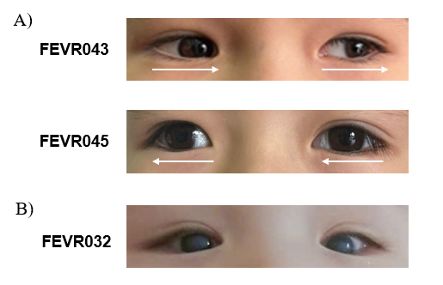
Figure 8: Ophthalmology phenotype of patients.
A) Patient with strabismus (arrows indicating the direction of ocular deviation in the primary position of gaze); B) Patient with cataract and corneal opacification.
The initial clinical suspects of patients FEVR031 and FEVR032 were both Norrie disease. Patient FEVR031 exhibited retinal detachment and cataract, with vitreous hemorrhage being the most severe complication. In patient FEVR032, a visual acuity test revealed corneal opacification in both eyes (Figure 8B). B-scan identified cataract and showed that axial length measurements were 15.2 mm in the right eye and 15.3 mm in the left eye, both significantly below the normal mean of approximately 19 mm according to current age of diagnosis, confirming bilateral microphthalmia in patient FEVR032.
Table 6: Clinical findings of suspected Norrie patients.
Familial ID | Sample ID | Age | Familial  history | Ocular features | Other findings
11 | FEVR031 | 5y | - | Vitreous hemorrhage, retinal detachment, cataract | -
12 | FEVR032 | 2m |  | Vitreoretinal proliferation, retinal detachment, cataract, microphthalmia | -
m: month, y: year, -: no

Blood sample collection and DNA extraction
The peripheral blood samples of total 16 patients, of which 14 cases with XLRS and 2 cases with ND, along with 26 patients’ relatives were collected. Genomic DNA extracted from the blood samples was examined by electrophoresis in 1% agarose gel. It showed that DNAs were well extracted, and all bands were intense and unbroken (Figure 9, Supplementary Figure 1).
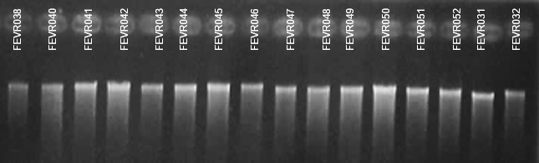
Figure 9: Visualization of extracted DNA from patient samples on 1% agarose gel.
The results showed that the concentration of samples ranged from 36.2 to 114.0 ng/μL. High purity of the extracted DNA was confirmed by A260/A280 ratios primarily between 1.8 and 2.2 (Table 7, Supplementary Table 1). Thus, the quality of the isolated total DNA was sufficient for downstream experiments.

Table 7: Concentration and purity assessment of DNA extracted from samples.
Familial ID | Sample  ID | DNA concentration (ng/μL) | A260/A280
1 | FEVR038 | 97.7 | 1.80
2 | FEVR040 | 73.3 | 1.82
3 | FEVR041 | 50.7 | 1.88
4 | FEVR042 | 61.1 | 1.81
4 | FEVR043 | 64.3 | 1.87
4 | FEVR044 | 39.0 | 1.80
5 | FEVR045 | 97.8 | 1.85
6 | FEVR046 | 56.2 | 1.81
6 | FEVR047 | 52.0 | 1.82
7 | FEVR048 | 63.3 | 1.84
8 | FEVR049 | 40.0 | 1.80
8 | FEVR050 | 36.2 | 1.82
9 | FEVR051 | 114.0 | 1.85
10 | FEVR052 | 69.6 | 1.86
11 | FEVR031 | 44.2 | 1.80
12 | FEVR032 | 65.6 | 1.82

Genetic analysis for X-linked retinoschisis group

Genetic analysis for XLRS patients and their familial members
In this study, two XLRS patients (FEVR038 and FEVR042) underwent WES to identify the pathogenic variant. Patient FEVR038 was the first case in this study cohort with complicated retinal symptoms. Patient FEVR042 is the youngest child in a family with three affected sons. While twelve patients were examined using Sanger sequencing for exons and intron-exon junction of the RS1 gene.
As the results showed in Table 8, WES analysis identified both the patient FEVR038 and FEVR042 had a nonsense variant, respectively, c.59T>A (p.Leu20*) located in exon 2 and c.657C>A (p.Cys219*) in exon 6 of the RS1 gene. Two above variants are novel because they have not been reported in international genetic databases including ClinVar and the Human Gene Mutation Database (HGMD). These variants were classified as likely pathogenic according to the ACMG guidelines (Richards et al., 2015). Sanger sequencing detected 9 variants of RS1 in 8 probands (FEVR040, FEVR041, FEVR045, FEVR046, FEVR048, FEVR049, FEVR051, FEVR052) of 8 remaining families. In which, the proband FEVR049 has a RS1 allele with twice missense variant, c.[221G>C;301G>A]:p.[Gly74Trp; Ala101Thr]. Four patients (FEVR043, FEVR044, FEVR047, FEVR050) who were second or third affected members in their family were also identified carrying RS1 variant. Sanger chromatogram showed all the affected males exhibited a single mutant peak confirming hemizygous status (Figure 10). Of these identified variants, there was one frameshift, two nonsenses, and seven missenses. The reference sequence of RS1 (NM_000330.4) was utilized for variant annotation.
All variants were classified as either pathogenic or likely pathogenic depending on disease and variation databases. For previously reported variants including c.176G>A, c.325G>C, c.424T>C, c.579dupC, c.625C>T, c.655T>C in RS1 gene, classification information was referenced from the ClinVar and HGMD, and dbSNP ID were provided in case of available conditions in public databases. While the remaining four variants are novel due to their absence from the public database and subsequently interpreted following the 2015 ACMG/AMP guidelines.

Table 8: Genetic variants identified in patients.
Sample ID | Gene | Variant change |  | Location | Variant type | Zygosity | SNP ID  reference | Classification | ACMG  /AMP  criteria
Sample ID | Gene | cDNA | Amino acid
FEVR038*** | RS1 | c.59T>A | p.Leu20* | Exon 2 | Nonsense | Hemi | Novel | Likely pathogenic ³ | PVS1,  PM2
FEVR040 | RS1 | c.424T>C | p.Cys142Arg | Exon 5 | Missense | Hemi | - | Pathogenic ^{1,2} | -
FEVR041 | RS1 | c.59T>A | p.Leu20* | Exon 2 | Nonsense | Hemi | Novel | Likely pathogenic ³ | PVS1,  PM2
FEVR042*** | RS1 | c.657C>A | p.Cys219* | Exon 6 | Nonsense | Hemi | Novel | Pathogenic ³ | PVS1,  PM2, PP1
FEVR043 | RS1 | c.657C>A | p.Cys219* | Exon 6 | Nonsense | Hemi | Novel | Pathogenic ³ | PVS1,  PM2, PP1
FEVR044 | RS1 | c.657C>A | p.Cys219* | Exon 6 | Nonsense | Hemi | Novel | Pathogenic ³ | PVS1,  PM2, PP1
FEVR045 | RS1 | c.579dupC | p.Ile194Hisfs*70 | Exon 6 | Frameshift | Hemi | rs199469697 | Pathogenic ^{1,2} | -
FEVR046 | RS1 | c.625C>T | p.Arg209Cys | Exon 6 | Missense | Hemi | rs281865361 | Pathogenic ^{1,2} | -
FEVR047 | RS1 | c.625C>T | p.Arg209Cys | Exon 6 | Missense | Hemi | rs281865361 | Pathogenic ^{1,2} | -
FEVR048 | RS1 | c.176G>A | p.Cys59Tyr | Exon 3 | Missense | Hemi | rs1928229547 | Likely pathogenic ^{1,2} | -
FEVR049 | RS1 | c.[221G>C; 301G>A] | p.[Gly74Trp; Ala101Thr] | Exon 4 | Missense | Hemi | Novel | Likely pathogenic ³ | PM2, PM5, PP1, PP2
FEVR050 | RS1 | c.[221G>C; 301G>A] | p.[Gly74Trp; Ala101Thr] | Exon 4 | Missense | Hemi | Novel | Likely pathogenic ³ | PM2, PM5, PP1, PP2
FEVR051 | RS1 | c.325G>C | p.Gly109Arg | Exon 4 | Missense | Hemi | rs104894934 | Pathogenic ^{1,2} | -
FEVR052 | RS1 | c.655T>C | p.Cys219Arg | Exon 6 | Missense | Hemi | rs281865369 | Likely pathogenic ^{1,2} | -
FEVR031*** | NDP | c.362G>A | p.Arg121Gln | Exon 3 | Missense | Hemi | - | Pathogenic ^{1,2} | -
FEVR032*** | NDP | c.77delC | p.Thr26Ilefs*15 | Exon 2 | Frameshift | Hemi | Novel | Likely pathogenic ³ | PVS1,  PM2
***: samples were performed WES, Hemi: Hemizygosity; -: unavailable.
¹, ², ³: clinical classification based on ClinVar, HGMD, ACMG/AMP’s guideline, respectively.
The reference sequence according to NCBI: RS1 gene: NM_000330.4, NDP gene: NM_000266.4.

For the location, RS1 variants were detected across exons 2 through 6, with each exon showing its characteristic pattern of mutation types. Of which, two different nonsense mutations were found at exons 2 and 6. Firstly, exon 2 contained only nonsense variant c.59T>A (p.Leu20*) identified in patients FEVR038 and FEVR041. This variant revealed a substitution of thymine to adenine at residue 59 of RS1 gene that changed a leucine to a stop codon at position 20 of retinoschisin. The variant c.59T>A (p.Leu20*) is expected to terminate the translation near the N-terminal signal peptide, which can lead to the deficiency of disulfide-linked octamer formation. This complex is associated with the bipolar cell surface which has the main function of standing for the structural retina integrity (Molday et al., 2007). Due to the presence of null variant and its absence from control data, c.59T>A (p.Leu20*) was classified as likely pathogenic by meeting two categories of ACMG/AMP’s guideline (PVS1 and PM2).
The second nonsense variant is c.657C>A (p.Cys219*) at exon 6 that was detected in three patients FEVR042, FEVR043, and FEVR044 who are siblings. This mutation could lead to the terminal cysteine residue and premature termination loss, which would be predicted to the decreasing of retinoschisin protein’s stability and function. While c.657C>A (p.Cys219*) has been absent from ClinVar/HGMD database, it was reported as pathogenic variant in a science report of Chinese cohort. The 60-year-old male diagnosed with XLRS carrying the variant c.657C>A with the manifestation of poor visual acuity and retinal atrophy (Guo et al., 2022). In contrast, three siblings in this study markedly exhibited more severe phenotypes at a younger age, supported to the pathogenic classification of the detected variants.

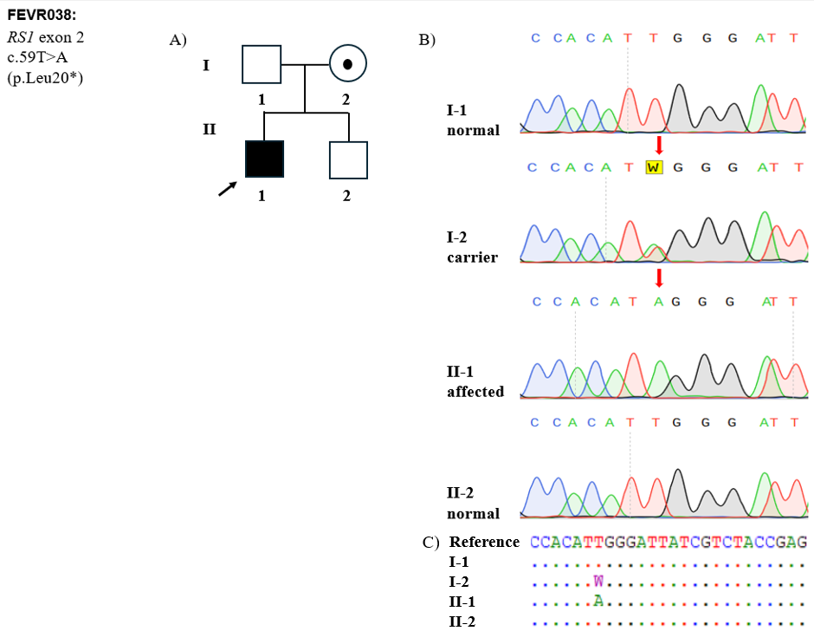
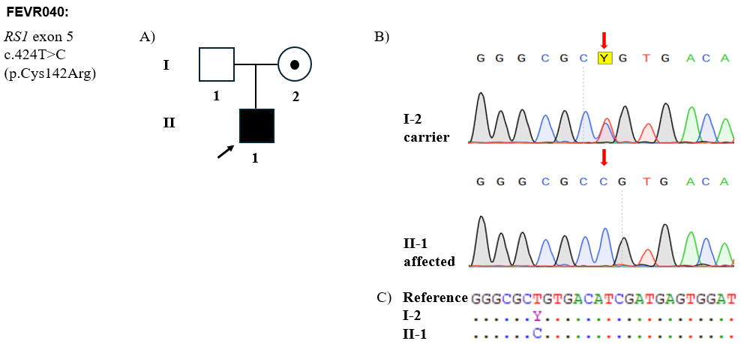
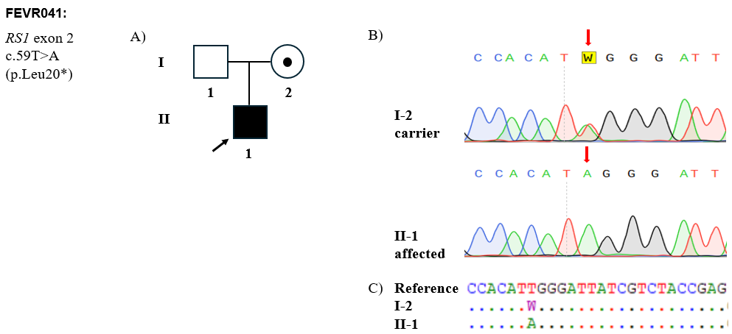
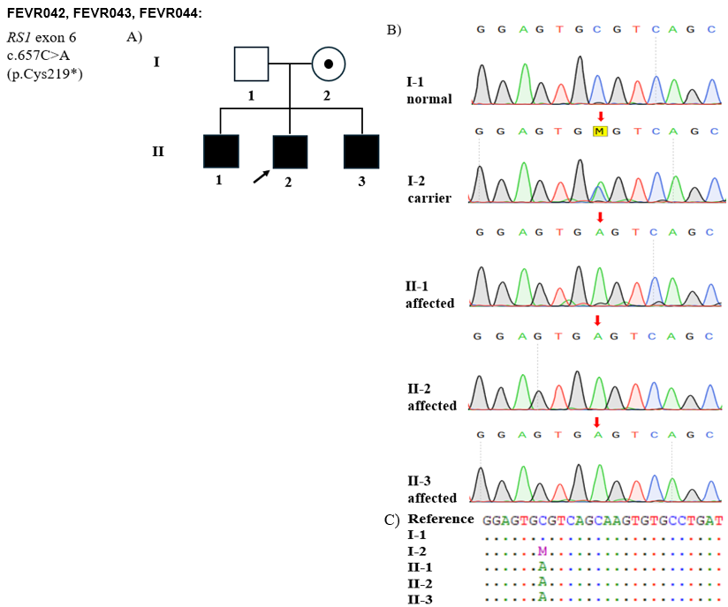
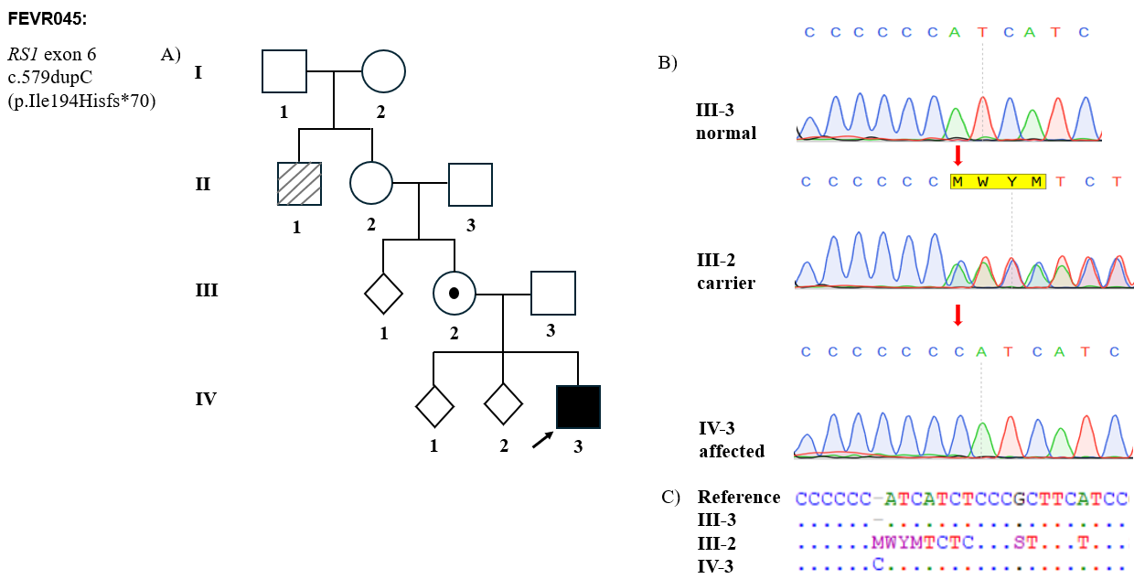
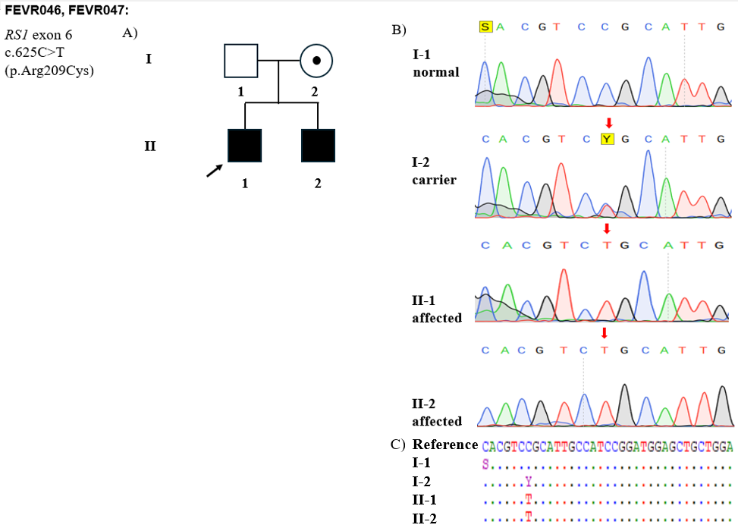
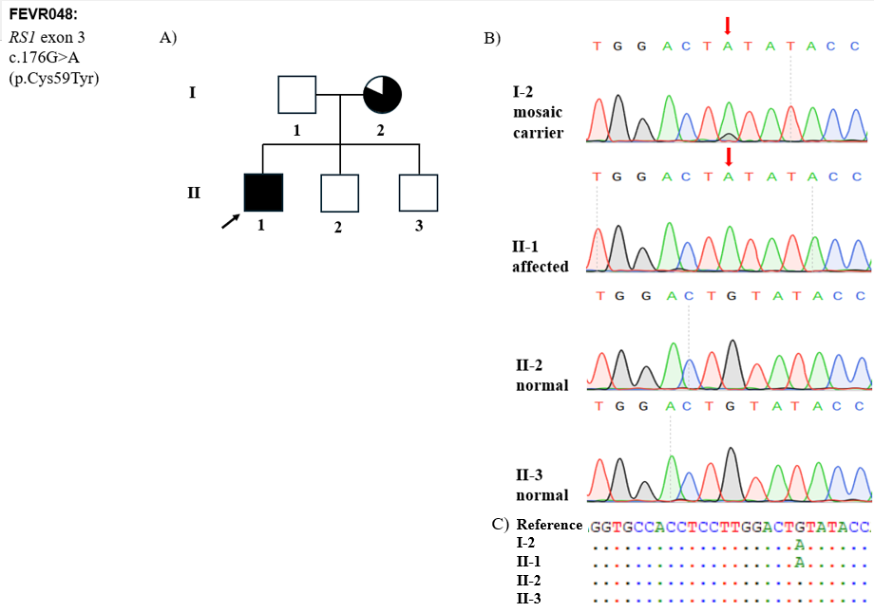
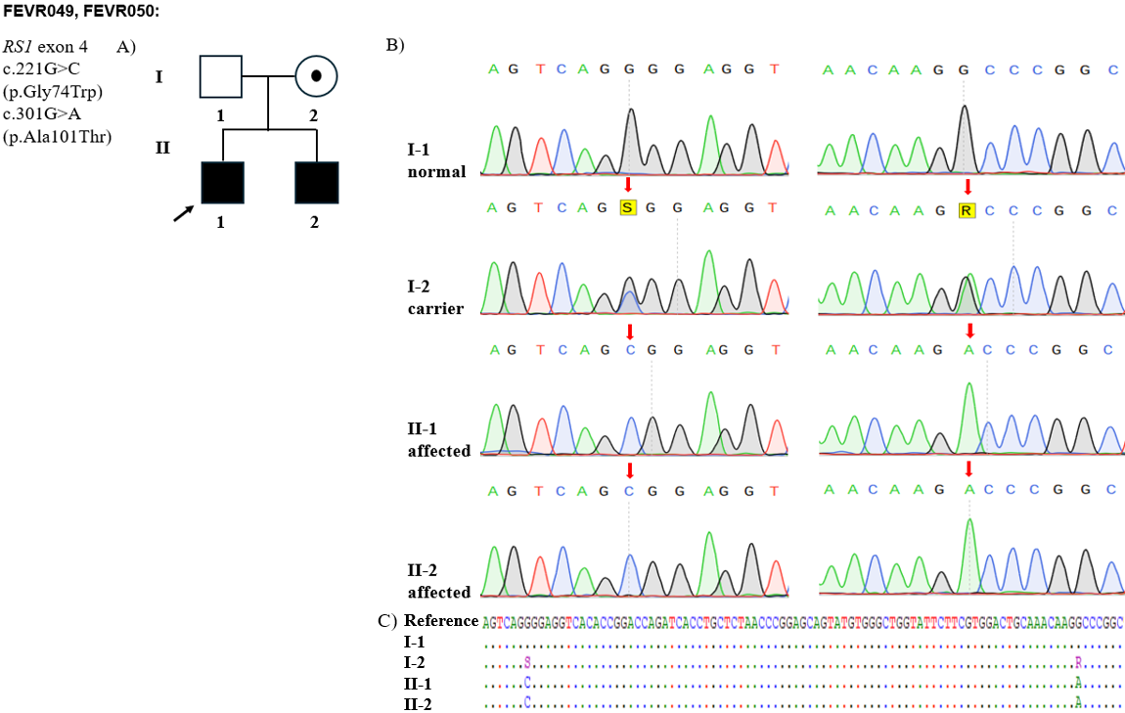
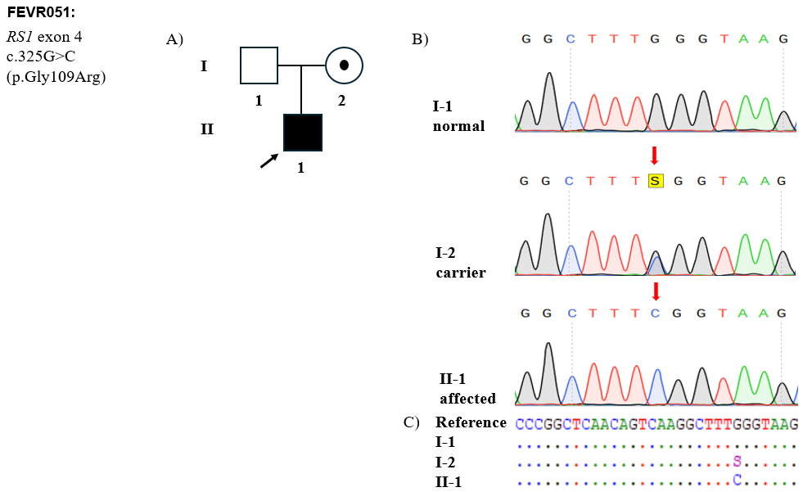
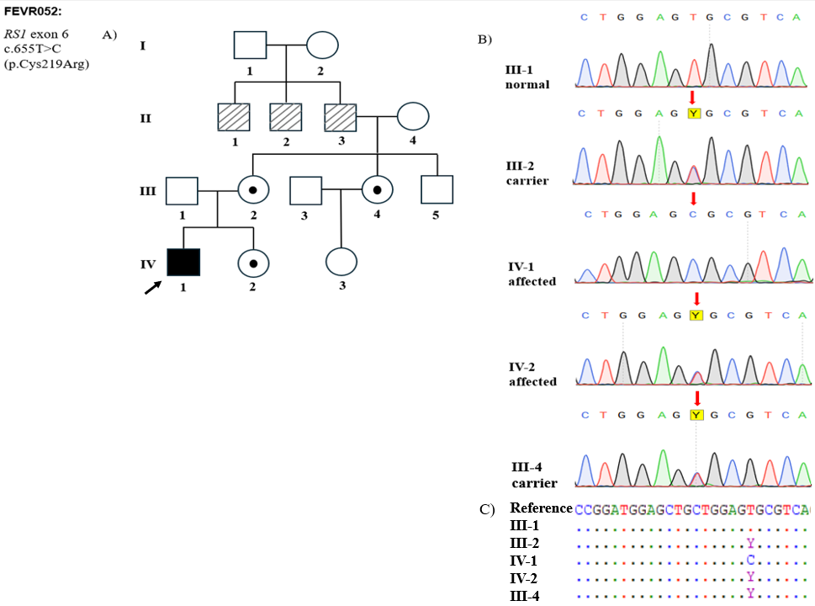
Figure 10: Molecular genomic analysis of familial pedigree in XLRS patients.
A) Patient’s familial pedigree with the inheritance of variants in the RS1 gene (the initial member tested in the family was noted by a black arrow);
B) Sanger sequencing chromatograms of the RS1 variants in the patients and familial members, the mutated nucleotide position was indicated with an arrow (red);
(C) Sequence alignment shows the variant site of exons compared to the reference sequence of RS1 gene.
In addition, a total of seven missense variants were detected in the retinoschisis group. The single variant c.176G>A (p.Cys59Tyr) at exon 3 of RS1 gene was determined in patient FEVR048 which was reported as likely pathogenic in ClinVar and HGMD database. The Cys59 residue is in the N-terminal region, while Cys223 resides within the discoidin domain (Figure 11) (Wu et al., 2005). The linkage between these two residues is important for the stability and spatial organization of the RS1 octamer complex that plays a crucial role in retinal cell adhesion. RS1 variants affect the p.Cys59 residue that can lead to the inability to build the disulfide bridge with p.Cys223 residue in a different subunit (Bender et al., 2022a), thereby impairing the oligomerization and function of protein. Consistently, patients in our study exhibited clinical manifestations typical of XLRS, thus strengthening the functional relevance of variant c.176G>A (p.Cys59Tyr).
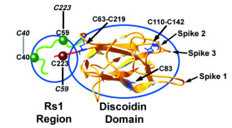
Figure 11: Disulfide bond between Cys59 and Cys223 in retinoschisin.
As illustrated, there were three patients who harbored the RS1 variant at exon 4 which showed the highest prevalence of missense changes in this study. Two distinct variants, c.221G>C (p.Gly74Trp) and c.301G>A (p.Ala101Thr) on the same allele, were novel and presented independently in two siblings’ patients FEVR049 and FEVR050. The previous identification of other pathogenic missense variants at amino acid positions 74 and 101 (p.Gly74Val, p.Ala101Val and p.Ala101Asp) supports the likely pathogenic classification of p.Gly74Trp and p.Ala101Thr, following the ACMG/AMP’s recommendation. At exon 4, another variant c.325G>C (p.Gly109Arg) was found in patient FEVR051, reported as pathogenic in ClinVar/HGMD database. The c.325G>C variant has been reported to be associated with retinoschisis and resulted in the inability of retinoschisin secretion and intracellular maintenance (Huopaniemi et al., 1999; Wang et al., 2002). The above substitutions change of exon 4 residue in the early portion of discoidin domain, suggesting that exon 4 would be a special sensitive region of RS1 gene.
At exon 5 of RS1 gene, the only one c.424T>C (p.Cys142Arg) variant in patient FEVR040 demonstrated a converting of an amino acid that was predicted to affect the thiol exchange of protein retinoschisin. As reported, cysteine at position 142 was conserved among 18 sequences of RS1 (Sergeev et al., 2010), thus it can affect the structure of the retinoschisin protein, altering the function or stability of that. Furthermore, other variants which disrupt cysteine residue have been found in individuals with RS1-related disorders, suggesting that it may be a clinically relevant amino acid residue (Chen et al., 2020; Hiriyanna et al., 1999). The variant c.424T>C (p.Cys142Arg) has been classified as pathogenic in the ClinVar and HGMD database and associated with X-linked disorder, especially retinoschisis (Bender et al., 2022b; Hahn et al., 2022b).
In contrast to the preceding exons, exon 6 exhibited both the greatest diversity and highest frequency of variants in this study. This location contained two identical missense variants c.625C>T (p.Arg209Cys) in two other siblings FEVR046 and FEVR047. Amino acid position 209 of retinoschisin has been reported as a mutational hotspot in the cohort of XLRS patients from Chinese that underscored the functional importance of this residue (Hu et al., 2017). Together with the pathogenic classification of the variant c.625C>T (p.Arg209Cys) in the ClinVar database, the concordance between genotype and clinical findings in patients FEVR046 and FEVR047 further supports the pathogenic role of this variant in XLRS.
The last missense variant c.655T>C (p.Cys219Arg) in exon 6 was detected in an independent case FEVR052. According to reports, the variation segregates with X-linked retinoschisis through two afflicted family members (Kiel et al., 2024). This amino acid residue p.Cys219 can be clinically relevant because other variants that disrupt it have been found in people with RS1-related disorders. Cysteine 219 has been reported as being conserved in 18 sequences of RS1 gene that is essential for retinoschisin function (Sergeev et al., 2010). Despite being at the nearly end of the discoidin domain, the ClinGen X-linked has classified another missense variant in the same codon such as c.655T>G (p.Cys219Gly), as likely pathogenic for XLRS and no benign missense variants have been found in this codon. These things strengthened the pathogenicity of variant c.655T>C, especially in the affected patient FEVR052 with several familial members who revealed vision impairment.
Especially, only frameshift variant in the XLRS dataset was c.579dupC (p.Ile194Hisfs*70) of patient FEVR045. The duplication of cytosine at residue 579 changed isoleucine to histidine, created a frameshift from codon 194 and the premature termination codon occurs after 70 aberrant amino acids downstream. It was predicted to disrupt the last 30 amino acids of retinoschisin protein, with its classification as pathogenic in ClinVar and HGMD database. The clinical characteristics of the 29-year-old male with XLRS who carried the variant c.579dupC were complicated including night vision impairment, foveal schisis, macular schisis, and central scotomas (Duncan et al., 2011). This variant was also reported to be one of the most prevalent variants in XLRS cohort from United Kingdom (Georgiou et al., 2022). The truncating effect of variant is also consistent with the typical retinoschisis phenotype observed in the patient FEVR045 and the presence of reduced visual function among affected family members.
The identified variants and their location in the RS1 gene along with the retinoschisin protein were demonstrated in Figure 12. Together, most variants detected in RS1 gene were missense in exons 4, 5, and 6, with half of XLRS patients having in this study. They mostly belong to the discoidin domain which is the primary structural and functional component of RS1. Variants in this region mostly result in the severe retinoschisin misfolding and the preservation of endoplasmic reticulum, which were considered as the main molecular mechanisms leading to XLRS related to missense variants in the RS1 gene (Dyka et al., 2008; Wu & Molday, 2003).
In addition, ten mothers, one aunt, and one sister of patients were determined as heterozygous carriers of causative variants. The presence of both wild-type and mutant alleles in the heterozygous individuals that were evidenced by two distinct peaks at the variant position. Especially for case FEVR048, the mutant allele peak in the mother (I-2) was higher than the wild-type peak, this finding is consistent with mosaicism rather than classical heterozygosity. For cases with accompanying sibling samples, only the sister of patient FEVR052 is a carrier, while the brothers of patients FEVR038 and FEVR048 were fortunately negative for the variant. For other relatives, the patient’s maternal aunt in family FEVR052 was also identified as a carrier. Given that the carrier mother transmits the variant to their affected son and the presence of other female carriers, all familial pedigree supported an X-linked recessive inheritance pattern of retinoschisis in 14 samples. The presence of RS1 carriers among female relatives highlights the significance of genetic examination in extended familial members. As observed in the maternal aunt of patient FEVR052, the identification of carrier status facilitates informed genetic counseling for future reproductive planning and allows for a more accurate assessment of inheritance risk. In addition, the efficiency of Sanger sequencing targeted on the RS1 gene to detect variants in XLRS patients was underlined in this study.

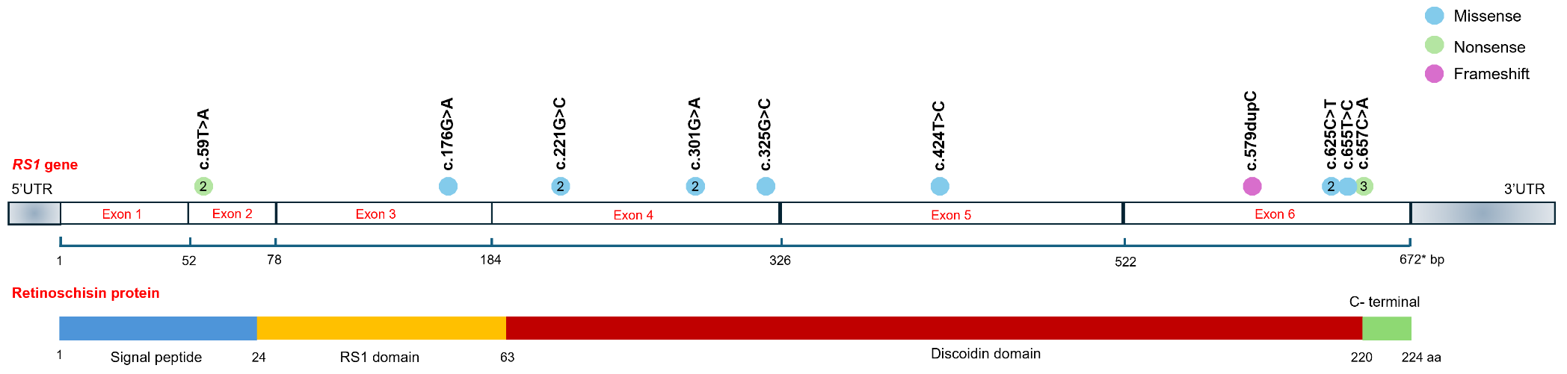
Figure 12: RS1 gene and retinoschisin protein structure highlighting mutation sites in this study.
The colored circles indicate the location and type of mutation. The number inside each dot represents the account for variants identified at that specific site. The retinoschisin protein is segmented into its functional domain.

4.3.2. Evaluation of genotype-phenotype correlation in XLRS patients
The relationship between the phenotype and genotype of XLRS has not been described clearly to date in Vietnam. Although the number of patients in this study was quite small, the range of phenotypes was heterogeneous, from mild to severe. The possible association between genotype and the observed phenotype was evaluated in the study cohort to better illustrate how specific variants contribute to patients' clinical manifestations.
By analyzing the RS1 variants across exons 2 to 6, a consistent genotype-phenotype link was shown and reflected the predicted impact of each on the function of retinoschisin. As shown in Table 9, variants in exon 2 represented by two identical nonsense changes which were associated with two cases of retinoschisis. While a case presented only retinal cyst, the remaining one had no additional complications, suggesting a milder clinical manifestation. The retinal cyst results from the cystoid degeneration with several small cavities and these changes would be consequences of retinoschisis (Keith, 1966).
In exons 3 to 5, variants were mainly missense substitutions at conserved residues that lead to light to moderate symptoms. In which, retinoschisis was the main phenotype and other sporadic secondary characteristics were retinal detachment, strabismus, vitreous opacities, or increased intraocular pressure (IOP). These results suggest that even though missense variations can interfere with the protein folding or secretion, they might still have enough structural stability to prevent more expanding retinal damage.
Exon 6 showed a possible genotype–phenotype pattern, in which missense and frameshift mutations were more commonly associated with severe clinical manifestations, including retinoschisis accompanied by retinal detachment, strabismus, and/or cataract in some patients (Table 9). Among the patients with missense variants, patient FEVR052 appeared to present the most severe phenotypes, having undergone scleral buckling surgery for retinal detachment. The consistent presence of more damaging retinal pathology can be explained by the significant loss-of-function effect of exon 6 above mutations. They are cluster within the discoidin domain necessary for retinoschisin oligomerization.

Collectively, most patients positive with RS1 variants had retinoschisis, and nearly half of total patients with RS1 revealed retinal detachment. Signs such as strabismus, vitreous opacities, and increased intraocular pressure were observed less consistently across patients. Overall, the findings suggested a possible gradient of clinical severity, in which early truncating variants in exon 2 tended to be associated with milder manifestations, variants in exons 3 to 5 with moderate to severe phenotypes, and exon 6 variants with more severe and complex presentations. A possible genotype–phenotype pattern was also observed across different RS1 variant types, with severe manifestations appearing more frequently among missense variants. These observations further suggest that phenotypic severity may be influenced more by the extent of functional disruption within the discoidin domain than by exon location alone.

Table 9: Phenotype-genotype correlation of XLRS patients.
Sample ID | Location | RS1 variant |  | Retinoschisis | Retinal detachment | Strabismus | Vitreous opacities | Increased  intraocular pressure | Other  special findings
Sample ID | Location | cDNA change | Amino acid  change
FEVR038 | Exon 2 | c.59T>A | p.Leu20* | + | - | - | - | - | Retinal cyst
FEVR041 | Exon 2 | c.59T>A | p.Leu20* | + | - | - | - | - | -
FEVR048 | Exon 3 | c.176G>A | p.Cys59Tyr | + | + | + | + | - | -
FEVR049 | Exon 4 | c.[221G>C; 301G>A] | p.[Gly74Trp; Ala101Thr] | - | - | - | + | + | -
FEVR050 | Exon 4 | c.[221G>C; 301G>A] | p.[Gly74Trp; Ala101Thr] | - | - | - | + | + | -
FEVR037* | Exon 4 | c.305G>A | p.Arg102Gln | - | - | - | + | - | -
FEVR051 | Exon 4 | c.325G>C | p.Gly109Arg | + | - | - | - | + | -
FEVR040 | Exon 5 | c.424T>C | p.Cys142Arg | + | - | - | - | - | -
FEVR034* | Exon 5 | c.445A>C | p.Thr149Pro | + | + | - | - | - | -
FEVR045 | Exon 6 | c.579dupC | p.Ile194Hisfs*70 | - | + | + | - | - | -
FEVR046 | Exon 6 | c.625C>T | p.Arg209Cys | + | + | - | + | - | -
FEVR047 | Exon 6 | c.625C>T | p.Arg209Cys | - | + | - | - | - | Cataract
FEVR052 | Exon 6 | c.655T>C | p.Cys219Arg | + | + | + | + | - | -
FEVR042 | Exon 6 | c.657C>A | p.Cys219* | - | + | - | - | - | -
FEVR043 | Exon 6 | c.657C>A | p.Cys219* | + | + | + | - | - | Cataract
FEVR044 | Exon 6 | c.657C>A | p.Cys219* | - | + | - | - | - | -
*: samples reported in another thesis of the same research center.
+: yes, -: no

Genetic analysis for Norrie disease group

4.4.1. Genetic analysis for ND patients and their familial members
Patients FEVR031 and FEVR032 suspected Norrie disease underwent WES analysis to determine the pathogenic variants. Results showed that patient FEVR031 harbored a missense variant c.362G>A (p.Arg121Gln) in exon 3 of NDP gene. As reported in ClinVar and HGMD, this variant is classified as pathogenic. Another variant in the NDP gene, a frameshift c.77delC (p.Thr26Ilefs*15), was identified in exon 2 of patient FEVR032. The variant c.77delC is novel due to its absence from genetic databases. According to ACMG’s guideline, this variant was classified as likely pathogenic, based on the very strong (PVS1) and moderate (PM2) evidence criteria (Table 8).
Sanger sequencing was used to confirm the pathogenic variant of patient FEVR031 and FEVR032, and genetic test for their familial members. Sequence analysis revealed that the clear substitution of guanine to adenine of patient FEVR031, while the deletion of cytosine alters the wild-type amino acid sequence of patient FEVR032, creating an aberrant sequence (-S.RMMRS) immediately following the frameshift (Figure 13).
The variant c.362G>A (p.Arg121Gln) of NDP gene, which is found at the C-terminal end of the Norrin protein, predicted to affect the protein's secondary structure and function (Iarossi et al., 2017). Previously, this variant was detected in some cases with complicated symptoms. For instance, one patient revealed retrolental masses and the other had bilateral atrophy, both were presented at early age of onset and from two distinct families with a long history of congenital blindness. These clinical findings associated with the variant p.Arg121Gln were considered as typical to diagnosis of ND in this case (Fuentes et al., 1993). Another research reported in an Italian family, c.362G>A (p.Arg121Gln) most likely related to the phenotypes of FEVR due to the vision preservation of two siblings (Iarossi et al., 2017). In our study, patient FEVR031 initially suspected of ND because of severe ocular manifestations, including vitreous hemorrhage, retinal detachment, and cataract. This finding and other identification from previous reports indicated that this variant has been associated with both ND and FEVR, suggesting that it contributes to a broad phenotypic spectrum of NDP-related retinopathy.
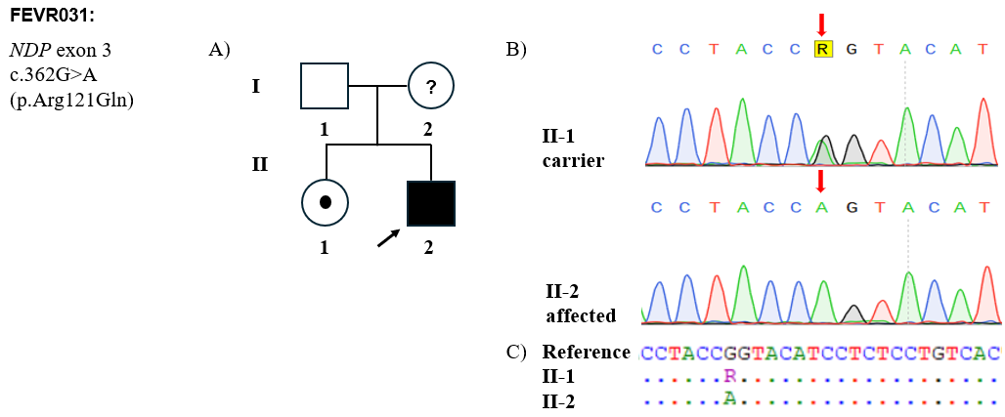
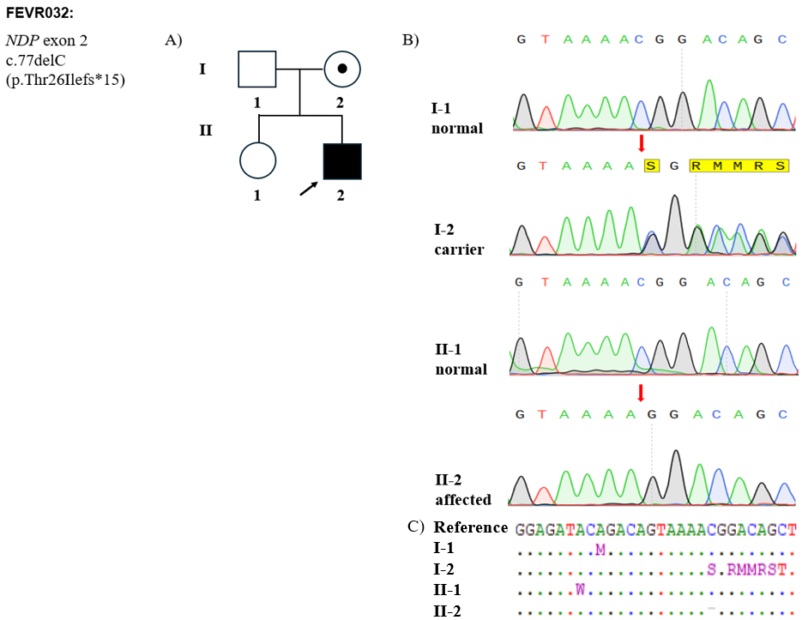

Figure 13: Molecular genomic analysis of familial pedigree in ND patients.
A) Patient’s familial pedigree with the inheritance of variants in the NDP gene (the initial member tested in the family was noted by a black arrow);
B) Sanger sequencing chromatograms of the NDP variants in the patients and familial members, the mutated nucleotide position was indicated with an arrow (red);
C) Sequence alignment shows the variant site of exons compared to the reference sequence of NDP gene.
For patient FEVR032, the results confirmed the proband's genotype as hemizygous NDP c.77delC variant, consistent with the WES data. This variant is highly deleterious due to the deletion of a single nucleotide, which introduces a frameshift at codon 26, substituting threonine with isoleucine and introducing a premature termination codon (PTC) 15 residues downstream. Consequently, the mutant transcript is predicted to undergo nonsense-mediated mRNA decay (NMD), as the PTC is located early in the coding sequence of exon 2 and upstream of the final exon–exon junction. If the transcript escapes NMD, a truncated Norrin protein lacking critical functional domains, such as the cysteine-knot domain essential for receptor binding, structural stability, and activation of the Wnt/β-catenin signaling pathway, may be produced.
As also shown in Figure 13, the older sister of patient FEVR031 (II-1) was identified as an asymptomatic heterozygous carrier for the NDP variant. The mother of FEVR031 was unfortunately unavailable for genetic testing. Additionally, the mother of FEVR032 (I-2) was also a heterozygous carrier, while the proband's sister (II-1) was negative. Similar to retinoschisis, the two pedigrees corroborate X-linked inheritance in ND, given the female carrier status in family FEVR031 and the maternal transmission of the variant to the affected male in family FEVR032.

4.4.2. Evaluation of genotype-phenotype correlation in ND patients
Variants in the NDP gene not only cause Norrie disease but also familial exudative vitreoretinopathy (FEVR), which has some similar visual symptoms but develops more slowly than Norrie (Luvisi & Blair, 2025). Pathogenic variants in the NDP gene cause a phenotypic spectrum ranging from severe Norrie disease to FEVR with considerable variability in phenotype (Luvisi & Blair, 2025). The patient FEVR031 showed a relatively milder effect because the missense variant may retain partial Norrin function, compared with truncating variant. In contrast, patient FEVR032 carrying the frameshift variant exhibited more complicated features at the early age of onset, including vitreoretinal proliferation, corneal opacification, retinal detachment, cataract, and microphthalmia, which are consistent with Norrie disease phenotype. While FEVR cases often presents later in infancy or childhood, with variable expressivity, incomplete peripheral retinal vascularization, and a broader clinical spectrum that may preserve useful vision in some individuals. The manifestations of FEVR032 were also much more severe than those previously reported in the four patients carrying the NDP pathogenic variants, which have been detected at our center to date (Table 10) (Trang et al., 2022c). This is likely to be a consequence of the null mutation causing incorrect synthesis of Norrin, leading to protein function impairment, especially in male individuals who carry only a single copy of the gene. The truncating or loss-of-function variants in NDP are more commonly associated with the classic phenotype of Norrie, whereas certain missense variants may retain partial protein function and present with FEVR-like features, as shown in the ClinVar database.
As a molecular diagnostic tool, WES is relatively comprehensive, as it can capture genetic profiles across the coding sequences of about 22.000 genes.. The WES potential has been demonstrated both in this study and several preceding studies (Le et al., 2025; Vu et al., 2025). It can not only screen existing disease-causing variants in patients but also pinpoint the potentially causative genetic variants in the family.
Table 10: Clinical ocular features of NDP-related retinopathies in Vietnam.
Sample  ID | NDP variant |  | Retinal vascular anomalies | Strabismus | Exudation | Retinal detachment | Nystagmus | Cataract | Microphthalmia
Sample  ID | cDNA change | Amino acid change
EVR-10 | c.112C>T | p.(Arg38Cys) | + | + | + | - | - | - | -
EVR-15 | c.131A>G | p.(Tyr44Cys) | + | - | - | + | + | - | +
EVR-19 | c.175-3A>G | Splicing | + | + | - | - | - | - | -
EVR-20 | exon-2 deletion |  | + | + | - | + | - | + | -
FEVR031 | c.362G>A | p.(Arg121Gln) | - | - | + | + | - | + | -
FEVR032 | c.77delC | p.(Thr26Ilefs*15) | + | - | + | + | - | + | +
+: yes, -: no

CHAPTER 5. CONCLUSION
5.1. Recapitulation
This study successfully employed comprehensive WES combined with Sanger sequencing to identify pathogenic RS1 and NDP variants in 16 Vietnamese children diagnosed with X-linked retinoschisis and Norrie disease, respectively. These findings contribute valuable data to the genetic understanding of inherited retinal disorders in Vietnam. The identification of 14 carrier females in 12 families help to support them in genetic counseling and clinical management in the future.
Given the significant clinical overlap between Norrie disease and familial exudative vitreoretinopathy (FEVR), our results suggest that WES may serve as an effective firster diagnostic tool for genetically heterogeneous conditions like these in Vietnam. In contrast, for suspected XLRS cases, where disease causation is exclusively linked to RS1, targeted Sanger sequencing of the RS1 gene remains a cost-effective and efficient diagnostic approach.
5.2. Limitations
Some limitations should be acknowledged in this study. Due to the rarity of X-linked retinoschisis and Norrie disease, the sample size was limited that may reduce the strength of genotype–phenotype correlation. Functional studies were not conducted to directly assess the biological effects of the identified variants, limiting further insights into their pathogenic mechanisms.
5.3. Recommendations
Disease management and patient care should be guided by the clinician. Children younger than 10 years of age should undergo annual evaluations by a pediatric ophthalmologist. Patients are advised to avoid head trauma as well as contact or high-impact sports due to the increased risk of retinal detachment. Amblyopia treatment should be initiated when indicated, particularly in cases of severe retinoschisis, significant hyperopia, or following surgery for retinal detachment. Low-vision support is recommended for children with reduced visual acuity, including the use of large-print educational materials and preferential seating at the front of the classroom.
The regular follow-up of patients from early disease stages, timely diagnosis, along with an increased number of study cases may improve understanding of disease mechanisms underlying these two conditions and help evaluate treatment outcomes for inherited retinal disorders in the Vietnamese population.
5.4. Perspectives
Future perspectives of this study focus on improving the understanding of disease mechanisms and clinical outcomes in inherited retinal disorders. Functional studies of RS1 and NDP variants may provide deeper insight into their pathogenic effects and support more accurate variant interpretation. Gene-based therapeutic strategies, which are currently under investigation to establish their clinical applicability, could be considered as a potential future direction for RS1- and NDP-related disorders. These advances may contribute to earlier diagnosis, personalized management, and the development of targeted therapies for inherited retinal disorders.

REFERENCES
Agarwal, A., Fan, S., Invernizzi, A., Do, D. V., Nguyen, Q. D., Harms, N. V., & Sepah, Y. J. (2015). Characterization of retinal structure and diagnosis of peripheral acquired retinoschisis using high-resolution ultrasound B-scan. Graefe’s Archive for Clinical and Experimental Ophthalmology 2015 254:1, 254(1), 69–75. https://doi.org/10.1007/S00417-015-3013-3
Altun, A. (2020). A Female Case of X-Linked Retinoschisis with Macular Hole Bilaterally. Case Reports in Ophthalmological Medicine, 2020, 8824995. https://doi.org/10.1155/2020/8824995
Barbisan, P. R. T., & Barbisan, P. A. (2021). Late ophthalmology findings in a X-linked juvenile retinoschisis patient. Rev Bras Oftalmol. , 80(1), 59–62. https://doi.org/10.5935/0034-7280.20210011
Beatson, B., Pham, A., Ong, S. S., Ahmed, I., Arevalo, J. F., & Handa, J. T. (2021). Repair of progressive retinal detachment complicating degenerative retinoschisis: surgical management and outcomes in phakic eyes. International Journal of Retina and Vitreous 2021 7:1, 7(1), 69-. https://doi.org/10.1186/S40942-021-00344-2
Bechrakis, N. E., Luthert, P. J., & Wilson, D. J. (2015). Retina. Eye Pathology: An Illustrated Guide, 307–401. https://doi.org/10.1007/978-3-662-43382-9_9
Bender, C., Woo, E. G., Guan, B., Ullah, E., Feng, E., Turriff, A., Tumminia, S. J., Sieving, P. A., Cukras, C. A., & Hufnagel, R. B. (2022a). Predominant Founder Effect among Recurrent Pathogenic Variants for an X-Linked Disorder. Genes, 13(4), 675. https://doi.org/10.3390/GENES13040675/S1
Ben-Yosef, T. (2022). Inherited Retinal Diseases. International Journal of Molecular Sciences, 23(21), 13467. https://doi.org/10.3390/IJMS232113467
Burton, M. J., Ramke, J., Marques, A. P., Bourne, R. R. A., Congdon, N., Jones, I., Ah Tong, B. A. M., Arunga, S., Bachani, D., Bascaran, C., Bastawrous, A., Blanchet, K., Braithwaite, T., Buchan, J. C., Cairns, J., Cama, A., Chagunda, M., Chuluunkhuu, C., Cooper, A., … Faal, H. B. (2021). The Lancet Global Health Commission on Global Eye Health: vision beyond 2020. The Lancet Global Health, 9(4), e489–e551. https://doi.org/10.1016/S2214-109X(20)30488-5/ASSET/80208C71-CED8-4F28-8A14-57AA856E9946/MAIN.ASSETS/GR10.JPG
Bush, M., Setiaputra, D., Yip, C. K., & Molday, R. S. (2016). Cog-Wheel Octameric Structure of RS1, the Discoidin Domain Containing Retinal Protein Associated with X-Linked Retinoschisis. PLOS ONE, 11(1), e0147653. https://doi.org/10.1371/JOURNAL.PONE.0147653
Carss, K., Arno, G., Erwood, M., Stephens, J., Sanchis-Juan, A., Hull, S., Megy, K., Grozeva, D., Dewhurst, E., Malka, S., Plagnol, V., Penkett, C. J., Stirrups, K., Rizzo, R., Wright, G., Josifova, D., Bitner-Glindzicz, M., Scott, R., Clement, E., … Yu, P. (2016a). Comprehensive Rare Variant Analysis via Whole-Genome Sequencing to Determine the Molecular Pathology of Inherited Retinal Disease. American Journal of Human Genetics, 100(1), 75. https://doi.org/10.1016/J.AJHG.2016.12.003
Chatterjee, S., Gupta, S., Kirola, L., Chandra, A., Mukherjee, A., & Mutsuddi, M. (2023). Identification and molecular characterization of two recurrent missense mutations in the RS1 gene in two families with X-linked retinoschisis from North India. American Journal of Medical Genetics Part A, 191(10), 2524–2535. https://doi.org/10.1002/AJMG.A.63327
Chen, C., Xie, Y., Sun, T., Tian, L., Xu, K., Zhang, X., & Li, Y. (2020). Clinical findings and RS1 genotype in 90 Chinese families with X-linked retinoschisis. Molecular Vision, 26, 291. https://pmc.ncbi.nlm.nih.gov/articles/PMC7155891/
Chen, D., & Zhu, S. (2021). Whole-exome sequencing identifies an RS1 variant in a Chinese family with X-linked retinoschisis. Experimental and Therapeutic Medicine, 22(6), 1406. https://doi.org/10.3892/ETM.2021.10842
Chowdhury, S., Chermakani, P., Baliga, G., Anjanamurthy, R., & Sundaresan, P. (2024). Genotypic and phenotypic diversity in X-linked retinoschisis: Findings from a South Indian patient cohort. Indian Journal of Ophthalmology, 72(6), 902. https://doi.org/10.4103/IJO.IJO_2525_23
Coonrod, E. M., Durtschi, J. D., Margraf, R. L., & Voelkerding, K. V. (2013). Developing Genome and Exome Sequencing for Candidate Gene Identification in Inherited Disorders: An Integrated Technical and Bioinformatics Approach. Archives of Pathology & Laboratory Medicine, 137(3), 415–433. https://doi.org/10.5858/ARPA.2012-0107-RA
Cremers, F. P. M., Boon, C. J. F., Bujakowska, K., & Zeitz, C. (2018). Special Issue Introduction: Inherited Retinal Disease: Novel Candidate Genes, Genotype–Phenotype Correlations, and Inheritance Models. Genes, 9(4), 215. https://doi.org/10.3390/GENES9040215
Dan, H., Wang, D., Huang, Z., Shi, Q., Zheng, M., Xiao, Y., & Song, Z. (2022). Whole exome sequencing revealed 14 variants in NDP, FZD4, LRP5, and TSPAN12 genes for 20 families with familial exudative vitreoretinopathy. BMC Medical Genomics, 15(1), 54. https://doi.org/10.1186/S12920-022-01204-0
De Silva, S. R., Arno, G., Robson, A. G., Fakin, A., Pontikos, N., Mohamed, M. D., Bird, A. C., Moore, A. T., Michaelides, M., Webster, A. R., & Mahroo, O. A. (2021). The X-linked retinopathies: Physiological insights, pathogenic mechanisms, phenotypic features and novel therapies. Progress in Retinal and Eye Research, 82, 100898. https://doi.org/10.1016/J.PRETEYERES.2020.100898
Den Dunnen, J. T., Kraayenbrink, T., Van Schooneveld, M., Van Vosse, E. De, De Jong, P. T. V. M., Ten Brink, J. B., Schuurman, E., Tijmes, N., Van Ommen, G. J. B., Bergen, A. A. B., Andolfi, G., Montini, E., Li, Y., Oudet, C., Bolz, H., Kaplan, J., Orth, U., Gal, A., Hanauer, A., … Yates, J. R. W. (1998). Functional implications of the spectrum of mutations found in 234 cases with X-linked juvenile retinoschisis. The Retinoschisis Consortium. Human Molecular Genetics, 7(7), 1185–1192. https://doi.org/10.1093/HMG/7.7.1185
Donnai, D., Mountford, R. C., & Read, A. P. (1988). Norrie disease resulting from a gene deletion: clinical features and DNA studies. Journal of Medical Genetics, 25(2), 73–78. https://doi.org/10.1136/JMG.25.2.73
Duan, C., Ding, C., Sun, X., Mao, S., Liang, Y., Liu, X., Ding, X., Chen, J., & Tang, S. (2024). Retinal organoids with X-linked retinoschisis RS1 (E72K) mutation exhibit a photoreceptor developmental delay and are rescued by gene augmentation therapy. Stem Cell Research and Therapy, 15(1), 1–19. https://doi.org/10.1186/S13287-024-03767-4/FIGURES/7
Duncan, J. L., Ratnam, K., Birch, D. G., Sundquist, S. M., Lucero, A. S., Zhang, Y., Meltzer, M., Smaoui, N., & Roorda, A. (2011). Abnormal Cone Structure in Foveal Schisis Cavities in X-Linked Retinoschisis from Mutations in Exon 6 of the RS1 Gene. Investigative Ophthalmology & Visual Science, 52(13), 9614–9623. https://doi.org/10.1167/IOVS.11-8600
Dyka, F. M., Wu, W. W. H., Pfeifer, T. A., Molday, L. L., Grigliatti, T. A., & Molday, R. S. (2008). Characterization and Purification of the Discoidin Domain Containing Protein Retinoschisin (RS1) and Its Interaction with Galactose. Biochemistry, 47(35), 9098. https://doi.org/10.1021/BI800938G
Eren, K., Taktakoğlu, N., & Pirim, I. (2022). DNA Sequencing Methods: From Past to Present. The Eurasian Journal of Medicine, 54(Suppl 1), S47. https://doi.org/10.5152/EURASIANJMED.2022.22280
Etikan, I., Abubakar Musa, S., & Sunusi Alkassim, R. (2016). Comparison of Convenience Sampling and Purposive Sampling. American Journal of Theoretical and Applied Statistics, 5(1), 1–4. https://doi.org/10.11648/j.ajtas.20160501.11
Fenner, B. J., Russell, J. F., Drack, A. V., Dumitrescu, A. V., Sohn, E. H., Russell, S. R., Boldt, H. C., Affatigato, L. M., Hoffmann, J. M., Andorf, J. L., Stone, E. M., & Han, I. C. (2023). Long-term functional and structural outcomes in X-linked retinoschisis: implications for clinical trials. Frontiers in Medicine, 10, 1204095. https://doi.org/10.3389/FMED.2023.1204095/BIBTEX
Fuentes, J. J., Volpinl, V., Fernandez-toral, F., Coto, E., & Estlvlll, X. (1993). Identification of two new missense mutations (K58N and R121Q) in the Norrie disease (ND) gene in two Spanish families. Human Molecular Genetics, 2(11), 1953–1955. https://doi.org/10.1093/HMG/2.11.1953
Garafalo, A. V., Cideciyan, A. V., Héon, E., Sheplock, R., Pearson, A., WeiYang Yu, C., Sumaroka, A., Aguirre, G. D., & Jacobson, S. G. (2020). Progress in treating inherited retinal diseases: Early subretinal gene therapy clinical trials and candidates for future initiatives. Progress in Retinal and Eye Research, 77, 100827. https://doi.org/10.1016/J.PRETEYERES.2019.100827
Garrido-Cardenas, J. A., Garcia-Maroto, F., Alvarez-Bermejo, J. A., & Manzano-Agugliaro, F. (2017). DNA Sequencing Sensors: An Overview. Sensors (Basel, Switzerland), 17(3), 588. https://doi.org/10.3390/S17030588
Gelatt, K. N. . (2021). Veterinary ophthalmology. https://books.google.com/books/about/Veterinary_Ophthalmology.html?hl=vi&id=g80cEAAAQBAJ
Georgiou, M., Finocchio, L., Fujinami, K., Fujinami-Yokokawa, Y., Virgili, G., Mahroo, O. A., Webster, A. R., & Michaelides, M. (2022). X-Linked Retinoschisis: Deep Phenotyping and Genetic Characterization. Ophthalmology, 129(5), 542–551. https://doi.org/10.1016/J.OPHTHA.2021.11.019
Goh, G., & Choi, M. (2012). Application of Whole Exome Sequencing to Identify Disease-Causing Variants in Inherited Human Diseases. Genomics & Informatics, 10(4), 214. https://doi.org/10.5808/GI.2012.10.4.214
Gong, Y., Liu, Z., Zhang, X., Shen, S., Xu, Q., Zhao, H., Shang, J., Li, W., Wang, Y., Chen, J., Liu, X., & Zheng, Q. Y. (2022). Endolymphatic Hydrop Phenotype in Familial Norrie Disease Caused by Large Fragment Deletion of NDP. Frontiers in Aging Neuroscience, 14, 771328. https://doi.org/10.3389/FNAGI.2022.771328/BIBTEX
Guo, Q., Li, Y., Li, J., You, Y., Liu, C., Chen, K., Li, S., & Lei, B. (2022). Phenotype Heterogeneity and the Association Between Visual Acuity and Outer Retinal Structure in a Cohort of Chinese X-Linked Juvenile Retinoschisis Patients. Frontiers in Genetics, 13, 832814. https://doi.org/10.3389/FGENE.2022.832814/BIBTEX
Gupta, H., Malaichamy, S., Mallipatna, A., Murugan, S., Jeyabalan, N., Suresh Babu, V., Ghosh, Anuprita, Ghosh, Arkasubhra, Santhosh, S., Seshagiri, S., Ramprasad, V. L., & Kumaramanickavel, G. (2021). Retinoblastoma genetics screening and clinical management. BMC Medical Genomics, 14(1), 188. https://doi.org/10.1186/S12920-021-01034-6
Hahn, L. C., van Schooneveld, M. J., Wesseling, N. L., Florijn, R. J., ten Brink, J. B., Lissenberg-Witte, B. I., Strubbe, I., Meester-Smoor, M. A., Thiadens, A. A., Diederen, R. M., van Cauwenbergh, C., de Zaeytijd, J., Walraedt, S., de Baere, E., Klaver, C. C. W., Ossewaarde-van Norel, J., van den Born, L. I., Hoyng, C. B., van Genderen, M. M., … Boon, C. J. F. (2022a). X-Linked Retinoschisis: Novel Clinical Observations and Genetic Spectrum in 340 Patients. Ophthalmology, 129(2), 191–202. https://doi.org/10.1016/J.OPHTHA.2021.09.021
Hahn, L. C., van Schooneveld, M. J., Wesseling, N. L., Florijn, R. J., ten Brink, J. B., Lissenberg-Witte, B. I., Strubbe, I., Meester-Smoor, M. A., Thiadens, A. A., Diederen, R. M., van Cauwenbergh, C., de Zaeytijd, J., Walraedt, S., de Baere, E., Klaver, C. C. W., Ossewaarde-van Norel, J., van den Born, L. I., Hoyng, C. B., van Genderen, M. M., … Boon, C. J. F. (2022b). X-Linked Retinoschisis: Novel Clinical Observations and Genetic Spectrum in 340 Patients. Ophthalmology, 129(2), 191–202. https://doi.org/10.1016/j.ophtha.2021.09.021
Hayashi, Y., Chiang, H., Tian, C., Indzhykulian, A. A., & Edge, A. S. B. (n.d.). Norrie disease protein is essential for cochlear hair cell maturation. https://doi.org/10.1073/pnas.2106369118/-/DCSupplemental
Heath Jeffery, R. C., Mukhtar, S. A., McAllister, I. L., Morgan, W. H., Mackey, D. A., & Chen, F. K. (2021). Inherited retinal diseases are the most common cause of blindness in the working-age population in Australia. Ophthalmic Genetics, 42(4), 431. https://doi.org/10.1080/13816810.2021.1913610
Hiraoka, M., Urakawa, Y., Kawai, K., Yoshida, A., Hosakawa, J., Takazawa, M., Inaba, A., Yokota, S., Hirami, Y., Takahashi, M., Ohara, O., Kurimoto, Y., & Maeda, A. (2024). Copy number variant detection using next-generation sequencing in EYS-associated retinitis pigmentosa. PLOS ONE, 19(6), e0305812. https://doi.org/10.1371/JOURNAL.PONE.0305812
Hiriyanna, K. T., Bingham, E. L., Yashar, B. M., Ayyagari, R., Fishman, G., Small, K. W., Weinberg, D. V, Weleber, R. G., Lewis, R. A., Andreasson, S., Richards, J. E., & Sieving, P. A. (1999). Novel Mutations in XLRS1 Causing Retinoschisis, Including First Evidence of Putative Leader Sequence Change. HUMAN MUTATION, 14, 423–427. www.expasy.ch/
Hu, Q. R., Huang, L. Z., Chen, X. L., Xia, H. K., Li, T. Q., & Li, X. X. (2017). Genetic analysis and clinical features of X-linked retinoschisis in Chinese patients. Scientific Reports 2017 7:1, 7(1), 1–9. https://doi.org/10.1038/srep44060
Huang, L., Zhang, L., Li, X., Lu, J., Sun, L., Chen, L., Ding, X., & Li, Z. (2022). Ocular manifestations of Chinese patients with copy number variants in the NDP gene. Molecular Vision, 28, 29. https://pmc.ncbi.nlm.nih.gov/articles/PMC9108013/
Huang, X. F., Tu, C. Sen, Xing, D. J., Gan, D. K., Xu, G. Z., & Jin, Z. B. (2014). R102W mutation in the RS1 gene responsible for retinoschisis and recurrent glaucoma. International Journal of Ophthalmology, 7(1), 169. https://doi.org/10.3980/J.ISSN.2222-3959.2014.01.31
Huang, X., Tian, M., Li, J., Cui, L., Li, M., & Zhang, J. (2017). Next-generation sequencing reveals a novel NDP gene mutation in a Chinese family with Norrie disease. Indian Journal of Ophthalmology, 65(11), 1161. https://doi.org/10.4103/IJO.IJO_442_17
Huopaniemi, L., Rantala, A., Forsius, H., Somer, M., De La Chapelle, A., & Alitalo, T. (1999). Three widespread founder mutations contribute to high incidence of X-linked juvenile retinoschisis in Finland. European Journal of Human Genetics : EJHG, 7(3), 368–376. https://doi.org/10.1038/SJ.EJHG.5200300
Iarossi, G., Bertelli, M., Maltese, P. E., Gusson, E., Marchini, G., Bruson, A., Benedetti, S., Volpetti, S., Catena, G., Buzzonetti, L., & Ziccardi, L. (2017). Genotype-Phenotype Characterization of Novel Variants in Six Italian Patients with Familial Exudative Vitreoretinopathy. Journal of Ophthalmology, 2017, 3080245. https://doi.org/10.1155/2017/3080245
Iwata, T. (2022). Japan to Global Eye Genetics Consortium: Extending Research Collaboration for Inherited Eye Diseases. Asia-Pacific Journal of Ophthalmology, 11(4), 360–368. https://doi.org/10.1097/APO.0000000000000535
J Shetty, P. (2020). The Evolution of DNA Extraction Methods. American Journal of Biomedical Science & Research, 8(1), 39–45. https://doi.org/10.34297/AJBSR.2020.08.001234
Järvinen, M. A., Baraas, R. C., Majander, A., Backlund, M. P., Krootila, J., Paavo, M., Lindahl, P., Vasara, K., Sankila, E. M., Kivelä, T. T., & Turunen, J. A. (2025). A retrospective longitudinal study of 52 Finnish patients with X-linked retinoschisis. Acta Ophthalmologica, 103(2), 196–204. https://doi.org/10.1111/AOS.16776
Jespersgaard, C., Fang, M., Bertelsen, M., Dang, X., Jensen, H., Chen, Y., Bech, N., Dai, L., Rosenberg, T., Zhang, J., Møller, L. B., Tümer, Z., Brøndum-Nielsen, K., & Grønskov, K. (2019). Molecular genetic analysis using targeted NGS analysis of 677 individuals with retinal dystrophy. Scientific Reports, 9(1), 1219. https://doi.org/10.1038/S41598-018-38007-2
Jia, L. Y., & Ma, K. (2021). Novel Norrie disease gene mutations in Chinese patients with familial exudative vitreoretinopathy. BMC Ophthalmology, 21(1), 84. https://doi.org/10.1186/S12886-021-01852-3
Karali, M., Testa, F., Di Iorio, V., Torella, A., Zeuli, R., Scarpato, M., Romano, F., Onore, M. E., Pizzo, M., Melillo, P., Brunetti-Pierri, R., Passerini, I., Pelo, E., Cremers, F. P. M., Esposito, G., Nigro, V., Simonelli, F., & Banfi, S. (2022). Genetic epidemiology of inherited retinal diseases in a large patient cohort followed at a single center in Italy. Scientific Reports, 12(1), 20815. https://doi.org/10.1038/S41598-022-24636-1
Keith, C. G. (1966). Retinal cysts and retinoschisis. The British Journal of Ophthalmology, 50(11), 617. https://doi.org/10.1136/BJO.50.11.617
Kiel, C., Biasella, F., Stöhr, H., Rating, P., Spital, G., Kellner, U., Hufendiek, K., Huchzermeyer, C., Jaegle, H., Ruether, K., & Weber, B. H. F. (2024). 18-Years of single-centre DNA testing in over 7000 index cases with inherited retinal dystrophies and optic neuropathies. Scientific Reports 2024 14:1, 14(1), 25529-. https://doi.org/10.1038/s41598-024-77014-4
Kim, L. S., Seiple, W., Fishman, G. A., & Szlyk, J. P. (2007). Multifocal ERG findings in carriers of X-linked retinoschisis. Documenta Ophthalmologica, 114(1), 21–26. https://doi.org/10.1007/S10633-006-9034-9/FIGURES/3
Kim, Y. J., Kim, Y. N., Yoon, Y. H., Seo, E. J., Seo, G. H., Keum, C., Lee, B. H., & Lee, J. Y. (2021). Diverse genetic landscape of suspected retinitis pigmentosa in a large korean cohort. Genes, 12(5), 675. https://doi.org/10.3390/GENES12050675/S1
Kjellstrm, S., Vijayasarathy, C., Ponjavic, V., Sieving, P. A., & Andréasson, S. (2010). Long-term 12 year follow-up of X-linked congenital retinoschisis. Ophthalmic Genetics, 31(3), 114. https://doi.org/10.3109/13816810.2010.482555
Kondo, H., Oku, K., Katagiri, S., Hayashi, T., Nakano, T., Iwata, A., Kuniyoshi, K., Kusaka, S., Hiyoshi, A., Uchio, E., Kondo, M., Oishi, N., Kameya, S., Mizota, A., Naoi, N., Ueno, S., Terasaki, H., Morimoto, T., Iwaki, M., … Iwata, T. (2019). Novel mutations in the RS1 gene in Japanese patients with X-linked congenital retinoschisis. Human Genome Variation, 6(1), 3. https://doi.org/10.1038/S41439-018-0034-6
Kooiker, M. J. G., van Gils, M. M., van der Zee, Y. J., Swarte, R. M. C., Smit, L. S., Loudon, S., van der Steen, S., Reiss, I. K. M., Pel, J. J. M., & van der Steen, J. (2021). Early Screening of Visual Processing Dysfunctions in Children Born Very or Extremely Preterm. Frontiers in Human Neuroscience, 15, 729080. https://doi.org/10.3389/FNHUM.2021.729080/BIBTEX
Le, H. T. T., Tran, H. T., Nguyen, L. K., Doan, L. T., La, Q. N. K., Nguyen-Huu, T. H., & Nguyen, H. H. (2025). The genetic profile of a neurofibromatosis type 1 Vietnamese patient with complicated pheochromocytomas and colorectal tumors. Open Exploration 2019 4:, 4, 1006102-. https://doi.org/10.37349/EN.2025.1006102
Le, V., Abdelmessih, G., Dailey, W. A., Pinnock, C., Jobczyk, V., Rashingkar, R., Drenser, K. A., & Mitton, K. P. (2023a). Mechanisms Underlying Rare Inherited Pediatric Retinal Vascular Diseases: FEVR, Norrie Disease, Persistent Fetal Vascular Syndrome. Cells, 12(21), 2579. https://doi.org/10.3390/CELLS12212579
Le, V., Abdelmessih, G., Dailey, W. A., Pinnock, C., Jobczyk, V., Rashingkar, R., Drenser, K. A., & Mitton, K. P. (2023b). Mechanisms Underlying Rare Inherited Pediatric Retinal Vascular Diseases: FEVR, Norrie Disease, Persistent Fetal Vascular Syndrome. Cells, 12(21), 2579. https://doi.org/10.3390/CELLS12212579
Li, H., Li, Z., Wang, D., Chen, C., Chen, Z., Wang, J., Xu, C., & Dong, X. (2022). Next-generation sequencing reveals a case of Norrie disease in a child with bilateral ocular malformation. Frontiers in Genetics, 13, 870232. https://doi.org/10.3389/FGENE.2022.870232/BIBTEX
Liew, G., Michaelides, M., & Bunce, C. (2014). A comparison of the causes of blindness certifications in England and Wales in working age adults (16–64 years), 1999–2000 with 2009–2010. BMJ Open, 4(2), e004015. https://doi.org/10.1136/BMJOPEN-2013-004015
Lin, S., Vermeirsch, S., Pontikos, N., Martin-Gutierrez, M. P., Daich Varela, M., Malka, S., Schiff, E., Knight, H., Wright, G., Jurkute, N., Simcoe, M. J., Yu-Wai-Man, P., Moosajee, M., Michaelides, M., Mahroo, O. A., Webster, A. R., & Arno, G. (2024). Spectrum of Genetic Variants in the Most Common Genes Causing Inherited Retinal Disease in a Large Molecularly Characterized United Kingdom Cohort. Ophthalmology Retina, 8(7), 699–709. https://doi.org/10.1016/J.ORET.2024.01.012
Liu, X., Tao, T., Zhao, L., Li, G., & Yang, L. (2021). Molecular diagnosis based on comprehensive genetic testing in 800 Chinese families with non-syndromic inherited retinal dystrophies. Clinical and Experimental Ophthalmology, 49(1), 46–59. https://doi.org/10.1111/CEO.13875
Lorenz, T. C. (2012). Polymerase Chain Reaction: Basic Protocol Plus Troubleshooting and Optimization Strategies. Journal of Visualized Experiments : JoVE, (63), 3998. https://doi.org/10.3791/3998
Luo, H. D., Pei, S. N., Wang, A. J., Yu, X. Q., Hu, H. J., Zeng, L., Wang, F. F., Jin, M., & Zhang, X. (2023). A pedigree with retinitis pigmentosa and its concomitant ophthalmic diseases. International Journal of Ophthalmology, 16(12), 1962. https://doi.org/10.18240/IJO.2023.12.07
Luvisi, J. R., & Blair, K. (2025). Familial Exudative Vitreoretinopathy (FEVR). StatPearls. https://www.ncbi.nlm.nih.gov/books/NBK614159/
Ma, T. H. T., Luong, T. L. A., Hoang, T. L., Nguyen, T. T. H., Vu, T. H., Tran, V. K., Nguyen, D. B., Trieu, T. S., Nguyen, H. H., Nong, V. H., & Nguyen, D. T. (2021). Novel and very rare causative variants in the COL7A1 gene of Vietnamese patients with recessive dystrophic epidermolysis bullosa revealed by whole-exome sequencing. Molecular Genetics & Genomic Medicine, 9(8), e1748. https://doi.org/10.1002/MGG3.1748
Marmiroli, N., & Maestri, E. (2025). Polymerase Chain Reaction (PCR). Food Toxicants Analysis: Techniques, Strategies and Developments, 147–187. https://doi.org/10.1016/B978-044452843-8/50007-9
McCombie, W. R., McPherson, J. D., & Mardis, E. R. (2019). Next-Generation Sequencing Technologies. Cold Spring Harbor Perspectives in Medicine, 9(11), a036798. https://doi.org/10.1101/CSHPERSPECT.A036798
Molday, L. L., Wu, W. W. H., & Molday, R. S. (2007). Retinoschisin (RS1), the Protein Encoded by the X-linked Retinoschisis Gene, Is Anchored to the Surface of Retinal Photoreceptor and Bipolar Cells through Its Interactions with a Na/K ATPase-SARM1 Complex. Journal of Biological Chemistry, 282(45), 32792–32801. https://doi.org/10.1074/JBC.M706321200
Molday, R. S., Kellner, U., & Weber, B. H. F. (2012). X-linked juvenile retinoschisis: Clinical diagnosis, genetic analysis, and molecular mechanisms. Progress in Retinal and Eye Research, 31(3), 195–212. https://doi.org/10.1016/J.PRETEYERES.2011.12.002
Neriyanuri, S., Dhandayuthapani, S., Arunachalam, J., & Raman, R. (2016). Phenotypic characterization of X-linked retinoschisis: Clinical, electroretinography, and optical coherence tomography variables. Indian Journal of Ophthalmology, 64(7), 513–517. https://doi.org/10.4103/0301-4738.190140
Ng, S. B., Turner, E. H., Robertson, P. D., Flygare, S. D., Bigham, A. W., Lee, C., Shaffer, T., Wong, M., Bhattacharjee, A., Eichler, E. E., Bamshad, M., Nickerson, D. A., & Shendure, J. (2009). Targeted capture and massively parallel sequencing of 12 human exomes. Nature 2009 461:7261, 461(7261), 272–276. https://doi.org/10.1038/nature08250
Ohlmann, A., & Tamm, E. R. (2012a). Norrin: Molecular and functional properties of an angiogenic and neuroprotective growth factor. Progress in Retinal and Eye Research, 31(3), 243–257. https://doi.org/10.1016/J.PRETEYERES.2012.02.002
Ohlmann, A., & Tamm, E. R. (2012b). Norrin: Molecular and functional properties of an angiogenic and neuroprotective growth factor. Progress in Retinal and Eye Research, 31(3), 243–257. https://doi.org/10.1016/J.PRETEYERES.2012.02.002
Paes, K. T., Wang, E., Henze, K., Vogel, P., Read, R., Suwanichkul, A., Kirkpatrick, L. L., Potter, D., Newhouse, M. M., & Rice, D. S. (2011). Frizzled 4 Is Required for Retinal Angiogenesis and Maintenance of the Blood-Retina Barrier. Investigative Ophthalmology & Visual Science, 52(9), 6452–6461. https://doi.org/10.1167/IOVS.10-7146
Pimenides, D., George, N. D., Yates, J. R., Bradshaw, K., Roberts, S. A., Moore, A. T., & Trump, D. (2005). X-linked retinoschisis: clinical phenotype and RS1 genotype in 86 UK patients. Journal of Medical Genetics, 42(6), e35. https://doi.org/10.1136/JMG.2004.029769
Pozo-Valero, M. Del, Riveiro-Alvarez, R., Martin-Merida, I., Blanco-Kelly, F., Swafiri, S., Lorda-Sanchez, I., Trujillo-Tiebas, M. J., Carreño, E., Jimenez-Rolando, B., Garcia-Sandoval, B., Corton, M., Avila-Fernandez, A., & Ayuso, C. (2022). Impact of Next Generation Sequencing in Unraveling the Genetics of 1036 Spanish Families With Inherited Macular Dystrophies. Investigative Ophthalmology & Visual Science, 63(2), 11. https://doi.org/10.1167/IOVS.63.2.11
Rabbani, B., Tekin, M., & Mahdieh, N. (2013a). The promise of whole-exome sequencing in medical genetics. Journal of Human Genetics 2014 59:1, 59(1), 5–15. https://doi.org/10.1038/jhg.2013.114
Richards, S., Aziz, N., Bale, S., Bick, D., Das, S., Gastier-Foster, J., Grody, W. W., Hegde, M., Lyon, E., Spector, E., Voelkerding, K., & Rehm, H. L. (2015). Standards and Guidelines for the Interpretation of Sequence Variants: A Joint Consensus Recommendation of the American College of Medical Genetics and Genomics and the Association for Molecular Pathology. Genetics in Medicine : Official Journal of the American College of Medical Genetics, 17(5), 405. https://doi.org/10.1038/GIM.2015.30
Rivera-Vega, M. R., Chiñas-Lopez, S., Jimenez Vaca, A. L., Arenas-Sordo, M. L., Kofman-Alfaro, S., Messina-Baas, O., & Cuevas-Covarrubias, S. A. (2005). Molecular analysis of the NDP gene in two families with Norrie disease. Acta Ophthalmologica Scandinavica, 83(2), 210–214. https://doi.org/10.1111/J.1600-0420.2005.00398.X
Sahel, J. A., Banin, E., Bennett, J., Duncan, J. L., & Roska, B. (2024). Retinal Disorders. Cold Spring Harbor Perspectives in Medicine, 14(12), a041728. https://doi.org/10.1101/CSHPERSPECT.A041728
Schneider, N., Sundaresan, Y., Gopalakrishnan, P., Beryozkin, A., Hanany, M., Levanon, E. Y., Banin, E., Ben-Aroya, S., & Sharon, D. (2022). Inherited retinal diseases: Linking genes, disease-causing variants, and relevant therapeutic modalities. Progress in Retinal and Eye Research, 89, 101029. https://doi.org/10.1016/J.PRETEYERES.2021.101029
Scruggs, B. A., Reding, M. Q., & Schimmenti, L. A. (2023). NDP-Related Retinopathies. GeneReviews®. https://www.ncbi.nlm.nih.gov/books/NBK1331/
Seaby, E. G., Pengelly, R. J., & Ennis, S. (2016). Exome sequencing explained: a practical guide to its clinical application. Briefings in Functional Genomics, 15(5), 374–384. https://doi.org/10.1093/BFGP/ELV054
Sergeev, Y. V., Caruso, R. C., Meltzer, M. R., Smaoui, N., MacDonald, I. M., & Sieving, P. A. (2010). Molecular modeling of retinoschisin with functional analysis of pathogenic mutations from human X-linked retinoschisis. Human Molecular Genetics, 19(7), 1302. https://doi.org/10.1093/HMG/DDQ006
Shastry, B. S., Hiraoka, M., Trese, D. C., & Trese, M. T. (1999). Norrie disease and exudative vitreoretinopathy in families with affected female carriers. European Journal of Ophthalmology, 9(3), 238–242. https://doi.org/10.1177/112067219900900312
Simonelli, F., Cennamo, G., Ziviello, C., Testa, F., De Crecchio, G., Nesti, A., Manitto, M. P., Ciccodicola, A., Banfi, S., Brancato, R., & Rinaldi, E. (2003). Clinical features of X linked juvenile retinoschisis associated with new mutations in the XLRS1 gene in Italian families. The British Journal of Ophthalmology, 87(9), 1130. https://doi.org/10.1136/BJO.87.9.1130
Sims, K., Irvine, A. R., & Good, W. V. (1997). Norrie Disease in a Family With a Manifesting Female Carrier. Archives of Ophthalmology, 115(4), 517–519. https://doi.org/10.1001/ARCHOPHT.1997.01100150519012
Smith, S. E., Mullen, T. E., Graham, D., Sims, K. B., & Rehm, H. L. (2012). Norrie disease: Extraocular clinical manifestations in 56 patients. American Journal of Medical Genetics Part A, 158A(8), 1909–1917. https://doi.org/10.1002/AJMG.A.35469
Stone, E. M., Andorf, J. L., Whitmore, S. S., DeLuca, A. P., Giacalone, J. C., Streb, L. M., Braun, T. A., Mullins, R. F., Scheetz, T. E., Sheffield, V. C., & Tucker, B. A. (2017). Clinically Focused Molecular Investigation of 1000 Consecutive Families with Inherited Retinal Disease. Ophthalmology, 124(9), 1314. https://doi.org/10.1016/J.OPHTHA.2017.04.008
Strupaitė, R., Ambrozaitytė, L., Cimbalistienė, L., Ašoklis, R., & Utkus, A. (2018). X-linked juvenile retinoschisis: phenotypic and genetic characterization. International Journal of Ophthalmology, 11(11), 1875. https://doi.org/10.18240/IJO.2018.11.22
Stuppia, L., Antonucci, I., Palka, G., & Gatta, V. (2012). Use of the MLPA Assay in the Molecular Diagnosis of Gene Copy Number Alterations in Human Genetic Diseases. International Journal of Molecular Sciences, 13(3), 3245. https://doi.org/10.3390/IJMS13033245
Sudha Aparna Ganapathy Puja Mohan Ashraf Mannan Shuba Krishna Srividya Neriyanuri Meenakshi Swaminathan Pukhraj Rishi Subbulakshmi Chidambaram Jayamuruga Pandian Arunachalam, D. U. (2017). Clinical and genetic analysis of Indian patients with NDP-related retinopathies. International Ophthalmology, 38. https://doi.org/10.1007/s10792-017-0589-0
Trang, D. T., Phu, N. M., Hung, D. M., Nhung, V. P., Ha, N. N., Thuong, M. T. H., Ngoc, T. T. B., Hiep, N. X., Ton, N. D., Hai, N. Van, & Ha, N. H. (2022a). Whole exome sequencing revealed novel pathogenic variants in Vietnamese patients with FEVR. Molecular Vision, 28, 480. https://pmc.ncbi.nlm.nih.gov/articles/PMC10115361/
van der Veen, I., Heredero Berzal, A., Koster, C., ten Asbroek, A. L. M. A., Bergen, A. A., & Boon, C. J. F. (2024). The Road towards Gene Therapy for X-Linked Juvenile Retinoschisis: A Systematic Review of Preclinical Gene Therapy in Cell-Based and Rodent Models of XLRS. International Journal of Molecular Sciences, 25(2), 1267. https://doi.org/10.3390/IJMS25021267/S1
Vu, P. N., Nguyen, H. H., Ma, T. H. T., Tran, T. B. N., Doan, T. K. P., Luong, T. L. A., Dang, T. T., & Nguyen, D. T. (2025). A novel autosomal dominant variant in TMC1 and rare autosomal recessive variants in GJB2, SLC26A4 caused congenital hearing loss in Vietnamese children. Human Gene, 46, 201480. https://doi.org/10.1016/J.HUMGEN.2025.201480
Wang, T., Waters, C. T., Rothman, A. M. K., Jankins, T. J., Römisch, K., & Trump, D. (2002). Intracellular retention of mutant retinoschisin is the pathological mechanism underlying X-linked retinoschisis. Human Molecular Genetics, 11(24), 3097–3105. https://doi.org/10.1093/HMG/11.24.3097
Wang, X. F., Chen, F. F., Zhou, X., Cheng, X. X., & Xie, Z. G. (2022). A novel mutation in RS1 and clinical manifestations in a Chinese twin family with congenital retinoschisis. Frontiers in Genetics, 13, 993157. https://doi.org/10.3389/FGENE.2022.993157
Weber, B. H. F., Schrewe, H., Molday, L. L., Gehrig, A., White, K. L., Seeliger, M. W., Jaissle, G. B., Friedburg, C., Tamm, E., & Molday, R. S. (2002). Inactivation of the murine X-linked juvenile retinoschisis gene, Rs1h, suggests a role of retinoschisin in retinal cell layer organization and synaptic structure. Proceedings of the National Academy of Sciences of the United States of America, 99(9), 6222. https://doi.org/10.1073/PNAS.092528599
Weisschuh, N., Obermaier, C. D., Battke, F., Bernd, A., Kuehlewein, L., Nasser, F., Zobor, D., Zrenner, E., Weber, E., Wissinger, B., Biskup, S., Stingl, K., & Kohl, S. (2020). Genetic architecture of inherited retinal degeneration in Germany: A large cohort study from a single diagnostic center over a 9-year period. Human Mutation, 41(9), 1514–1527. https://doi.org/10.1002/HUMU.24064
Wey, S., Brill, D. A., Miraldi Utz, V., & Sisk, R. A. (2023). Carbonic anhydrase inhibitors limit complications in X-linked retinoschisis. Frontiers in Medicine, 10, 1281068. https://doi.org/10.3389/FMED.2023.1281068
Wu, W. C., Drenser, K., Trese, M., Capone, A., & Dailey, W. (2007). Retinal Phenotype–Genotype Correlation of Pediatric Patients Expressing Mutations in the Norrie Disease Gene. Archives of Ophthalmology, 125(2), 225–230. https://doi.org/10.1001/ARCHOPHT.125.2.225
Wu, W. W. H., & Molday, R. S. (2003). Defective Discoidin Domain Structure, Subunit Assembly, and Endoplasmic Reticulum Processing of Retinoschisin are Primary Mechanisms Responsible for X-linked Retinoschisis. Journal of Biological Chemistry, 278(30), 28139–28146. https://doi.org/10.1074/JBC.M302464200
Wu, W. W. H., Wong, J. P., Kast, J., & Molday, R. S. (2005). RS1, a Discoidin Domain-containing Retinal Cell Adhesion Protein Associated with X-linked Retinoschisis, Exists as a Novel Disulfide-linked Octamer. Journal of Biological Chemistry, 280(11), 10721–10730. https://doi.org/10.1074/JBC.M413117200
Xiao, Y., Liu, X., Tang, L., Wang, X., Coursy, T., Guo, X., & Li, Z. (2016). X-Linked Retinoschisis: Phenotypic Variability in a Chinese Family. Scientific Reports 2016 6:1, 6(1), 1–9. https://doi.org/10.1038/srep20118
Xu, F., Xiang, H., Jiang, R., Dong, F., & Sui, R. (2011). Phenotypic expression of X-linked retinoschisis in Chinese families with mutations in the RS1 gene. Documenta Ophthalmologica, 123(1), 21–27. https://doi.org/10.1007/S10633-011-9278-X/FIGURES/4
Yang, Y., Muzny, D. M., Reid, J. G., Bainbridge, M. N., Willis, A., Ward, P. A., Braxton, A., Beuten, J., Xia, F., Niu, Z., Hardison, M., Person, R., Bekheirnia, M. R., Leduc, M. S., Kirby, A., Pham, P., Scull, J., Wang, M., Ding, Y., … Eng, C. M. (2013). Clinical Whole-Exome Sequencing for the Diagnosis of Mendelian Disorders. New England Journal of Medicine, 369(16), 1502–1511. https://doi.org/10.1056/NEJMOA1306555/SUPPL_FILE/NEJMOA1306555_DISCLOSURES.PDF
Ye, X., Wang, Y., Cahill, H., Yu, M., Badea, T. C., Smallwood, P. M., Peachey, N. S., & Nathans, J. (2009). Norrin, Frizzled4, and Lrp5 signaling in endothelial cells controls a genetic program for retinal vascularization. Cell, 139(2), 285. https://doi.org/10.1016/J.CELL.2009.07.047
Zhou, Y., Shapiro, M. J., Burton, B. K., Mets, M. B., & Kurup, S. P. (2021). Case report: A case of Norrie disease due to deletion of the entire coding region of NDP gene. American Journal of Ophthalmology Case Reports, 23, 101151. https://doi.org/10.1016/J.AJOC.2021.101151

APPENDICES
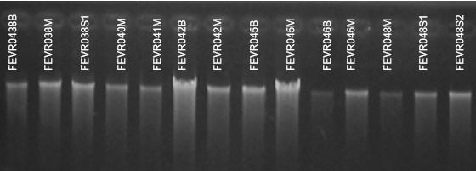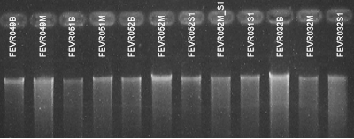
Supplementary Figure 1: Visualization of extracted DNA from familial samples of patients.
Supplementary Table 1: Concentration and purity assessment of DNA extracted from familial members.
Familial ID | Sample  ID | DNA concentration (ng/μL) | A260/A280 | Relationship with patient
1 | FEVR038B  FEVR038M  FEVR038S1 | 46.08  79.09  62.3 | 1.84  1.85  1.81 | Father  Mother  Brother
2 | FEVR040M | 48.7 | 1.82 | Mother
3 | FEVR041M | 45.9 | 1.80 | Mother
4 | FEVR042B  FEVR042M | 55.7  64.0 | 1.82  1.81 | Father  Mother
5 | FEVR045B  FEVR045M | 48.2  65.5 | 1.82  1.79 | Father  Mother
6 | FEVR046B  FEVR046M | 40.0  42.2 | 1.79  1.86 | Father  Mother
7 | FEVR048M  FEVR048S1  FEVR048S2 | 44.7  47.2  46.2 | 1.83  1.80  1.81 | Mother  Brother  Brother
8 | FEVR049B  FEVR049M | 42.3  44.6 | 1.80  1.81 | Father  Mother
9 | FEVR051B  FEVR051M | 57.1  82.9 | 1.80  1.82 | Father  Mother
10 | FEVR052B  FEVR052M  FEVR052S1  FEVR052M_S1 | 96.2  79.3  71.1  39.6 | 1.86  1.82  1.86  1.80 | Father  Mother  Sister  Aunt
11 | FEVR031S1 | 81.8 | 1.85 | Sister
12 | FEVR032B  FEVR032M  FEVR032S1 | 40.8  60.08  97.5 | 1.83  1.80  1.82 | Father  Mother  Sister

